IEEE P802.11  
Wireless LANs

|  |  |  |  |  |
| --- | --- | --- | --- | --- |
| CR for EDP Epoch Start Time | | | | |
| Date: 2024-11-28 | | | | |
| Author(s): | | | | |
| Name | Affiliation | Address | Phone | Email |
| Stéphane Baron | Canon Research centre France |  |  | Stephane.baron@crf.canon.fr |
| Julien Sevin |  |  | Julien.sevin@crf.canon.fr |
| Patrice Nezou |  |  | Patrice.nezou@crf.canon.fr |
|  |  |  |  |

Abstract

Abstract

This submission proposes resolutions and discussions for 23 CIDs number:

1031, 1050, 1051, 1052, 1080, 1244, 1245, 1246, 1247, 1248, 1249, 1250, 1251, 1252, 1253, 1254, 1256, 1259, 1260, 1265, 1266, 1267, 1518 on 802.11bi D0.4:

Revisions:

* Rev 0: Initial version of the document.

1. Introduction

Interpretation of a Motion to Adopt

A motion to approve this submission means that the editing instructions and any changed or added material are actioned in the TGbi Draft. The introduction and the explanation of the proposed changes are not part of the adopted material.

The baseline for this text is 802.11 REVme D7.0, and 802.11 TGbi draft D0.7

|  |  |  |  |  |  |
| --- | --- | --- | --- | --- | --- |
| CID | Page | Line | Comment | Proposed Change | Resolution |
| 1031 | 41 | 26 | It's not necessary to use PGTK to derive the GETn+1. The information is secured since the element is carried in a unicast protected action frame. | A simple pseudorandom integer drawn from a uniform distribution over the interval [0,RandTR] should be fine. | Rejected  The start times of the group EDP epochs are not exchanged but computed locally by the EDP AP MLDs and EDP non-AP MLDs. A shared secret is then needed, as input of the computation, in order to determine same value by both the AP MLD and the non-AP MLD. |
| 1050 | 41 | 23 | Regarding the Next EDP Epoch Starting Time computed, is it needed to be synchronised between the AP and the STA? if so, there cannot be two different computation algorithms | If the calculation needs to be in sync, choose one algorithm. If the second one is used, we do not need to distribute PGTK | Revised.  Agree in principle with the commenter. The calculation between the AP and the STA needs to be synchronized. For sake of simplicity, only one way to make the computation is proposed now. Alternative implementation corresponding to the second method, is now in a dedicated note1.  ***Instructions to the editor:***  **Please make the changes as shown under CID 1050 in 11-24/1999r0.** |
| 1051 | 41 | 23 | GTn is not defined | GT is defined as the reference start time of the EDP Epoch, how do you know this value? | Revised.  GTn is now replaced by RefTSFStartTime(n), and defined in clause 10.71.2.5 : RefTSFStartTime(n) = FirstTSFStartTime + n  EpochInterval  ***Instructions to the editor:***  **Please make the changes as shown under CID 1051 in 11-24/1999r0.** |
| 1052 | 41 | 30 | GEI cannot be added/multiplied/divided (see lines 30, 35 and 38) as defined | GEI as defined, Epoch Interval Duration, cannot be added as it is, since it has units which are not considered. | Revised.  The unit of GEI (now EpochInterval) is the value expressed in TU of the Epoch Interval Duration field originally expressed in Epoch Interval Unit of the Epoch Interval field as specified in section 9.4.1.76 EDP Epoch Setting fields  ***Instructions to the editor:***  **Please make the changes as shown under CID 1052 in 11-24/1999r0.** |
| 1080 | 41 | 48 | The term "GT" is not used | Please remove "GT" | Revised.  Agree in principle, GT should be GTn and is now renamed as RefTSFStartTime(n) and defined in 10.71.2.5 (see CID 1051 resolution).  ***Instructions to the editor:***  **Please make the changes as shown under CID 1051 in 11-24/1999r0.** |
| 1244 | 41 | 23 | "GTn+1" is not defined | As it says in the comment | Revised.  Agree in principle, GTn+1 is now not used anymore and renamed by RefTSFStartTime(n) that is defined in 10.71.2.5 (see CID 1051 resolution).  ***Instructions to the editor:***  **Please make the changes as shown under CID 1051 in 11-24/1999r0.** |
| 1245 | 41 |  | All this computational stuff shouldn't be in Clause 9 | As it says in the comment | Revised.  Agree in principle with the commenter, computation is now in moved in new clause 10.71.2.5  ***Instructions to the editor:***  No change needed; CID already solved by CID resolution of CID1116 |
| 1246 | 41 | 25 | What is \? | As it says in the comment | Revised.  Agree in principle with the commenter, Formula is revised according to the 802.11 editing style.  ***Instructions to the editor:***  **Please make the changes as shown under CID 1246 in 11-24/1999r0.** |
| 1247 | 41 | 38 | What is x? | As it says in the comment | Revised.  Agree in principle with the commenter, change the letter “x” by ““  Formula is revised according to the 802.11 editing style.  ***Instructions to the editor:***  **Please make the changes as shown under CID 1247 in 11-24/1999r0.** |
| 1248 | 41 | 33 | I have no idea what "Or" means here | As it says in the comment | Revised.  Agree in principle with the commenter, only one way to make the computation is proposed now. Alternative implementation corresponding to the "Or” part, is now in a dedicated note1.  ***Instructions to the editor:***  **Please make the changes as shown under CID 1248 in 11-24/1999r0.** |
| 1249 | 41 | 25 | I think PRF returns a bitstring, not a number, so it's not clear how you apply mod to it | As it says in the comment | Revised.  Agree in principle with the commenter. “Int()” cast has been added according to clause 1.5  ***Instructions to the editor:***  **Please make the changes as shown under CID 1249 in 11-24/1999r0.** |
| 1250 | 41 |  | Hyphens should be minuses in maths | As it says in the comment | Revised.  Agree in principle with the commenter. Minus now replaces hyphen.  ***Instructions to the editor:***  **Please make the changes as shown under CID 1250 in 11-24/1999r0.** |
| 1251 | 41 | 50 | "the Epoch Interval Duration" missing "field" | As it says in the comment | Revised.  Agree in principle with the commenter. “field” added after “Epoch Interval Duration”.  ***Instructions to the editor:***  **Please make the changes as shown under CID 1251 in 11-24/1999r0.** |
| 1252 | 41 | 55 | Do we have TSF counters as opposed to TSF times? | As it says in the comment | Revised.  Assuming commenter is referring to TSF timers, “TSF counter” replaced by “TSF timer” across the chapter  ***Instructions to the editor:***  **Please make the changes as shown under CID 1252 in 11-24/1999r0.** |
| 1253 | 41 | 60 | "of EDP Epoch Settings field" missing "the" | As it says in the comment | Revised.  Agree in principle with the commenter. “of EDP Epoch Settings” replaced by “of the EDP Epoch Settings”.  ***Instructions to the editor:***  **Please make the changes as shown under CID 1253 in 11-24/1999r0.** |
| 1254 | 41 |  | It's not clear what an iteration of an EDP epoch sequence is | As it says in the comment | Revised.  Iteration of an EDP Epoch is now replaced by the EDP epoch number that is the element number of a sequence, with first element number equal to 0 (see also CID1260 resolution).  ***Instructions to the editor:***  **Please make the changes as shown under CID 1254 in 11-24/1999r0.** |
| 1256 | 42 | 9 | "GET" is not defined | As it says in the comment | Revised.  GET is now replaced by EpochTSFStartTIme, and defined as follow in clause 10.71.2.5  EpochTSFStartTime(n) = RefTSFStartTime(n) + TSFOffset + ΔIT  ***Instructions to the editor:***  **Please make the changes as shown under CID 1256 in 11-24/1999r0.** |
| 1259 | 42 | 13 | "The time range field is" should be "The Time Range field contains" and the units are not given. Also "the range used by the stations" is not clear. Also is "the stations" different from "the STAs", and which are "the stations" anyway? | As it says in the comment | Revised.  As per discussion below  The unit is the Epoch Interval Unit to be coherent with the unit selected for the duration of an EDP epoch  Replace "the stations" by non-AP MLD  ***Instructions to the editor:***  **Please make the changes as shown under CID 1259 in 11-24/1999r0.** |
| 1260 | 41 | 60 | "Next Epoch Start Time field" should be defined better than a passing mention in a "where" for some equations | As it says in the comment | Revised.  Field name is now First Epoch TSF Start Time and a definition is provided  ***Instructions to the editor:***  **Please make the changes as shown under CID 1260 in 11-24/1999r0.** |
| 1265 | 42 | 3 | This should be part of the where, i.e. indented | As it says in the comment | Revised.  Agree in principle, indentation has been added in the new formula “where” statement.  ***Instructions to the editor:***  **Please make the changes as shown under CID 1265 in 11-24/1999r0.** |
| 1266 | 42 | 9 | "If the effective start time GET of an EDP Epoch occurs during an ongoing TXOP, the Epoch starts at the end of this TXOP." -- how do receivers know this, if they missed all the frames in the TXOP? | As it says in the comment | Revised.  Agree in principle with the commenter. A sentence indicating the behaviour if a start time occurs during an on going TXOP ***Instructions to the editor:***  **Please make the changes as shown under CID 1266 in 11-24/1999r0.** |
| 1267 | 42 | 9 | Anyway, what is "the effective start time"? GET is previously defined as " the start time [...] of the next EDP Epoch of the sequence", with no effectiveness | As it says in the comment | Revised.  The new formula account for resolution of this comment. “Effective” has been removed and GET renamed by EpochTSFStartTime.  ***Instructions to the editor:***  **Please make the changes as shown under CID 1267 in 11-24/1999r0.** |
| 1518 |  |  | A single offset calcualtion reduces operation overheads and improves STA and AP efficiency. |  | Rejected  Commenter do not clearly indicate what calculation it is referring to. |

Discussion: Simultaneous epoch start time across links.

In order to determine the same instant in time for an EDP epoch start time on every link of every non-AP station belonging to the same EDP group, there is a need for a common time reference.

To avoid issues during link reconfiguration, this common reference shall not be one of the TSF timers of the setup links.

The proposal here is that the AP uses an internal reference clock ticking at 1us, and indicates the TSF offset value between this reference clock and the TSF timer of the link used for EDP setup procedure, during the EDP setup procedure.

By doing so, the non-AP stations can compute at any time the TSF timer value for any of its link corresponding to the EDP epoch start time.

The figure below gives an example of the usage of this AP internal reference clock.

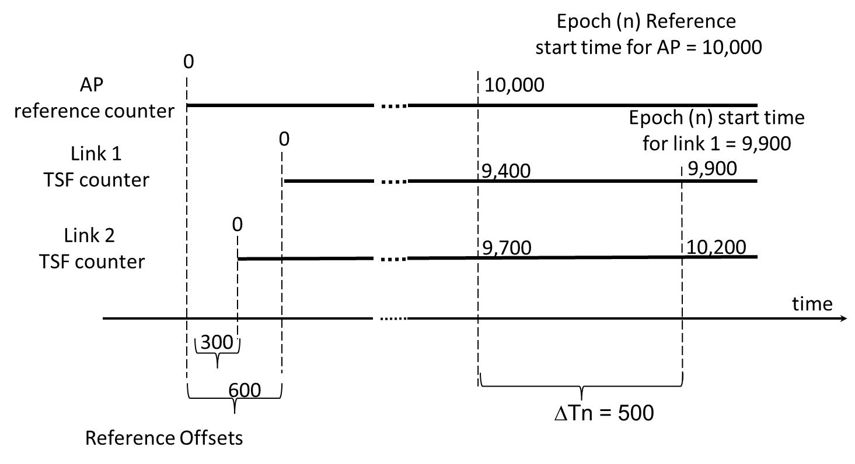

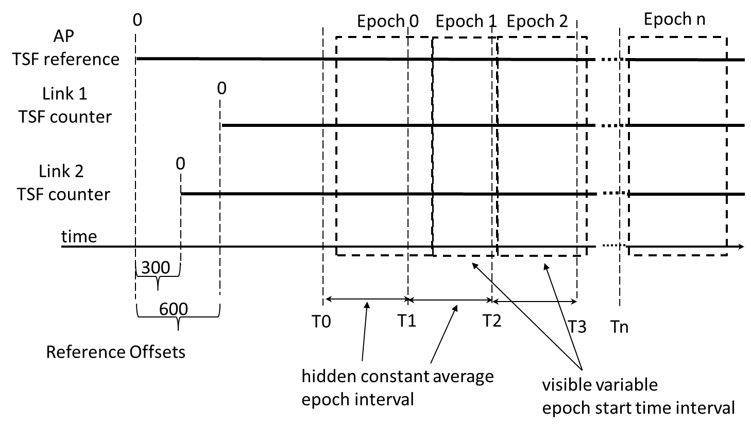

***TGbi editor: Modify clause 9.4.1.76 as follow***

* EDP Epoch Setting fields (#1070)

The EDP Epoch Settings field includes the information regarding the actual parameters of an Epoch.

|  |  |  |  |  |  |  |  |  |  |
| --- | --- | --- | --- | --- | --- | --- | --- | --- | --- |
|  | EDP Epoch Settings Control | Group ID | Epoch Interval | First Epoch TSF Start Time | Link TSF Offset (#1256) | Time Range | Epochs Remaining | Minimum Epoch Pacing Parameters | Number Of participating Affiliated STAs |
| Bits: | 8 | 0 or 8 | 16 | 0 or 64 | 0 or 64 | 0 or 16 | 0 or 8 | 0 or 16 | 0 or 8 or 16 or 24 |

* EDP Epoch Settings field format(#Ed)

The EDP Epoch Settings field contains the EDP epoch parameters of an EDP epoch sequence for the non-AP MLD.

The Group ID field signals an identifier of the EDP group. Value 0 indicates the default group. Value 255 is reserved.

The EDP Epoch Settings Control is defined as follows:

|  |  |  |  |  |  |  |  |  |
| --- | --- | --- | --- | --- | --- | --- | --- | --- |
|  | Group ID Present | First Epoch  TSF Start Time  Present | Time Range  Present | Epochs Remaining  Present | Participating Affiliated STAs Count Present(#Ed) | Participating Affiliated STAs Percentage Present(#Ed) | Minimum Epoch Pacing Parameters  Present | Reserved |
| Bits: | | 1 | 1 | 1 | 1 | 1 | 1 | 1 | 1 |

* EDP Epoch Settings Control field format(#Ed)

Each of the bits of the EDP Epoch Settings Control field indicate the presence of the corresponding field in the EDP Epoch Settings field when set to 1 and its absence when set to 0.

The Epoch Interval field is defined as follows:

|  |  |  |  |
| --- | --- | --- | --- |
|  | Epoch Interval Unit | Epoch Interval Length | Reserved |
| Bits: | 3 | 11 | 2 |

* Epoch Interval field format(#Ed)

The Epoch Interval Length field contains the length of the EDP epoch, expressed in Epoch Interval Units, shown in Table 9-129g (Epoch Interval Units and epoch durations). Epoch Interval Length value 0 is reserved.

|  |  |  |
| --- | --- | --- |
| Epoch Interval Unit field value | Epoch Interval Unit | Max Epoch Duration (approx.) |
| 0 | 1000 s | 23 d 16 h 36 min 40 s |
| 1 | 1 s | 34 min 7 s |
| 2 | Reserved | N/A |
| 3 | Reserved | N/A |
| 4 | Reserved | N/A |
| 5 | Reserved | N/A |
| 6 | Reserved | N/A |
| 7 | Reserved | N/A |

* Epoch Interval Units and epoch durations

(#1260)The First Epoch TSF Start Time filed contains the value of the TSF timer of the AP internal reference clock at the start time of the first EDP epoch of the sequence (EDP epoch number 0).

(#1256)

The Link TSF offset field value is a expressed in 2 TU unit and contains the offset between the AP internal reference clock and the TSF timer of the receiving link (TSF Ref -TSF Link) . (10.71.2.6 : EDP epoch start time).

The Minimum Epoch Pacing field signals the minimum epoch duration value that the non-AP MLD can support. The format of the Minimum Epoch Pacing element is the same as the Epoch Interval field.

The Time Range(#Ed) field contains (#1259) the range of values, expressed in Epoch Interval Units (#1259) as defined in Table 9-129g (Epoch Interval Units and epoch durations), used by the AP and each non-AP stations member of the EDP group (#1259) to determine a random delay added to the EDP epoch reference start time (EpochTSFStartTime) as defined in 10.71.2.6 (EDP epoch start time) (#1259).

The Epochs Remaining field indicates the number of EDP Epochs left in the sequence after the current epoch finishes, except 255, which means that the sequence duration is unlimited. The length of the Epoch Sequence Duration field is 1 octet.

The Number of Participating Affiliated STAs field is optional. When present, the field signals an indication of the number of affiliated STAs currently participating to this group EDP epoch on the current link.

|  |  |  |
| --- | --- | --- |
|  | Participating Affiliated STAs Count | Participating Affiliated STAs Percentage |
| Octets: | 2 | 1 |

* Number of Participating Affiliated STAs field format(#Ed)

The Participating Affiliated STAs Count field represents an indication of the number of affiliated STAs participating in the signaled group on the link. The Participating Affiliated STAs Percentage field, with values in the range of 0 to 100, represents an indication of the percentage of the associated affiliated STAs participating to the signalled group on the link. Values 101-255 are reserved.

***TGbi editor: Modify clause 10.71.2.3 as follow***

12.71.2.3 EDP epoch transitions operations (#1116)

[…]

(#1347, #1348)The next epoch boundary is derived (as described in 10.71.2.5 (EDP epoch start time computation (#1051)(#1091))) from the value of the next epoch start time(#1349, #1095, #1116) defined in the EDP Epoch

Settings field of the Group Enhanced Privacy element of the (Re)Association Response frame or the EDP

epoch setting action response frame. The Epoch Interval Duration field of the same fields and frames defines

the interval of the following Group EDP epochs sequence.

(#1096, #1353)

A CPE non-AP MLD belonging to an EDP group(#1096) and the CPE AP MLD may calculate the new OTA

values to be used for the non-AP MLD in the next(#1354) group EDP epoch(#1030).

At the start of the new group(#1030) EDP epoch, the new anonymization parameters are used to anonymize

the selected OTA fields of all new(#1175) individual frames transmitted during the epoch(#1355).

To account for clock drifts, the CPE non-AP MLD and CPE AP MLD shall begin to accept individually

addressed frames that use the new anonymization parameters for a dot11EpochStartTimeMargin before the

start of the(#1356) new epoch. The CPE non-AP MLD and CPE AP MLD shall accept individually

addressed frames with the old anonymization parameters for dot11EpochTransitionTime after the start of

the new epoch. The rules of 10.71.2.1 (General(#1091)) apply for frame retransmissions and acknowledgments.

***TGbi editor: Create clause 10.71.2.5 as follow***

10.71.2.5 EDP epoch start time computation (#1116)

To avoid an easy determination of the epoch stat time by an eavesdropper, the start time of each EDP epoch is determined by introducing a pseudo random variation around a reference start time occurring at a regular interval.

At any point of time, for any EDP epoch(#1243) (#1254) number n ( n > 0) in an EDP epoch(#1101) sequence, the start time of the EDP epoch , is computed according to the formula:

(#1051) EpochTSFStartTime(n) = ReferenceTSFStartTime(n) + TSFOffset + ΔIT

With :

n = ⌊ ⌋ (#1246) (#1250)

ReferenceTSFStartTime(n) = FirstTSFStartTime + n  EpochInterval (#1051) (#1247) (#1256)(#1244)

ΔIT = int (#1249) (KDF-Hash*-Length*(PGTK, "ERCM", ReferenceTSFStartTime(n))) mod RandTR .(#1246)

(#1248, #1050)and where:

n is the current number (#1254) of the EDP epoch in the EDP epoch sequence.

ReferenceTSFStartTime(n) is the TSF timer(#1252) value for the AP reference corresponding to the start time of the EDP epoch number n in the EDP epoch sequence. (#1051)(#1256)

TSFOffset is the value indicated in the Link TSF Offset field of EDP Epoch Settings Field

EpochInterval is the value in TU corresponding to the (#1052)Epoch Interval Duration field (#1251) of the EDP Epoch Settings field

TSFLink is the current value of the internal TSF timer(#1252) of the link used during the EDP Epoch Settings exchange.

KDF-Hash-*Length* is the key derivation function as defined in 12.7.1.6.2 (Key derivation function (KDF)) using the hash algorithm identified by the AKM suite selector (see Table 9-190 (AKM suite selectors)) .(#1246).

*Length* is the number of bits to derive. 64-bits are derived for ΔIT.(#1246)

FirstTSFStartTime is the value indicated in the First Epoch TSF Start Time field of the (#1253) EDP Epoch Settings Field.

RandTR is the value in TU corresponding to the Time Range field, of the EDP Epoch Settings field

PGTK (for Privacy GTK) (#1265)is the cryptographic key assigned by an EDP AP MLD that is used to manage the group EDP epoch, distributed to the EDP non-AP MLDs associated with the EDP AP MLD.

Note1: In some implementation, the number of the current Epoch of an EDP epoch sequence can be maintained as a counter starting at 0 for the first epoch of the sequence and incremented by one after the start of the next epoch in the sequence. (#1248, #1050)

Note2: For a given link, the TSF timer value, for this link, corresponding to the EDP Epoch start time, can be determined by using the value of the TSF Offset value between the current link and the link used during the EDP epoch setup procedure, received in the latest Basic Multi-Link element exchange. (#1256)

If the start time of an EDP epoch occurs during an ongoing TXOP, the FA parameters corresponding to the new EDP Epoch applies at the end of this TXOP. (#1266)

***TGbi editor: Modify clause 10.71.3 as follow***

**10.71.3 Establishing frame anonymization parameter sets** (#1002)

[…]

For a given EDP epoch, the EDP FA block shall be generated as:

EDP FA block =*KDF*-*Hash*-*Length*( KDK, "EDP CPE frame anonymization", ReferenceTSFStartTime(n) (#1244))

where:

EDP FA block is the block of bits which is partitioned into the sets of all possible values for each

EDP frame anonymization parameter

KDF-*Hash*-*Length* is the key derivation function as defined in 12.7.1.6.2 (Key derivation function

(KDF)) using the hash algorithm identified by the AKM suite selector (see Table

9-190 (AKM suite selectors))

KDK is the Key Derivation Key

ReferenceTSFStartTime(n) (#1244)is the reference start time of the EDP Epoch (see

9.4.2.348 (EDP(#1235) element))

*Length* is the total number of bits to derive. A total of 1728 bits are derived for a EDP

FA block.

***TGbi editor: Modify clause 10.71.4 as follow***

**10.71.4 Establishing BPE frame anonymization parameter sets(#1521)**

All associated BPE non-AP MLDs and the BPE AP MLD shall generate EDP BPE frame anonymization

parameters for a given EDP epoch by computing a single pseudorandom EDP BPE FA block which is partitioned

into a(#Ed) set of EDP BP frame anonymization parameters according to the following tables.(#Ed)

For a given EDP epoch, the EDP FA block shall be generated as:

EDP_BPE_FA_block = KDF-*Hash*-*Length* (PGTK, "EDP BPE frame anonymization", ReferenceTSFStartTime(n) (#1244)),

where:

KDF-*Hash*-*Length* is the key derivation function as defined in 12.7.1.6.2 (Key derivation function

(KDF)) using the hash algorithm identified by the AKM suite selector (see Table

9-190 (AKM suite selectors)); Length is equal to 872 bits for offset calculation.

PGTK is the Privacy Group Transient Key.

ReferenceTSFStartTime(n)is the reference start time of the EDP Epoch (see 9.4.2.348 (EDP(#1235) element)).