IEEE P802.11  
Wireless LANs

|  |  |  |  |  |
| --- | --- | --- | --- | --- |
| 802.11 bn PHY ad-hoc minutes for the November 2024 Interim session | | | | |
| Date: 2024-11-14 | | | | |
| Author(s): | | | | |
| Name | Affiliation | Address | Phone | email |
| Sigurd Schelstraete | MaxLinear |  |  | sschelstraete@maxlinear.com |

Abstract

This document contains the PHY ad hoc meeting minutes for TGbn held on:

* Monday AM1, November 11, 2024
* Tuesday AM2, November 12, 2024
* Tuesday PM1, November 12, 2024
* Tuesday EVE, November 12, 2024
* Wednesday AM2, November 13, 2024
* Wednesday PM2, November 13, 2024
* Thursday AM1, November 14, 2024
* Thursday AM2, November 14, 2024

## Monday November 11th, 2024 8:00 – 10:00 PT

**Introduction**

1. The Chair (Dongguk Lim, LGE) calls the meeting to order at 8:00am PT.
2. The Chair follows the agenda in 11-24/**1667r2**.
3. Reminder for registration for the Interim meeting.
4. The Chair reminds everyone to report their attendance by using IMAT system and by sending an e-mail to the Co-chair, Tianyu Wu (Apple), Sigurd Schelstraete (MaxLinear) or the Chair himself if unable to record attendance via IMAT system.
5. The Chair goes through the IPR policy and asks if anyone is aware of any potentially essential patents. **Nobody speaks up.**
6. The Chair goes through the Copyright policy.
7. Discussions on the agenda.

**Straw Polls**

**SP1 – Mahmoud Kamel – DRU (24/1552r1)**

Do you agree to add the following to 11bn SFD:

The LTF type that 11bn supports for DRU in TB PPDU is 4xLTF, i.e., each tone of every DRU in 11bn will have a nonzero value in the DRU LTF sequence.

1xLTF and 2xLTF are TBD

Withdrawn

**SP2 – Eunsung Park – DRU (24/1471)**

Do you agree to add the following text to the TGbn SFD?

For 80 MHz PPDU where one of the 20 MHz channels is punctured, the following distribution bandwidth mode is allowed for DRU

20 MHz + 40 MHz (or 40 MHz + 20 MHz) mode

Deferred

**SP3 – Eunsung Park– DRU (24/1471)**

Do you agree to add the following text to the TGbn SFD?

For 160 MHz and 320 MHz PPDUs, in an 80 MHz channel where one of the 20 MHz channels is punctured, the following distribution bandwidth mode is allowed for DRU

20 MHz + 40 MHz (or 40 MHz + 20 MHz) mode

Deferred

**SP4 – Eunsung Park – DRU (24/1471)**

Do you agree to add the following text to the TGbn SFD?

* For 160 MHz and 320 MHz PPDUs, in an 80 MHz frequency subblock where one of the 40 MHz channels is punctured (i.e., either 1100 or 0011 case), the following distribution bandwidth mode is allowed for DRU
  + 40 MHz mode

Y/N/A: 46/12/16

**SP5 – Eunsung Park – DRU (24/1471)**

Do you agree to add the following text to the TGbn SFD?

* For a 40 MHz PPDU, the following distribution bandwidth modes are allowed for DRU
  + 40 MHz mode
  + 20 MHz + 20 MHz mode

Deferred

**SP6 – Eunsung Park – DRU (24/1471)**

Do you agree to add the following text to the TGbn SFD?

* Information to indicate a DRU transmission in a TB PPDU is contained in the Common Info field or the Special User Info field of the Trigger frame

Withdrawn – replaced with below SP

**SP2 from 1471 (instead of SP6)**

Do you agree to add the following text to the TGbn SFD?

For 160 MHz and 320 MHz PPDUs, in a non-punctured 80 MHz channel, the following distribution bandwidth modes are allowed for DRU

* 80 MHz mode
* 20 MHz + 20 MHz + 40 MHz (or 40 MHz + 20 MHz + 20 MHz) mode

Y/N/A: 33/14/14

**Technical contributions**

**24/1487 LDPC and Framing Settings for Ultra High Reliability (Rainer Strobel)**

The Choice of LDPC framing parameters can be improved in several ways:

Choosing shortening over repetition improves reliability. LDPC parameters can be chosen to provide higher protection for the start of the payload, the retransmitted packets.

Discussion

Q: agree that shortening is more effective. Please clarify graphs on slide 5. N_pld should show step behavior rather than linear behavior. Should be padded to OFDM symbol boundary.

A: Npld was the sweep parameter.

Q: How does receiver know N_CW if there is flexibility in choosing it. May be challenging to convey all information to the receiver.

A: maybe new signaling, but there may be other solutions

Q: do you assume same airtime or is it longer?

A: allow for extra time. Also concerned about extra signaling part.

Q: why is error rate higher in the beginning of PPDU

A: adaptive equalizer or clock convergence can cause this.

**24/1828 2xLDPC Encoding Parameters (Shengquan Hu)**

To accommodate the LDPC codes with codeword length of 3888, the existing LDPC encoding parameter table need be updated. It is proposed to have a 1x/2x indication in the User Info field.

Discussion

Q: if 2x were mandatory, do you still need this flexibility?

Q: the second issue only exists for small payloads? Can’t this be captured in the table? Is there a payload size above which use of 2x LDPC shouldn’t be switched off?

A: better to have the flexibility

Q: 2xLDPC is most likely optional. In broadcast packet, 2x LDPC can not be used. In some cases, 2x may not be as good as 1x.

Q: is it necessary to limit the CW to be at least two?

Continue discussion offline.

**24/1492 Comparison between Dynamic and Fixed Start CSD Assignment (Bo Gong)**

Dynamic scheme for selecting CSDs provides more accurate power measurement than the fixed scheme. Follow-up of previous results and comparison with related submissions.

A dynamic scheme is more appropriate in terms of both performance and implementation.

Discussion

Q: clarification

**24/1556 Thoughts on DRU Availability for Regulatory Compliance (Yusuke Asai)**

Deferred till next session

**24/1901 DRU LTF Sequence Design for 40MHz DBW (Chenchen LIU)**

Deferred till next session

**Recess**

The meeting is Recessed at 10:00am PT.

## Tuesday November 12th, 2024 10:30 – 12:30 PT

**Introduction**

1. The Chair (Dongguk Lim, LGE) calls the meeting to order at 10:30am PT.
2. The Chair follows the agenda in 11-24/**1667r4**.
3. Reminder for registration for the Interim meeting.
4. The Chair reminds everyone to report their attendance by using IMAT system and by sending an e-mail to the Co-chair, Tianyu Wu (Apple), Sigurd Schelstraete (MaxLinear) or the Chair himself if unable to record attendance via IMAT system.
5. The Chair goes through the IPR policy and asks if anyone is aware of any potentially essential patents. **Nobody speaks up.**
6. The Chair goes through the Copyright policy.
7. Discussions on the agenda.

**Straw Polls**

SP1 – Rethna Pulikkoonattu (23/1985)

Do you support the adoption of LDPC codes with blocklength of 3888 bits for UHR?

* The supported code rates are 1//2, 2//3, 3//4 and 5//6
* The parity matrix representation of these LDPC codes are as described in the slides 22-31(DCN: 23/1985-r6)

No Objection

SP2 – Shenquan Hu (24/1828)

**Do you agree to add the following text to the TGbn SFD?**

update the LDPC PPDU encoding parameter table for UHR as below:

* If FEC coding scheme is LDPC and Navbits ≤ 3888, the 2xLDPC subfield shall be set to 0 and the LDPC codeword length selection shall follow the pre-UHR LDPC procedure, specifically using codeword lengths (648, 1296, or 1944) bits based on the table below

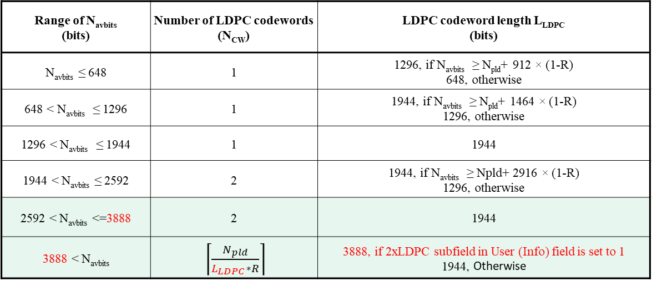

Y/N/A: 80/9/27

SP3 – Lin Yang (24/1510r2)

* **Do you agree to add the following text to the TGbn SFD?**
  + 11bn supports the following DBW dependent DRU size support to maximize BW and power efficiency
    - No MRU in distributed transmission
    - 20MHz: RU26, RU52, RU106
    - 40MHz: RU26, RU52, RU106, RU242
    - 80MHz: RU52, RU106, RU242, RU484

No Objection

SP4 – Lin Yang (24/1510r2)

* **Do you agree to add the following text to the TGbn SFD?**
  + 11bn supports per 80MHz DRU/RRU switch if PPDU BW >80MHz and no hybrid DRU and RRU mode for up to 80MHz
    - DRU (distributed tone RU)
    - RRU (regular RU)

Y/N/A: 75/10/16

SP5 – Lin Yang (24/1510r2)

* **Do you agree to add the following text to the TGbn SFD?**

In mixed RRU and DRU transmission the RRU LTF follows the exact same rule as if there is no DRU. The DRU LTF sequence depends on the distribution BW

No Objection

SP6 – Lin Yang (24/1510r2)

* **Do you agree to add the following text to the TGbn SFD?**

DRU transmission uses single stream pilots in both LTF and data portion

No Objection

SP7 – Lin Yang (24/1510r2)

* **Do you agree to add the following text to the TGbn SFD?**

DRU only uses 4x LTF

No Objection

SP8 – Lin Yang (24/1510r2)

* **Do you agree to add the following text to the TGbn SFD?**

In DRU transmission, global CSD provides CSD start index i for each DRU. If Nss for this DRU is larger than 1, then it will use CSD[mod(i: i+Nss-1, 8)] for each ss

No Objection

**Technical presentations**

**24/1556 Thoughts on DRU Availability for Regulatory Compliance (Yusuke Asai)**

Some patterns of DRU do not satisfy with the Japanese regulatory rules “The number of subcarriers per 1 MHz is equal to or more than one in OFDM transmissions.”. To resolve this, 11bn should define to restrict DRU patterns according to the regulatory domain.

Discussion

Q: for punctured cases, current rules may not be followed either. How strict are these rules?

A: let’s discuss offline

Q: maybe need to check if the rule is really limiting, see what the true requirement is.

Q: for 26 tone DRU, max gain is achieved for 40 MHz or more. So Table on slide 5 implies some performance loss for some DRU cases.

Q: it’s a stretch to say that legacy devices already break the rules, as some people have claimed. Regulation needs to be respected.

**24/1901 DRU LTF Sequence Design for 40MHz DBW (Chenchen Liu)**

Design DRU LTF sequences tailored specifically to the DRU tone plan and pilot locations are presented.

SP will be run when similar SPs are addressed.

**24/1586 Reducing CSD collisions for DRU STF (Leonardo Lanante)**

Proposes a technique to reduce CSD collisions when multiple STAs transmit multiple spatial streams.

This is done by interleaving/splitting the RRU tones of the STF into the number of spatial streams of the transmitted TB PPDU.

Discussion

Q: this is not a typical case. There should be multiple DRU users, occupying at least e.g. 50% of the BW.

A: we use it to test the proposal.

Q: don’t see benefit from performance point of view, but leads to extra complexity.

**24/1071 LPI PPDU Puncturing (Pelin Salem)**

Deferred to next session

**24/1700 Collision detection mark for enhanced channel access (Daniel Verenzuela)**

Deferred to next session

**Recess**

The meeting is Recessed at 12:30 pm PT.

## Tuesday November 12th, 2024 13:30 – 15:30 PT

**Introduction**

1. The Chair (Dongguk Lim, LGE) calls the meeting to order at 1:30pm PT.
2. The Chair follows the agenda in 11-24/**1667r4**.
3. Reminder for registration for the Interim meeting.
4. The Chair reminds everyone to report their attendance by using IMAT system and by sending an e-mail to the Co-chair, Tianyu Wu (Apple), Sigurd Schelstraete (MaxLinear) or the Chair himself if unable to record attendance via IMAT system.
5. The Chair goes through the IPR policy and asks if anyone is aware of any potentially essential patents. **Nobody speaks up.**
6. The Chair goes through the Copyright policy.
7. Discussions on the agenda.

**Technical presentations**

**24/1470 Proposal-for-dru-tone-plan (Eunsung Park)**

Proposal for 20 MHz and 80 MHz tone plans. Comparison is made with other tone plans. The advantages of the mirror symmetry are highlighted.

Discussion

Q: there are some potential issues in your 20 and 80 MHz proposal. Disagree with the claim that this is simpler.

**24/1712 DRU Tone Plan for 20 MHz Distribution Bandwidth (Mahmoud Kamel)**

A tone allocation plan for 20 MHz based on a prior contribution is proposed. All DRUs are shifted versions of each other.

Discussion

Q: DRUs not aligned with RU242 boundary. DRUs will be shifted within 20 MHz subblock.

Q: tone plan needs to be designed globally. Need to consider all other simultaneous DRUs.

**24/1856 Tone Distribution in DRU with Puncturing - Follow-up (Yan Xin)**

Design presented earlier. This contribution further proposes a mode of tone distribution in DRU with distribution BW of 60 MHz, in which only the highest 20 MHz subchannel is punctured in a 80 MHz subblock. Only SP language modified.

Discussion

Q: most designs are based on powers of 2, This does not apply to 60 MHz. May be difficult for HW design.

A: full BW is still 80 MHz.

**DRU Straw Polls**

SP1 – Shenquan Hu (24/0468r2)

Do you agree to include the following text to the 11bn SFD?

* Data and pilot subcarrier indices for DRUs in a 20 MHz UHR PPDU are defined in following table:

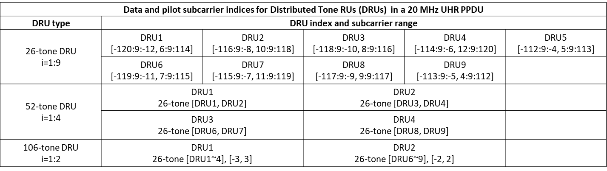

Y/N/A: 51/11/27

SP2 – Shenquan Hu (24/0468r2)

Do you agree to include the following text to the 11bn SFD?

* Data and pilot subcarrier indices for DRUs in a 40 MHz UHR PPDU are defined in following table:

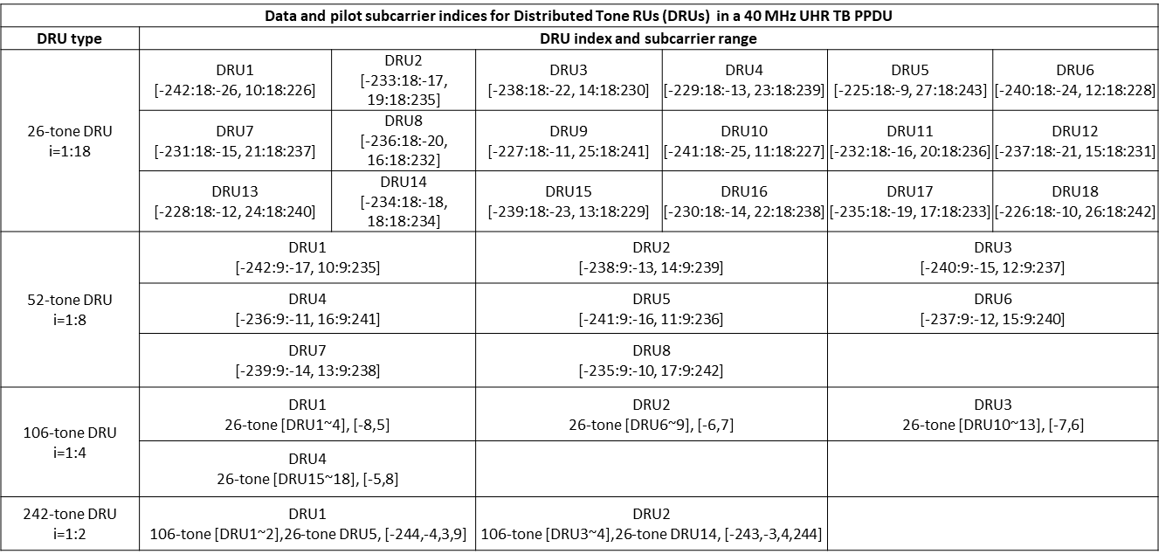

No Objection

SP3 – Shenquan Hu (24/0468r2)

Do you agree to include the following text to the 11bn SFD?

Data and pilot subcarrier indices for DRUs in an 80 MHz UHR PPDU are defined in following table:

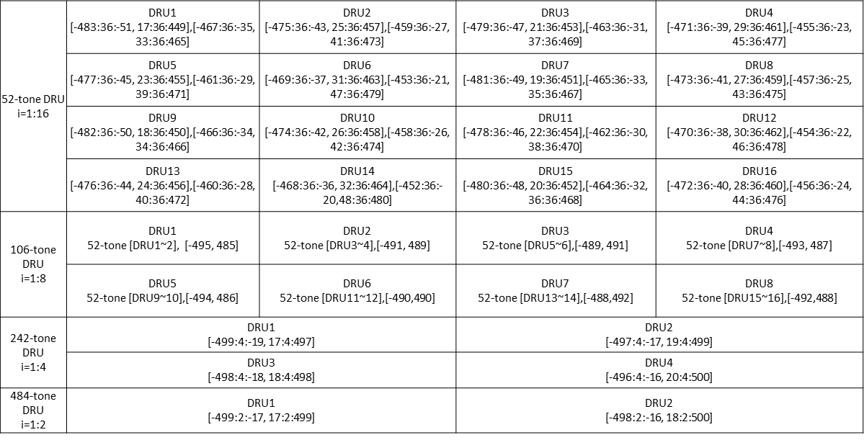

No Objection

SP4 – Shenquan Hu (24/1188r2)

Do you agree to include the following text to the 11bn SFD?

* DRU index based global CSD start index assignment will be used for DRU UHR-STF transmission
* Global CSD start index assignment for DRU UHR-STF transmission will be based on the following table

No Objection

SP5 – Shenquan Hu (24/1189r1)

Do you agree to include the following text to the 11bn SFD?

* DRUs on frequency subblocks of wide bandwidth PPDU should be defined as DRUs on 20MHz, 40MHz and 80MHz PPDU with the following constant shifts?

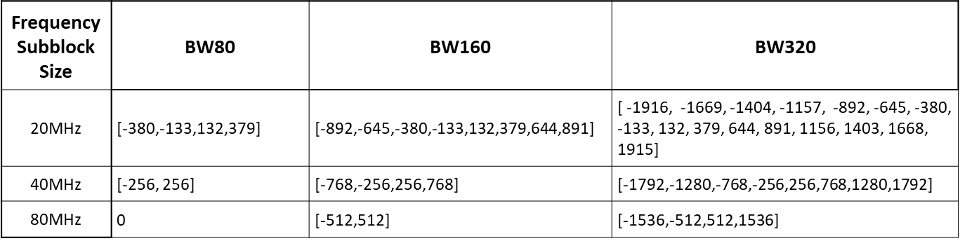

No Objection

SP6 – Shenquan Hu (24/1489r1)

Do you agree to include the following text to the 11bn SFD?

use 4-bit bitmap in Common Info field (B56-B59) for DRU indication?

1 bit/80MHz to indicate each 80MHz is used for DRU or RRU

Y/N/A: 62/9/18

SP7 – Shenquan Hu (24/1489r1)

Do you agree to include the following text to the 11bn SFD?

* Re-purpose 2 bits of SS Allocation subfield in User Info field for distribution bandwidth indication if DRU

No Objection

SP8 – Lin Yang (24/1510r2)

**Do you agree to add the following text to the TGbn SFD?**

The following pilot index table from hierarchical uniform pilot structure of distance of 11 will be used for distributed transmission over 20MHz

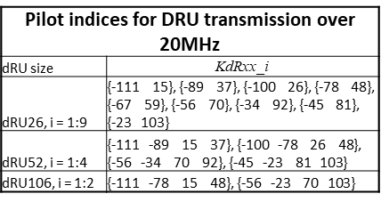

No Objection

SP9 – Lin Yang (24/1510r2)

* **Do you agree to add the following text to the TGbn SFD?**

The following pilot index table from hierarchical uniform pilot structure of distance of 11 will be used for distributed transmission over 40MHz

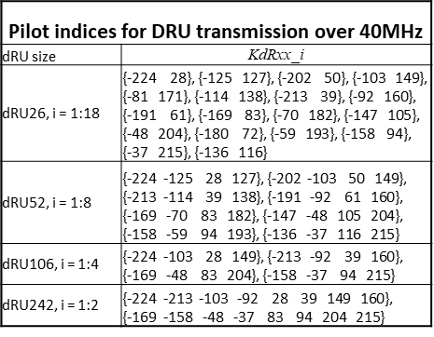

No Objection

SP10 – Lin Yang (24/1510r2)

* **Do you agree to add the following text to the TGbn SFD?**

The following pilot index table from hierarchical uniform pilot structure of distance of 11 will be used for distributed transmission over 80MHz

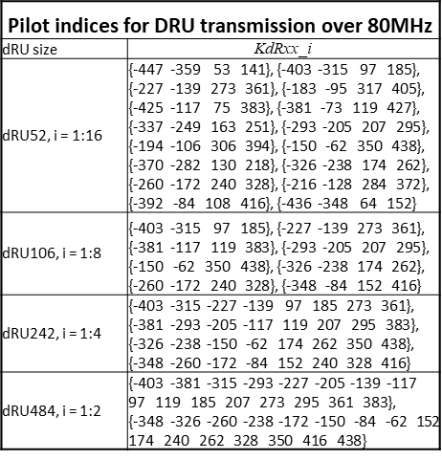

No Objection

SP11 – Yan Xin (24/1856r0)

* **Do you agree to add the following text to the TGbn SFD?**

A DRU distribution bandwidth of 60 MHz in an 80 MHz frequency subblock (with the highest 20 MHz subchannel unallocated) shall be defined in a UHR TB PPDU.

* No allocation is made in the highest 20 MHz subchannel

No Objection

SP12 – Eunsung Park (24/1471r2)

* **Do you agree to add the following text to the TGbn SFD?**
  + For 80 MHz PPDU where one of the 20 MHz channels is punctured, the following distribution bandwidth mode is allowed for DRU
    - 20 MHz + 40 MHz (or 40 MHz + 20 MHz) mode

No Objection

SP13 – Eunsung Park (24/1471r2)

* **Do you agree to add the following text to the TGbn SFD?**
  + For 160 MHz and 320 MHz PPDUs, in an 80 MHz frequency subblock where one of the 20 MHz channels is punctured, the following distribution bandwidth mode is allowed for DRU
    - 20 MHz + 40 MHz (or 40 MHz + 20 MHz) mode

No Objection

SP14 – Eunsung Park (24/1471r2)

* **Do you agree to add the following text to the TGbn SFD?**
  + For a 40 MHz PPDU, the following distribution bandwidth modes are allowed for DRU
    - Only 40 MHz mode

No Objection

SP15 – Shenquan Hu (23/2020r2)

**Do you agree to include the following text to the 11bn SFD?**

* Minimum size of RRU in hybrid mode in 160MHz and 320MHz is 242

No Objection

SP16 – Mahmoud Kamel (24/0520r1)

Do you agree to use the notation sDRUb to refer to a DRU of size s and a distribution bandwidth b:

* sDRUb_i is the i-th DRU with size s and distribution bandwidth b

Y/N/A: 15/39/34

SP17 – Mahmoud Kamel (24/1712r1)

Do you agree that the tone indices of different DRUs with the same size and distribution bandwidth within the same operating bandwidth should be shifted versions of each other to ensure they perform similarly in fading channels?

Y/N/A: 15/49/27

**Technical presentations**

**24/1771 Antenna selection for UHR (Ross Jian Yu)**

This contribution proposes to enable ASEL in 802.11bn. ASEL 11n procedure is used as a first proposal. Trigger based method could be used to enable Tx ASEL with multiple STAs.

Signaling details are for further discussion.

**Recess**

The meeting is Recessed at 3:25 pm PT.

## Tuesday November 12th, 2024 19:30 – 21:30 PT

**Introduction**

1. The Chair (Dongguk Lim, LGE) calls the meeting to order at 7:30pm PT.
2. The Chair follows the agenda in 11-24/**1667r7**.
3. Reminder for registration for the Interim meeting.
4. The Chair reminds everyone to report their attendance by using IMAT system and by sending an e-mail to the Co-chair, Tianyu Wu (Apple), Sigurd Schelstraete (MaxLinear) or the Chair himself if unable to record attendance via IMAT system.
5. The Chair goes through the IPR policy and asks if anyone is aware of any potentially essential patents. **Nobody speaks up.**
6. The Chair goes through the Copyright policy.
7. Discussions on the agenda.

**Straw Polls**

SP1 – Dongguk Lim (24/1485r2)

* **Do you agree to include the following text to the 11bn SFD?**
  + The U-SIG field in ELR PPDU consists of 2 OFDM symbols and includes the same version independent fields defined in the U-SIG field of EHT PPDU
    - The details for the version dependent fields are TBD.

No Objection

SP2 – Dongguk Lim (24/1485r2)

* **Do you agree to include the following text to the 11bn SFD?**
  + In the ELR transmission, the power boosting is applied on L-STF, L-LTF, ELR-STF, and ELR-LTF.
    - The value of power boosting is 3 dB.

Y/N/A: 47/12/20

SP3 – Dongguk Lim (24/1486r1)

* **Do you agree to include the following text in the 11bn SFD?**
  + The BW of ELR PPDU is 20MHz and one Spatial stream is used for ELR transmission.

No Objection

SP4 – Dongguk Lim (24/1486r1)

* **Do you agree to include the following text in the 11bn SFD?**
  + In the ELR transmission, a repeating of 52-tone RRU is used in 20MHz.
    - The same data is repeated in four 52-tone RRUs in 20 MHz.
    - The subcarrier allocation of 52-tone RRU equals the 52-tone RU defined in 11be.

No Objection

SP5 – Lin Yang (24/1478)

* **Do you agree to include the following into the 11bn SFD?**
  + ELR packet detection is done at L-STF, which has same length as legacy with 3dB power boosting
    - L-LTF also has same length as legacy with same power boosting as L-STF

Y/N/A: 49/8/14

SP6 – Lin Yang (24/1478)

* **Do you agree to include the following into the 11bn SFD?**
  + U-SIG carries STA-ID in ELR PPDU

No Objection

SP7 – Lin Yang (24/1478)

* **Do you agree to include the following into the 11bn SFD?**
  + Define two ELR-Mark symbols for ELR mode classification
    - ELR-Mark symbols carry a known sequence to receiver
    - ELR-Mark symbols carry BSS color info in ELR-Mark sequence
    - No power boosting on ELR-Mark symbols
    - Two ELR-Mark symbols are both QBPSK modulated on data subcarriers
    - ELR-Mark symbols use the following tone plan
      * 4 regular pilots as EHT-SIG + 48 data tones

No Objection

SP8 – Lin Yang (24/1478)

* **Do you agree to include the following into the 11bn SFD?**
  + 11bn defines the following PPDU frame format for ELR
    - PE TBD



No Objection

SP9 – Lin Yang (24/1478)

* **Do you agree to include the following into the 11bn SFD?**
  + ELR PPDU has 3dB boosting applied on both ELR-STF and ELR-LTF
    - ELR PPDU has ELR-STF duration and sequence same as that of UHR DL SU/MU PPDU
      * 4us using EHT-STF sequence
    - ELR PPDU defines a fixed/single mode of LTF+GI
      * 11bn supports 2x LTF+1.6us GI only for ELR PPDU
      * 11bn uses two UHR-LTF symbols for ELR PPDU

No Objection

SP10 – Lin Yang (24/1478)

* **Do you agree to include the following into the 11bn SFD?**
  + ELR PPDU defines two symbols for ELR-SIG, specifically
    - ELR PPDU defines separately encoded two symbols for ELR-SIG
      * Each symbol has separate CRC and tail bits (6 bits)
    - ELR-SIG has same tone plan and duplication scheme as ELR-data and BCC encoded with MCS0

No Objection

SP11 – Wook Bong Lee (24/1573)

* **Do you agree to add following text to the TGbn SFD?**
  + Define an enhanced long range (ELR) PPDU in IEEE 802.11bn with the following targets
    - Downlink and Uplink in 2.4 GHz (within BSS range with 11b beacon)
    - Uplink only in 5 GHz and 6 GHz bands
    - Minimum data rate is greater than or equal to 1.5 Mbps

No Objection

SP12 – Wook Bong Lee (24/1573)

* **Do you agree to add the following text to the TGbn SFD?**
  + In ELR PPDU, STA boosts L-STF and L-LTF by 3 dB
    - For UL, non-AP STA corrects CFO before transmission
    - Note: Non-AP STA pre-correction CFO requirement for residual CFO is TBD

Y/N/A: 51/6/23

SP13 – Shenquan Hu (24/1573)

* Do you agree to include the following text to the 11bn SFD?

ELR PPDU only supports the following two modulation and coding schemes:

- BPSK with coding rate R=1/2

- QPSK with coding rate R=1/2

Y/N/A: 62/6/19

SP14 – Shenquan Hu (24/1573)

* Do you agree to include the following text to the 11bn SFD?

ELR transmission shall apply the phase rotations as below for both BPSK and QPSK modulations

* + The rotation of -1 will be applied on data subcarriers of lower half of RU3 and upper half of RU4 for 52-tone regular RU (RRU52) on 20MHz

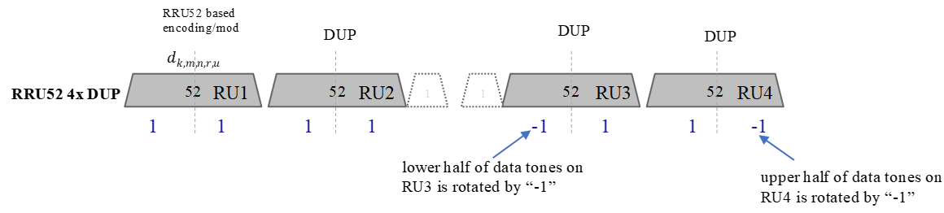

No Objection

**Technical Presentations**

**24/1071 LPI PPDU Puncturing (Pelin Salem)**

FCC currently does not permit PPDU Puncturing in LPI BSSs. A method is proposed for composite APs to be able to puncture in LPI mode.

Discussion

Q: clarify the need for puncturing in LPI

Q: what new functionality is needed?

A: want to bring this to 11mf, asking for input

**24/1542 Sounding Schemes for Coordinated Beamforming (Sameer Vermani)**

Similar to proposal from September.

New discussion on CFO issues. In Joint sounding AP2 needs precorrection to bring the frequency close to AP1. Estimate can be made from NDPA. The second sounding should preserve the precorrection used for the first NDP. 350 Hz is proposed as a target for the precorrection. Simulations show that precorrection would also be needed for the sequential sounding case.

Discussion

Q: is there a time sync between the NDPs in joint sounding case?

A: should be similar to UL MU-MIMO case.

Q: sounding framework clarification

A: AP2 will overhear feedback from STA1. There is no backhaul assumption.

Q: should each phase fit in the same TXOP?

A: needs further discussion in Joint or MAC sessions. Shorter is better.

Q: Agree with the observations. Clarification of simulation results.

Q: if we eliminate the double transmission of NDPAs, this would eliminate the problem

A: we only want NDPA to address the in-BSS STAs

**Recess**

The meeting is Recessed at 9:30 pm PT.

## Wednesday November 13th, 2024 10:30 – 12:30 PT

**Introduction**

1. The Chair (Dongguk Lim, LGE) calls the meeting to order at 10:30am PT.
2. The Chair follows the agenda in 11-24/**1667r10**.
3. Reminder for registration for the Interim meeting.
4. The Chair reminds everyone to report their attendance by using IMAT system and by sending an e-mail to the Co-chair, Tianyu Wu (Apple), Sigurd Schelstraete (MaxLinear) or the Chair himself if unable to record attendance via IMAT system.
5. The Chair goes through the IPR policy and asks if anyone is aware of any potentially essential patents. **Nobody speaks up.**
6. The Chair goes through the Copyright policy.
7. Discussions on the agenda.

**Straw Polls**

SP1 – Juan Fan (24/1590)

* **Do you agree to include the following into the 11bn SFD?**
  + ELR LDPC rate matching will reuse the existing 802.11ac LDPC rate matching with 1-bit LDPC extra OFDM symbol indication

No Objection

SP2 – Juan Fan (24/1590)

* **Do you agree to include the following into the 11bn SFD?**
  + ELR-SIG will use the following two OFDM symbols design

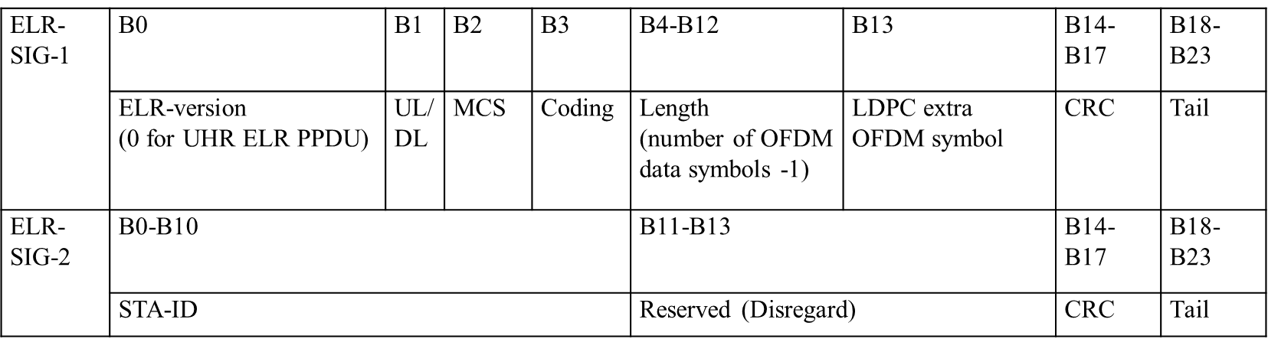

No Objection

SP3 - Rethna Pulikkoonattu (24/1571)

* Do you support using ELR Mark symbols that consist of two 1x OFDM symbols?
  + Each symbol will have duration of 4μS (3.2μS + GI=0.8μS).

No Objection

SP4 - Rethna Pulikkoonattu (24/1571)

* Do you support to include the following to the SFD using ELR Mark symbols with the following tone mapping?
  + The 48 data tones are Q-BPSK mapped
  + The pilots follow BPSK mapping (polarity -1 mapped to [1, 1, 1, -1])

No Objection

SP5 - Rethna Pulikkoonattu (24/1571)

* Do you support to include the following in the SFD: Adopt the ELR Mark sequence design as described by the matrix H.

H=[

-1,-1,-1,-1,1,-1,-1,-1,-1,1,1,-1,1,-1,1,-1,-1,-1,1,1,-1,1,1,-1,-1,1,-1,-1,1,1,1,-1,1,-1,1,-1,-1,1,1,1,1,-1,1,1,1,1,1,-1

1,-1,-1,-1,-1,1,1,-1,1,-1,1,-1,-1,-1,1,1,-1,1,1,-1,-1,1,-1,-1,1,1,1,-1,1,-1,1,-1,-1,1,1,1,1,-1,1,1,1,1,1,-1,-1,-1,-1,-1

-1,-1,-1,-1,1,1,-1,1,-1,1,-1,-1,-1,1,1,-1,1,1,-1,-1,1,-1,-1,1,1,1,-1,1,-1,1,-1,-1,1,1,1,1,-1,1,1,1,1,1,-1,-1,-1,-1,1,-1

-1,-1,-1,1,1,-1,1,-1,1,-1,-1,-1,1,1,-1,1,1,-1,-1,1,-1,-1,1,1,1,-1,1,-1,1,-1,-1,1,1,1,1,-1,1,1,1,1,1,-1,-1,-1,-1,1,-1,-1

-1,-1,1,1,-1,1,-1,1,-1,-1,-1,1,1,-1,1,1,-1,-1,1,-1,-1,1,1,1,-1,1,-1,1,-1,-1,1,1,1,1,-1,1,1,1,1,1,-1,-1,-1,-1,1,-1,-1,-1

-1,1,1,-1,1,-1,1,-1,-1,-1,1,1,-1,1,1,-1,-1,1,-1,-1,1,1,1,-1,1,-1,1,-1,-1,1,1,1,1,-1,1,1,1,1,1,-1,-1,-1,-1,1,-1,-1,-1,-1

1,1,-1,1,-1,1,-1,-1,-1,1,1,-1,1,1,-1,-1,1,-1,-1,1,1,1,-1,1,-1,1,-1,-1,1,1,1,1,-1,1,1,1,1,1,-1,-1,-1,-1,1,-1,-1,-1,-1,-1

1,-1,1,-1,1,-1,-1,-1,1,1,-1,1,1,-1,-1,1,-1,-1,1,1,1,-1,1,-1,1,-1,-1,1,1,1,1,-1,1,1,1,1,1,-1,-1,-1,-1,1,-1,-1,-1,-1,1,-1

1,-1,1,-1,-1,-1,1,1,-1,1,1,-1,-1,1,-1,-1,1,1,1,-1,1,-1,1,-1,-1,1,1,1,1,-1,1,1,1,1,1,-1,-1,-1,-1,1,-1,-1,-1,-1,1,1,-1,-1

-1,1,-1,-1,-1,1,1,-1,1,1,-1,-1,1,-1,-1,1,1,1,-1,1,-1,1,-1,-1,1,1,1,1,-1,1,1,1,1,1,-1,-1,-1,-1,1,-1,-1,-1,-1,1,1,-1,1,-1

1,-1,-1,-1,1,1,-1,1,1,-1,-1,1,-1,-1,1,1,1,-1,1,-1,1,-1,-1,1,1,1,1,-1,1,1,1,1,1,-1,-1,-1,-1,1,-1,-1,-1,-1,1,1,-1,1,-1,-1

-1,-1,-1,1,1,-1,1,1,-1,-1,1,-1,-1,1,1,1,-1,1,-1,1,-1,-1,1,1,1,1,-1,1,1,1,1,1,-1,-1,-1,-1,1,-1,-1,-1,-1,1,1,-1,1,-1,1,-1

-1,-1,1,1,-1,1,1,-1,-1,1,-1,-1,1,1,1,-1,1,-1,1,-1,-1,1,1,1,1,-1,1,1,1,1,1,-1,-1,-1,-1,1,-1,-1,-1,-1,1,1,-1,1,-1,1,-1,-1

-1,1,1,-1,1,1,-1,-1,1,-1,-1,1,1,1,-1,1,-1,1,-1,-1,1,1,1,1,-1,1,1,1,1,1,-1,-1,-1,-1,1,-1,-1,-1,-1,1,1,-1,1,-1,1,-1,-1,-1

1,1,-1,1,1,-1,-1,1,-1,-1,1,1,1,-1,1,-1,1,-1,-1,1,1,1,1,-1,1,1,1,1,1,-1,-1,-1,-1,1,-1,-1,-1,-1,1,1,-1,1,-1,1,-1,-1,-1,-1

-1,1,1,-1,-1,1,-1,-1,1,1,1,-1,1,-1,1,-1,-1,1,1,1,1,-1,1,1,1,1,1,-1,-1,-1,-1,1,-1,-1,-1,-1,1,1,-1,1,-1,1,-1,-1,-1,1,1,-1

-1,-1,1,-1,-1,1,1,1,-1,1,-1,1,-1,-1,1,1,1,1,-1,1,1,1,1,1,-1,-1,-1,-1,1,-1,-1,-1,-1,1,1,-1,1,-1,1,-1,-1,-1,1,1,-1,1,1,-1

-1,1,-1,-1,1,1,1,-1,1,-1,1,-1,-1,1,1,1,1,-1,1,1,1,1,1,-1,-1,-1,-1,1,-1,-1,-1,-1,1,1,-1,1,-1,1,-1,-1,-1,1,1,-1,1,1,-1,-1

1,-1,-1,1,1,1,-1,1,-1,1,-1,-1,1,1,1,1,-1,1,1,1,1,1,-1,-1,-1,-1,1,-1,-1,-1,-1,1,1,-1,1,-1,1,-1,-1,-1,1,1,-1,1,1,-1,-1,-1

-1,-1,1,1,1,-1,1,-1,1,-1,-1,1,1,1,1,-1,1,1,1,1,1,-1,-1,-1,-1,1,-1,-1,-1,-1,1,1,-1,1,-1,1,-1,-1,-1,1,1,-1,1,1,-1,-1,1,-1

-1,1,1,1,-1,1,-1,1,-1,-1,1,1,1,1,-1,1,1,1,1,1,-1,-1,-1,-1,1,-1,-1,-1,-1,1,1,-1,1,-1,1,-1,-1,-1,1,1,-1,1,1,-1,-1,1,-1,-1

1,1,1,-1,1,-1,1,-1,-1,1,1,1,1,-1,1,1,1,1,1,-1,-1,-1,-1,1,-1,-1,-1,-1,1,1,-1,1,-1,1,-1,-1,-1,1,1,-1,1,1,-1,-1,1,-1,-1,-1

1,1,-1,1,-1,1,-1,-1,1,1,1,1,-1,1,1,1,1,1,-1,-1,-1,-1,1,-1,-1,-1,-1,1,1,-1,1,-1,1,-1,-1,-1,1,1,-1,1,1,-1,-1,1,-1,-1,1,-1

1,-1,1,-1,1,-1,-1,1,1,1,1,-1,1,1,1,1,1,-1,-1,-1,-1,1,-1,-1,-1,-1,1,1,-1,1,-1,1,-1,-1,-1,1,1,-1,1,1,-1,-1,1,-1,-1,1,1,-1

-1,1,-1,1,-1,-1,1,1,1,1,-1,1,1,1,1,1,-1,-1,-1,-1,1,-1,-1,-1,-1,1,1,-1,1,-1,1,-1,-1,-1,1,1,-1,1,1,-1,-1,1,-1,-1,1,1,1,-1

1,-1,1,-1,-1,1,1,1,1,-1,1,1,1,1,1,-1,-1,-1,-1,1,-1,-1,-1,-1,1,1,-1,1,-1,1,-1,-1,-1,1,1,-1,1,1,-1,-1,1,-1,-1,1,1,1,-1,-1

-1,-1,1,1,1,1,-1,1,1,1,1,1,-1,-1,-1,-1,1,-1,-1,-1,-1,1,1,-1,1,-1,1,-1,-1,-1,1,1,-1,1,1,-1,-1,1,-1,-1,1,1,1,-1,1,-1,1,-1

-1,1,1,1,1,-1,1,1,1,1,1,-1,-1,-1,-1,1,-1,-1,-1,-1,1,1,-1,1,-1,1,-1,-1,-1,1,1,-1,1,1,-1,-1,1,-1,-1,1,1,1,-1,1,-1,1,-1,-1

1,1,1,1,-1,1,1,1,1,1,-1,-1,-1,-1,1,-1,-1,-1,-1,1,1,-1,1,-1,1,-1,-1,-1,1,1,-1,1,1,-1,-1,1,-1,-1,1,1,1,-1,1,-1,1,-1,-1,-1

1,1,1,-1,1,1,1,1,1,-1,-1,-1,-1,1,-1,-1,-1,-1,1,1,-1,1,-1,1,-1,-1,-1,1,1,-1,1,1,-1,-1,1,-1,-1,1,1,1,-1,1,-1,1,-1,-1,1,-1

1,-1,1,1,1,1,1,-1,-1,-1,-1,1,-1,-1,-1,-1,1,1,-1,1,-1,1,-1,-1,-1,1,1,-1,1,1,-1,-1,1,-1,-1,1,1,1,-1,1,-1,1,-1,-1,1,1,1,-1

1,1,1,1,1,-1,-1,-1,-1,1,-1,-1,-1,-1,1,1,-1,1,-1,1,-1,-1,-1,1,1,-1,1,1,-1,-1,1,-1,-1,1,1,1,-1,1,-1,1,-1,-1,1,1,1,1,-1,-1]

No Objection

SP6 – Hari Ram Balakrishnan (24/1592)

* **Do you agree to add the following definition for the USIG content of UHR ELR PPDU to the TGbn SFD?**

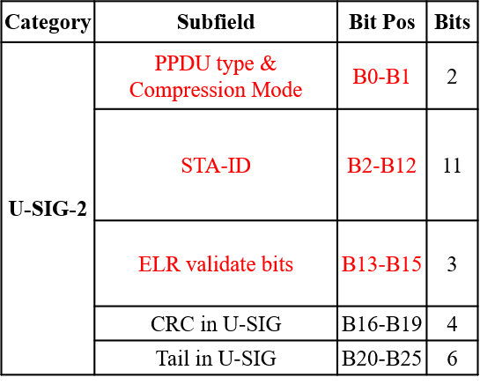

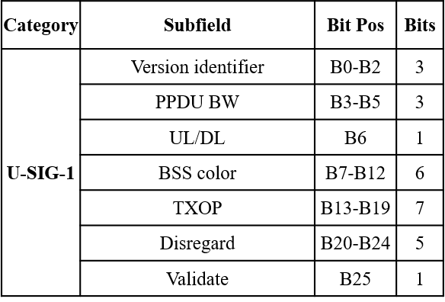

* ELR PPDU indication: PPDU type & compression mode set to ‘11’.
* STA-ID (11 bit): B2-B12 bit in USIG-2.
* ELR validate bits (B13-B15 of USIG-2): Set to all ‘1’ for ELR PPDU.
  + Note: B11-B15 – in EHT MU PPDU indicates “Number of EHT-Sig symbols”, and in UHR MU PPDU indicates “Number of UHR-Sig symbols”

No Objection

SP7 – Ron Porat (24/1568)

* Do you support to add the following the SFD:
  + both sequential NDP based and joint NDP based sounding options will be supported for COBF in 11bn?

No Objection

SP8 – Ron Porat (24/1568)

* Do you support to add the following to the SFD:
  + two separate capabilities shall be defined for the maximum number of spatial streams supported for reception of a sounding NDP in UHR and the maximum total number of streams (across all users) supported for reception in UHR DL MU-MIMO and COBF PPDUs?
  + The only possible values for each capability are 4 and 8

No Objection

SP10 – Sameer Vermani (24/1542r4)

* Do you support adding the following to the SFD?
  + The Coordinated beamforming (COBF) transmission phase in 802.11bn shall be limited to 2 APs

No Objection

SP11 – Sameer Vermani (24/1542r4)

* Do you support to add the following to the SFD?
  + The sequential NDP based sounding protocol will be as shown below for COBF
    - Sounding happens one BSS at a time
    - NDPA only addresses the in-BSS STAs
    - MAC related additional frames are TBD

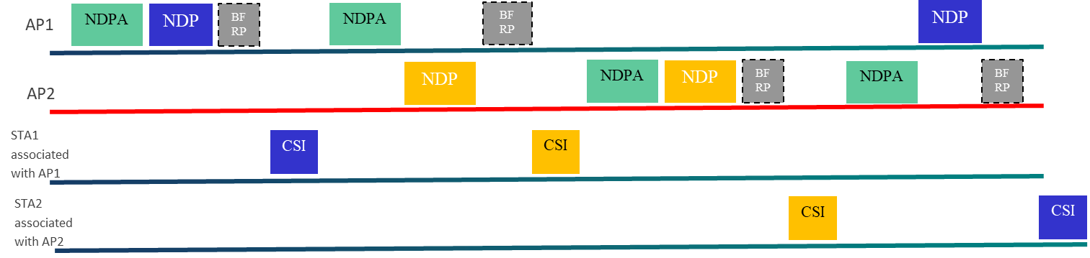

Y/N/A: 60/12/23

SP12 – Sameer Vermani (24/1542r4)

* Do you support to add the following to the SFD?
  + The joint NDP based sounding protocol will be as shown below for COBF
    - Sounding happens for one BSS’s STA at a time
    - NDPA only addresses the in-BSS STAs
    - MAC related additional frames are TBD
    - Joint NDP based feedback will be based on large V-based feedback where the eigen-vectors span the antennas across both APs

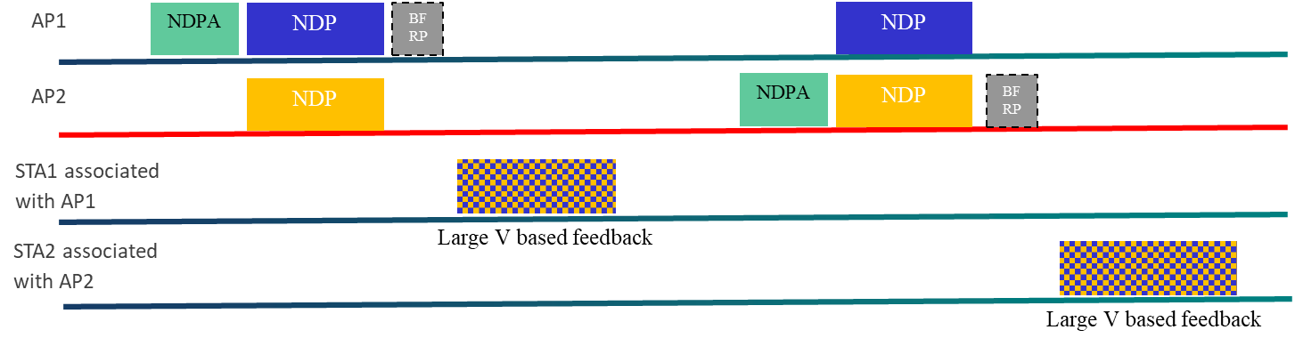

No Objection

SP13 – Sameer Vermani (24/1542r4)

* Do you support to add the following to the SFD?
  + For sequential NDP based sounding, one AP will frequency synchronize to the other for both of its NDP transmissions
    - For both its NDPs, the AP doing the correction brings its frequency within in a certain TBD range of the reference AP

Y/N/A: 56/7/27

SP14 – Sameer Vermani (24/1542r4)

* Do you support to add the following to the SFD?
  + For joint NDP based sounding, one AP will frequency synchronize to the other for both of its NDP transmissions
    - For both the NDPs, the AP doing the correction brings its frequency within in a certain TBD range of the reference AP

No Objection

SP15 – Sameer Vermani (24/1542r4)

* Do you support to add the following to the SFD?
  + In the UHR sounding process for COBF, for the joint sounding case as well as for the sequential sounding case, the NDP shall always carry the BSS color of the AP which transmitted the NDPA

No Objection

**Technical Presentations**

**24/1749 Discussion on Coordinated Sounding (Kosuke Aio)**

To reduce the overhead, it is desirable for AP to collect BF Reports only from STAs with high interference levels from OBSS AP. SNR feedback is used to allow the AP to determine which STAs to sound for COBF.

Discussion

Q: there are existing messages. Not sure we need new protocol to measure SNR? How frequently do we have to report this?

A: might be beneficial for power consumption. Procedure should be optional.

Q: the max NSS in NDP is 8, so overhead is not an issue.

Q: think this lowers the efficiency

Q: SNR is SNR after beamforming?

A: same as existing feedback

**24/1779 Multi-AP Sounding and Precoding (Rainer Strobel)**

Jointly optimized spatial nulling provides a performance advantage. Simulation results show approx. 40% increased PHY rate. Inefficiencies in the sounding protocols are analyzed.

No Discussion

**24/1822 COBF Design for UHR (Sameer Vermani)**

COBF as a separate PDDU type.

Various limits are proposed on number of STAs, APs and NSS.

Pre-UHR portion of the preamble needs to be identical between APs.

Discussion

Q: we can use 6-bit BSS Color and STAID so we can pack more parameters.

Q: prefer to have BSS color and STAID negotiation before.

A: disagree. Pairwise BSS colors create a lot of overhead.

**Recess**

The meeting is Recessed at 12:30 pm PT.

## Wednesday November 13th, 2024 16:00 – 18:00 PT

**Introduction**

1. The Chair (Dongguk Lim, LGE) calls the meeting to order at 4:00pm PT.
2. The Chair follows the agenda in 11-24/**1667r11**.
3. Reminder for registration for the Interim meeting.
4. The Chair reminds everyone to report their attendance by using IMAT system and by sending an e-mail to the Co-chair, Tianyu Wu (Apple), Sigurd Schelstraete (MaxLinear) or the Chair himself if unable to record attendance via IMAT system.
5. The Chair goes through the IPR policy and asks if anyone is aware of any potentially essential patents. **Nobody speaks up.**
6. The Chair goes through the Copyright policy.
7. Discussions on the agenda.

**Technical presentations**

**24/1726 Complementary Sequence-Based LTF Design for DRU (Rui Yang)**

This contribution proposes a complementary sequence (CS) based LTF design for DRU in UHR.

Discussion

Q: believe it’s better to keep same +/-1 modulation as regular LTF. Results are close to previous proposal. That proposal may be good enough.

Q: can you clarify what happens for pilot tones.

A: also search for best sequence on the pilot tones.

Q: binary sequence is preferred for simplicity. Did you apply the pilots when evaluating PAPR?

A: yes

**24/1754 20-mhz-uhr-ltf-sequence-for-dru (Eunsung Park)**

20 MHz 4x UHR-LTF sequences are proposed for two 20 MHz DRU tone plans.

The proposed sequences guarantee low PAPR for a DRU transmission.

Discussion

Q: improvement in PAPR is very minimal, but shows some degradations for some DRUs.

A: believe this design is better.

Q: repeated simulations with the proposed sequence. However, I saw some minor differences. Also simulated the sequences in the reference. The PAPR performance improvement is less than 0.3-0.4 dB.

**24/1796 New LTF Sequences for DRU (Mahmoud Kamel)**

The PAPR performance is significantly better than that of the RRU and the earlier proposed LTF sequence. Longer sequences are constructed from component sequence of length 26 each.

Discussion

Q: Is this 1 SS?

A: optimized for 1SS, but same search can be done for 2 SS.

Q: what if you have a mixture of DRUs, are there different sequence at the receiver?

A: yes, receiver has to determine sequence based on allocation.

Q: proposal is incomplete design. Only shows 1SS. Prefer to see single sequence.

Q: agree that design is not complete. There could be an issue if all users use the same sequence.

Q: How are the base sequences constructed

A: through exhaustive search,

**Straw Polls**

SP1 – Ron Porat (24/1567)

Do you agree to add to the 11bn SFD the following design for 20MHz 4xLTF for DRU?

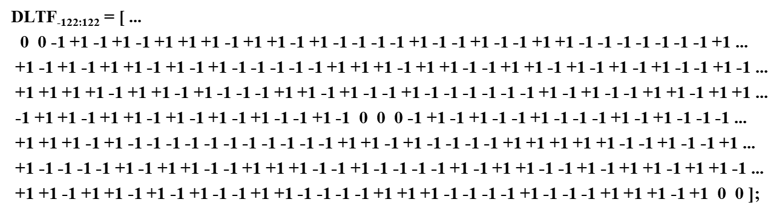

Y/N/A: 59/13/21

SP2 – Ron Porat (24/1567)

Do you agree to add to the 11bn SFD the following design for 80MHz 4xLTF for DRU?

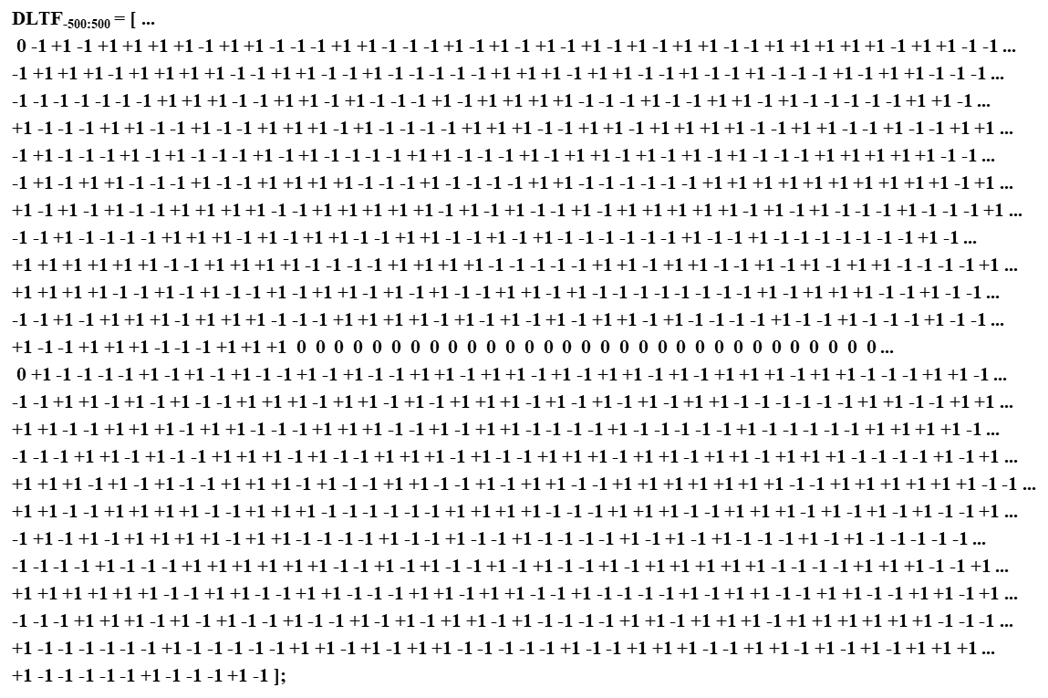

Y/N/A: 74/8/30

SP3 – Chenchen Liu (24/1901)

Do you agree to include the proposed 40MHz DBW 4xLTF sequence design for DRU in the 11bn SFD?

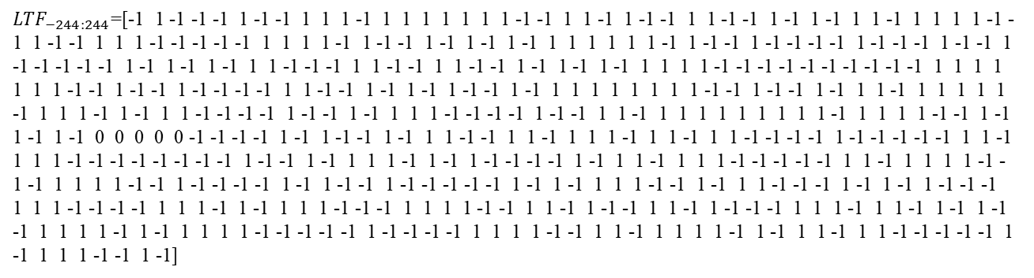

No Objection

**Technical presentations**

**24/1822 COBF Design for UHR (Sameer Vermani) – Q&A**

Q: How do both APs learn the information needed for the user fields

A: extra handshake needed.

Q: looks challenging to include all information in NDPA

A: use special user info field

**24/1829 UHR-SIG Signaling for COBF (Shengquan Hu)**

Proposes a signaling for the PPDU used in COBF.

Discussion

Q: How do STAs know the Color?

A: by location in the U-SIG field

Q: have concern about two BSS colors

A: Will defer SP2 to allow for further discussion

Q: COBF only used for non-OFDMA case?

A: yes

**24/1835 Backward Compatible Sounding for CoBF (Qinghua Li)**

It is desirable that STA supporting EHT BF sounding/feedback doesn’t need any change to support UHR CoBF.

* To be continued in next session

**Recess**

The meeting is Recessed at 6:00 pm PT.

## Thursday November 14th, 2024 8:00 – 10:00 PT

**Introduction**

1. The Chair (Dongguk Lim, LGE) calls the meeting to order at 8:00am PT.
2. The Chair follows the agenda in 11-24/**1667r12**.
3. Reminder for registration for the Interim meeting.
4. The Chair reminds everyone to report their attendance by using IMAT system and by sending an e-mail to the Co-chair, Tianyu Wu (Apple), Sigurd Schelstraete (MaxLinear) or the Chair himself if unable to record attendance via IMAT system.
5. The Chair goes through the IPR policy and asks if anyone is aware of any potentially essential patents. **Nobody speaks up.**
6. The Chair goes through the Copyright policy.
7. Discussions on the agenda.

**Straw Polls**

SP1 –Shengquan Hu (24/1488r1)

**Do you agree to include the following text to the 11bn SFD?**

Pilot values and mapping rules of ELR-SIG and Data symbols in ELR PPDU are the same as that of four RRU52 in DL OFDMA

No Objection

**Technical presentations**

**24/1835 Backward Compatible Sounding for CoBF (Qinghua Li)**

It is desirable that STA supporting EHT BF sounding/feedback doesn’t need any change to support UHR CoBF. Proposals are made for NDPA that is backwards compatible with EHT.

Discussion

Q: what if we need to expand special user info field in future?

Q: agree there’s no protocol change, but there may be change in requirements for STAs

**24/1837 UHR NDPA Signaling (Mahmoud Hasabelnaby)**

There is no remaining space in the NDPA Announcement frame to indicate new variants like UHR and future NDPA frame versions. The submission extends the NDP Announcement frame to accommodate the UHR and beyond variants, as well as considering the Co-BF sounding parameters. Special AID value is used to distinguish between VHT and UHR.

Discussion

Q: should focus on Wi-Fi 8. We have enough flexibility.

A: the design can be used for UHR and future generations

Q: we believe we can reuse EHT design.

Q: legacy EHT can not parse this. The proposal is mostly to make future proof, but there is less focus on WiFi8.

Q: VHT based can enable 2x (including 4x) byte length, EHT based can only enable 4x byte length, with 11 bit wasted from the 2nd 4 byte.

**24/1843 OBSS sounding for C-BF (Insik Jung)**

Some signaling in NDPA might be required to trigger OBSS AP’s NDP. An AP to AP frame exchange is proposed to deliver the overhearing channel quality information

Discussion

Q: AP to AP channel should also be considered.

Q: How does AP2 know the link quality?

A: open to discussion. Maybe through previous sounding phase – implementation dependent.

**24/1865 Universal Sounding and NDPA Signaling (You-Wei Chen)**

A universal sounding can be applied for MU TB sounding and coordinated sounding. Universal NDPA should be self-contained and carry all required information.

**Straw Polls**

SP2 –You-Wei Chen (24/1582r2)

**Do you support to include the following text into the 11bn SFD?**

* For the maximum number of spatial streams supported for reception of sounding NDP in UHR and the maximum total number of streams (across all users) supported for reception in UHR DL MU-MIMO and COBF PPDUs:
  + 4 is mandatory except for Non-AP STA with 20 MHz-Only Limited Capabilities Support subfield equal to 1.
  + 8 is optional for DL MU-MIMO and sounding NDP (Note: More than 4 is not allowed for COBF PPDUs)

No Objection

SP3 –You-Wei Chen (24/1582r2)

**Do you support to include the following text into the 11bn SFD?**

The COBF sequential sounding support to be conditional mandatory if the device supports COBF?

No Objection

SP4 – Sameer Vermani (24/1822r3)

**Do you support to add the following to the SFD:**

* The pre-UHR portion (the portion up-to and including UHR-SIG) of the COBF PPDU shall be transmitted in a non-beamformed (omni) manner?

No Objection

SP5 – Sameer Vermani (24/1822r3)

**Do you support to add the following to the SFD:**

* The pre-UHR portion of a COBF PPDU shall have identical content across two APs.

No Objection

SP6 – Sameer Vermani (24/1822r3)

**Do you support to add the following to the SFD:**

* COBF data transmission shall be indicated in the U-SIG for 802.11bn

No Objection

SP7 – Sameer Vermani (24/1822r3)

**Do you support to add the following to the SFD:**

* In a COBF transmission, the maximum spatial streams given to one user will be 2

No Objection

**Technical Presentations**

**24/1826 5 bit MCS Table (Ron Porat)**

Proposes extended MCS coding, including the newly added MCS.

Discussion

Q: bits are used very sparsely. Other proposals have better compression.

Q: What happens to the unused values?

A: they’re undefined

Q: like the simplicity. Easy for implementation.

Q: other values will be reserved, either validate or disregard

**Recess**

The meeting is Recessed at 10:00 am PT.

## Thursday November 14th, 2024 10:30 – 12:30 PT

**Introduction**

1. The Chair (Dongguk Lim, LGE) calls the meeting to order at 10:30am PT.
2. The Chair follows the agenda in 11-24/**1667r12**.
3. Reminder for registration for the Interim meeting.
4. The Chair reminds everyone to report their attendance by using IMAT system and by sending an e-mail to the Co-chair, Tianyu Wu (Apple), Sigurd Schelstraete (MaxLinear) or the Chair himself if unable to record attendance via IMAT system.
5. The Chair goes through the IPR policy and asks if anyone is aware of any potentially essential patents. **Nobody speaks up.**
6. The Chair goes through the Copyright policy.
7. Discussions on the agenda.

**Straw Polls**

SP1 – Alice Yang (24/474, 24/498, 24/507)

**Do you agree to add the following text to 11bn SFD?**

* UHR defines unequal modulation which uses joint LDPC encoding across multiple spatial streams while at least one spatial stream uses a different modulation order compared to the first spatial stream, and is applicable only to non-MU-MIMO beamformed transmissions using 2 to 4 spatial streams in a UHR MU PPDU.

No Objection

**Technical Presentations**

**24/1700 Collision detection mark for enhanced channel access (Daniel Verenzuela)**

Proposes a collision resolution mechanism for low UL channel access delay. Non-AP STAs include a collision detection mark (CD mark) in preamble. Simulation results are presented.

Discussion

Q: what if Mark symbols are aligned?

A: different users will use different carrier sets

Q: other mechanisms could also be considered.

**24/1644 Compact User field encodings (Brian Hart)**

The submission explores compressed encodings while recognizing the spectrum of device complexity.

Lower-capability devices should be given less (de)compression work to do (e.g., bit slicing) while

higher-capability devices should bear the brunt of the (de)compression work. Some other proposed encodings are inefficient.

Discussion

Q: we want to keep it simple – add new features in new field.

Q: moving MCS table away from legacy is problematic. This is HW implementation.

A: bits will be converted in actual parameters.

Q: it’s a tradeoff. The problem is the reuse of some bits.

Q: product tiers are not as clear cut as presented here.

Q: how much efficiency airtime can be saved? May require higher complexity.

**24/1645 Compact User field encodings - detailed examples (Brian Hart)**

Example of encodings proposed in 24/1644.

**24/1695 11bn signaling design for extra MCS, UEQM, 2xLDPC (You-Wei Chen)**

Proposes a signaling designs for non-MU-MIMO, MU-MIMO user field.

Prefer using 5bit for 11bn MCS table. Include 2xLDPC indication in the preamble.

Discussion

Q: 24 bits may actually be a better choice if we move away from 22 bits.

Q: should there be additional constraints on the use of 1x/2x LDPC.

A: needs further discussion.

Q: For future, we don’t know how many features we will introduce. Having 2x indication is good, may be removed in future if all devices support it.

**24/1772r0 Signaling for UHR follow up (Ross Jian Wu)**

Proposes signaling for UHR User Info field. A MCS field and UEQM patterns field are proposed to simplify the parsing. Similar as EQM case and comparable to joint QAM combinations in 11n.

Discussion

Q: presents a use case that motivates the explicit indication of 1x/2x LDPC use.

**24/1830 Efficient UHR-SIG encoding (Sigurd Schelstraete)**

Proposes a signaling for the UHR User Info field that uses 22 bits and leaves room for extension through a reserved bit.

**Recess**

The meeting is Recessed at 12:30 pm PT.