IEEE P802.11
Wireless LANs
11me SB1 CID6081 do-over
Date: 2024-11-10
Author(s):
Name | Affiliation | Address | Phone | Email
Brian Hart | Cisco Systems |  |  | brianh@cisco.com

Abstract

No available CID; but soliciting the following change regardless.

Revisions:
- Rev 0: Initial version of the document.

TGme editor: Please note Baseline is 11me D7.0. Edits are expressed via Word track changes:

Comment:
In detail, the SB1 sheet of 23/1742 (REVme SA Ballot Comments) shows a pro forma rejection …
6081 | 2562 | 1 | 11.19.3 | The Time Zone procedure is heavyweight for some use cases | An 802.11 WG member will bring a proposal | REJECTED - The comment fails to identify changes in sufficient detail so that the specific wording of the changes that will satisfy the commenter can be determined. | 20240118 Approved | Resolved | MAC: 2023-11-11 00:00:22Z - status set to: Submission Required | N | 2024/1/22 1:00 | EDITOR
This was not present in r3 (uploaded 2024-Jan-18, where there was just “Submission required”) but was present in r4 (uploaded 2024-Jan-28).
However, the minutes in 24/0039 (Minutes for REVme 2024 Jan Interim – Panama; uploaded 2024-Jan-29) show that the work in 23/2144 that addressed 6081 was marked ready for motion in 2024-Jan-18 Thu PM2
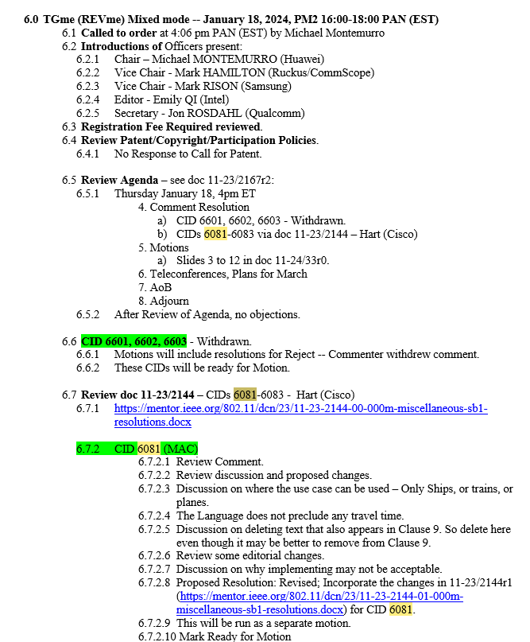
Later that same session, it was motioned into the draft via motion 141:
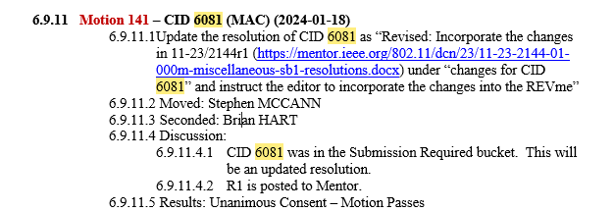
Presumably this successful motion got lost in all the activity.
Recommendation: revisit this topic with a gentle bias towards accepting the previously-accepted work, by re-running 11be motion 141, but on this work after re-basing to 11meD7.0

Change Text to Motion
NOTE to reader, not for inclusion in the draft: copied from 23/2144r1 (uploaded 2024-Jan-18), with re-basing to 11meD7.0

6081 | 11.19.3 | 2562 | 1 | The Time Zone procedure is heavyweight for some use cases | An 802.11 WG member will bring a proposal | Revised; in general agreement with commenter; see changes under 6081 in doc 23/xxxx<motionedRevision>.
Discussion
11v defined a feature where both the Time Advertisement element (e.g., 13 octets) and the Time Zone element (e.g., 6 octets) could be sent in all probe responses and in intermittent beacons (etc):
11.19.3 UTC TSF Offset procedures
When dot11UTCTSFOffsetActivated is true, the Time Advertisement and Time Zone elements shall be included in all Probe Response frames, (11ay)the Time Advertisement element shall be included in the Beacon frame every dot11TimeAdvertisementDTIMInterval DTIM intervals(#4221)(11ay), and the Time Advertisement element shall be included in the DMG Beacon frame or in the Announce frame at least every dot11DMGTimeAdvertisementBeaconInterval. When dot11UTCTSFOffsetActivated is false, the Time Advertisement and Time Zone elements shall not be included in Beacon(11ay), Probe Response, and Announce frames.
The AP should periodically synchronize to a UTC reference clock (ITU-R Recommendation TF.460-6 (2002) [B59]) so that the UTC TSF offset can account for drift. The AP shall increment the Time Update Counter field value in the Time Advertisement element each time the synchronization occurs. The method the AP uses to synchronize with a UTC reference clock is out of scope of the standard.
Meanwhile, cruise ships go from port to port and cross time-zones (for instance, consider a Mediterranean cruise). Typically, “Ship Time” is locally defined by the captain according to his/her convenience. We can assume that Ship Time always follows a well-known time-zone; and typically Ship Time uses the time-zone of the last / next port of call. Importantly, the transition from one time zone to the next does not follow normal geopolitical boundaries.
Meanwhile, a connected device (e.g., smartphone) can easily obtain and track UTC “over the top” without specific any ongoing signaling in a Probe Response or Beacon. The connected device just needs to know the local time-zone (here, the tome zone used for Ship Time).
Cruise lines and cruising patrons get confused when their connected devices do not report Ship Time. The smartphone might determine a time-zone from last cell tower (e.g., port of departure) / coastal cell towers along the way / GNSS / etc; but none of these are aware of Ship Time so are not good sources of information.
Accordingly we propose to define a new, more efficient mechanism where just the Time Zone element may be included in all probe response frames.
Changes for CID 6081
Table 9-67—Probe Response frame body (continued)
Order | Information | Notes
39 | Time Zone | The Time Zone element is present if dot11UTCTSFOffsetActivated or dot11TimeZoneActivated is true.

Bit | Information | Notes
27 | UTC TSF Offset/Time Zone | The STA sets the UTC TSF Offset/Time Zone field to 1 when dot11UTCTSFOffsetActivated or dot11TimeZoneActivated is true and sets it to 0 otherwise. See 11.19.3 (UTC TSF Offset procedures).
Table 9-190—Extended Capabilities field

11.19.3 UTC TSF Offset procedures
When dot11UTCTSFOffsetActivated is true, the Time Advertisement and Time Zone elements shall be included in all Probe Response frames, (11ay)the Time Advertisement element shall be included in the Beacon frame every dot11TimeAdvertisementDTIMInterval DTIM intervals(#4221)(11ay), and the Time Advertisement element shall be included in the DMG Beacon frame or in the Announce frame at least every dot11DMGTimeAdvertisementBeaconInterval.
When dot11UTCTSFOffsetActivated is true, the AP should periodically synchronize to a UTC reference clock (ITU-R Recommendation TF.460-6 (2002) [B59]) so that the UTC TSF offset can account for drift. The AP shall increment the Time Update Counter field value in the Time Advertisement element each time the synchronization occurs. The method the AP uses to synchronize with a UTC reference clock is out of scope of the standard.
Annex C
Dot11WirelessMgmtOptionsEntry ::=
SEQUENCE {
dot11LocationActivated TruthValue,
dot11FMSImplemented TruthValue,
dot11FMSActivated TruthValue,
dot11EventsActivated TruthValue,
dot11DiagnosticsActivated TruthValue,
dot11MultiBSSIDImplemented TruthValue,
dot11MultiBSSIDActivated TruthValue,
dot11TFSImplemented TruthValue,
dot11TFSActivated TruthValue,
dot11WNMSleepModeImplemented TruthValue,
dot11WNMSleepModeActivated TruthValue,
dot11TIMBroadcastImplemented TruthValue,
dot11TIMBroadcastActivated TruthValue,
dot11ProxyARPImplemented TruthValue,
dot11ProxyARPActivated TruthValue,
dot11BSSTransitionActivated TruthValue,
dot11QoSTrafficCapabilityImplemented TruthValue,
dot11QoSTrafficCapabilityActivated TruthValue,
dot11ACStationCountImplemented TruthValue,
dot11ACStationCountActivated TruthValue,
dot11CoLocIntfReportingImplemented TruthValue,
dot11CoLocIntfReportingActivated TruthValue,
dot11MotionDetectionImplemented TruthValue,
dot11MotionDetectionActivated TruthValue,
dot11TODImplemented TruthValue,
dot11TODActivated TruthValue,
dot11TimingMsmtImplemented TruthValue,
dot11TimingMsmtActivated TruthValue,
dot11ChannelUsageImplemented TruthValue,
dot11ChannelUsageActivated TruthValue,
dot11TriggerSTAStatisticsActivated TruthValue,
dot11SSIDListImplemented TruthValue,
dot11SSIDListActivated TruthValue,
dot11MulticastDiagnosticsActivated TruthValue,
dot11LocationTrackingImplemented TruthValue,
dot11LocationTrackingActivated TruthValue,
dot11DMSImplemented TruthValue,
dot11DMSActivated TruthValue,
dot11UAPSDCoexistenceImplemented TruthValue,
dot11UAPSDCoexistenceActivated TruthValue,
dot11WNMNotificationImplemented TruthValue,
dot11WNMNotificationActivated TruthValue,
dot11UTCTSFOffsetImplemented TruthValue,
dot11UTCTSFOffsetActivated TruthValue,
dot11FineTimingMsmtRespActivated TruthValue,
dot11FineTimingMsmtInitActivated TruthValue,
dot11LciCivicInNeighborReport TruthValue,
dot11RMFineTimingMsmtRangeRepImplemented TruthValue,
dot11RMFineTimingMsmtRangeRepActivated TruthValue,
dot11RMLCIConfigured TruthValue,
dot11RMCivicConfigured TruthValue,
(11az)dot11SecureLTFImplemented TruthValue,
(11az)dot11TriggerBasedRangingRespImplemented TruthValue,
(11az)dot11NonTriggerBasedRangingRespImplemented TruthValue,
(11az)dot11RSTARequiresPMFActivated INTEGER,
(11az)dot11PassiveTBRangingResponderImplemented TruthValue,
(11az)dot11PassiveTBRangingInitiatorImplemented TruthValue,
(11az)dot11AOAMeasurementImplemented TruthValue,
(11az)dot11I2RLMRFeedbackPolicy TruthValue,
(11az)dot11LOSAssessmentTXImplementedTruthValue,
(11az)dot11LOSAssessmentRXImplemented TruthValue,
(11az)dot11PassiveTBRangingAODImplemented TruthValue,
(11az)dot11PhaseShiftFeedbackImplemented TruthValue,
(#6016)dot11ChannelUsageCapabilityNotificationImplemented TruthValue,
dot11TimeZoneImplemented TruthValue,
dot11TimeZoneActivated TruthValue
}

After dot11RMCivicConfigureddot11ChannelUsageCapabilityNotificationImplemented, insert:

dot11TimeZoneImplemented OBJECT-TYPE
SYNTAX TruthValue
MAX-ACCESS read-only
STATUS current
DESCRIPTION
"This is a capability variable.
Its value is determined by STA capabilities.
This attribute, when true, indicates that the STA is capable of supporting time zone advertisement when dot11WirelessManagementImplemented is equal to true."
::= { dot11WirelessMgmtOptionsEntry 54 }

dot11TimeZoneActivated OBJECT-TYPE
SYNTAX TruthValue
MAX-ACCESS read-write
STATUS current
DESCRIPTION
"This is a control variable.
It is written by an external management entity or the SME.
Changes take effect as soon as practical in the implementation. This attribute, when true and when dot11WirelessManagementImplemented is equal to true, indicates that time zone advertisement is enabled at the station. The capability is disabled, otherwise."
DEFVAL { false }
::= { dot11WirelessMgmtOptionsEntry 55 }

