IEEE P802.11  
Wireless LANs

|  |  |  |  |  |
| --- | --- | --- | --- | --- |
| SA110 comments – CID R1-32, 36, 37 | | | | |
| Date: 2024-11-xx | | | | |
| Author(s): | | | | |
| Name | Affiliation | Address | Phone | email |
| Rui Du | Huawei | Shenzhen, China |  | Ray.du@huawei.com |
| Zhuqing Tang |  |  |  |
| Narengerile |  |  |  |
| Mengshi Hu |  |  |  |

**Abstract**

This document proposes the resolutions to the following CIDs for SA110:

R1-32, 36, 37

R0: initial version on Nov xx, 2024.

# R1-32, R1-36, R1-37

|  |  |  |  |  |  |
| --- | --- | --- | --- | --- | --- |
| **CID** | **Clause** | **Page** | **Comment** | **Proposed change** | **Proposed resolution** |
| R1-32 | 9.4.1.81.1 | 52.19 | what do you mean by basic reporting? | change to non-threshold based CSI reporting or a better name | **Rejected.** |
| R1-36 | 9.4.1.81.4 | 55.48 | Basic reporting? The naming is not clear, please change. | as in comment | **Rejected.** |
| R1-37 | 11.55.1.5.2.6.1 | 156.08 | Basic reporting phase? The naming is not intuitive. | Maybe consider a different naming? | **Rejected.** |

**Rejected Reason:**

1. The ‘basic reporting phase’ is used to discriminated from ‘threshold based reporting phase’, and corresponding definitions are included in 11.55.1.5.2.6.1 clearly.

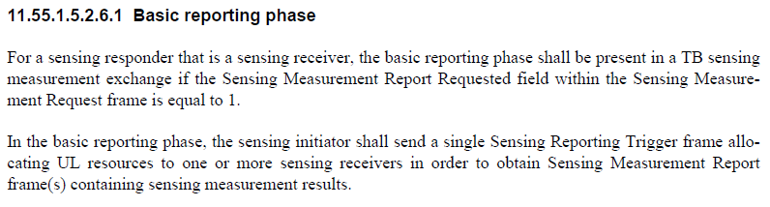

1. In REVmeD5.0, there is a measurement type also use ‘basic’ as the name. So, it will be ok to use ‘basic’ in 11bf.

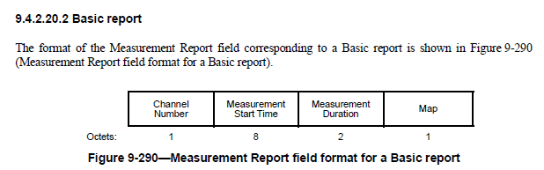

Based on the above reasons, R1-32/36/37 are rejected.

SP:

Do you agree to the resolutions provided for CID R1-32, 36, 37 in 24/1906r0 to be included in the latest 11bf Draft?

Y/N/A