IEEE P802.11  
Wireless LANs

|  |  |  |  |  |
| --- | --- | --- | --- | --- |
| SA110 CID resolutions | | | | |
| Date: 2024-11-10 | | | | |
| Author(s): | | | | |
| Name | Affiliation | Address | Phone | email |
| Zhuqing Tang | Huawei Technologies | Huawei Base, Shenzhen, China |  | tangzhuqing@huawei.com |
| Rui Du |  |  |
| Narengerile |  |  |
| Mengshi Hu |  |  |

**Abstract**

This document proposes the resolutions to the following SA110 CIDs:

R1-20, R1-24, R1-27

R0: Initial version.

|  |  |  |  |  |  |
| --- | --- | --- | --- | --- | --- |
| **CID** | **Clause** | **Page** | **Comment** | **Proposed change** | **Proposed resolution** |
| R1-20 | 11.55.1.1 | 137.03 | "initial control frame" - in the next paragraph (line7) it is ICF, unify or define? | As per comment | **Revised**.  Agree with the commenter.  Please refer to the changes specified in 1900r0.  (<https://mentor.ieee.org/802.11/dcn/24/11-24-1900-00-00bf-SA110-CID-Resolutions.docx>) |

**Discussion**

For reference:

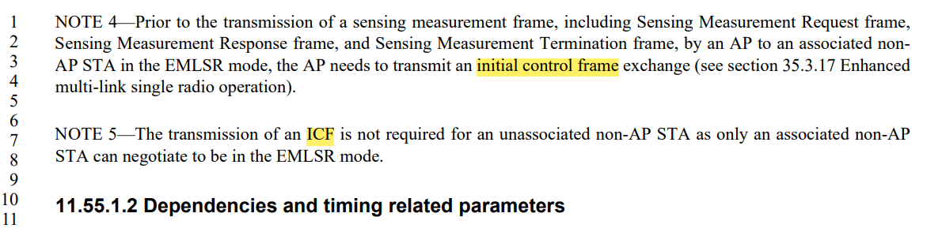

After a global search in 11be 7.0, the abbreviation “ICF” has not been used.

**Resolution:**

***Instructions to the editor: please replace all “ICF” with “initial control frame” in the draft.***

|  |  |  |  |  |  |
| --- | --- | --- | --- | --- | --- |
| **CID** | **Clause** | **Page** | **Comment** | **Proposed change** | **Proposed resolution** |
| R1-24 | 11.55.1.2 | 137.34 | "The RSSI reported for each receive chain in the Sensing Measurement Report frame shall be in the range from 0 to 62" - those are the possible values. This is a redundant statement and should be removed. | As per comment | **Accepted**. |

**Discussion**

For reference:

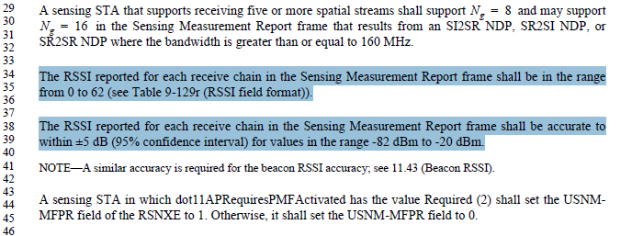

**In Clause 9:**

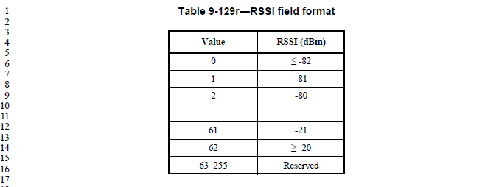

|  |  |  |  |  |  |
| --- | --- | --- | --- | --- | --- |
| **CID** | **Clause** | **Page** | **Comment** | **Proposed change** | **Proposed resolution** |
| R1-27 | 11.55.1.4.1 | 141.51 | "or it requests to poll the non-AP STA in the TB sensing measurement exchange" - who is "it" ? Who is requesting here? | Please clarify sentence. | **Revised**.  Agree with the commenter.  Please refer to the changes specified in 1900r0.  (<https://mentor.ieee.org/802.11/dcn/24/11-24-1900-00-00bf-SA110-CID-Resolutions.docx>) |

**Discussion**

For reference:

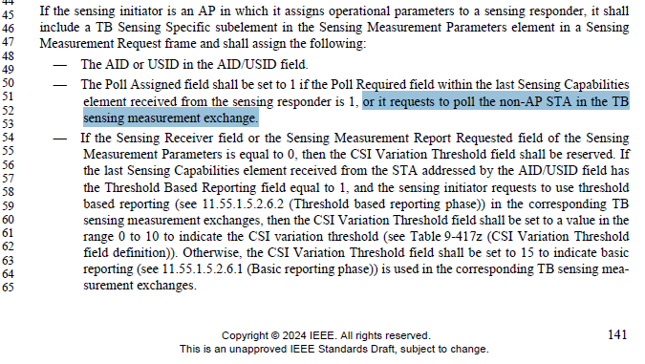

**Resolution:**

***Instructions to the editor: please make the following changes to the paragraph at P141L52 in the subclause 11.55.1.4 Sensing measurement session in D5.0 as shown below:***

If the sensing initiator is an AP in which it assigns operational parameters to a sensing responder, it shall include a TB Sensing Specific subelement in the Sensing Measurement Parameters element in a Sensing Measurement Request frame and shall assign the following:

— The AID or USID in the AID/USID field.

— The Poll Assigned field shall be set to 1 if the Poll Required field within the last Sensing Capabilities element received from the sensing responder is 1, or the sensing initiator requests to poll the non-AP STA in the TB sensing measurement exchange.

SP:

Do you agree to the resolutions provided for CIDs R1-20, R1-24, R1-27 in 24/1900r0 to be included in the latest 11bf Draft?

Y/N/A