IEEE P802.11
Wireless LANs
Clarification of identifiers for WUR frames
Date: 2024-11-06
Author(s):
Name | Affiliation | Address | Phone | email
Michael Montemurro | Huawei Technologies Co., Ltd | Toronto, Ontario, Canada |  | Montemurro.michael@gmail.com
Abstract
This contribution proposes additional clarification text to describe WUR identifiers

During the process of producing REVme D7.0 for SA Ballot recirculation, the resolution to CID 8042 was only partially implemented.

CID 8042:
8042 | 1869.00 | 9.9.2.2.2 |  | V | An initial ballot comment (i-139) explained that the text allows the WUR Vendor ID to be any OUI or CID; however, it needs to be one that is assigned to the vendor (i.e., the vendor is not authorized to use someone else's OUI). | In the "Identifier Description" column, change the last cell to "The 24-bit WUR Vendor ID is a public unique identifier assigned by the IEEE Registration Authority as a 24-bit OUI or a 24-bit CID (see [B15] and [B16])) and identifies the entity specifying the format of the WUR Vendor Specific frame. The 12 LSBs of the identifier are carried in the ID field and the 12 MSBs are carried in the Type Dependent Control field(#6139)." | REVISED (SEC: 2024-07-08 15:02:06Z) -  Make the proposed change, and at 1874.4, 4817.13 and 4817.32 change "OUI" to "OUI or CID"

“OUI” was changed to “OUI or CID” at the cited locations, but the change to the table description was not changed.

The cited text in D7.0 is the second column of the last row of the following table:

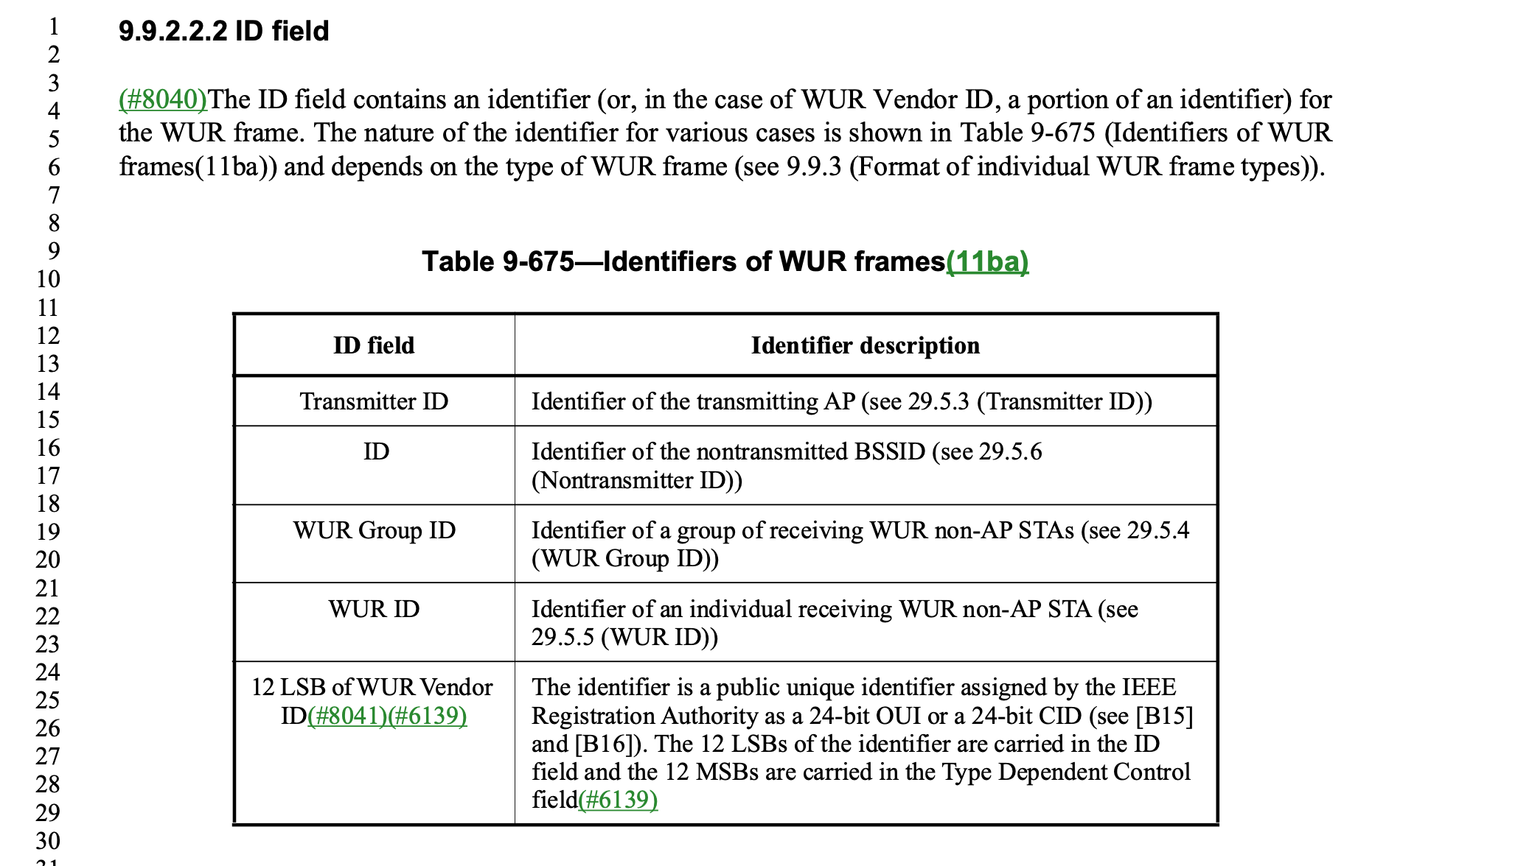

The proposed change is to modify the last cell to:
“The 24-bit WUR Vendor ID is a public unique identifier assigned by the IEEE Registration Authority as a 24-bit OUI or a 24-bit CID (see [B15] and [B16])) and identifies the entity specifying the format of the WUR Vendor Specific frame. The 12 LSBs of the identifier are carried in the ID field and the 12 MSBs are carried in the Type Dependent Control field(#6139)."

Adding, “and identifies the entity specifying the format of the WUR Vendor Specific frame.”

Note that this proposed addition is consistent with the definition of an equivalent field in the Vendor Specific element:
“The Organization Identifier field contains the identity of the entity that has defined the content of the Vendor
Specific element”

Proposed changes:
In REVme D7.0 at 1869.24, change:
“The identifier is a public unique identifier assigned by the IEEE Registration Authority as a 24-bit OUI or a 24-bit CID (see [B15] and [B16]).”
To
“The 24-bit WUR Vendor ID is a public unique identifier assigned by the IEEE Registration Authority as a 24-bit OUI or a 24-bit CID (see [B15] and [B16])) and identifies the entity specifying the format of the WUR Vendor Specific frame.”

