IEEE P802.11
Wireless LANs
Proposed resolutions for SA104 comments
Date: 2024-08-26
Author(s):
Name | Affiliation | Address | Phone | email
Claudio da Silva | Meta Platforms
Abstract
This document contains proposed resolutions for comments on D4.0 (SA104).

CIDs: 6059, 6060, 6185

CID | Clause | Page | Comment | Proposed change
6185 | 4.11 | 20.20 | The cited sentence indicates that "measurements obtain with WLAN sensing might support applications such as presence detection, motion detection and gesture classification.  Comparing this technology to image sensing, there are procedures in image sensing that provide privacy protection, but WLAN sensing, as defined in this amendment provides none. | Either provide a mechanism to improve WLAN sensing privacy or add the following text in clause 11.55.1.1 on p138.22:  "The sensing procedure defined in this standard provides no means of privacy protection. Any privacy requirements associated with WLAN sensing would need to be addressed by a sensing application."

Proposed resolution: Rejected

Justification: (The comment was discussed in an 802.11bf conference call held on August 27th, 2024.) The commenter did not provide technical justification for its claim on privacy. The WLAN sensing procedure defined in the 802.11bf amendment uses waveforms (PPDUs) defined in its baseline, and follows a packet exchange that is consistent with protocols also defined in its baseline, such as the ranging protocol.

CID | Clause | Page | Comment | Proposed change
6059 | 11.55.2.1 | 147.25 | In TB sensing mode, NDPA sounding which doesn't need reporting cannot be done without a polling phase as described in D4.0. Removing the polling phase requirement can result in a low-power mechanism to do sensing at the non-AP STA side. The polling phase is not needed for each sensing PPDU for the AP to make sure the STA is present during the availability windows. Since there is a requirement for sensing activity every session expiry period, a polling response can be required once every session expiry time period. As long as the AP is aware of the STA's presence (e.g. STA sends at least one sensing frame before the session expiry), the AP can use the sensing setup as a service providing requirement for that duration. A similar comment was unable to receive consensus in the group in the previous LBs hence repeated in this round. | Allow a TB session to consist of only NDPA sounding phase. In order for the AP to make sure the STA is present, a polling response can be required once in measurement session expiry time period.

Proposed resolution: Rejected

Background:
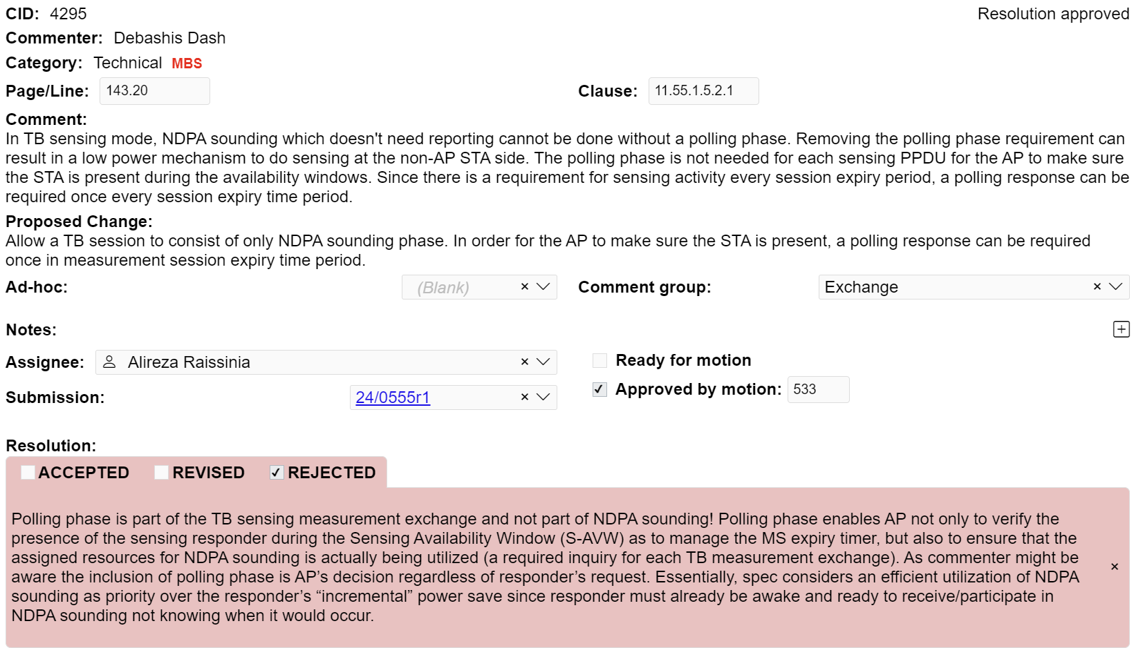

Justification: (The comment was discussed in an 802.11bf conference call held on August 27th, 2024.) Comment 6059 is identical in nature to comment 4295 received in LB281. As no technical contribution has been provided to address the comment, the resolution provided to comment 4295 and approved by the group with motion 533, is kept. Specifically, "Polling phase is part of the TB sensing measurement exchange and not part of NDPA sounding! Polling phase enables AP not only to verify the presence of the sensing responder during the Sensing Availability Window (S-AVW) as to manage the MS expiry timer, but also to ensure that the assigned resources for NDPA sounding is actually being utilized (a required inquiry for each TB measurement exchange). As commenter might be aware the inclusion of polling phase is AP’s decision regardless of responder’s request. Essentially, spec considers an efficient utilization of NDPA sounding as priority over the responder’s “incremental” power save since responder must already be awake and ready to receive/participate in NDPA sounding not knowing when it would occur."

CID | Clause | Page | Comment | Proposed change
6060 | 11.55.1.5.2.1 | 147.10 | Some sensing procedures, e.g. NDPA sounding without reporting in a TB exchange, can be used for extracting CSI at the non-AP STA side. Hence a non-AP STA should be allowed to setup a TB session. Currently only an AP can initiate a TB sensing session. SBP is not a feature with equal footing since it is deemed to be optional. A similar comment was unable to receive consensus in the group in the previous LBs hence repeated in this round. | Allow a non-AP STA to initiate a TB sensing session setup with the AP. Note that the non-AP STA doesn't need to send trigger frames. The AP still is the node sending the trigger frames and sensing PPDUs. This will not incur any extra overhead during the measurement phase. A setup procedure similar to SBP can be allowed to request a TB session by the non-AP STA.

Proposed resolution: Rejected

Background:
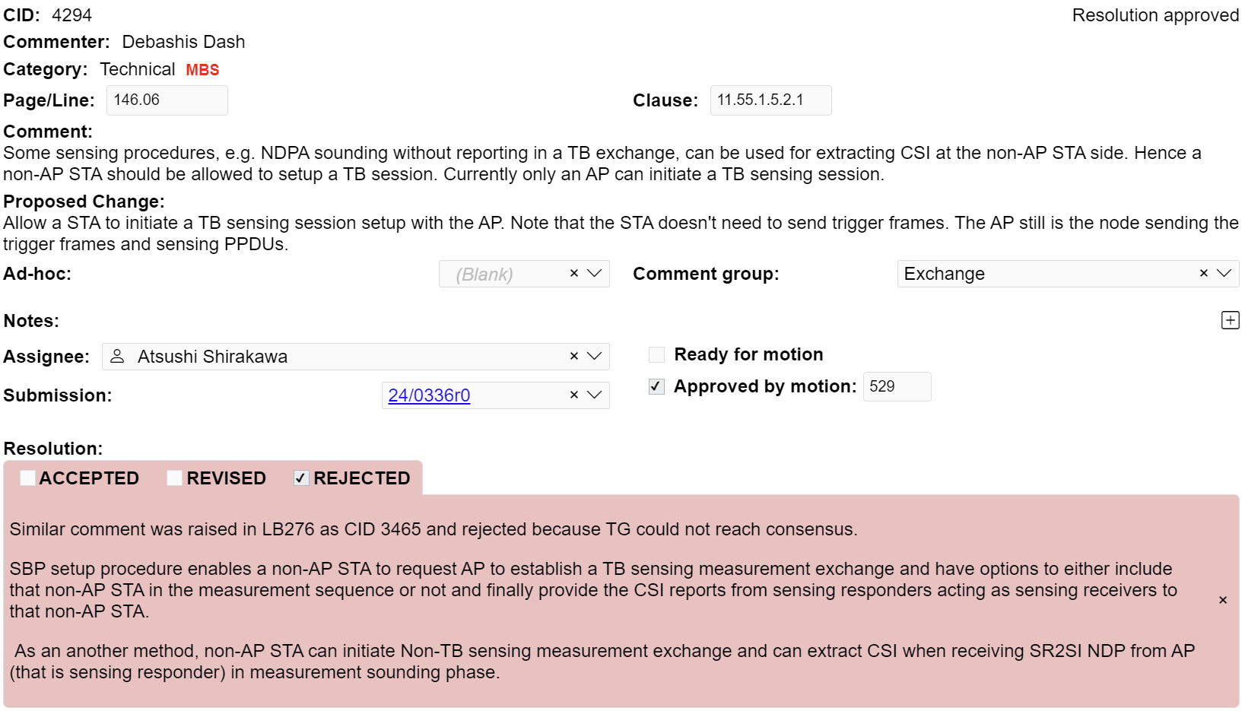

Justification: (The comment was discussed in an 802.11bf conference call held on August 27th, 2024.) Comment 6060 is identical in nature to comment 4294 received in LB281. As no technical contribution has been provided to address the comment, the resolution provided to comment 4294 and approved by the group with motion 529, is kept. Specifically, "SBP setup procedure enables a non-AP STA to request AP to establish a TB sensing measurement exchange and have options to either include that non-AP STA in the measurement sequence or not and finally provide the CSI reports from sensing responders acting as sensing receivers to that non-AP STA. As an another method, non-AP STA can initiate Non-TB sensing measurement exchange and can extract CSI when receiving SR2SI NDP from AP (that is sensing responder) in measurement sounding phase.".

