IEEE P802.11  
Wireless LANs

|  |  |  |  |  |
| --- | --- | --- | --- | --- |
| Initial SA ballot comments – DMG Beam Sector comment | | | | |
| Date: 2024-08-10 | | | | |
| Author(s): | | | | |
| Name | Affiliation | Address | Phone | email | |
| Pu (Perry) Wang | MERL | Cambridge, MA, USA |  | [pwang@ieee.org](mailto:pwang@ieee.org); [pwang@merl.com](mailto:pwang@merl.com) | |
|  |  |  |  |  | |

**Abstract**

This document proposes the resolutions to the following “DMG Beam Sector” CIDs:

6065, 6084, 6113 (3 in total)

# ****6065****

|  |  |  |  |  |  |
| --- | --- | --- | --- | --- | --- |
| **CID** | **Clause** | **Page** | **Comment** | **Proposed change** | **Proposed resolution** |
| 6065 | 11.55.3.6.2.2 | 186.21 | The "equals" should be a "set" in this sentence. | Change "...the duration of the transmission of the DMG Sensing Measurement Report frame shall be equal to the Report Duration field of the DMG Sensing Response frame of the DMG sensing measurement exchange with the Sensing Exchange SN field equals i - 1" to "...the duration of the transmission of the DMG Sensing Measurement Report frame shall be set to the Report Duration field of the DMG Sensing Response frame of the DMG sensing measurement exchange, when the Sensing Exchange SN field is equal to i - 1". | Rejected.  In this context, either “shall” or “set” is fine to reflect that the duration of the transmission of …..shall be the same as the value in the Report Duration field of the DMG Sensing Response frame.  However, it is REJECTED because in the precding sentence, the same term of “shall be equal to” is also used for the case of the Sensing Exchange SN field of the TDD Beamforming Information field.    Simply putting, it is rejected to keep the terminology consistent. |

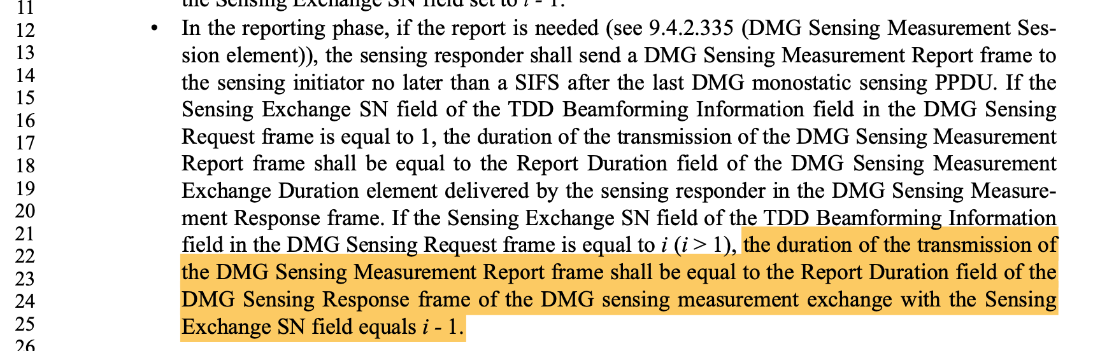

# ****6084****

|  |  |  |  |  |  |
| --- | --- | --- | --- | --- | --- |
| **CID** | **Clause** | **Page** | **Comment** | **Proposed change** | **Proposed resolution** |
| 6084 | 9.4.2.342 | 107.29 | Within DMG Beacon Sector Descriptor element, there isn't a field to specify the value of N. Suggest add a field to specify the value of N. Although the value of N can be obtained from DMG Passive Sensing Beacon element, but it is within a different element from DMG Beacon Sector Descriptor element. [ng] | Suggest add a field in DMG Beacon Sector Descriptor element to specify the value of N | Rejected.  Right below Figure 9-1072da (DMG Beacon Sector Descriptor element format), it is stated that the number of sectors N is equal to the number of sectors defined within the DMG Passive Sensing Beacon element (see 9.4.2.341 (DMG Passive Sensing Beacon element)). |

The comment is that there isn’t a field in the DMG Beacon Sector Descriptor element (see the image below) to specify the number of beacon beam sectors *N*.

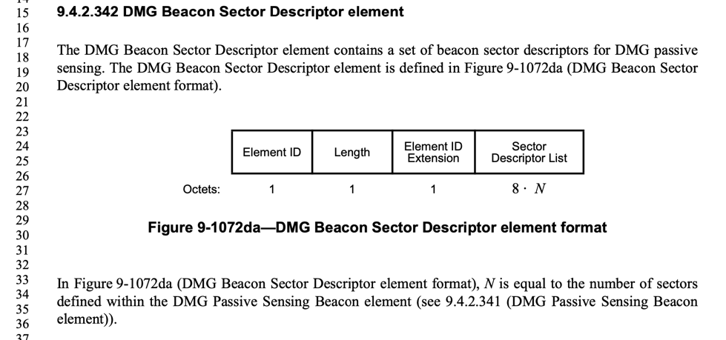

However, in the paragraph following Figure 9-1072da, it is stated that *N* is equal to the number of sectors defined within the DMG Passive Sensing Beacon element (see Figure below)

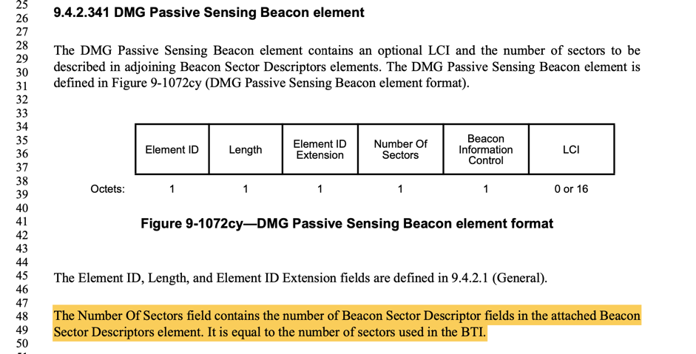

I suggest “Rejected” as in its current form it is clear where N is from. But I am open to other suggestions as the commentor recommended for a self-contained DMG Beacon Sector Descriptor element, rather than looking for the value N from a different element.

# ****6113****

|  |  |  |  |  |  |
| --- | --- | --- | --- | --- | --- |
| **CID** | **Clause** | **Page** | **Comment** | **Proposed change** | **Proposed resolution** |
| 6113 | 9.4.2.333 | 84.60 | The value of N is not given in the DMG Sensing Beam Descriptor element. It is not straightforward to know how many beam descriptors are included in this element. Suggest add a field in this element to specify the value of N. [ng] | Suggest add a field in DMG Sensing Beam Descriptor element to specify the value of N. | Rejected.  I rejected this CID as the value of N, the number of beam sectors, is stated or specified in DMG Sensing Capabilities element. |

This comment is similar to CID 6084. The commentor recommended for a self-contained DMG Sensing Beam Descriptor element (see the figure below) with an additional field for the value of N,

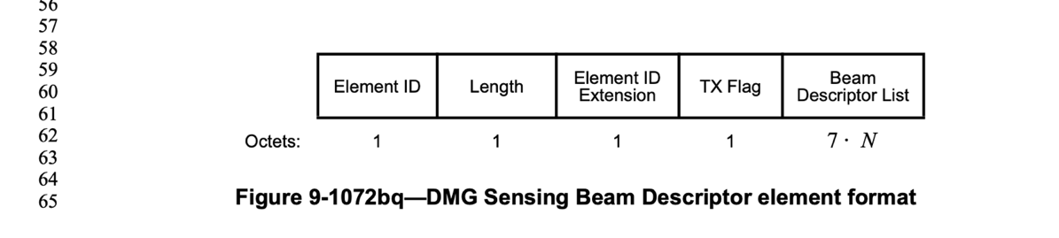

rather than looking for the value N from a different element. In this case, the value of N is obtained from DMG Sensing Capabilities element, where N can be either the maximum number of TX Directions or the Maximum number of RX Directions.

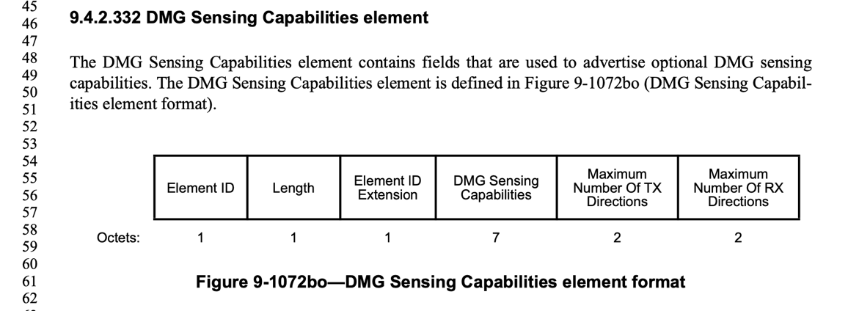

SP: Do you agree to the resolutions of CIDs 6065, 6084, 6113 as depicted in 11-24-1420r1?

**references: Draft P802.11bf_D4.0**