IEEE P802.11  
Wireless LANs

|  |  |  |  |  |
| --- | --- | --- | --- | --- |
| Resolution to CID 6181 and 6182 | | | | |
| Date: 2024-08-01 | | | | |
| Author(s): | | | | |
| Name | Affiliation | Address | Phone | email |
| Cheng Chen | Intel |  |  | cheng.chen@intel.com |

Abstract

This submission proposes resolutions to the following comments submitted in SA1 Ballot under Exchange topic. The CIDs are referring to D4.0. The text used as reference is D4.0.

CIDs: 6181 6182

Revision history:

R0: Original version

|  |  |  |  |  |  |
| --- | --- | --- | --- | --- | --- |
| **CID** | **Commenter** | **Page** | **Comment** | **Proposed change** | **Proposed resolution** |
| 6181 | Stephen Sand | 34.45 | The text reads "then the assigned STAs transmit power is HE-MCS 6 for an HE TB PPDU or EHTMCS 6 for an EHT TB PPDU." In 11be D5.1 it reads "the assigned HE-MCS is assumed to be HE-MCS 6 in terms of setting the STAs transmit power." | Please change the main clause of the sentences as follows: then the assigned STAs transmit power is that used for HE-MCS 6 for an HE TB PPDU or that used for EHT-MCS 6 for an EHT TB PPDU. | Revised. The text needs to be consistent between 11be, 11bk and 11bf draft. See proposed resolution in <DCN1357r0>. |
| 6182 | Stephen Sand | 34.38 | The text reads "then the assigned STAs transmit power is HE-MCS 0". In 11be D5.1 it reads "then the assigned STAs transmit power is HE-MCS 0". | Please change the main clause of the sentences as follows: then the assigned STAs transmit power is that used for HE-MCS 0 for an HE TB PPDU or that used for EHT-MCS 0 for an EHT TB PPDU. | Revised. The text needs to be consistent between 11be, 11bk and 11bf draft. See proposed resolution in <DCN357r0>. |

**Discussion:** The referenced table has recently been revised in IEEE 802.11bk D3.0. We just need to update it in 11bf to keep it consistent with 11be and 11bk.

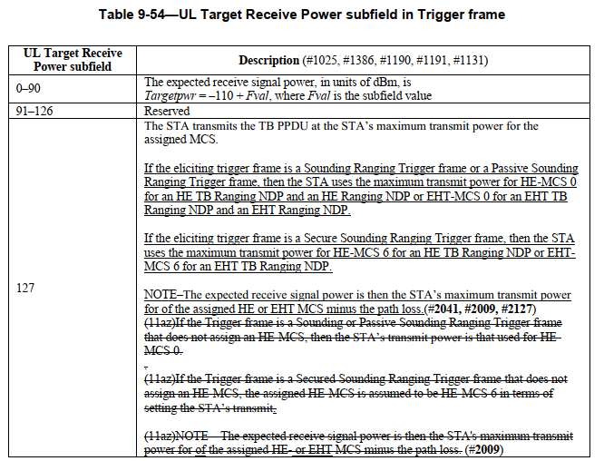

***TGbf editor, make the following change in the Description Column of Table 9-46k (P34) in 9.3.1.22.1***

## The STA transmits the TB PPDU at the STA’s maximum transmit power for the assigned MCS.

If the eliciting trigger frame is a Sounding Ranging Trigger frame, ~~or~~ a Passive Sounding Ranging Trigger frame, an SR2SI Sounding Trigger frame, or an SR2SR Sounding Trigger frame, then the STA uses the maximum transmit power for HE-MCS 0 for an HE TB Ranging NDP and an HE Ranging NDP or EHT-MCS 0 for an EHT TB Ranging NDP and an EHT Ranging NDP.

If the eliciting trigger frame is a Secure Sounding Ranging Trigger frame, then the STA uses the maximum transmit power for HE-MCS 6 for an HE TB Ranging NDP or EHTMCS 6 for an EHT TB Ranging NDP.

NOTE–The expected receive signal power is then the STA’s maximum transmit power for of the assigned HE or EHT MCS minus the path loss.

## ~~If the Sounding Ranging Trigger frame, or the Passive Sounding Ranging Trigger frame, SR2SI Sounding Trigger frame, or sensing responder to sensing responder (SR2SR) Sounding Trigger frame does not assign an MCS, then the assigned STA’s transmit power is HE-MCS 0 for an HE TB PPDU or EHT-MCS 0 for an EHT TB PPDU.~~

## ~~If the Secured Sounding Ranging Trigger frame does not assign an MCS, then HE-MCS 6 for an HE TB PPDU EHT-MCS 6 for an EHT TB PPDU.~~

## ~~NOTE—The expected receive signal power is then the STA's transmit power minus the path loss.~~

## SP

Do you support the proposed resolutions to the CIDs and incorporate the text changes into the latest TGbf draft?

Y/N/A