IEEE P802.11  
Wireless LANs

|  |  |  |  |  |
| --- | --- | --- | --- | --- |
| Initial SA Ballot Comment Resolutions for OST | | | | |
| Date: 2024.08.06 | | | | |
| Author(s): | | | | |
| Name | Affiliation | Address | Phone | email |
| Zhuqing Tang | Huawei Technologies | Huawei Base, Shenzhen, Guangdong, China, 518129 |  | tangzhuqing@huawei.com |
| Rui Du |  |  |  |
| Narengerile |  |  |  |
| Mengshi Hu |  |  |  |
| Yiyan Zhang |  |  |  |

Abstract

This submission contains the proposed comment resolutions for the CIDs 6024, 6032, 6171, 6172 submitted to Initial SA Ballot. The reference text is 11bf D4.0.

R0: initial document

R1: revised the resolutions of CID 6024, 6032, 6172

|  |  |  |  |  |  |
| --- | --- | --- | --- | --- | --- |
| **CID** | **Clause** | **Page**  **Line** | **Comment** | **Proposed Change** | **Resolution** |
| 6024 | 11.55.1.3 | 140.18 | There is no reserved value defined for the Responder Needed field. Clause 9 defines the field as The Responder Needed field is set to 1 to indicate the need for new sensing responders, and is set to 0 to indicate that new sensing responders are not needed. | Change shall be set to the reserved value to shall be set to 0. | Revised  TGbf Editor make changes specified in 1353r1.  (<https://mentor.ieee.org/802.11/dcn/24/11-24-1353-01-00bf-Initial SA-Ballot-Comment-Resolutions-for-OST.docx>) |

**Discussion:**

The location that the commenter indicates:

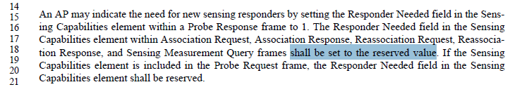

The location to describe *Responder needed field* in clause 9 is shown as follows:

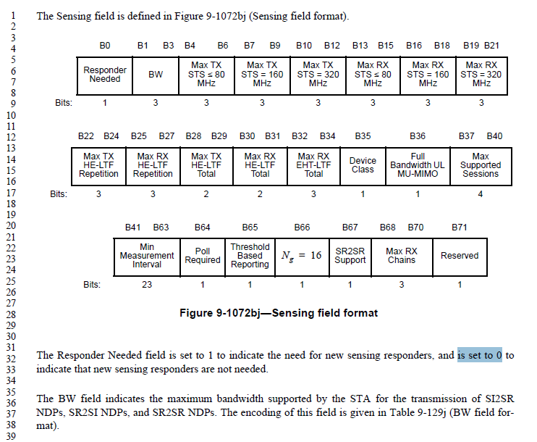

***Instructions to the editor: please make the following changes to the paragraph from P177L32 to P177L33 in the subclause 9.4.2.330 Sensing Capabilities element in D4.0 as shown below:***

The Responder Needed field is set to 1 in Probe Response frames to indicate the need for new sensing responders, and is set to 0 to indicate that new sensing responders are not needed. The Responder Needed field is reserved in Association Request, Association Response, Reassociation Request, Reassociation Response, Probe Request, and Sensing Measurement Query frames.

***Instructions to the editor: please make the following changes to the paragraph from P140L15 to P140L21 in the subclause 11.55.1.3 Sensing capabilities exchange in D4.0 as shown below:***

An AP may indicate the need for new sensing responders by setting the Responder Needed field in the Sensing Capabilities element within a Probe Response frame to 1.

|  |  |  |  |  |  |
| --- | --- | --- | --- | --- | --- |
| **CID** | **Clause** | **Page**  **Line** | **Comment** | **Proposed Change** | **Resolution** |
| 6032 | 11.55.1.1 | 138.01 | The USID usage shall follow the same rules as that of AIDs specified in 9.4.1.8 (AID field) is not sufficiently specific. 9.4.1.8 starts with In infrastructure BSS operation, the AID field contains a value assigned by an AP or PCP during association, which clearly should not apply to USIDs. | Change to The range of values for the USID shall be the same as the ranges for AIDs specified in 9.4.1.8." | Revised  Agree with the commenter in principle.  TGbf Editor make changes specified in 1353r1.  (<https://mentor.ieee.org/802.11/dcn/24/11-24-1353-01-00bf-Initial SA-Ballot-Comment-Resolutions-for-OST.docx>) |

**Taken from 11bf**

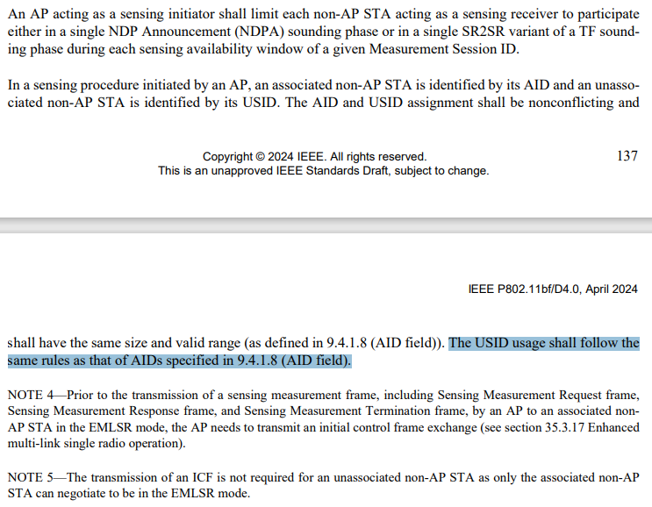

**Taken from REVme D5.0:**

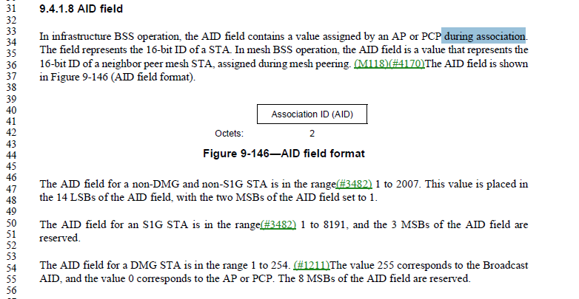

It is true that it’s not accurate to say that “the USID usage shall follow the same rules as that of AIDs”. The point here is to say their ranges are identical.

***Instructions to the editor: please make the following changes to the paragraph from P138L1 to P138L2 in the subclause 11.55.1.1 Overview in D4.0 as shown below:***

In a sensing procedure initiated by an AP, an associated non-AP STA is identified by its AID and an unassociated non-AP STA is identified by its USID. The AID and USID assignment shall be nonconflicting and shall have the same size and range (as defined in 9.4.1.8 (AID field)).

|  |  |  |  |  |  |
| --- | --- | --- | --- | --- | --- |
| **CID** | **Clause Number** | **Page**  **Line** | **Comment** | **Proposed Change** | **Resolution** |
| 6171 | 9.4.2.329 | 73.40 | In Figure 9-1072be the fields TX LTF Repetition and RX LTF Repetition are shown, but on P73L40 and P73L43 the field names are TX HE-LTF Repetition and RX HE-LTF Repetition. | Please change the field names to TX LTF Repetition and RX LTF Repetition as in Figure 9-1072be | Revised  Agree with the commenter in principle.  TGbf Editor make changes specified in 1353r1.  (<https://mentor.ieee.org/802.11/dcn/24/11-24-1353-01-00bf-Initial SA-Ballot-Comment-Resolutions-for-OST.docx>) |
| 6172 | 9.4.2.330 | 78.11 | In 11bk D2.0 HE-LTF repetitions is replaced with LTF repetitions. Hence 11bf D4.0 should also remove rename the fields Max TX HE-LTF Repetition, Max RX HE-LTF Repetition, Max TX HE-LTF Total, and Max RX HE-LTF Total to Max TX LTF Repetition, Max RX LTf Repetition, Max TX LTF Total, and Max RX LTF Total. Further the Max RX EHT-LTF Total field should be removed. | Please replace in Figure 9-1072bj the fields Max TX HE-LTF Repetition, Max RX HE-LTF Repetition, Max TX HE-LTF Total, and Max RX HE-LTF Total with Max TX LTF Repetition, Max RX LTf Repetition, Max TX LTF Total, and Max RX LTF Total.  Please remove the Max RX EHT-LTF Total field.  Please replace the text on P78L11-34 with the following text (note P30-34 are deleted):  The Max TX LTF Repetition field is set to the maximum number of LTF repetitions that the STA  supports in the transmission of an SI2SR NDP, SR2SI NDP, or SR2SR NDP that is either an HE Ranging  NDP, an HE TB Ranging NDP, an EHT Ranging NDP, or an EHT TB Ranging NDP. The field is set to the number of LTF repetitions minus 1.  The Max RX LTF Repetition field is set to the maximum number of LTF repetitions that the STA  supports in reception of an SI2SR NDP, SR2SI NDP, or SR2SR NDP that is either an HE Ranging NDP,  an HE TB Ranging NDP, an EHT Ranging NDP, or an EHT TB Ranging NDP. The field is set to the number of LTF repetitions minus 1.  The Max TX LTF Total field and the Max RX LTF Total field indicate the maximum number of  LTFs that the STA supports in the transmission and the reception, respectively, of an SI2SR NDP,  SR2SI NDP, or SR2SR NDP that is either an HE Ranging NDP, an HE TB Ranging NDP, an EHT Ranging NDP, or an EHT TB Ranging NDP. The encoding of the Max TX LTF Total and the Max RX LTF Total fields is given in Table 9-413 (Max R2I/I2R  LTF Total subfields).  NOTEThe maximum number of LTFs limits the allowed combinations of number of space-time streams and LTF repetitions in an HE Ranging NDP, an HE TB Ranging NDP, an EHT Ranging NDP, or an EHT TB Ranging NDP. | Revised  Agree with the commenter in principle.  TGbf Editor make changes specified in 1353r1.  (<https://mentor.ieee.org/802.11/dcn/24/11-24-1353-01-00bf-Initial SA-Ballot-Comment-Resolutions-for-OST.docx>) |

***Instructions to the editor: please make the following changes to the paragraph from P73L40 to P73L44 in the subclause 9.4.2.329 Sensing Measurement Parameters element in D4.0 as shown below:***

The TX LTF Repetition and TX STS fields are reserved if the Sensing Transmitter field is set to 0.

The RX LTF Repetition, RX STS, and Number of RX Chains fields are reserved if the Sensing Receiver field is set to 0.

***Instructions to the editor: please make the following changes to the paragraph from P77L3 to P77L29 in the subclause 9.4.2.329 Sensing Measurement Parameters element in D4.0 as shown below:***



Figure 9-1072bj—Sensing field format

***Instructions to the editor: please make the following changes to the paragraph from P78L11 to P78L35 in the subclause 9.4.2.329 Sensing Measurement Parameters element in D4.0 as shown below:***

The Max TX LTF Repetition field is set to the maximum number of LTF repetitions that the STA

supports in the transmission of an SI2SR NDP, SR2SI NDP, or SR2SR NDP that is either an HE Ranging

NDP, an HE TB Ranging NDP, an EHT Ranging NDP or an EHT TB Ranging NDP, the field is set to the number of LTF repetitions minus 1.

The Max RX LTF Repetition field is set to the maximum number of LTF repetitions that the STA

supports in reception of an SI2SR NDP, SR2SI NDP, or SR2SR NDP that is either an HE Ranging NDP, an HE TB Ranging NDP, an EHT Ranging NDP or an EHT TB Ranging NDP, the field is set to the number of LTF repetitions minus 1.

The Max TX LTF Total field and the Max RX LTF Total field indicate the maximum number of

HE-LTFs or EHT-LTFs that the STA supports in the transmission and the reception, respectively, of an SI2SR NDP, SR2SI NDP, or SR2SR NDP that is either an HE Ranging NDP,an HE TB Ranging NDP, an EHT Ranging NDP or an EHT TB Ranging NDP. The encoding of the Max TX LTF Total and the Max HE-LTF Total fields is given in Table 9-411 (Max R2I/I2R LTF Total subfields).

NOTE—The maximum number of HE-LTFs or EHT-LTFs limits the allowed combinations of number of space-time streams and LTF repetitions in an HE Ranging NDP, an HE TB Ranging NDP, an EHT Ranging NDP and an EHT TB Ranging NDP.

## SP

Do you support the proposed resolutions to the CIDs and incorporate the text changes into the latest TGbf draft?

Y/N/A