IEEE P802.11  
Wireless LANs

|  |  |  |  |  |
| --- | --- | --- | --- | --- |
| Initial SA Ballot Comment Resolution for CID 6018 | | | | |
| Date: 2024.07.29 | | | | |
| Author(s): | | | | |
| Name | Affiliation | Address | Phone | email |
| Zhuqing Tang | Huawei Technologies | Huawei Base, Shenzhen, Guangdong, China |  | tangzhuqing@huawei.com |
| Ali Raissinia | Qualcomm Inc. |  |  | alirezar@qti.qualcomm.com |
| Rui Du | Huawei Technologies |  |  |  |
| Narengerile |  |  |  |
| Mengshi Hu |  |  |  |
| Yiyan Zhang |  |  |  |

Abstract

This submission contains the proposed comment resolutions for the CID 6018 submitted to Initial SA Ballot. The reference text is 11bf D4.0.

R0: initial document

|  |  |  |  |  |  |
| --- | --- | --- | --- | --- | --- |
| **CID** | **Clause** | **Page**  **Line** | **Comment** | **Proposed Change** | **Resolution** |
| 6018 | 11.55.1.5.2.1 | 148.07 | Prohibiting data frame transmissions, especially by an AP, during the entire sensing availability window will negatively impact other services and performance at other STAs. Also, the sensing availability window may be longer than the time needed to complete the sensing activities. | Change to Within each sensing availability window, non-AP sensing initiator and sensing responder(s) should not transmit or trigger transmission of any Data frames until the completion of sensing activities related to polling, NDPA sounding, TF sounding, reporting, and SBP reporting for the current availability window. | Revised  TGbf Editor make changes specified in 1352r0. (<https://mentor.ieee.org/802.11/dcn/24/11-24-1352-00-00bf-Initial SA-Ballot-Comment-Resolution-for-CID-6018.docx>) |

**Discussion**

Taken from 11bf, for reference.

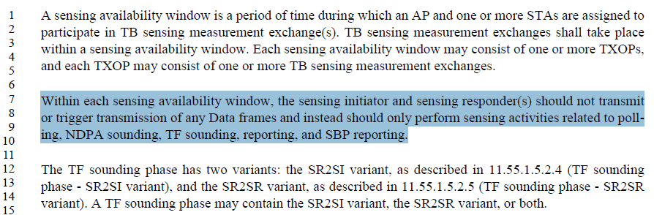

It is possible that the data transmission is allowed after the sensing activities are completed within that availability window.

The original text "should not transmit ... Data frames" followed by "should only perform sensing activities" strongly discourages data transmission.

Rephrase the text to make the channel available for other activities after all sensing measurement exchanges have completed.

***Instructions to the editor: please make the following changes to the paragraph from P148L7 to P148L9 in the subclause 11.55.1.1 Overview in D4.0 as shown below:***

At the beginning of each sensing availability window, the sensing initiator (AP) and sensing responder(s) shall only transmit frames corresponding to the sensing measurement exchange, i.e., polling, NDPA sounding, TF sounding, reporting, and SBP reporting and subsequently complete all sensing activities before channel becomes available for other activities.

## SP

Do you support the proposed resolution to the CID 6018 and incorporate the text changes into the latest TGbf draft?

Y/N/A