IEEE P802.11  
Wireless LANs

|  |  |  |  |  |
| --- | --- | --- | --- | --- |
| Initial SA Ballot Comment Resolutions for DMG Part 2 | | | | |
| Date: 2024.07.xx | | | | |
| Author(s): | | | | |
| Name | Company | Address | Phone | email |
| Rui Du | Huawei Technologies | F3, Huawei Base, Shenzhen, Guangdong, China, 518129 |  | Ray.du@huawei.com |
| Narengerile |  |  |
| Zhuqing Tang |  |  |
| Yiyan Zhang |  |  |
|  |  |  |

Abstract

This submission contains the proposed comment resolutions for the CIDs 6083, 6090, 6100, 6101, 6102, 6103, 6104, 6107, 6108, 6109, 6111, 6125, 6126, 6120, 6121, 6128 submitted to Initial SA Ballot. The reference text is 11bf D4.0.

R0: initial document

R1: fix typo

# CID 6083

|  |  |  |  |  |  |
| --- | --- | --- | --- | --- | --- |
| CID | Page.  Line | Clause Number | Comment | Proposed Change | Resolution |
| 6083 | 127.28 | 9.6.21.10 | Why is "Optionallly Present" indicated in the Table 9-604c? It is confusing. Does it mean that all fields with order number 1 to 5 are optionally present in DMG Sensing Measurement Report frame? [ng] | Please remove "(Optionally Present)". | Accepted. |

***Instructions to the editor: please make the following changes to Table 9-604c -- DMG Sensing Measurement Report frame Action field format in D4.0 as shown below:***

Table 9-604c—DMG Sensing Measurement Report frame Action field format

|  |  |
| --- | --- |
| **Order** | **Information** |
| 1 | Category |
| 2 | Unprotected DMG Action |
| 3 | Dialog Token |
| 4 | DMG Sensing Report Control element |
| 5 | DMG Sensing Report element or one or more Channel Measuremet Feedback elements |

# CID 6090

|  |  |  |  |  |  |
| --- | --- | --- | --- | --- | --- |
| CID | Page.  Line | Clause Number | Comment | Proposed Change | Resolution |
| 6090 | 105.30 | 9.4.2.340 | The description for DMG Measurement Session ID, Measurement Burst ID and Sensing Exchange SN fiels is not complete. | Please change this sentence to "The DMG Measurement Session ID, Measurement Burst ID and Sensing Exchange SN fields identify the DMG sensing measurement session, the DMG sensing burst, and the DMG sensing measurement exchange, respectively." | Accepted. |

***Instructions to the editor: please make the following changes from P105L30 to P105L32 to in the subclause 9.4.2.340 BRP Sensing element in D4.0 as shown below:***

The DMG Measurement Session ID, Measurement Burst ID and Sensing Exchange SN fields identify the DMG sensing measurement session, the DMG sensing burst and the DMG sensing measurement exchange, respectively.

# CID 6100

|  |  |  |  |  |  |
| --- | --- | --- | --- | --- | --- |
| CID | Page.  Line | Clause Number | Comment | Proposed Change | Resolution |
| 6100 | 103.26 | 9.4.2.339.4 | For Range Axis Present field, Azimuth Axis Present field, Elevation Axis Present field, Radial Velocity Present field, Azimuth Velocity Present field, Receive Elevation Velocity Present field, the texts do not specify the value to indicate the presence of a certain field. | Please change "The Range Axis Present field indicates the presence of Range Axis Index field in the Reflection Set field." to "The Range Axis Present field is set to 1 to indicate the presence of Range Axis Index field in the Target field. It is set to 0 otherwise." Please make similiar changes to Azimuth Axis Present field, Elevation Axis Present field, Radial Velocity Present field, Azimuth Velocity Present field, Receive Elevation Velocity Present field. | Accepted. |

***Instructions to the editor: please make the following changes from P103L26 to P103L43 in the subclause 9.4.2.339.4 DMG Sensing Targets Report Data subelement in D4.0 as shown below:***

The Range Axis Present field is set to 1 to indicate the presence of Range Axis Index field in the Target field. It is set to 0 otherwise.

The Azimuth Axis Present field is set to 1 to indicate the presence of Azimuth Axis Index field in the Target field. It is set to 0 otherwise.

The Elevation Axis Present field is set to 1 to indicate the presence of Elevation Axis Index field in the Target field. It is set to 0 otherwise.

The Radial velocity Axis Present field is set to 1 to indicate the presence of Radial Velocity Axis Index field in the Target field. It is set to 0 otherwise.

The Azimuth velocity Axis Present field is set to 1 to indicate the presence of Azimuth Velocity Axis Index field in the Target field. It is set to 0 otherwise.

The Elevation velocity Axis Present field is set to 1 to indicate the presence of Elevation Velocity Axis index field in the Target field. It is set to 0 otherwise.

# CID 6101

|  |  |  |  |  |  |
| --- | --- | --- | --- | --- | --- |
| CID | Page.  Line | Clause Number | Comment | Proposed Change | Resolution |
| 6101 | 99.61 | 9.4.2.339.3 | For Range Axis Present field, Doppler Axis Present field, Receive Beam Index Present field, Transmitter Beam Index Present field, Phase Present field, Receive Azimuth Present field, Receive Elevation Present field, the texts do not specify the value to indicate the presence of a certain field. | Please change "The Range Axis Present field indicates the presence of Range Axis Index field in the Reflection Set field." to "The Range Axis Present field is set to 1 to indicate the presence of Range Axis Index field in the Reflection Set field. It is set to 0 otherwise." Please make similiar changes to Doppler Axis Present field, Receive Beam Index Present field, Transmitter Beam Index Present field, Phase Present field, Receive Azimuth Present field, Receive Elevation Present field. | Accepted. |

***Instructions to the editor: please make the following changes from P99L61 to P100L16 in the subclause 9.4.2.339.3 DMG Sensing Image Report Data subelement in D4.0 as shown below:***

The Range Axis Present field is set to 1 to indicate the presence of Range Axis Index field in the Reflection Set field. It is set to 0 otherwise.

The Doppler Axis Present field is set to 1 to indicate the presence of Doppler Axis Index field in the Reflection Set field. It is set to 0 otherwise.

The Receiver Beam Index Present field is set to 1 to indicate the presence of Receiver Beam Index field in the Reflection Set field. It is set to 0 otherwise.

The Transmitter Beam Index Present field is set to 1 to indicate the presence of Transmitter Beam Index field in the Reflection Set field. It is set to 0 otherwise.

The Phase Present field is set to 1 to indicate the presence of Phase Value field in the Reflection Set field. It is set to 0 otherwise.

The Receive Azimuth Present field is set to 1 to indicate the presence of receive azimuth angles in the Reflection subelements. It is set to 0 otherwise.

The Receive Elevation Present field is set to 1 to indicate the presence of receive elevation angles in the Reflection subelements. It is set to 0 otherwise.

# CID 6102, 6103, 6104

|  |  |  |  |  |  |
| --- | --- | --- | --- | --- | --- |
| CID | Page.  Line | Clause Number | Comment | Proposed Change | Resolution |
| 6102 | 98.34 | 9.4.2.339.2 | The description "indicates the presence or absence of" does not specify how to interprete this field, i.e., which value indicates the presence and which value indicates the absence. The texts needs further clarification. [ng] | Please change "The AoA Present field indicates the presence or absence of the AoA field in the DMG Sensing Report Header subelement" to "The AoA Present field is set to 1 to indicate that the AoA field is present in the DMG Sensing Report Header subelement; it is set to 0 otherwise." | Accepted. |
| 6103 | 98.31 | 9.4.2.339.2 | The description "indicates the presence or absence of" does not specify how to interprete this field, i.e., which value indicates the presence and which value indicates the absence. The texts needs further clarification. [ng] | Please change "The Range Present field indicates the presence or absence of the Range field in the DMG Sensing Report Header subelement" to "The Range Present field is set to 1 to indicate that the Range field is present in the DMG Sensing Report Header subelement; it is set to 0 otherwise." | Accepted. |
| 6104 | 98.27 | 9.4.2.339.2 | The description "indicates the presence or absence of" does not specify how to interprete this field, i.e., which value indicates the presence and which value indicates the absence. The texts needs further clarification. [ng] | Please change "The LCI Present field indicates the presence or absence of the LCI field in the DMG Sensing Report Header subelement" to "The LCI Present field is set to 1 to indicate that the LCI field is present in the DMG Sensing Report Header subelement; it is set to 0 otherwise." | Accepted. |

***Instructions to the editor: please make the following changes from P98L27 to P98L36 in the subclause 9.4.2.339.2 DMG Sensing Report Header subelement in D4.0 as shown below:***

The LCI Present field is set to 1 to indicate the presence or absence of the LCI field in the DMG Sensing Report Header subelement. It is set to 0 otherwise.

The Range Present field is set to 1 to indicate the presence or absence of the Range field in the DMG Sensing Report Header subelement. It is set to 0 otherwise.

The AoA Present field is set to 1 to indicate the presence or absence of the AoA field in the DMG Sensing Report Header subelement. It is set to 0 otherwise.

# CID 6107

|  |  |  |  |  |  |
| --- | --- | --- | --- | --- | --- |
| CID | Page.  Line | Clause Number | Comment | Proposed Change | Resolution |
| 6107 | 92.19 | 9.4.2.335.3 | What does it mean by "until another sensing measurement session"? Even if there is another sensing measurement session establishment, the current burst belongs to the current sensing measurement session, it will not end until termination. Another sensing measurement session will not affect the existing sensing measurement session. | Please delete "another sensing measurement session or". | Accepted. |

***Instructions to the editor: please make the following changes from P92L18 to P92L19 in the subclause 9.4.2.335.3 DMG Sensing Scheduling subelement in D4.0 as shown below:***

The Number Bursts field contains the number of times to repeat the Burst. A value of 0 indicates repeat until tear down.

# CID 6109, 6108

|  |  |  |  |  |  |
| --- | --- | --- | --- | --- | --- |
| CID | Page.  Line | Clause Number | Comment | Proposed Change | Resolution |
| 6109 | 91.38 | 9.4.2.335.3 | In DMG Sensing Scheduling subelement, the inter-burst interval and intra-burst interval are in the same time units, but the number of octets for intra-burst interval is more that the number of octets for inter-burst interval. This would mean that intra-burst interval can be longer than inter-burst interval, which is not correct. | Please swap the number of octets for Interburst Interval field and Intraburst Interval field to make Interburst have 2 octets and Intraburst have 1 octet. | Accepted. |
| 6108 | 91.44 | 9.4.2.335.3 | The Start Of Burst field, Interburst Interval field, and Intraburst Interval fields are in units TSF, which is confusing. Does it mean in the unit of microsecond? | Please change the time unit to microsecond. Please also change other appearances of "in TSF units" in the draft to "in microsecond". | Accepted. |

***Instructions to the editor: please make the following changes to Figure 9-1072cb—DMG Sensing Scheduling subelement format as follows:***

Change the length of ‘Interburst Interval’ from ‘1’ to ‘2’.

Change the length of ‘Intraburst Interval’ from ‘2’ to ‘1’.

***Instructions to the editor: please make the following changes from P91L31 to P91L54 in the subclause 9.4.2.335.3 DMG Sensing Scheduling subelement in D4.0 as shown below:***

The Start Of Burst field contains the time for the start of the first burst in units of microsecond. A value of 0 indicates that the time for the start of the first burst is unspecified.

The Interburst Interval field contains the time between the start of successive bursts. This field is in units of microsecond. A value of 0 indicates that the time between the start of successive bursts is unspecified.

The Intraburst Interval field contains the time between the start of successive DMG sensing measurement exchanges in a burst. This field is in units of microsecond. A value of 0 indicates that the time between the start of successive DMG sensing measurement exchanges in a burst is unspecified.

# CID 6111

|  |  |  |  |  |  |
| --- | --- | --- | --- | --- | --- |
| CID | Page.  Line | Clause Number | Comment | Proposed Change | Resolution |
| 6111 | 88.03 | 9.4.2.335 | For coordinate bistatic, RX initiator field is needed to specify the role of the sensing responder. So, the field of RX initiator field is also valid if the sensing type is set to 1 (coordinated bistatic). | Please change "This field is reserved if the Sensing Type field is not set to 2 (Bistatic)" to "This field is reserved if the Sensing Type field is not set to 1 (Coordinated Bistatic) or 2 (Bistatic)". | Revised  TGbf Editor make changes specified in 1351r1.  (https://mentor.ieee.org/802.11/dcn/24/11-24-1351-01-00bf-initial-sa-ballot-comment-resolutions-for-dmg-part-2.docx) |

***Instructions to the editor: please make the following changes from P88L1 to P88L4 in the subclause 9.4.2.335 DMG Sensing Measurement Session element in D4.0 as shown below:***

The RX Initiator field is set to 1 if the sensing initiator is the sensing receiver in coordinated bistatic or bistatic sensing, and to 0 if the sensing initiator is the sensing transmitter in coordinated bistatic or bistatic sensing. This field is reserved if the Sensing Type field is not set to 1 (coordinated bistatic) or 2 (Bistatic).

# CID 6125, 6126

|  |  |  |  |  |  |
| --- | --- | --- | --- | --- | --- |
| CID | Page.  Line | Clause Number | Comment | Proposed Change | Resolution |
| 6125 | 196.44 | 11.55.3.7 | There is no such a field throughout the draft: DMG Sensing Targets Report field in the draft. | Please clarify or refer to the correct field. | Revised  TGbf Editor make changes specified in 1351r1.  (https://mentor.ieee.org/802.11/dcn/24/11-24-1351-01-00bf-initial-sa-ballot-comment-resolutions-for-dmg-part-2.docx) |
| 6126 | 196.43 | 11.55.3.7 | It should be DMG Sensing Target Report Data subelement, not the DMG Sensing Image Report Data subelement. | Please change "DMG Sensing Image Report Data subelements" to "DMG Sensing Target Report Data subelements". | Accepted. |

***Discussion***

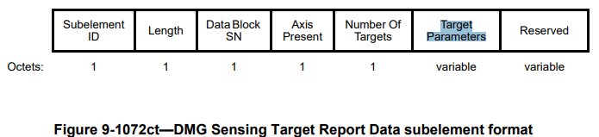

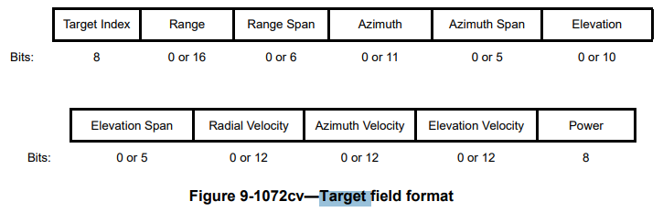

***Instructions to the editor: please make the following changes from P196L42 to P196L49 in the subclause 9.4.2.335.3 DMG Sensing Scheduling subelement in D4.0 as shown below:***

If the Report Type field of the Report Control field of a DMG Sensing Report Control element is set to 7 (Target) then the DMG Sensing Target Report Data subelements in the associated DMG Sensing Report Element contains Target Parameters fields. Each Target Parameters field, is associated with a Target and identified by the Target Index field. A Target Index is associated with measurements that the STA generating the report estimates that belong to a single object. If a STA estimates that a particular target is consistent in different reports (in different times, e.g., over different bursts), it may set the Target Index field to a consistent nonzero value.

***Instructions to the editor: please make change the name of ‘Figure 9-1072cv—Target field format’ to ‘Figure 9-1072cv—Target Parameters field format’***

# CID 6120

|  |  |  |  |  |  |
| --- | --- | --- | --- | --- | --- |
| CID | Page.  Line | Clause Number | Comment | Proposed Change | Resolution |
| 6120 | 197.50 | 11.55.3.9 | Sensing Support field does not indicate the capability of passive sensing. [ng] | Please add "except DMG passive sensing" after "any type of sensing". | Accepted. |

***Discussion***

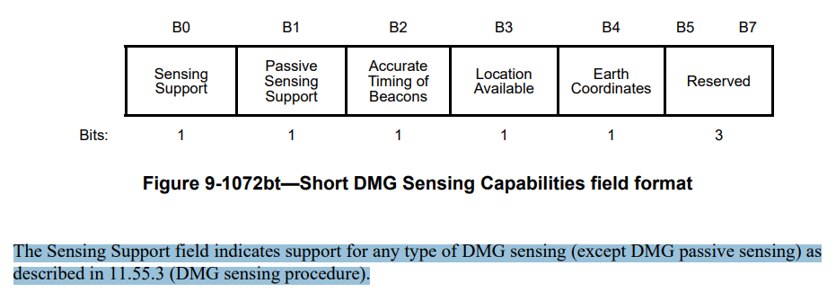

***Instructions to the editor: please make the following changes from P197L47 to P197L56 in the subclause 11.55.3.9 DMG passive sensing in D4.0 as shown below:***

A DMG AP or DMG PCP advertises the capability to perform passive sensing in the DMG Sensing Short Capabilities element (see 9.4.2.334 (DMG Sensing Short Capabilities element)). The DMG AP or DMG PCP shall set the Sensing Support field of the Short DMG Sensing Capabilities field to 1 to indicate that it supports any type of sensing except DMG passive sensing. The DMG AP or DMG PCP shall set the Passive Sensing Support field to 1 if it supports DMG passive sensing. The DMG AP or DMG PCP shall set the Accurate Timing of Beacons to 1 if the SBIFS between beacon transmissions in the BTI is exactly where is defined in Table 20-4 (Timing related parameters). The DMG AP or DMG PCP shall set the Location Available field to 1, if it can provide an LCI field in a DMG Passive Sensing Beacon element (see 9.4.2.341 (DMG Passive Sensing Beacon element)).

# CID 6121

|  |  |  |  |  |  |
| --- | --- | --- | --- | --- | --- |
| CID | Page.  Line | Clause Number | Comment | Proposed Change | Resolution |
| 6121 | 197.38 | 11.55.3.8 | DMG MSID and the MAC address of the sensing initiator are used to identify a sensing measurement session uniquely. For example, the measurement session with DMG MSID = 1 is terminated by sensing initiator A. The sensing responder can still participate in a different sensing measurement session with another sensing intiator B that also sets DMG MSID to 1. | Please add "with the same sensing initiator" before the period. | Accepted. |

***Instructions to the editor: please make the following changes from P197L36 to P197L38 in the subclause 11.55.3.8 DMG sensing measurement termination in D4.0 as shown below:***

Once the DMG sensing measurement session between a sensing initiator and a sensing responder is terminated, the sensing responder shall not participate in any sensing measurement exchange associated with the corresponding DMG Measurement Session ID with the same sensing initiator.

# CID 6128

|  |  |  |  |  |  |
| --- | --- | --- | --- | --- | --- |
| CID | Page.  Line | Clause Number | Comment | Proposed Change | Resolution |
| 6128 | 195.57 | 11.55.3.7 | It should be the Report Delay field, not the Report Type field. [ng] | Please change "Report Type" to "Report Delay". | Accepted. |

***Discussion***

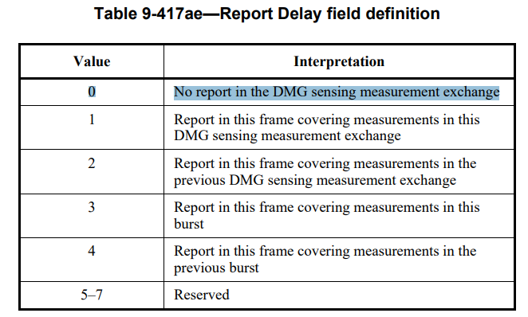

***Instructions to the editor: please make the following changes from P92L18 to P92L19 in the subclause 9.4.2.335.3 DMG Sensing Scheduling subelement in D4.0 as shown below:***

For the Channel Measurement Feedback elements, carried within a BRP frame, the measurements on which the report is based upon are defined in the Report Delay field of the Report Control field of the BRP Sensing element (see 9.4.2.340 (BRP Sensing element)). If the value of the field is 1, the report is based on a measurement in the current DMG sensing measurement exchange. If the value of the field is 2, the report is based on a measurement in the previous DMG sensing measurement exchange. The Report Delay field in the first DMG sensing measurement exchange of the burst can be set to 0, indicating no report in this DMG sensing measurement exchange, or 4, indicating report of measurements in the last DMG sensing measurement exchange of the previous burst.

# SP

Do you support resolutions to the following CIDs and incorporate the text changes into the latest TGbf draft: 6083, 6090, 6100, 6101, 6102, 6103, 6104, 6107, 6108, 6109, 6111, 6125, 6126, 6120, 6121, 6128 in 11-24/1351r1?

Y/N/A