IEEE P802.11
Wireless LANs
Misc Hamilton REVme CIDs
Date: 2024-07-17
Author(s):
Name | Affiliation | Address | Phone | Email
Mark Hamilton | Ruckus/CommScope | 350 W Java Dr  Sunnyvale, CA 94089 | +1.303.818.8472 | mark.hamilton2152@gmail.com
Abstract
This document provides comment resolutions to CIDs 8257, 8259, 8229, 8120.

CID | Page | Line | Clause | Comment | Proposed Change
8257 | 1697 | 24 | 9.6.7.45 | Normative verb in clause 9. | Change "may use" to "optionally uses"

Context:

…

Discussion:

In this context, the GAS Extension element is indicating parameters of the STA transmitting the request, that the AP or PCP uses to respond.

It is suggested to say something like: "The GAS Extension element indicates parameters that the requesting STA requests the responder to use.”

Proposed Resolution:

Revised

Change the cited sentence to:
The GAS Extension element indicates parameters that the STA transmitting the request is responder to use while processing this request.

CID | Page | Line | Clause | Comment | Proposed Change
8259 | 1676 | 23 | 9.6.7.32 | Normative verbs in clause 9. | Replace "shall contain" with "contains". Same thing at P1676.24.

Context:

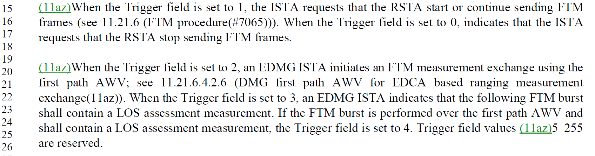

Discussion:

Each trigger style (as requested by values in the Trigger field) is requesting that the FTM burst/exchange have particular attributes. Style 2 is requesting using first path AWV; style 3 is requesting to include an LOS assessment measurement; and style 4 is requesting both.

Discussion:

Subclause 11.21.6.3.8 describes the behavior associated with requesting LOS assessment measurements between STAs that indicate support for it. So, here in the FTM Request (action) frame definition, this is the ISTA requesting use of the facility during this FTM burst.

: "indicates that the following following FTM burst is requested to contain LOS assessment measurements."

Proposed resolution:

Revised

Change:
When the Trigger field is set to 3, an EDMG ISTA indicates that the following FTM burst shall contain a LOS assessment measurement. If the FTM burst is performed over the first path AWV and shall contain a LOS assessment measurement, the Trigger field is set to 4.
to:
When the Trigger field is set to 3, an EDMG ISTA indicates that the following FTM burst is requested to contain LOS assessment measurements. If the FTM burst is performed over the first path AWV and is requested to contain LOS assessment measurements, the Trigger field is set to 4.

CID | Page | Line | Clause | Comment | Proposed Change
8229 | 740 | 20 | 9.3.3.5 | What does "ought" mean in this context (738.20, D5.0)? "Should"?? "Shall"?? Something non-normative?? Also, this is already stated in 11.1.4.6, "An S1G or CMMG STA should not include supported rates in frames it transmits since its MCS capabilities are indicated in its Capabilities element." Make this an understandable xref. Same thing at P740.31, P743.57, P744.11, P748.48, P748.59, P754.17, P754.28, P759.16, P759.29, P762.16, and P763.11. | At P740.19, P743.56, P748.47, P754.16, P759.15, and P762.14, replace the entire content of the Notes box, with "See 11.1.4.6 for details on the inclusion of this element when dot11S1GOptionImplemented or dot11DMGOptionImplemented is true. At P740.30, P744.10, P748.58, P754.27, P759.27, and P763.10, replace the similar sentence in the Notes box, with the same change.
8120 |  |  | 14 | define "might" and "ought to" as informative suggestions and recommendations respectively | As it says in the comment

Context:

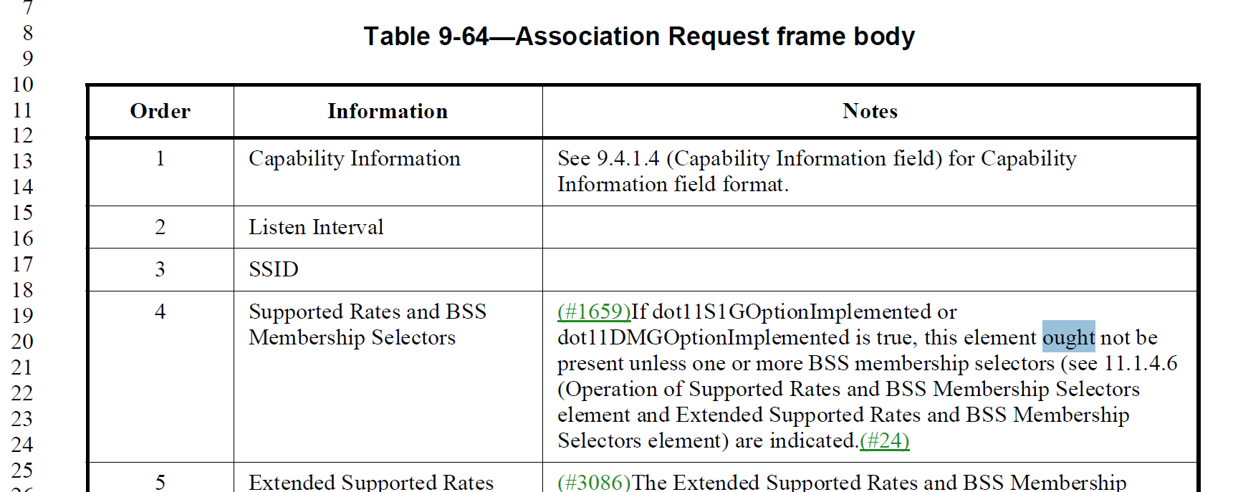

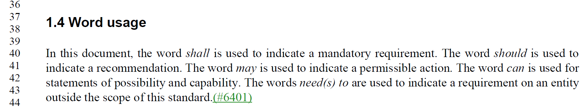

Discussion:

There are two places that “ought” is used in the Draft.

The above example (cited in CID 8229) is a use in frame formats in clause 9, and all these uses are of this same form and all reference the [Extended] Supported Rates and BSS Membership Selectors elements.

There are also 4-5 uses of “ought” within NOTEs scattered through the Draft.

CID 8229 requests to not use this (currently not well defined) verb in the frame definitions. It offers an alternate wording which replaces these “you should do X because 11.1.4.6 says so” to just say “see 11.1.4.6 for rules about doing X”, which seems like a more direct statement of the requiement anyway.

CID 8120 notes that two verbs, “ought” and “might” are not well-defined. And, even with application of the CID 8229 resolution, there are still uses of “ought” in NOTEs at other locations, so the need to define the word “ought” is valid.

Hence, the suggestion is to accept both, in effect.

Proposed Resolutions:

CID 8229
Accepted.

CID 8120
Revised.

Replace the first paragraph of subclause 1.4 with:
In this document, the word shall is used to indicate a mandatory requirement. The word should is used to indicate a recommendation (informatively, the words ought to are used). The word may is used to indicate a permissible action (informatively, the word might is used). The word can is used for statements of possibility and capability (informatively, the word might is used for this also). The words need(s) to are used to indicate a requirement on an entity outside the scope of this standard.

References: P802.11REVme D6.0

