IEEE P802.11
Wireless LANs
Initial SA Ballot Comment Resolutions for Reporting CIDs
Date: 2024.07.17
Author(s):
Name | Affiliation | Address | Phone | email
Zhuqing Tang | Huawei Technologies | Huawei Base, Shenzhen, Guangdong, China, 518129 |  | tangzhuqing@huawei.com
Rui Du
Narengerile
Mengshi Hu
Yiyan Zhang
Abstract
This submission contains the proposed comment resolutions for the CIDs 6050 6051 6052 6053 6054 6055 6056 6057 submitted to Initial SA Ballot. The reference text is 11bf D4.0.

R0: initial document
R1: modified the resolution for CID 6055

CID | Clause | Page  Line | Comment | Proposed Change | Resolution
6050 | 11.55.1.2 | 138.43 | "receive antenna" should be "receive chain". | As in comment. | Revised  Agree with the commenter in principle.  TGbf Editor make changes specified in 1306r1. (https://mentor.ieee.org/802.11/dcn/24/11-24-1306-01-00bf- Initial-SA-Ballot-Comment-Resolutions-for- Reporting-CIDs.docx)

Discussion:

The location that the commenter indicates:
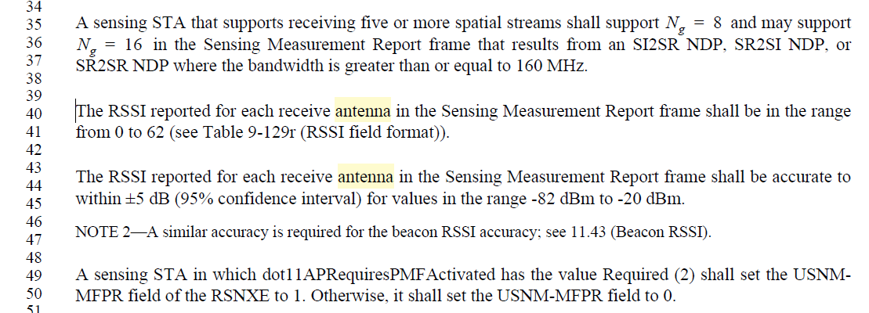
In the previous rounds, “antenna” has been changed to “chain”, as N_{RX} and N_{TX} have been defined as the number of receive chains and number of transmit chains in REVme.

Instructions to the editor: please make the following changes to the paragraph from P138L40 to P138L45 in the subclause 11.55.1.2 Dependencies and timing related parameters in D4.0 as shown below:

The RSSI reported for each receive chain in the Sensing Measurement Report frame shall be in the range from 0 to 62 (see Table 9-129r (RSSI field format)).

The RSSI reported for each receive chain in the Sensing Measurement Report frame shall be accurate to within ±5 dB (95% confidence interval) for values in the range -82 dBm to -20 dBm.

CID | Clause | Page  Line | Comment | Proposed Change | Resolution
6051 | 9.4.1.78.4 | 66.27 | "antenna" should be "chain". | As in comment. | Accepted
6052 | 9.4.1.78.4 | 66.26 | "antenna" should be "chain". | As in comment. | Accepted
6053 | 9.4.1.78.4 | 66.01 | "antenna" should be "chain". | As in comment. | Accepted
6054 | 9.4.1.78.4 | 58.43 | "antenna" should be "chain". | Change the beginning of the sentence from "For each RX/TX antenna pair " to "For each pair of transmit chain and receive chain". | Accepted

Discussion

Taken from 11bf
Page 66
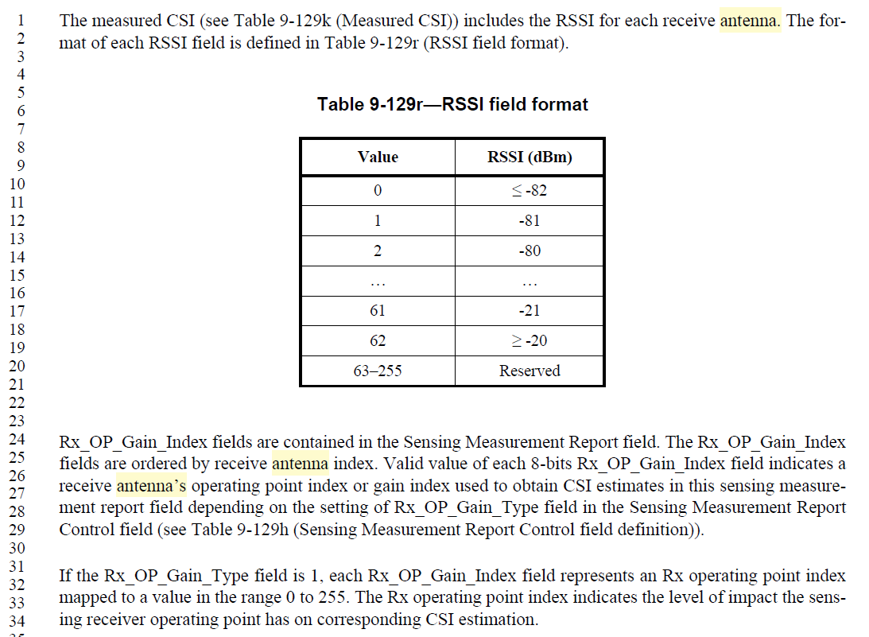

Page 58
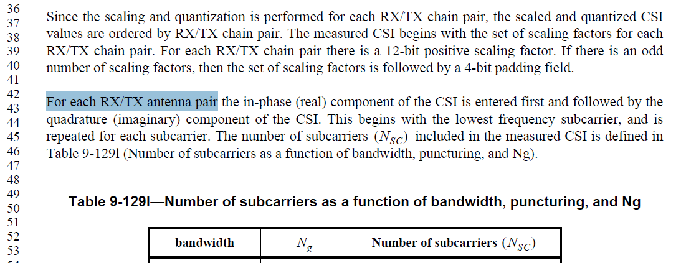

CID | Clause | Page  Line | Comment | Proposed Change | Resolution
6055 | 9.4.1.78.2.1 | 52.60 | This paragraph doesn't cover the case when the number of transmit chains is larger than the number of STSs. In addition, the rule in 11.55.1.5.4 (Common rules) about the Q matrix covers the content of the NOTE. So, there is no need to mention the relationship between the transmit chains and STSs here. | Remove this NOTE (L60 - L63). Or change the NOTE to "For transmission constraints imposed on the Q matrix should follow the rules described in 11.55.1.5.4 (Common rules)." | Revised  Agree with the commenter in principle.  TGbf Editor make changes specified in 1306r1.  (https://mentor.ieee.org/802.11/dcn/24/11-24-1306-01-00bf- Initial-SA-Ballot-Comment-Resolutions-for- Reporting-CIDs.docx)

Discussion:

Taken from 11bf
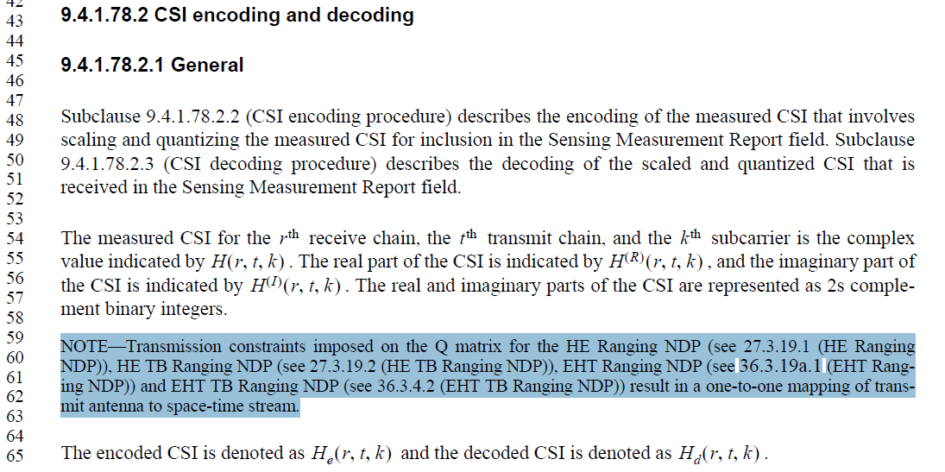

Instructions to the editor: please remove the note from P52L60 to P52L63 in the subclause 9.4.1.78.2 CSI encoding and decoding in D4.0 as shown below:

CID | Clause | Page  Line | Comment | Proposed Change | Resolution
6056 | 11.55.1.5.4 | 163.20 | Using "chains/antennas" is inconsistent to the terms used the in the later paragraph from L44 to L52. Also, "antenna swapping" is a vague term, which should be avoid. | Change the first part of sentence to "The sensing transmitter shall use the same ordered set of RF chains and antenna elements without changing the order " | Revised  Agree with the commenter in principle.  TGbf Editor make changes specified in 1306r1.  (https://mentor.ieee.org/802.11/dcn/24/11-24-1306-01-00bf- Initial-SA-Ballot-Comment-Resolutions-for- Reporting-CIDs.docx)
6057 | 11.55.1.5.4 | 163.14 | Using "chains/antennas" is inconsistent to the terms used the in the later paragraph from L44 to L52. Also, "antenna swapping" is a vague term, which should be avoided. | Change the first part of sentence to "The sensing receiver shall use the same ordered set of RF chains and antenna elements without changing the order " | Revised  Agree with the commenter in principle.  TGbf Editor make changes specified in 1306r1.  (https://mentor.ieee.org/802.11/dcn/24/11-24-1306-01-00bf- Initial-SA-Ballot-Comment-Resolutions-for- Reporting-CIDs.docx)

Discussion:

Taken from 11bf

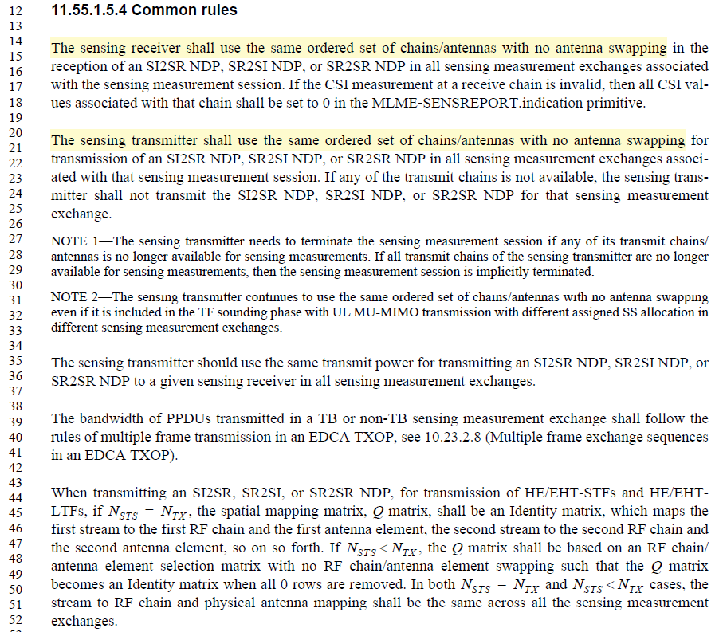
Instructions to the editor: please make the following changes to the paragraph from P163L14 to P163L22 in the subclause 11.55.1.5.4 Common rules in D4.0 as shown below:

The sensing receiver shall use the same ordered set of RF chains and antenna elements without changing the order in the reception of an SI2SR NDP, SR2SI NDP, or SR2SR NDP in all sensing measurement exchanges associated with the sensing measurement session. If the CSI measurement at a receive chain is invalid, then all CSI values associated with that chain shall be set to 0 in the MLME-SENSREPORT.indication primitive.

The sensing transmitter shall use the same ordered set of RF chains and antenna elements without changing the order for transmission of an SI2SR NDP, SR2SI NDP, or SR2SR NDP in all sensing measurement exchanges associated with that sensing measurement session. If any of the transmit chains is not available, the sensing transmitter shall not transmit the SI2SR NDP, SR2SI NDP, or SR2SR NDP for that sensing measurement exchange.

SP

Do you support the proposed resolutions to the CIDs 6050 6051 6052 6053 6054 6055 6056 6057 and incorporate the text changes into the latest TGbf draft?

Y/N/A

