IEEE P802.11
Wireless LANs
Initial SA Ballot Comment Resolutions for Exchange CIDs
Date: 2024.07.16
Author(s):
Name | Affiliation | Address | Phone | email
Zhuqing Tang | Huawei Technologies | F3, Huawei Base, Shenzhen, Guangdong, China, 518129 |  | tangzhuqing@huawei.com
Rui Du
Narengerile
Mengshi Hu
Yiyan Zhang
Abstract
This submission contains the proposed comment resolutions for the CIDs 6007 6008 6018 6169 submitted to Initial SA Ballot. The reference text is 11bf D4.0.

R0: initial document

CID | Clause | Page  Line | Comment | Proposed Change | Resolution
6007 | 9.3.1.22.15.3 | 38.03 | I believe there is a normative requirement implied by this sentence which is not correctly stated. It seems this is specifying the format of a field WHEN the condition is met. | When the AID12/USID12 subfield is equal to 2008 the format of the User Info field in the SR2SI Sounding Trigger frame shall be as shown in Figure 9-103e (User Info field format for SR2SI/SR2SR Sounding Trigger frame if the AID12/USID12 subfield is equal to 2008). | Revised  Agree with the commenter in principle.  TGbf Editor make changes specified in 1297r0. (https://mentor.ieee.org/802.11/dcn/24/11-24-1297-00-00bf- Initial-SA-Ballot-Comment-Resolutions-for- Exchange-CIDs.docx)

Discussion:

The location that the commenter indicates:
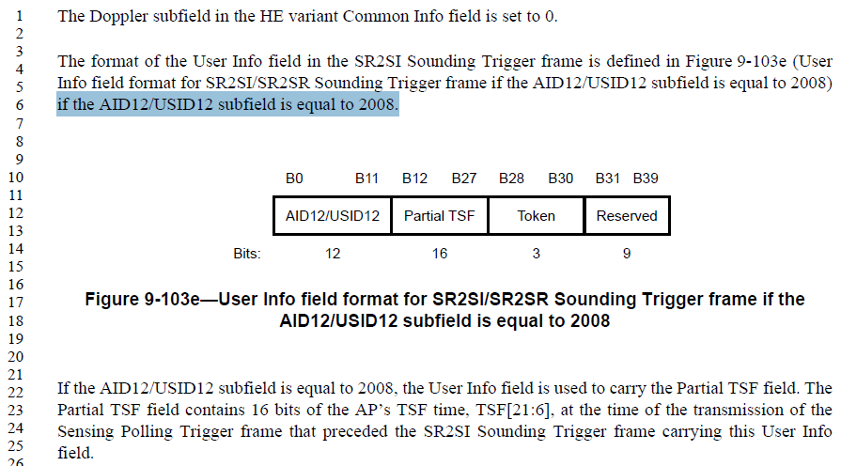
There exists a normative requirement in the current spec, it has been put in a rearward position.

Instructions to the editor: please make the following changes to the paragraph from P38L3 to P38L7 in the subclause 9.3.1.22 Trigger frame format in D4.0 as shown below:

The format of the User Info field in the SR2SI Sounding Trigger frame if the AID12/USID12 subfield is equal to 2008 is defined in Figure 9-103e (User Info field format for SR2SI/SR2SR Sounding Trigger frame if the AID12/USID12 subfield is equal to 2008).

CID | Clause | Page  Line | Comment | Proposed Change | Resolution
6008 | 9.3.1.22.15.3 | 37.20 | I think that there is a normative requirement in this sentence somewhere which is not correctly stated. Perhaps this is meant to say that WHEN the AID12/USID12 subfield is not equal to 2008 the User Info Field in the SR2SI Sounding Trigger frame shall be formatted as defined in Figure 9-103d..??? | change to: When the AID12/USID12 subfield is not equal to 2008 the User Info Field in the SR2SI Sounding Trigger frame shall be formatted as defined in Figure 9-103d (the AID12/USID12 subfield is not equal to 2008 the User Info Field in the SR2SI Sounding Trigger frame shall be formatted as defined in Figure 9-103d). | Revised  Agree with the commenter in principle.  TGbf Editor make changes specified in 1297r0. (https://mentor.ieee.org/802.11/dcn/24/11-24-1297-00-00bf- Initial-SA-Ballot-Comment-Resolutions-for- Exchange-CIDs.docx)

The location that the commenter indicates:
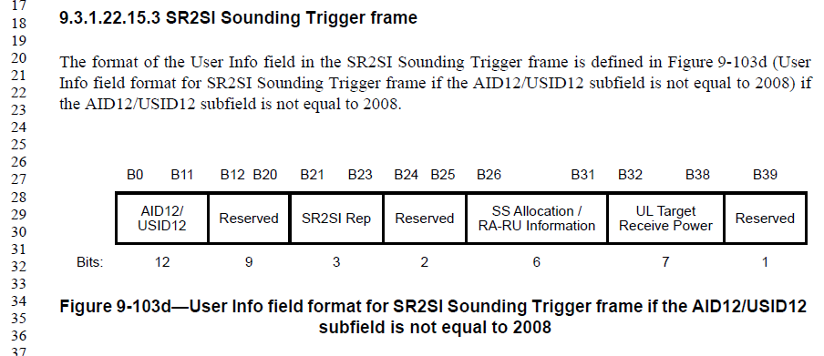

Instructions to the editor: please make the following changes to the paragraph from P37L20 to P37L23 in the subclause 9.3.1.22 Trigger frame format in D4.0 as shown below:

The format of the User Info field in the SR2SI Sounding Trigger frame if the AID12/USID12 subfield is not equal to 2008 is defined in Figure 9-103d (User Info field format for SR2SI Sounding Trigger frame if the AID12/USID12 subfield is not equal to 2008).

CID | Clause | Page  Line | Comment | Proposed Change | Resolution
6018 | 11.55.1.5.2.1 | 148.07 | Prohibiting data frame transmissions, especially by an AP, during the entire sensing availability window will negatively impact other services and performance at other STAs. Also, the sensing availability window may be longer than the time needed to complete the sensing activities. | Change to Within each sensing availability window, non-AP sensing initiator and sensing responder(s) should not transmit or trigger transmission of any Data frames until the completion of sensing activities related to polling, NDPA sounding, TF sounding, reporting, and SBP reporting for the current availability window. | Revised  TGbf Editor make changes specified in 1297r0. (https://mentor.ieee.org/802.11/dcn/24/11-24-1297-00-00bf- Initial-SA-Ballot-Comment-Resolutions-for- Exchange-CIDs.docx)

Discussion

Taken from 11bf
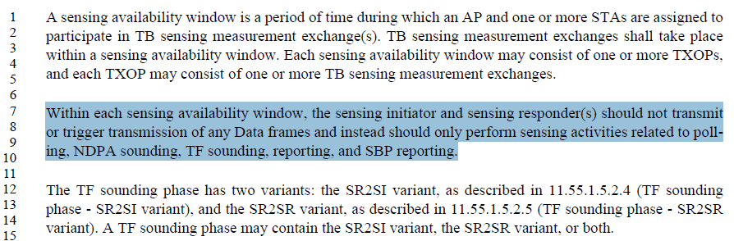
The indicated sentences use the word “should” which implies that data transmission is not prohibited within each sensing availability window. It is possible that the data transmission is allowed after the sensing activities are completed within that availability window.

The proposed change is to allow the data transmission behaviour explicitly, not implicitly.

Instructions to the editor: please make the following changes to the paragraph from P148L7 to P148L9 in the subclause 11.55.1.1 Overview in D4.0 as shown below:

Within each sensing availability window, the sensing initiator and sensing responder(s) should not transmit or trigger transmission of any Data frames until the completion of sensing activities related to polling, NDPA sounding, TF sounding, reporting, and SBP reporting for the current availability window.

CID | Clause | Page  Line | Comment | Proposed Change | Resolution
6169 | 11.55.1.5.2.5 | 156.44 | In "When transmitting an SR2SI Sounding Trigger frame" - "SR2SI" should be "SR2SR" in this subclause. | As in the comment | Accepted

Discussion:

Taken from 11bf
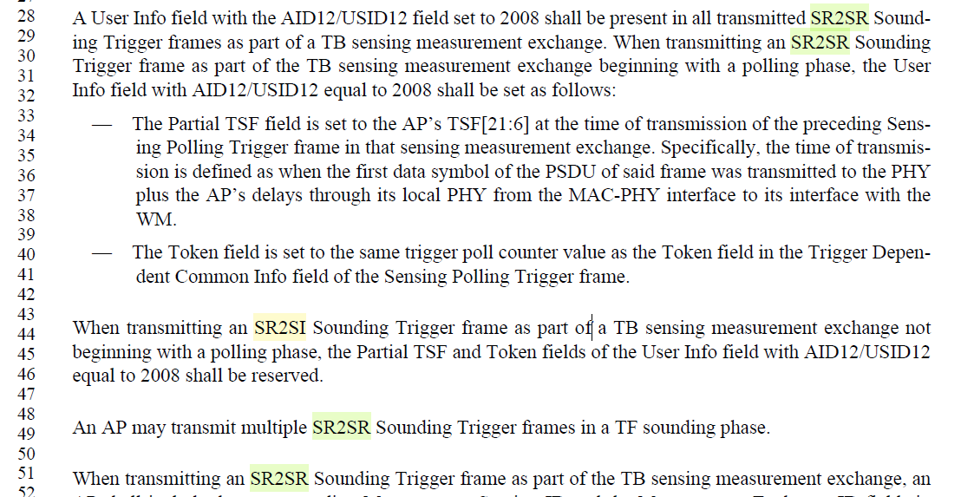

SP

Do you support the proposed resolutions to the CIDs and incorporate the text changes into the latest TGbf draft?

Y/N/A

