IEEE P802.11
Wireless LANs
Resolution for SA1 comments
Date: 2024-07-01
Author(s):
Name | Affiliation | Address | Phone | email
Chaoming Luo | OPPO |  |  | luochaoming@oppo.com
Abstract
This submission resolves miscellaneous comments. The following CIDs are resolved: 6023, 6029, 6035, 6036, 6037, 6196, 6197.

Revisions:

- Rev 0: Initial version of the document.

6023

CID | Commenter | Page | Comment | Proposed Change | Resolution
6023 | Henry Ptasinski | 114.35 | Per the meaning of REJECTED_WITH_SUGGESTED_CHANGES in table 9-80, this status code is only defined for use with TSPEC negotiations. | Define a new status code for use with sensing and use it throughout the 802.11bf draft instead of REJECTED_WITH_SUGGESTED_CHANGES. | Revised.  Agree with the commenter in principle.  TGbf editor to add a new status code REJECTED_WITH_SUGGESTED_SENSING_PARAMETERS into Table 9-80—Status codes, and make a global change to replace REJECTED_WITH_SUGGESTED_CHANGES with REJECTED_WITH_SUGGESTED_SENSING_PARAMETERS on draft D4.0.

Discussion

According to 11me D6.0, REJECTED_WITH_SUGGESTED_CHANGES is bound to TSPEC negotiation.
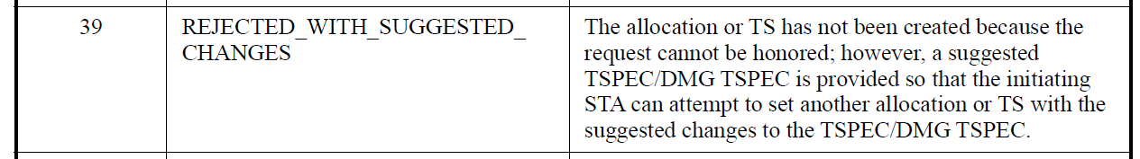
While other features have separate reject with suggested/recommended information status codes, it is better let sensing use a new status code REJECTED_WITH_SUGGESTED_SENSING_PARAMETERS.

Note that there is no such issue with REQUEST_DECLINED.

6029

CID | Commenter | Page | Comment | Proposed Change | Resolution
6029 | Henry Ptasinski | 138.22 | non-MLD non-AP EHT STA is undefined. 802.11be has a definition for non-MLD non-AP STA which can be either a non-EHT STA or an EHT STA operating in non-MLD non-AP mode. | Provide a definition for non-MLD non-AP EHT STA". | Revised  Agree with the commenter in principle. However, such a device should be HE STA.  TGbf editor to make the changes shown in https://mentor.ieee.org/802.11/dcn/24/11-24-1090-00-00bf-sa1-cr.docx under all headings that include CID 6029.

Discussion
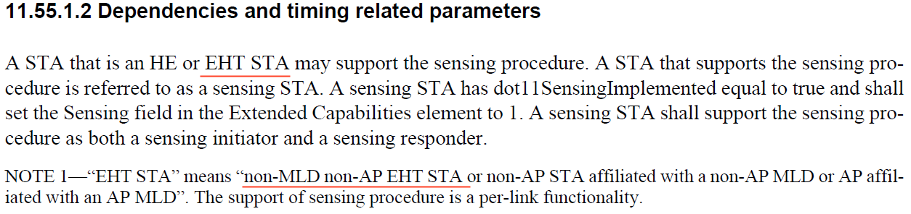

11be has defined “non-MLD non-AP STA”, which refers to pre-EHT non-AP STAs, i.e., non-AP HE STAs, non-AP VHT STAs, non-AP HT STAs, non-AP non-HT STAs.

The term “non-MLD non-AP EHT STA” was used to refer to an EHT STA operating in non-MLD non-AP mode (refer to 11be 4.5.3.2 Mobility types, MLO to non-MLO), however, such a STA should be called as a HE STA since it shall not use any EHT feature in such a mode.

Resolution

TGbf editor to change the paragraphs at P138L22 of draft D4.0 as follows:
11.55.1.2 Dependencies and timing related parameters
A STA that is an HE or EHT STA may support the sensing procedure. A STA that supports the sensing procedure is referred to as a sensing STA. A sensing STA has dot11SensingImplemented equal to true and shall set the Sensing field in the Extended Capabilities element to 1. A sensing STA shall support the sensing procedure as both a sensing initiator and a sensing responder.
NOTE 1—"EHT STA" means "non-MLD non-AP EHT STA or (#6029) non-AP STA affiliated with a non-AP MLD or AP affiliated with an AP MLD". The support of sensing procedure is a per-link functionality.

6035 & 6036 & 6037

CID | Commenter | Page | Comment | Proposed Change | Resolution
6035 | Henry Ptasinski | 136.11 | In the baseline, the phrase is established is used for the process of establishing the item in question (in this case the PMKSA). has been established is used for cases that depend on the result of a prior establishment procedure. The change from exists to is established makes the class 1a filtering only apply during the establishment process for the PTKSA and not afterwards. | Change is established to has been established | Accepted.
6036 | Henry Ptasinski | 136.14 | Text does not match baseline text in 802.11REVme_D5.0. | Update text to match 802.11REVme (and other amendments that precede 802.11bf). | Revised  Changes from 11REVme D6.0 and 11bh D4.0 is incorporated.  TGbf editor to make the changes shown in https://mentor.ieee.org/802.11/dcn/24/11-24-1090-00-00bf-sa1-cr.docx under all headings that include CID 6036.
6037 | Henry Ptasinski | 136.16 | Text from 802.11bh_D4.0 is missing. | Incorporate text from 802.11bh and renumber list items as appropriate. | Revised  Changes from 11REVme D6.0 and 11bh D4.0 is incorporated and list items renumbered.  TGbf editor to make the changes shown in https://mentor.ieee.org/802.11/dcn/24/11-24-1090-00-00bf-sa1-cr.docx under all headings that include CID 6037.

Discussion

There were changes on the same text in 11REVme D6.0, 11bh D4.0 and 11bf D4.0, incorporate them is better for reading.

11REVme D6.0:
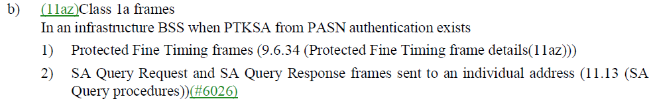

11bh D4.0:
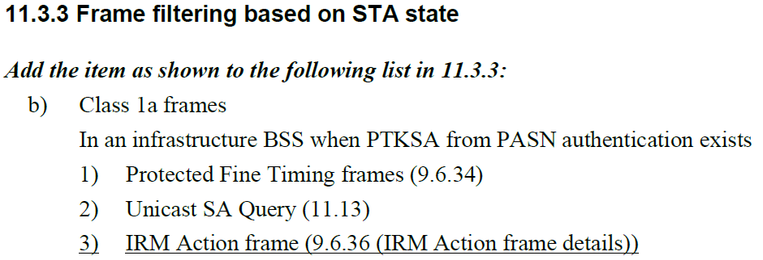

11bf D4.0:
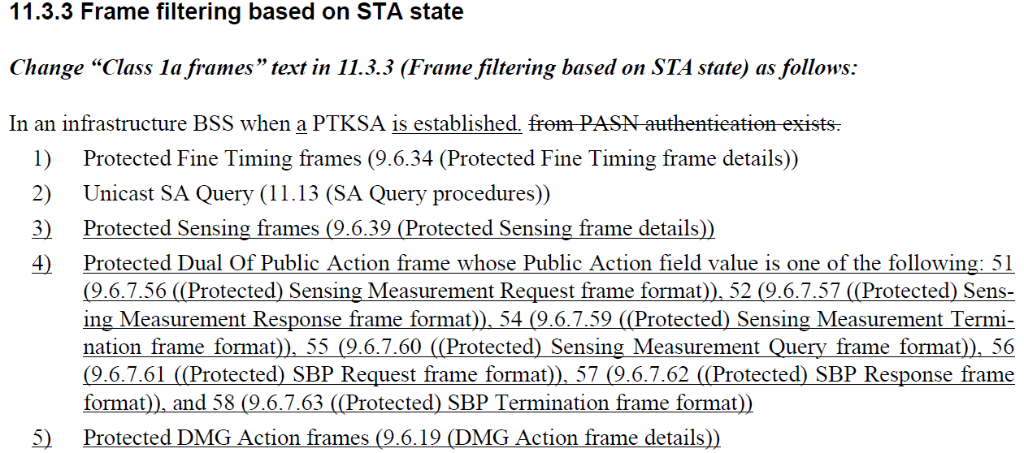

Resolution

TGbf editor to change the paragraphs at P136L11 of draft D4.0 as follows:

11.3 STA authentication and association
11.3.3 Frame filtering based on STA state

Change “Class 1a frames” text in 11.3.3 (Frame filtering based on STA state) as follows:

In an infrastructure BSS when a PTKSA is has been (#6035) established. from PASN authentication exists.
1) Protected Fine Timing frames (9.6.34 (Protected Fine Timing frame details))
2) SA Query Request and SA Query Response frames sent to an individual address (11.13 (SA
Query procedures))
3) IRM Action frame (9.6.36 (IRM Action frame details))
4) Protected Sensing frames (9.6.39 (Protected Sensing frame details))
5) Protected Dual Of Public Action frame whose Public Action field value is one of the following: 51 (9.6.7.56 ((Protected) Sensing Measurement Request frame format)), 52 (9.6.7.57 ((Protected) Sensing Measurement Response frame format)), 54 (9.6.7.59 ((Protected) Sensing Measurement Termination frame format)), 55 (9.6.7.60 ((Protected) Sensing Measurement Query frame format)), 56 (9.6.7.61 ((Protected) SBP Request frame format)), 57 (9.6.7.62 ((Protected) SBP Response frame format)), and 58 (9.6.7.63 ((Protected) SBP Termination frame format))
6) Protected DMG Action frames (9.6.19 (DMG Action frame details)) (#6036, #6037)

6196 & 6197

CID | Commenter | Page | Comment | Proposed Change | Resolution
6196 | R K Rannow | 204.48 | (see 9.6.39 (Protected Sensing frame details)) | (see 9.6.39 for frame details) | Rejected.  The clause name of 9.6.39 is Protected Sensing frame details, so no change is required.
6197 | R K Rannow | 204.62 | If management frame protection is negotiated, the receiver shall set the MFPC bit on a given link to 1, it shall maintain a single replay counter for received individually addressed robust Management frames (except Protected Fine Timing frames (see 9.6.34 (Protected Fine Timing frame details)) that are received with the To DS subfield equal to 0, and a single replay counter for received individually addressed robust  Appears to be a run-on sentence and may be ambiguous. | If management frame protection is negotiated, the receiver shall set the MFPC bit on a given link to 1. The receiver shall maintain a single replay counter for received individually addressed robust Management frames received with the To DS subfield equal to 0, and a single replay counter for received individually addressed robust. Note, exception for Protected Fine Timing frames. See 9.6.34, Protected Fine Timing frame details. | Rejected.  It’s not good to change the skeleton of the existing baseline text. It’s better to leave it to 11REVme if there does have ambiguous issue.

Reference
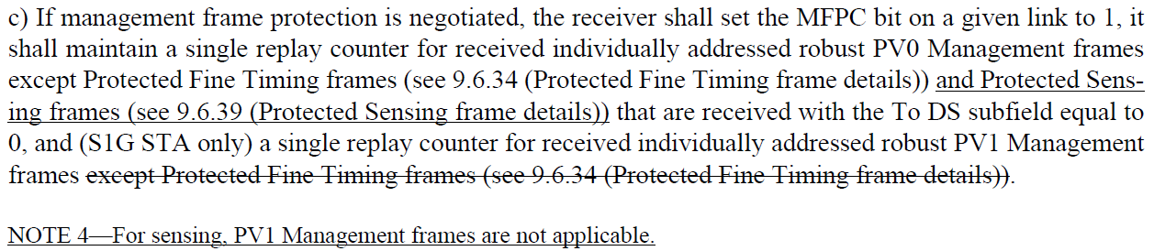

SP
Do you support resolutions to the following CIDs and incorporate the text changes into the latest TGbf draft: 6023, 6029, 6035, 6036, 6037, 6196, 6197, in 11-24/1090r0.

Y/N/A

