IEEE P802.11
Wireless LANs
Resolutions for Exchange CIDs for SA1 Ballot
Date: 2024-06-19
Author(s):
Name | Affiliation | Address | Phone | email
Cheng Chen | Intel |  |  | cheng.chen@intel.com
Abstract
This submission proposes resolutions to the following comments submitted in SA1 Ballot under Exchange topic. The CIDs are referring to D4.0. The text used as reference is D4.0.

CIDs: 6000 6001 6048 6181 6182 6191

Revision history:
R0: Original version
R1: Removed CIDs 6001, 6181, 6182

CID | Commenter | Page | Comment | Proposed change | Proposed resolution
6000 | Mahmoud Kamel | 155.40 | The note is written in normative language. | Either merge the text of the note into the previous paragraph or change the language of the note to "NOTEThe AP can be one of the sensing receivers and perform sensing measurement on the SR2SR NDP." | Revised. See proposed resolution in <DCN1052r1>.

Discussion: Agree with the commenter that this needs to be corrected.

TGbf editor, make the following change in the following paragraph (P155L40) in 11.55.1.5.2.5

NOTE—The AP may can be one of the sensing receivers and perform sensing measurement on the SR2SR NDP.

CID | Commenter | Page | Comment | Proposed change | Proposed resolution
6001 | Mahmoud Kamel | 155.16 | In the SR2SR variant of a TF sounding phase, there is one Transmitter and one or more Receivers as specified in "If supported, the AP shall transmit  an SR2SR Sounding Trigger frame to one non-AP STA that is a sensing transmitter and one or more non-AP STAs that are sensing receivers ... " . However, the sentence "In the SR2SR variant of a TF sounding phase, the AP solicits SR2SR NDP transmissions from one or more non-AP STAs, on which one or more non-AP STAs perform sensing measurements." indicates that the AP solicits SR2SR NDP transmissions from one or more non-AP STAs, which is not correct. | Change the sentence "In the SR2SR variant of a TF sounding phase, the AP solicits SR2SR NDP transmissions from one or more non-AP STAs, on which one or more non-AP STAs perform sensing measurements." to  "In the SR2SR variant of a TF sounding phase, the AP solicits one SR2SR NDP transmission from one non-AP STAs, on which one or more non-AP STAs perform sensing measurements." | Revised. Agree with the commenter’s proposed text with some minor editorial correction. See proposed resolution in <DCN1052r0>.

TGbf editor, make the following change in the following paragraph (P155L16) in 11.55.1.5.2.5
In the SR2SR variant of a TF sounding phase, the AP solicits SR2SR NDP transmissions from one or more non-AP STAs, on which one or more non-AP STAs perform sensing measurements.

CID | Commenter | Page | Comment | Proposed change | Proposed resolution
6048 | Mahmoud Kamel | 146.52 | This sentence states that "More than one sensing responder may participate in a TB sensing measurement exchange." However, in the definition of the TB sensing measurement exchange in P147L10 it is stated that " .. It is  applicable to sensing measurement sessions in which an AP is the sensing initiator and one or more non-AP STAs are the sensing responders.". So, we may have a sensing measurement exchange which includes only one responder. | Replace "More than one sensing responder may participate in a TB sensing measurement exchange." with "One or more sensing responders may participate in a TB sensing measurement exchange." | Accepted.

CID | Commenter | Page | Comment | Proposed change | Proposed resolution
6181 | Stephen Sand | 34.45 | The text reads "then the assigned STAs transmit power is HE-MCS 6 for an HE TB PPDU or EHTMCS 6 for an EHT TB PPDU." In 11be D5.1 it reads "the assigned HE-MCS is assumed to be HE-MCS 6 in terms of setting the STAs transmit power." | Please change the main clause of the sentences as follows:  then the assigned STAs transmit power is that used for HE-MCS 6 for an HE TB PPDU or that used for EHT-MCS 6 for an EHT TB PPDU. | Revised. The text needs to be consistent between 11be and 11bf draft. See proposed resolution in <DCN1052r0>.
6182 | Stephen Sand | 34.38 | The text reads "then the assigned STAs transmit power is HE-MCS 0". In 11be D5.1 it reads "then the assigned STAs transmit power is HE-MCS 0". | Please change the main clause of the sentences as follows:  then the assigned STAs transmit power is that used for HE-MCS 0 for an HE TB PPDU or that used for EHT-MCS  0 for an EHT TB PPDU. | Revised. The text needs to be consistent between 11be and 11bf draft. See proposed resolution in <DCN1052r0>.

Discussion: Currently, the corresponding text in 11be D6.0 and 11bf D4.0 are as follows:
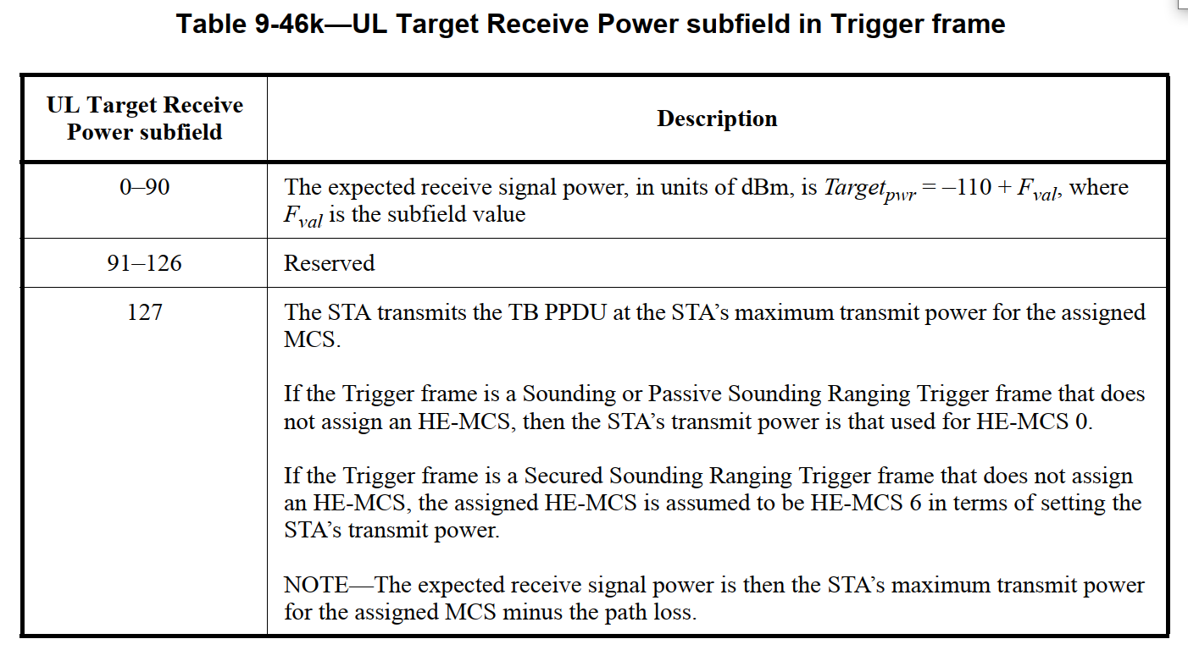

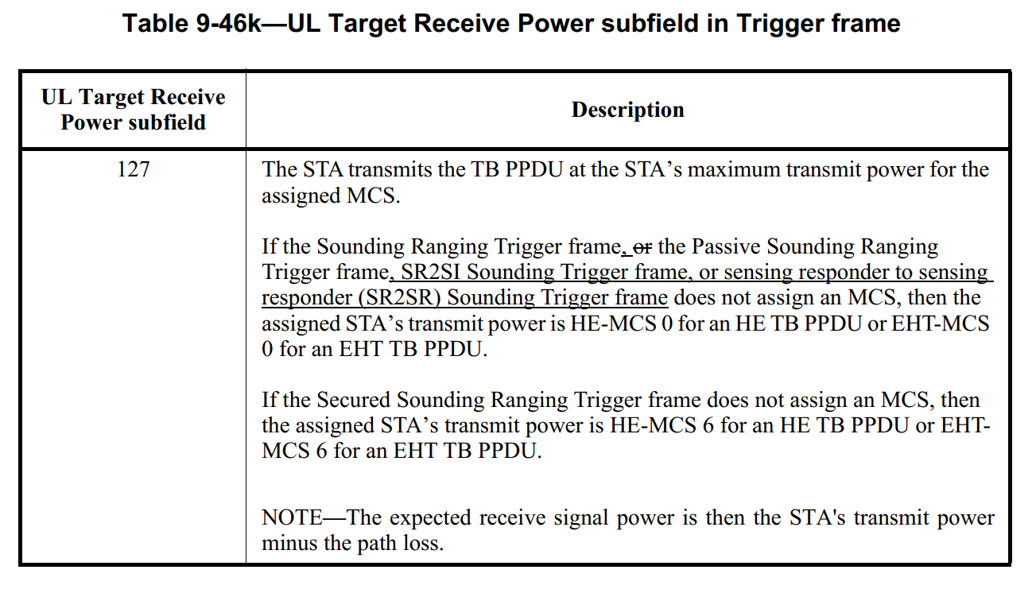
TGbf editor, make the following change in the Description Column of Table 9-46k (P34) in 9.3.1.22.1

The STA transmits the TB PPDU at the STA’s maximum transmit power for the assigned MCS.

If the Sounding Ranging Trigger frame, or the Passive Sounding Ranging Trigger frame, SR2SI Sounding Trigger frame, or sensing responder to sensing responder (SR2SR) Sounding Trigger frame does not assign an MCS, then the assigned STA’s transmit power is that used for HE-MCS 0 for an HE TB PPDU or that used for EHT-MCS 0 for an EHT TB PPDU.

If the Trigger frame is a Secured Sounding Ranging Trigger frame that does not assign an MCS, then in terms of setting the STA’s transmit power, the assigned STA’s transmit power is HE-MCS is assumed to be HE-MCS 6 for an HE TB PPDU, and the assigned EHT-MCS is assumed to be or EHT-MCS 6 for an EHT TB PPDU.

NOTE—The expected receive signal power is then the STA's transmit power minus the path loss.

CID | Commenter | Page | Comment | Proposed change | Proposed resolution
6191 | R K Rannow | 159.30 | The adjective "both" appears to be rhetorical and ambiguous | Review the use this adjective through-out the document. | Revised. See proposed change in <DCN1052r1>.

Discussion:

The word “both” here is used to identify a valid role of the non-AP STA acting as a sensing initiator. That is, the non-AP STA can participate in a non-TB sensing measurement exchange as both a sensing transmitter and a receiver. This is consistent with the normative text in Section 11.55.1.1 P137L42, where it says:
- A sensing initiator may participate in a sensing measurement exchange as a sensing transmitter, as a sensing receiver, as both a sensing transmitter and a sensing receiver, or as neither a sensing transmitter nor a sensing receiver. A sensing responder may participate in a sensing measurement exchange as a sensing transmitter, as a sensing receiver, or as both a sensing transmitter and a sensing receiver.

Therefore, the contributor proposes to add a reference to 11.55.1.1 in this sentence, so that readers can refer to section 11.55.1.1 to understand this is talking about possible roles the non-AP STA can take in a non-TB sensing measurement exchange.

TGbf editor, make the following change in P159L30 in 11.55.1.5.3.1

A non-TB sensing measurement exchange is the non-trigger-based variant of a sensing measurement exchange. It is applicable to sensing measurement sessions in which a non-AP STA is the sensing initiator, and an AP is the sensing responder. A non-AP STA acting as a sensing initiator shall participate in a non-TB sensing measurement exchange as a sensing transmitter, a sensing receiver, or both a sensing transmitter and a sensing receiver (see 11.55.1.1 (Overview)). Whenever the WM is available, the non-AP STA may initiate a non-TB sensing measurement exchange. The AP may limit the frequency with which the non-AP STA may initiate a non-TB sensing measurement exchange by conveying a minimum time interval between two consecutive non-TB sensing measurement exchanges in the Min Measurement Interval field in the Sensing field during the sensing capabilities exchange.

SP

Do you support the proposed resolutions to the CIDs and incorporate the text changes into the latest TGbf draft?

Y/N/A

