IEEE P802.11
Wireless LANs
Initial SA ballot comments – Individual comments
Date: 2024-06-19
Author(s):
Name | Affiliation | Address | Phone | email
Narengerile | Huawei | Shenzhen, China |  | narengerile@huawei.com
Rui Du
Mengshi Hu
Zhuqing Tang
Yiyan Zhang

Abstract
This document proposes the resolutions to the following “Individual” CIDs:
6010, 6068, 6114, 6117, 6118, 6122, 6123, 6130, 6131, 6135, 6137, 6138, 6139, 6149, 6153, 6155 (16 in total)

R0: initial version on June 19, 2024.

6010
CID | Clause | Page | Comment | Proposed change | Proposed resolution
6010 | 6.5.24d | 24.21 | "the set of MLME primitives in this subclause does not assume one of the general forms of MLME-SAP interface primitives defined in 6.3 (MLME SAP interface)." it seems a bit odd to describe what the set of primitives is not. It seems more useful to state what it is. Clearly this is not an exhaustive list of what this set of MLME primitives is not. | Delete sentence. | Revised.  Agree with the commenter in principle.  Please refer to the modifications labelled with #6010 in DCN 24/1046r0: https://mentor.ieee.org/802.11/dcn/24/11-24-1046-00-00bf-initial-sa-ballot-comments-individual-comments.docx
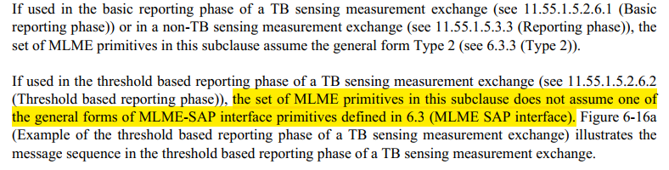
Modifications (#6010):
If used in the threshold based reporting phase of a TB sensing measurement exchange (see 11.55.1.5.2.6.2 (Threshold based reporting phase)), the use of the set of MLME primitives is illustrated in Figure 6-16a (Example of the threshold based reporting phase of a TB sensing measurement exchange). (#6010)

6068
CID | Clause | Page | Comment | Proposed change | Proposed resolution
6068 | 6.5.24d.4.4 | 26.63 | A "CSI variation feedback value" is not defined within this draft or 802.11REVme. | "CSI variation feedback value" needs to be introduced within this clause, or a forward reference should be added. In addition change "the CSI" to "a CSI". | Revised.  Agree with the commenter. Please refer to the modifications labelled with #6068 in DCN 24/1046r0: https://mentor.ieee.org/802.11/dcn/24/11-24-1046-00-00bf-initial-sa-ballot-comments-individual-comments.docx
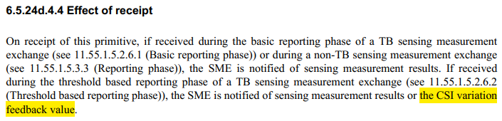
Discussions:
CSI variation feedback value is contained in the SensingMeasurementReportContainer parameter delivered in the MLME-SENSREPORTRQ.indication primitive. CSI variation feedback value can be introduced in the Description of the SensingMeasurementReportContainer parameter.

During LB276, Motion 430 had approved the spec change proposed in DCN 23/1648r1, which was not a resolution to a specific comment, but a ‘bug-fix’ contribution. The bug was discovered during offline discussions: the parameters contained in the MLME-SENSREPORTRQ.indication primitive should be swapped with the parameters contained in the MLME-SENSREPORTRQ.confirm primitive. But this change was not included in the latest version of the draft…

The following modifcation is made based on the spec change in DCN 23/1648r1 that should have been adopted.
To TGbf editor: Please modify 6.5.24d.3.2 and 6.5.24d.4.2 according to DCN 23/1648r1.

Modifications (#6068):
To TGbf editor: Please modify 6.5.24d.4.2 on P26 as follows.
6.5.24d.4 MLME-SENSREPORTRQ.indication
6.5.24d.4.1 Function
This primitive indicates that a Sensing Measurement Report frame has been received.
6.5.24d.4.2 Semantics of the service primitive
The primitive parameters are as follows:
MLME-SENSREPORTRQ.indication(
PeerSTAAddress,
SensingMeasurementReportContainer
)
Name | Type | Valid range | Description
PeerSTAAddress | MAC address | Any valid individual MAC address | Specifies the MAC address of the sensing responder from which the Sensing Measurement Report frame is sent.
SensingMeasurementReportContainer | As defined in 9.4.1.73 (Sensing Measurement  Report Container field). | As defined in 9.4.1.73 (Sensing Measurement Report Container field). | Provides sensing measurement results or a CSI variation feedback value obtained from a sensing measurement exchange, as defined in 9.4.1.73 (Sensing Measurement Report Container field). (#6068)

6114, 6117, 6118, 6122, 6123, 6130, 6131, 6135, 6137, 6138, 6139, 6149, 6153, 6155
CID | Clause | Page | Comment | Proposed change | Proposed resolution
6114 | 11.55.4.4 | 203.2 | It should be the MLME of the SBP initiator or the SBP responder that issues the primitive. [ng] | Please add "MLME of" before "the SBP initiator or the SBP responder". | Accepted.
6117 | 11.55.4.2 | 200.01 | It should be the MLME of the SBP initiator that issues the primitive. [ng] | Please add "MLME of the" before "SBP initiator". | Accepted.
6118 | 11.55.4.2 | 199.42 | It should be the MLME of the SBP responder that issues the primitive. [ng] | Please add "MLME of the" before "SBP responder". | Accepted.
6122 | 11.55.3.8 | 197.09 | It should be the MLME of the DMG STA that issues the primitive. [ng] | Please add "MLME of the" before "DMG STA". | Accepted.
6123 | 11.55.3.8 | 197.05 | It should be the MLME of the DMG STA that issues the primitive. [ng] | Please add "MLME of the" before "DMG STA". | Accepted.
6130 | 11.55.3.6.5.3 | 195.05 | It should be the MLME of the sensing initiator that issues the primitive. [ng] | Please add "MLME of the" before "sensing initiator". | Accepted.
6131 | 11.55.3.6.5.2 | 194.49 | It should be the MLME of the sensing responder that issues the primitive. [ng] | Please add "MLME of the" before "sensing responder". | Accepted.
6135 | 11.55.3.6.3 | 192.61 | It should be the MLME of the sensing initiator that issues the primitive. [ng] | Please add "MLME of the" before "sensing initiator". | Accepted.
6137 | 11.55.3.6.3 | 192.44 | It should be the MLME of the sensing initiator that issues the primitive. [ng] | Please add "MLME of the" before "sensing initiator". | Accepted.
6138 | 11.55.3.6.3 | 192.38 | It should be the SME of the sensing responder that issues the primitive. [ng] | Please add "SME of the" before "sensing responder". | Accepted.
6139 | 11.55.3.6.3 | 192.37 | It should be the MLME of the sensing responder that issues the primitive. [ng] | Please add "MLME of the" before "sensing responder". | Accepted.
6149 | 11.55.3.6.1 | 184.14 | It should be the SME of the sensing initiator that initiates a DMG sensing measurement exchange, not just SME. [ng] | Please add "of the sensing initiator" after "SME". | Accepted.
6153 | 11.55.3.4 | 181.47 | It should be the MLME of the sensing initiator that issues the primitive. [ng] | Please add "MLME of the" before "sensing initiator". | Accepted.
6155 | 11.55.3.4 | 180.56 | It should be the MLME of the sensing responder that issues the primitive. [ng] | Please add "MLME of the" before "sensing responder". | Accepted.

SP:
Do you agree to the resolutions provided for CIDs 6010, 6068, 6114, 6117, 6118, 6122, 6123, 6130, 6131, 6135, 6137, 6138, 6139, 6149, 6153, 6155 in 24/1046r0 to be included in the latest 11bf Draft?

Y/N/A

