IEEE P802.11
Wireless LANs
D6.0 Miscellaneous CIDs
Date: 2024-06-26
Author(s):
Name | Affiliation | Address | Phone | email
Youhan Kim | Qualcomm Technologies, Inc. |  |  | youhank@qti.qualcomm.com

Abstract
This submission proposes resolutions for the following comments from SB2 on P802.11be D6.0:

23099, 23121, 23122, 23126, 23129, 23130, 23131, 23132, 23137, 23138

NOTE – Set the Track Changes Viewing Option in the MS Word to “All Markup” to clearly see the proposed text edits.

Revision History:

R0: Initial version.
R1: Editorial update made during the TGbe PHY teleconference call on June 26, 2024.

CID 23099

CID  Clause  Page.Line | Comment | Proposed Change
23099  36.3.25  935.35 | Pesky "may" for something outside the scope if this standard (regulations). This is a statement of fact. | Change sentence to : "Regulations are subject to change."

Background
11be D6.0 P935
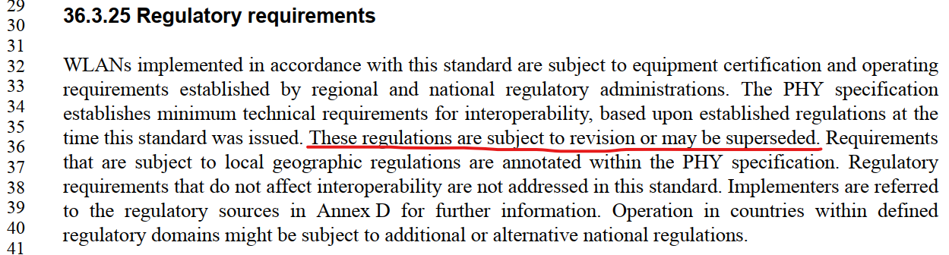

Proposed Resolution: CID 23099
REVISED

Instruction to TGbe Editor:
Implement the proposed text updates for CID 23099 in https://mentor.ieee.org/802.11/dcn/22/11-24-1042-01-00be-d6-0-miscellaneous-cids.docx

Note to commenter:
“may be superseded” has been removed as suggested by the commenter.

Proposed Text Updates: CIDs 23099
Instruction to TGbe Editor: Add the following at 11be D6.0 P935L35:
36.3.25 Regulatory requirements

WLANs implemented in accordance with this standard are subject to equipment certification and operating requirements established by regional and national regulatory administrations. The PHY specification establishes minimum technical requirements for interoperability, based upon established regulations at the time this standard was issued. These regulations are subject to change. Requirements that are subject to local geographic regulations are annotated within the PHY specification. Regulatory requirements that do not affect interoperability are not addressed in this standard. Implementers are referred to the regulatory sources in Annex D for further information. Operation in countries within defined regulatory domains might be subject to additional or alternative national regulations.

CID 23130

CID  Clause  Page.Line | Comment | Proposed Change
23130  3.2  62.25 | Definitions should not include references to other parts of the standard. An informative note may be provided to refer the user to another part of the standard. " (IEEE standards style manual, clause 12). [reference to clause 35.3.7.2]. In this case "clause 36" is not needed nor helpful as EHT is well established already. | remove "Clause 36 (Extremely high throughput (EHT) PHY specification) " replace with "EHT".

Discussion
The comment is on 11be D6.0 P62:
The commenter is referring to the IEEE SA Standards Style Manual (https://mentor.ieee.org/myproject/Public/mytools/draft/styleman.pdf), where in section 12.4.3 (Construction of the definitions clause) states:
Definitions should not include references to other parts of the standard. An informative note may be provided to refer the user to another part of the standard.
Note that the IEEE SA Standards Style Manual says that definitions “should” not include references, as opposed to “shall” not include references.
Moreover, IEEE 802.11 also has its own 802.11 Style Guide (https://mentor.ieee.org/802.11/dcn/09/11-09-1034-21-0000-802-11-editorial-style-guide.docx). In it, section 1.2 states:

1.2 WG802.11 style vs IEEE-SA style

What right do we have to define an 802.11 Style? Surely the IEEE-SA Style guide is all we need?
There are many elements of convention that are not addressed in the IEEE-SA Style guide where we benefit from consistency in 802.11.
There are also elements of style in 802.11 that fail to comply with the IEEE-SA Style guide. The fact that this material has been through IEEE-SA publication editing and approved multiple times shows that slavish consistency to the IEEE-SA Style Guide is not a requirement of the IEEE-SA standards development process.
…
Note that there are five instances in Clause 3.2 of P802.11REVme D6.0 where reference to other parts of the standard is made.
Hence, given that we are not violating the 802.11 Style Guide and is following the precedence in the REVme, it is not necessary to remove references to other part of the standard from clause 3.2.

Proposed Resolution: CID 23130
REJECTED
The 802.11 Style Guide (https://mentor.ieee.org/802.11/dcn/09/11-09-1034-21-0000-802-11-editorial-style-guide.docx) does not disallow including references to other parts of the standard in Clause 3. See also section 1.2 of the 802.11 Style Guide on the relationship between the IEEE SA Style Guide and the 802.11 Style Guide.
This is the earlier section of the amendment (Clause 3), and EHT clause comes much later (Clause 36). And countless locations in the amendment prior to Clause 36 uses the term “EHT PPDU”, hence it is appropriate to define the term “EHT PPDU” here, referring to Clause 36. Also, adopting the proposed change by the commenter results in the definition being “EHT PPDU: An EHT PPDU” which is not a valid definition.

CID 23121

CID  Clause  Page.Line | Comment | Proposed Change
23121  3.2  61.1 | All the definition of various PPDUs do not belong in clause 3. All contain technical details of the particular PPDU that are normative specification and thus belong in an appropriate normative clause. | Delete everything with "PPDU' in the term or description from clause 3.2

Background
11be D6.0 P61
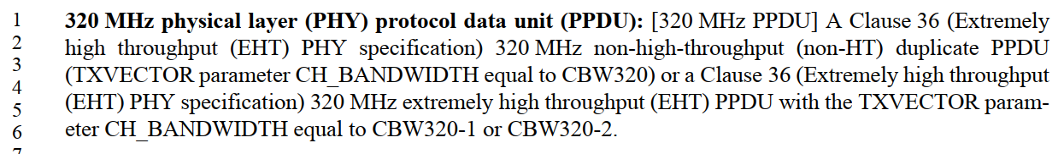

Proposed Resolution: CID 23121
REJECTED
The 802.11 Style Guide (https://mentor.ieee.org/802.11/dcn/09/11-09-1034-21-0000-802-11-editorial-style-guide.docx) does not disallow technical details to be included in Clause 3. See also section 1.2 of the 802.11 Style Guide on the relationship between the IEEE SA Style Guide and the 802.11 Style Guide.
As for the term “320 MHz PPDU” cited by the commenter as an example, the term is used 46 times throughout the 11be draft. The term “320 MHz PPDU” without a proper definition lacks clarity on what it means, and it is not practical to define the term at each of the places where it is used. Hence, it is appropriate to define the term in Clause 3.

CID 23122

CID  Clause  Page.Line | Comment | Proposed Change
23122  3.2  63.44 | More technical details that do not belong in clause 3. This should be in the normative description of the specific PPDU. | Replace with "An EHT PPDU that is transmitted using a single resource unit (RU) or a single multiple resource unit (MRU) ".

Background
11be D6.0 P63
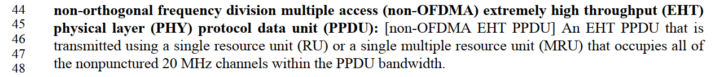

Proposed Resolution: CID 23122
REJECTED
The 802.11 Style Guide (https://mentor.ieee.org/802.11/dcn/09/11-09-1034-21-0000-802-11-editorial-style-guide.docx) does not disallow technical details to be included in Clause 3. See also section 1.2 of the 802.11 Style Guide on the relationship between the IEEE SA Style Guide and the 802.11 Style Guide.
Furthermore, the new definition suggested by the commenter allows, for example, a 20 MHz EHT DL OFDMA with a single 106-tones RU allocated to be classified as a “non-OFDMA EHT PPDU”. That is technically different from the current definition and is not correct.

CID 23126

CID  Clause  Page.Line | Comment | Proposed Change
23126  3.2  63.15 | Technical characteristics of MRU that do not belong in clause 3. RU is defined in the base standard. If this is intended to restrict an MRU to a group of a subset of possible RUs then this definitely DOES NOT belong here (it belongs in a normative clause). | Replace with "A group of subcarriers that consists of multiple RUs".

Background
11be D6.0 P63

Proposed Resolution: CID 23126
REJECTED
The 802.11 Style Guide (https://mentor.ieee.org/802.11/dcn/09/11-09-1034-21-0000-802-11-editorial-style-guide.docx) does not disallow technical characteristics to be included in Clause 3. See also section 1.2 of the 802.11 Style Guide on the relationship between the IEEE SA Style Guide and the 802.11 Style Guide.
The current definition in D6.0 has no error and is more accurate than the alternative suggested by the commenter.

CID 23129

CID  Clause  Page.Line | Comment | Proposed Change
23129  3.2  62.36 | "This PPDU carries a single physical layer service data unit (PSDU)." is a technical detail of the thing to which the term refers, and is incorrect in the definition of the term in clause 3. | Remove "This PPDU carries a single physical layer service data unit (PSDU)."

Background
11be D6.0 P62

Proposed Resolution: CID 23129
REJECTED
The 802.11 Style Guide (https://mentor.ieee.org/802.11/dcn/09/11-09-1034-21-0000-802-11-editorial-style-guide.docx) does not disallow technical details to be included in Clause 3. See also section 1.2 of the 802.11 Style Guide on the relationship between the IEEE SA Style Guide and the 802.11 Style Guide.
The statement that an EHT TB PPDU carries a single PSDU is a correct statement and does not need to be removed.

CID 23131

CID  Clause  Page.Line | Comment | Proposed Change
23131  3.2  62.28 | Definitions should not include references to other parts of the standard. An informative note may be provided to refer the user to another part of the standard. " (IEEE standards style manual, clause 12). [reference to clause 35.3.7.2] | Remove definition, or include xref in an informative note.

Background
11be D6.0 P62
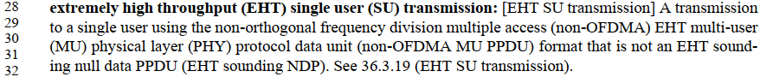

Proposed Resolution: CID 23131
REJECTED
The 802.11 Style Guide (https://mentor.ieee.org/802.11/dcn/09/11-09-1034-21-0000-802-11-editorial-style-guide.docx) does not disallow including references to other parts of the standard in Clause 3. See also section 1.2 of the 802.11 Style Guide on the relationship between the IEEE SA Style Guide and the 802.11 Style Guide.

CID 23132

CID  Clause  Page.Line | Comment | Proposed Change
23132  3.2  62.14 | Technical details that do not belong in the definitions clause. TMI. | Replace with:  extremely high throughput (EHT) modulation and coding scheme (MCS): [EHT-MCS] A combination of EHT physical layer (PHY) parameters that consists of modulation order and forward error correction (FEC) coding rate.

Background
11be D6.0 P62
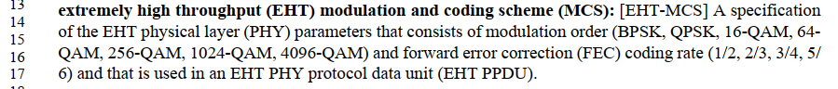

Proposed Resolution: CID 23132
REJECTED
The 802.11 Style Guide (https://mentor.ieee.org/802.11/dcn/09/11-09-1034-21-0000-802-11-editorial-style-guide.docx) does not disallow including technical details in Clause 3. See also section 1.2 of the 802.11 Style Guide on the relationship between the IEEE SA Style Guide and the 802.11 Style Guide.
The lists modulation order and coding rates are accurate, and thus do not need to be removed.

CID 23137

CID  Clause  Page.Line | Comment | Proposed Change
23137  3.2  61.1 | Definitions should not include references to other parts of the standard. An informative note may be provided to refer the user to another part of the standard. " (IEEE standards style manual, clause 12). [reference to clause 36] | Remove definition.

Background
11be D6.0 P61
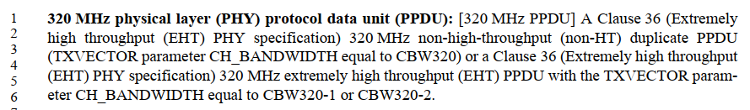

Proposed Resolution: CID 23137
REJECTED
The 802.11 Style Guide (https://mentor.ieee.org/802.11/dcn/09/11-09-1034-21-0000-802-11-editorial-style-guide.docx) does not disallow including references to other parts of the standard in Clause 3. See also section 1.2 of the 802.11 Style Guide on the relationship between the IEEE SA Style Guide and the 802.11 Style Guide.
As for the term “320 MHz PPDU” cited by the commenter as an example, the term is used 46 times throughout the 11be draft. The term “320 MHz PPDU” without a proper definition lacks clarity on what it means, and it is not practical to define the term at each of the places where it is used. Hence, it is appropriate to define the term in Clause 3.

CID 23138

CID  Clause  Page.Line | Comment | Proposed Change
23138  3.2  60.55 | Inappropriate information in a definition (clause 3): ". Definitions  should not include references to other parts of the standard. An informative note may be provided to refer  the user to another part of the standard. " (IEEE standards style manual, clause 12). | Remove all the new definitions from clause 3 or follow the style manual and provide references via informative notes if absolutely needed (which is seldom the case).

Background
11be D6.0 P60
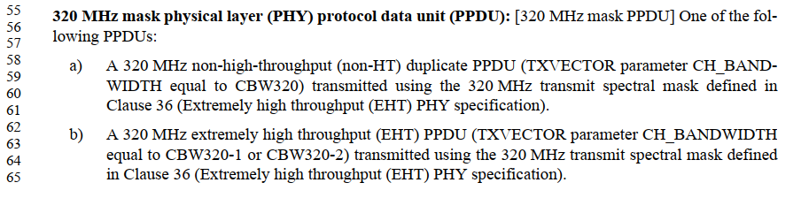

Proposed Resolution: CID 23138
REJECTED
The 802.11 Style Guide (https://mentor.ieee.org/802.11/dcn/09/11-09-1034-21-0000-802-11-editorial-style-guide.docx) does not disallow including references to other parts of the standard in Clause 3. See also section 1.2 of the 802.11 Style Guide on the relationship between the IEEE SA Style Guide and the 802.11 Style Guide.

[End of File]

