IEEE P802.11
Wireless LANs
CID 23095
Date: 2024-06-17
Author(s):
Name | Affiliation | Address | Phone | email
Sigurd Schelstraete | MaxLinear |  |  | sschelstraete@maxlinear.com
This submission proposes a resolution to SA Ballot comment CID 23095.

Introduction

CID | Clause | Page | Comment | Proposed Change | Resolution
23095 | B.4.40 | 967.09 | Remove the entry EHTP5.2.9. The entry EHTP5.2.9 should not be listed in the table. 996+484+242 tone RU is not allowed in OFDMA. It is only for SU MRU support. | Remove the entry of EHTP5.2.9. | Revised.  Accept in principle. Make further editorial changes to correct numbering after removal of entry EHTP5.2.9, as shown in doc.: IEEE 802.11-24/1035r1

Discussion

PICS entries EHTP5.2.7 to EHTP5.2.12 list the MRU sizes for OFDMA. See D6.0, page 966, line 59:

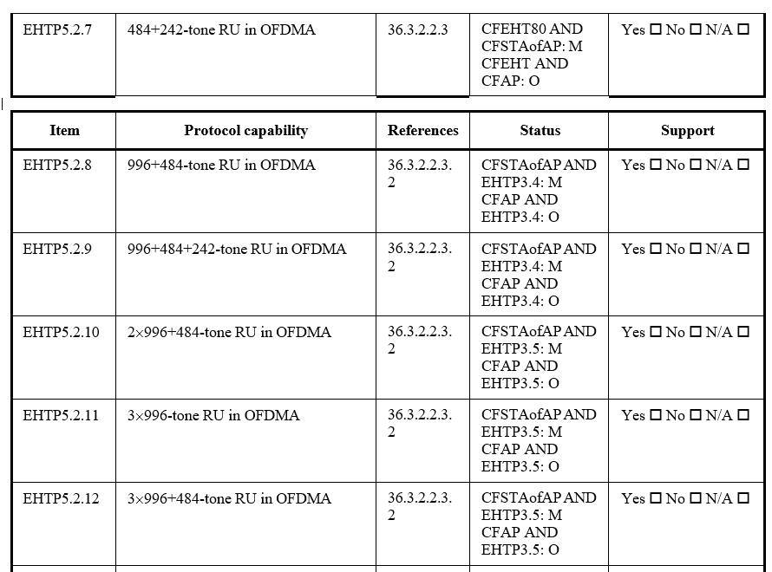

The commenter points out that the 996+484+242 tone RU is not one of the RU sizes allowed for OFDMA.

As stated in clause 36.3.2.2.3.2, this is correct. See D6.0, page 742, line 46:

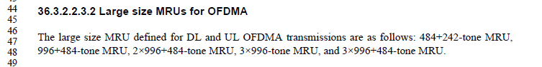

As such, entry EHTP5.2.9 should be removed to make the Table in B4.40.1 (EHT PHY features) consistent with the main body of the amendment – as proposed by the commenter.

Proposed Changes

Instructions to the Editor:
- Make the changes shown below in the Table in B4.40.1:

EHTP5.2.7 | 484+242-tone RU in OFDMA | 36.3.2.2.3 | CFEHT80 AND CFSTAofAP: M CFEHT AND CFAP: O | Yes □ No □ N/A □

Item | Protocol capability | References | Status | Support
EHTP5.2.8 | 996+484-tone RU in OFDMA | 36.3.2.2.3.  2 | CFSTAofAP AND EHTP3.4: M CFAP AND EHTP3.4: O | Yes □ No □ N/A □
EHTP5.2.9 | 996+484+242-tone RU in OFDMA | 36.3.2.2.3.  2 | CFSTAofAP AND EHTP3.4: M CFAP AND EHTP3.4: O | Yes □ No □ N/A □
EHTP5.2.910 | 2×996+484-tone RU in OFDMA | 36.3.2.2.3.  2 | CFSTAofAP AND EHTP3.5: M CFAP AND EHTP3.5: O | Yes □ No □ N/A □
EHTP5.2.1011 | 3×996-tone RU in OFDMA | 36.3.2.2.3.  2 | CFSTAofAP AND EHTP3.5: M CFAP AND EHTP3.5: O | Yes □ No □ N/A □
EHTP5.2.1112 | 3×996+484-tone RU in OFDMA | 36.3.2.2.3.  2 | CFSTAofAP AND EHTP3.5: M CFAP AND EHTP3.5: O | Yes □ No □ N/A □

In addition, add the following note after the first paragraph of 36.3.2.2.3.2:

“NOTE - 996+484+242-tone MRU is not used in DL and UL OFDMA transmissions.”

