IEEE P802.11
Wireless LANs
Correction to TGbe Fig 7-2
Date: 2024-06-28
Author(s):
Name | Affiliation | Address | Phone | email
Mark Hamilton | Ruckus/CommScope | 350 W Java Dr.  Sunnyvale, CA 94089 | +1-303-818-8472 | mark.hamilton2152@gmail.com
Abstract
This contribution proposed a resolution to CID 23074 on P802.11be D6.0.

Background:

This document proposes a resolution to the following comment on P802.11be D6.0:

CID | Commenter | Subclause | Page | Line | Comment | Proposed Change
23074 | Michael Montemurro | 7.1 | 113 | 12 | [AK] A5:F22In Figure 7-2 (Example DS access fir an AP MLD with two affiliated APs), the upper MAC sublayer of the AP MLD is erroneously designated as "Non-MLD upper MAC sublayer".  Please correct the designation as suggested | The upper MAC sublayer of the AP MLD shall be designated as "MLD upper MAC sublayer"

Context:

Figure 7-2 in 802.11be D6.0:

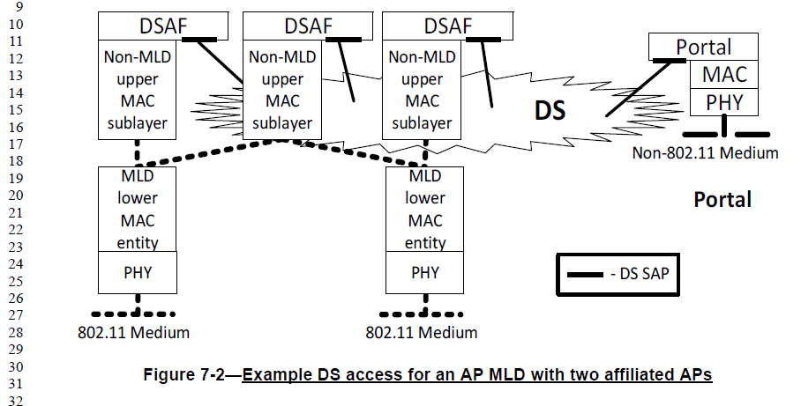

The corrected figure would be:

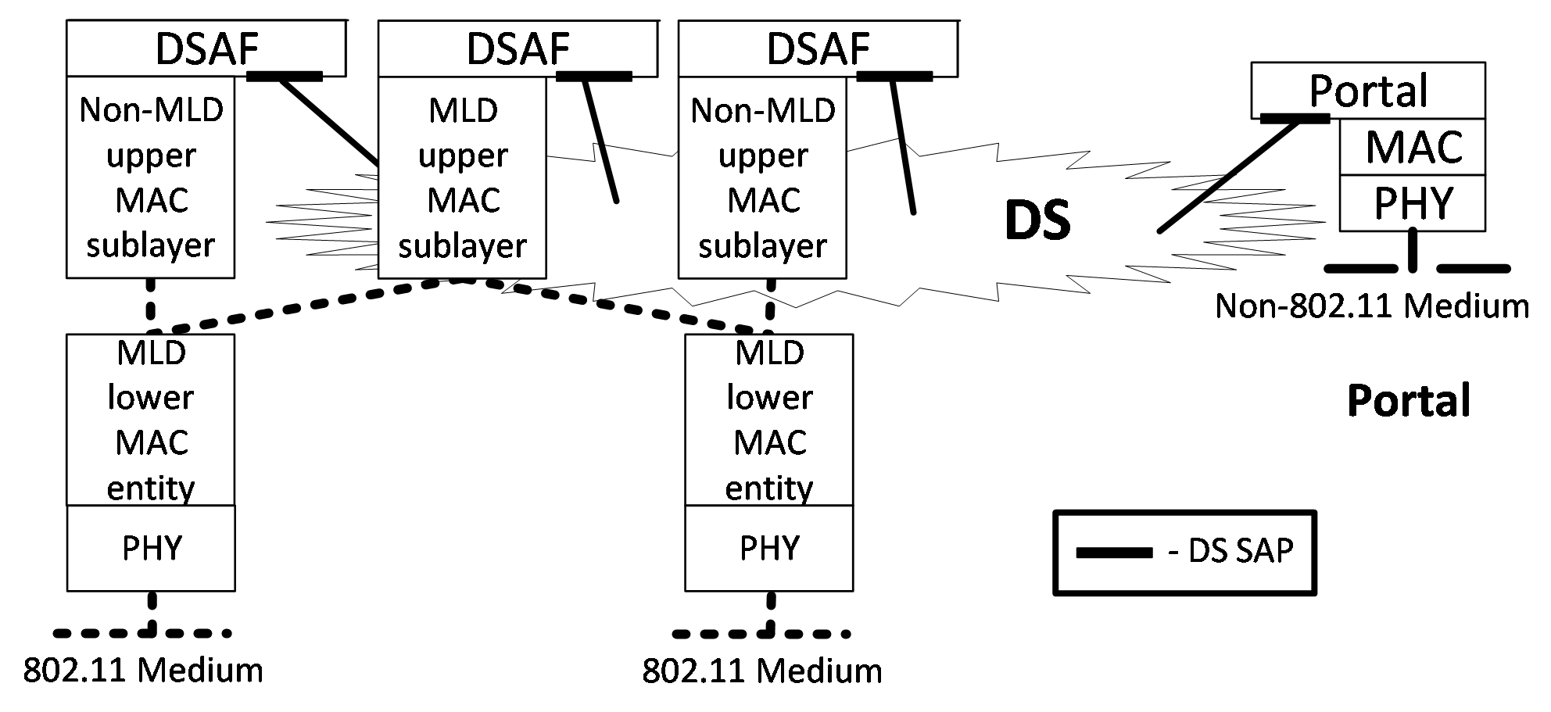

Proposed Resolution:

Accepted.

