IEEE P802.11
Wireless LANs
SA Ballot CR for CID 23023
Date: 2024.06.17
Author(s):
Name | Company | Address | Phone | email
Mengshi Hu | Huawei Technologies | F3, Huawei Base, Bantian, Longgang, Shenzhen, Guangdong, China, 518129 |  | humengshi@huawei.com
Ming Gan
Stephen McCann
Abstract
This submission contains the proposed comment resolutions of CIDs in 24/0994 IEEE 802.11be SA ballot comments.

1 comment (CID 23023) in subclause 36.3.13.11 (Pilot subcarriers) is resolved.

Revision Notes
R0 | Initial revision

CID 23023
CID | Page.  Line | Clause Number | Comment | Proposed Change | Resolution
23023 | 878.21 | 36.3.13.11 | It is not clear what "{not defined}" means in Table 36-53—Pilot indices for a 26-tone RU transmission. Delete? Or say Reserved or something like that? | as in comment. | REVISED.  Agree with the commenter that the wording is not clear. A note is added to clarify that the pilot indices for the 26-tone RU 19 are not defined in an 80 MHz PPDU  Instructions to the editor:  Please make the changes as shown under CID 23023 in 11-24/1031r0.

Discussion (the related text is shown below):
P878:

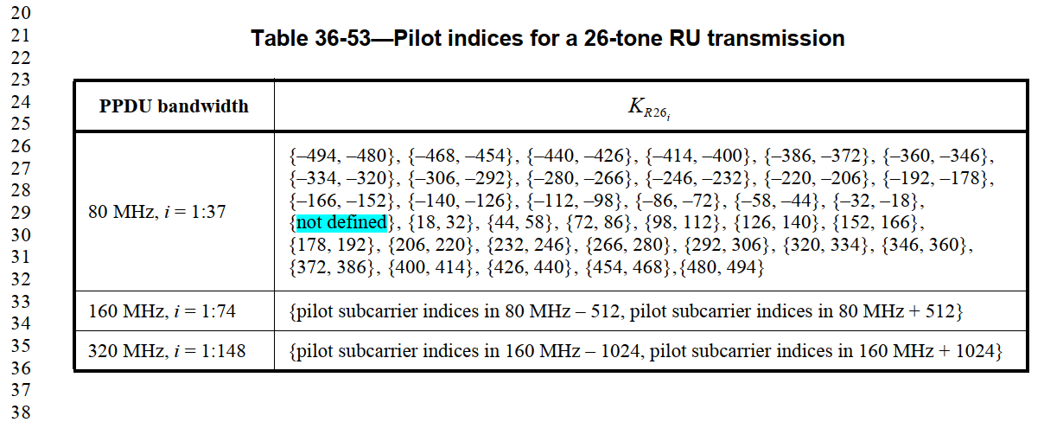

P722:
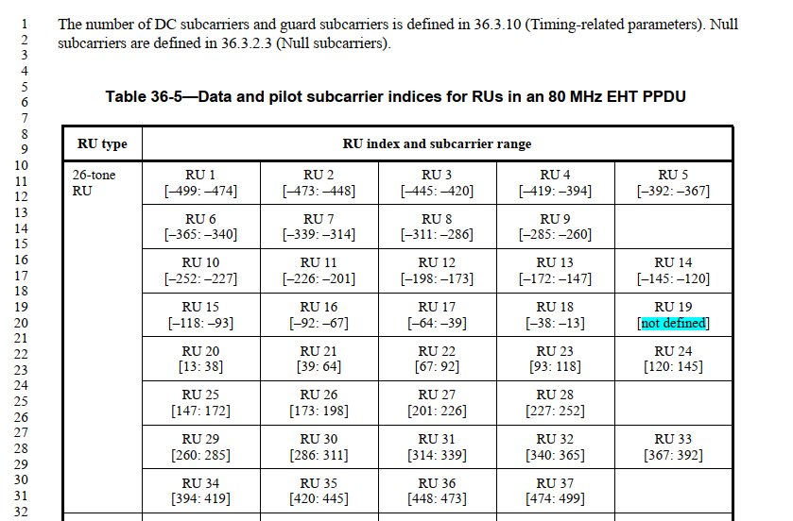

Instructions to the editor: please make the following changes to Page 878, Line 38 in the subclause 36.3.13.11 (Pilot subcarriers) in D6.0 as shown below:
NOTE — The pilot indices for the 26-tone RU 19 are not defined in an 80 MHz EHT PPDU (see 36.3.2.1 (Subcarriers and resource allocation in EHT PPDUs)).

