IEEE P802.11  
Wireless LANs

|  |  |  |  |  |
| --- | --- | --- | --- | --- |
| SA Ballot CR for CID 23023 | | | | |
| Date: 2024.06.17 | | | | |
| Author(s): | | | | |
| Name | Company | Address | Phone | email |
| Mengshi Hu | Huawei Technologies | F3, Huawei Base, Bantian, Longgang, Shenzhen, Guangdong, China, 518129 |  | humengshi@huawei.com |
| Ming Gan |  |  |  |
| Stephen McCann |  |  |  |  |

Abstract

This submission contains the proposed comment resolutions of CIDs in 24/0994 IEEE 802.11be SA ballot comments.

1 comment (CID 23023) in subclause 36.3.13.11 (Pilot subcarriers) is resolved.

Revision Notes

|  |  |
| --- | --- |
| R0 | Initial revision |

## CID 23023

|  |  |  |  |  |  |
| --- | --- | --- | --- | --- | --- |
| CID | Page.  Line | Clause Number | Comment | Proposed Change | Resolution |
| 23023 | 878.21 | 36.3.13.11 | It is not clear what "{not defined}" means in Table 36-53—Pilot indices for a 26-tone RU transmission. Delete? Or say Reserved or something like that? | as in comment. | REVISED.  Agree with the commenter that the wording is not clear. A note is added to clarify that the pilot indices for the 26-tone RU 19 are not defined in an 80 MHz PPDU  ***Instructions to the editor:***  **Please make the changes as shown under CID 23023 in 11-24/1031r0.** |

Discussion (the related text is shown below):

P878:

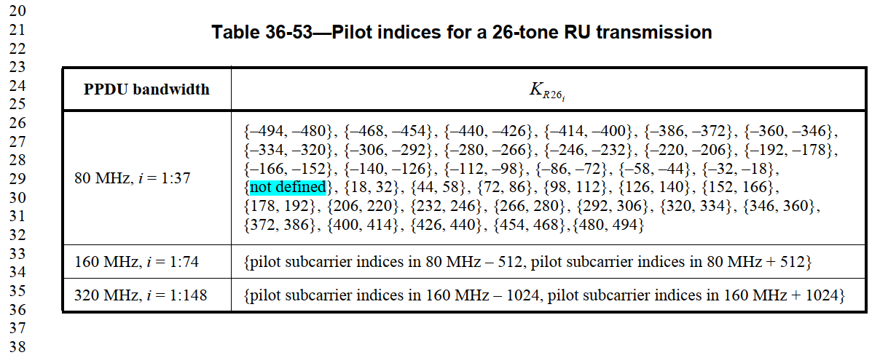

P722:



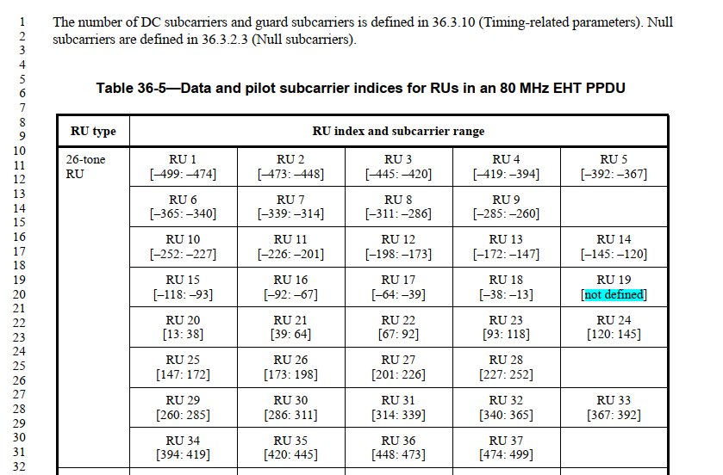

***Instructions to the editor: please make the following changes to Page 878, Line 38 in the subclause 36.3.13.11 (Pilot subcarriers) in D6.0 as shown below:***

NOTE — The pilot indices for the 26-tone RU 19 are not defined in an 80 MHz PPDU (see 36.3.2.1 (Subcarriers and resource allocation in EHT PPDUs)).