IEEE P802.11
Wireless LANs
Recirculation SA Ballot Issue on EMLSR and TXS (CID 23167)
Date: 2024-07-05
Author(s):
Name | Affiliation | Address | Phone | email
Juseong Moon | KNUT |  |  | jsmoon0211@a.ut.ac.kr
Ronny Yongho Kim | KNUT |  |  | ronnykim@ut.ac.kr
Woojin Ahn | KNUT |  |  | woojin.ahn@ut.ac.kr
Gwangho Lee | KNUT |  |  | gwangho.lee@a.ut.ac.kr
Sunghyun Hwang | ETRI |  |  | shwang@etri.re.kr
Abstract
This submission explains remaining issue for CID 23167 received in recirculation SA ballot of 11be.

R0: Initial version.
R1 ~ R5: Modified discussions and proposed text.

Related Comment
CID | Commenter | Clause | P.L | Comment | Proposed Change
23167 | Yongho Kim | 35.3.17 | 599.65 | When a non-AP STA affiliated with an EMLSR non-AP STA performs a TXS operation as defined in 35.2.1.2 and transmits a CTS response to a MU-RTS frame, since it shall switch back after the end of the frame exchanges as defined in 35.3.17 due to not receiving PHY-RXSTART.indication in shared TXOP, it can not perform TXS operation. Therefore, the EMLSR non-AP STA's transmission to the AP or to a peer STA is not possible. The 802.11be draft shall define an EMLMR non-AP MLD's TXS operation. The related comment was rejected in the last resolution. However, the issue still exists in the 11be D6.0. | Add the following paragraph:  When a non-AP STA affiliated with the non-AP MLD gets the time allocation from the AP with the MU-RTS TXS Trigger frame specified in 35.2.1.2 (Triggered TXOP sharing procedure), it can be considered that the non-AP STA initiates a TXOP, and the item l) is applied to the non-AP STA. When the non-AP STA returned the time allocation or the time allocation ends, The non-AP MLD shall be switched back to the listening operation on the EMLSR links after the EMLSR transition delay time indicated by the non-AP MLD.

Discussion

[Issue #1]

When a non-AP STA, which is operating in EMLSR operation, 1) received an initial Control frame and received an MU-RTS TXS Trigger frame from an AP, the time is allocated to the non-AP STA by the AP. 2) The non-AP STA transmits CTS frame to the AP if it received the MU-RTS TXS Trigger frame. Because CTS frame is a response to the mostly received frame from the AP affiliated with the AP MLD, a time of aSIFSTime + aSlotTime + aRxPHYStartDelay starts. 3) In this case, since the non-AP STA transmits a PPDU, there is no event of PHY-RXSTART.indication reception during a time of aSIFSTime + aSlotTime + aRxPHYStartDelay. Therefore, the non-AP STA shall be switched back to the listening operation by the rules defined in subclause 35.3.17.

“
    - Enhanced multi-link single-radio (EMLSR) operation
(…)
e) 1)After receiving the initial Control frame of frame exchanges and transmitting an immediate response frame as a response to the initial Control frame, a non-AP STA affiliated with the non-AP MLD that was listening on the corresponding link shall be able to transmit or receive frames on the link on which the initial Control frame was received and shall not transmit or receive on the other EMLSR link(s) until the end of the frame exchanges, and subject to its spatial stream capabilities, operation mode, and the minimum MAC frame padding duration of the Padding field of the initial Control frame, the non-AP STA affiliated with the non-AP MLD shall be capable of receiving a PPDU that is sent using more than one spatial stream on the link on which the initial Control frame was received a SIFS after the end of its response frame transmission solicited by the initial Control frame. During the frame exchanges, the other AP(s) affiliated with the AP MLD shall not transmit frames to the other non-AP STA(s) affiliated with the non-AP MLD on the other EMLSR link(s).
(…)
i) 3)The non-AP MLD shall be switched back to the listening operation on the EMLSR link(s) after the EMLSR transition delay time most recently indicated by the non-AP MLD if any of the following conditions is met, and this is defined as the end of the frame exchanges:
  - 3) The MAC of the non-AP STA affiliated with the non-AP MLD that received the initial Control frame does not receive a PHY-RXSTART.indication primitive during a timeout interval of aSIFSTime + aSlotTime + aRxPHYStartDelay, where aRxPHYStartDelay is equal to 20 µs, 2) starting at the end of the PPDU transmitted by the non-AP STA affiliated with the non-AP MLD as a response to the most recently received frame from the AP affiliated with the AP MLD or starting at the end of the reception of the PPDU containing a frame for the non-AP STA from the AP affiliated with the AP MLD that does not require immediate acknowledgement.
“

During the TXS period, the non-AP STA is supposed to trasnsmit a PPDU. According to the current spec, the EMLSR non-AP STA shall be switched back to listening operation while transmitting the PPDU. We need a condition not switching into listening operation when the EMLSR non-AP STA transmits a frame during a timeout interval of aSIFSTime+aSlotTime+aRXPHYStartDelay.

Proposed modification) When the non-AP STA transmits PPDU during the timout interval of aSIFSTime + aSlotTime + aRxPHYStartDelay in TXS, the MAC of the non-AP STA transmits a PHY-TXSTART.request primitive and receives a PHY-TXSTART.confirm primitive. If this condition is added for not being switched back to the listening operation, the non-AP STA can transmit PPDUs without returning to the listening operation during the TXS allocated time. The proposed modification is as the following and is illustrated in the figure below.

i) The non-AP MLD shall be switched back to the listening operation on the EMLSR link(s) after the EMLSR transition delay time most recently indicated by the non-AP MLD if any of the following conditions is met, and this is defined as the end of the frame exchanges:
- The MAC of the non-AP STA affiliated with the non-AP MLD that received the initial Control frame does not receive a PHY-RXSTART.indication primitive and does not transmit a PHY-TXSTART.request primitive and receive a PHY-TXSTART.confirm primitive (issue #1) during a timeout interval of aSIFSTime + aSlotTime + aRxPHYStartDelay, where aRxPHYStartDelay is equal to 20 µs, starting at the end of the PPDU transmitted by the non-AP STA affiliated with the non-AP MLD as a response to the most recently received frame from the AP affiliated with the AP MLD, or starting at the end of the reception of the PPDU containing a frame for the non-AP STA from the AP affiliated with the AP MLD that does not require immediate acknowledgement.

[Issue #2]
In EMLSR, there are two EMLSR non-AP STA’s communication cases:
- PPDU Reception: the EMLSR non-AP STA receives an initial control frame prior to the reception of PPDUs.
- PPDU Transmission: the EMLSR non-AP STA initiates TXOP(TXOP holder) for PPDU transmission.

In TXS mode 1 procedure, since the EMLSR non-AP STA transmits PPDUs to the APduring the allocated time, the non-AP STA plays a role of TXOP holder during the TXS allocated time. However, in TXS case, since the non-AP STA already received an EMLSR initial control frame for TXS procedure and is not a TXOP holder during the allocated TXS time, the following statement in 35.3.17 EMLSR does not apply:

When a non-AP STA affiliated with the non-AP MLD initiates a TXOP, the following applies:
- The non-AP MLD shall be switched back to the listening operation on the EMLSR links after the EMLSR transition delay time indicated by the non-AP MLD after the end of the TXOP.

Therefore, a condition for an EMLSR non-AP STA to be switched back to the listening operation during TXS allocated time is needed.

Proposed solution) Without a condition for an EMLSR non-AP STA to be a TXOP holder during TXS allocated time, the rule in subclause 35.3.17 with the modification proposed for issue #1 can resolve this issue.

[Issue #3]
Issue #3-1) PPDU transmission to another STA
In TXS mode 2, an EMLSR non-AP STA can transmit a PPDU to another STA and receive BA from another STA. In this case, the time interval (aSIFSTime+aSlotTime+aRXPHYStartDelay) starting rule in subclause 35.3.17 can not be applied since the PPDU is not from the AP. Another STA transmission case can be newly added.

Proposed modification) A condition to start the timer of (aSIFSTime+aSlotTime+aRXPHYStartDelay) in case of the reception of the PPDU from another STA can be added.

i) The non-AP MLD shall be switched back to the listening operation on the EMLSR link(s) after the EMLSR transition delay time most recently indicated by the non-AP MLD if any of the following conditions is met, and this is defined as the end of the frame exchanges:
  - The MAC of the non-AP STA affiliated with the non-AP MLD that received the initial Control frame does not receive a PHY-RXSTART.indication primitive and does not transmit a PHY-TXSTART.request primitive and receive a PHY-TXSTART.confirm primitive(issue #1) during a timeout interval of aSIFSTime + aSlotTime + aRxPHYStartDelay, where aRxPHYStartDelay is equal to 20 µs, starting at the end of the PPDU transmitted by the non-AP STA affiliated with the non-AP MLD as a response to the most recently received frame from the AP affiliated with the AP MLD, or starting at the end of the reception of the PPDU containing a frame for the non-AP STA from the AP affiliated with the AP MLD or from another STA (issue #3-1) that does not require immediate acknowledgement.

Issue #3-2) UL PPDU with No Ack Policy Transmission
When an EMLSR non-AP STA transmits an uplink frame with Ack Policy set to No Ack to its associated AP in the allocated time, there are no condition to be switched back to the listening operation. QoS Data or QoS Null frame that includes an HE variant HT Control field with a CAS Control subfield with the RDG/More PPDU subfield equal to 0 to finish TXS operation. Such QoS Data or QoS Null frame can set Ack Policy set to No Ack or Normal Ack/Implicit BAR. In case of No Ack, a new condition proposed as the following can make the STA be switched back to the listening operation. In case of Normal Ack/Implicit BAR case, since ACK is a frame not requiring immediate acknowledgement, the time interval of aSIFSTime+aSlotTime+aRXPHYStartDelay starts and if no further frame is received during the time interval, the STA is switched back to the listening operation.

Proposed modification) A condition to start the timer of (aSIFSTime+aSlotTime+aRXPHYStartDelay) in case of the transmission of the PPDU including a frame with Ack Policy set to No Ack can be added.

The proposed modification is as the following.

i) The non-AP MLD shall be switched back to the listening operation on the EMLSR link(s) after the EMLSR transition delay time most recently indicated by the non-AP MLD if any of the following conditions is met, and this is defined as the end of the frame exchanges:
The MAC of the non-AP STA affiliated with the non-AP MLD that received the initial Control frame does not receive a PHY-RXSTART.indication primitive and does not transmit a PHY-TXSTART.request primitive and receive a PHY-TXSTART.confirm primitive(issue #1) during a timeout interval of aSIFSTime + aSlotTime + aRxPHYStartDelay, where aRxPHYStartDelay is equal to 20 µs, starting at the end of the PPDU transmitted by the non-AP STA affiliated with the non-AP MLD as a response to the most recently received frame from the AP affiliated with the AP MLD, or starting at the end of the reception of the PPDU containing a frame for the non-AP STA from the AP affiliated with the AP MLD or from another STA(issue #3-1) that does not require immediate acknowledgement or starting at the end of the PPDU including a frame with an ack policy set to No Ack (issue #3-2).

The following figure illustrates the proposed modification for issue #3-1 and #3-2.

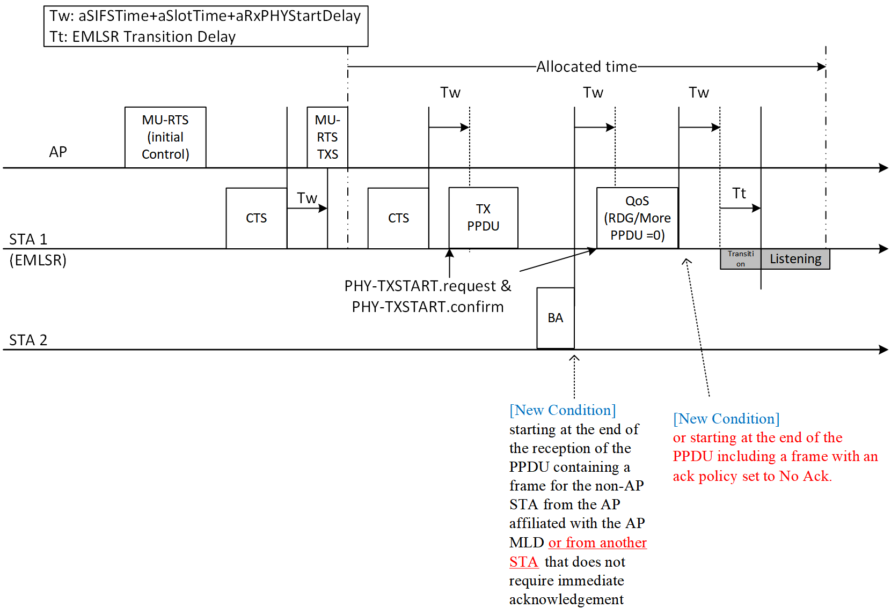

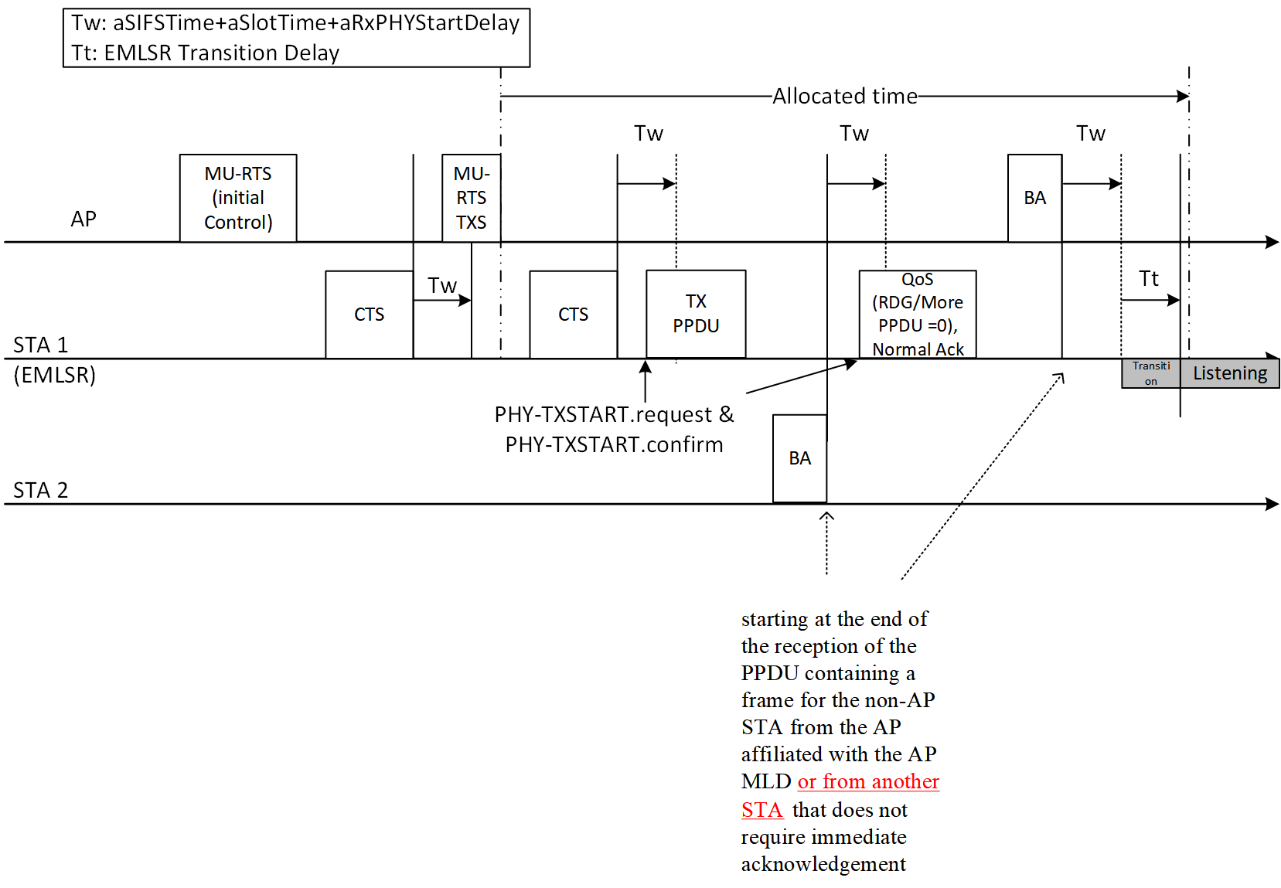

[Options for the resolution of the issues]

No change can not be one of options because of the following reasons:
  - This option forces implementors to neglect mandatory statement.
  - If an impelementation neglect of the mandatory statement of not returning to the listening operation, there is no condition of returning to the listening operation after PPDUs transmission (issues #3-1 and #3-2).

To resolve the issues above, this document suggests 2 options for 11be D6.0.
- Exclude non-AP MLD with EMLSR operation from TXS operation since EMLSR STAs can not work in TXS operation according to the current spec.
  - This option can resolve all the issues because non-AP MLD with EMLSR cannot use the TXS procedures in 11be D6.0.
- Add conditions for PPDUs transmission in TXS allocated time in subclause 35.3.17 (EMLSR operation)
  - Add a condition not switching into listening operation when the EMLSR non-AP STA transmits a frame during a timeout interval of aSIFSTime + aSlotTime + aRXPHYStartDelay.
    - In the event of occurrence of PHY-TXSTART primitives, a non-AP STA shall not be switched back to the listening operation.
  - Add conditions for the frame exchange with another STA and for the transmission of the PPDU including a frame with Ack Policy set to No Ack.
    - In the event of the frame exchange with another STA, start condition of the timer of (aSIFSTime+aSlotTime+aRXPHYStartDelay) for case of the reception of the PPDU from another STA can be added.
    - A condition to start the timer of (aSIFSTime+aSlotTime+aRXPHYStartDelay) in case of the transmission of the PPDU including a frame with Ack Policy set to No Ack can be added.

Proposed Text for 11be D6.0

<Option 1: Exclude non-AP MLD with EMLSR operation from TXS operation>

35.2.1.2 Triggered TXOP sharing (TXS) procedure

35.2.1.2.2 AP behavior
(P512 L40)
An EHT AP shall not send an MU-RTS TXS Trigger frame with TXS Mode subfield equal to 1 or 2 and with the User Info field that is addressed to an associated non-AP STA which is affiliated with a non-AP MLD operating in EMLSR mode.

<Option 2: Add conditions for PPDUs transmission in TXS allocated time in subclause 35.3.17 (EMLSR operation)>

35.3.17 Enhanced multi-link single-radio (EMLSR) operation
(P599 L19)
i) The non-AP MLD shall be switched back to the listening operation on the EMLSR link(s) after the EMLSR transition delay time most recently indicated by the non-AP MLD if any of the following conditions is met, and this is defined as the end of the frame exchanges:
  - The MAC of the non-AP STA affiliated with the non-AP MLD that received the initial Control frame does not receive a PHY-RXSTART.indication primitive and does not transmit a PHY-TXSTART.request primitive and receive a PHY-TXSTART.confirm primitive during a timeout interval of aSIFSTime + aSlotTime + aRxPHYStartDelay, where aRxPHYStartDelay is equal to 20 µs, starting at the end of the PPDU transmitted by the non-AP STA affiliated with the non-AP MLD as a response to the most recently received frame from the AP affiliated with the AP MLD, or starting at the end of the reception of the PPDU containing a frame for the non-AP STA from the AP affiliated with the AP MLD or from another STA that does not require immediate acknowledgement or starting at the end of the PPDU including a frame with an ack policy set to No Ack.

