IEEE P802.11
Wireless LANs
Recirculation SA Ballot Issue on EMLSR and TXS (CID 23167)
Date: 2024-06-19
Author(s):
Name | Affiliation | Address | Phone | email
Juseong Moon | KNUT |  |  | jsmoon0211@a.ut.ac.kr
Ronny Yongho Kim | KNUT |  |  | ronnykim@ut.ac.kr
Woojin Ahn | KNUT |  |  | woojin.ahn@ut.ac.kr
Gwangho Lee | KNUT |  |  | gwangho.lee@a.ut.ac.kr
Sunghyun Hwang | ETRI |  |  | shwang@etri.re.kr
Abstract
This submission explains remaining issue for CID 23167 received in recirculation SA ballot of 11be.

R0: Initial version.
R1: Modified discussions.

Related Comment
CID | Commenter | Clause | P.L | Comment | Proposed Change
23167 | Yongho Kim | 35.3.17 | 599.65 | When a non-AP STA affiliated with an EMLSR non-AP STA performs a TXS operation as defined in 35.2.1.2 and transmits a CTS response to a MU-RTS frame, since it shall switch back after the end of the frame exchanges as defined in 35.3.17 due to not receiving PHY-RXSTART.indication in shared TXOP, it can not perform TXS operation. Therefore, the EMLSR non-AP STA's transmission to the AP or to a peer STA is not possible. The 802.11be draft shall define an EMLMR non-AP MLD's TXS operation. The related comment was rejected in the last resolution. However, the issue still exists in the 11be D6.0. | Add the following paragraph:  When a non-AP STA affiliated with the non-AP MLD gets the time allocation from the AP with the MU-RTS TXS Trigger frame specified in 35.2.1.2 (Triggered TXOP sharing procedure), it can be considered that the non-AP STA initiates a TXOP, and the item l) is applied to the non-AP STA. When the non-AP STA returned the time allocation or the time allocation ends, The non-AP MLD shall be switched back to the listening operation on the EMLSR links after the EMLSR transition delay time indicated by the non-AP MLD.

Discussion

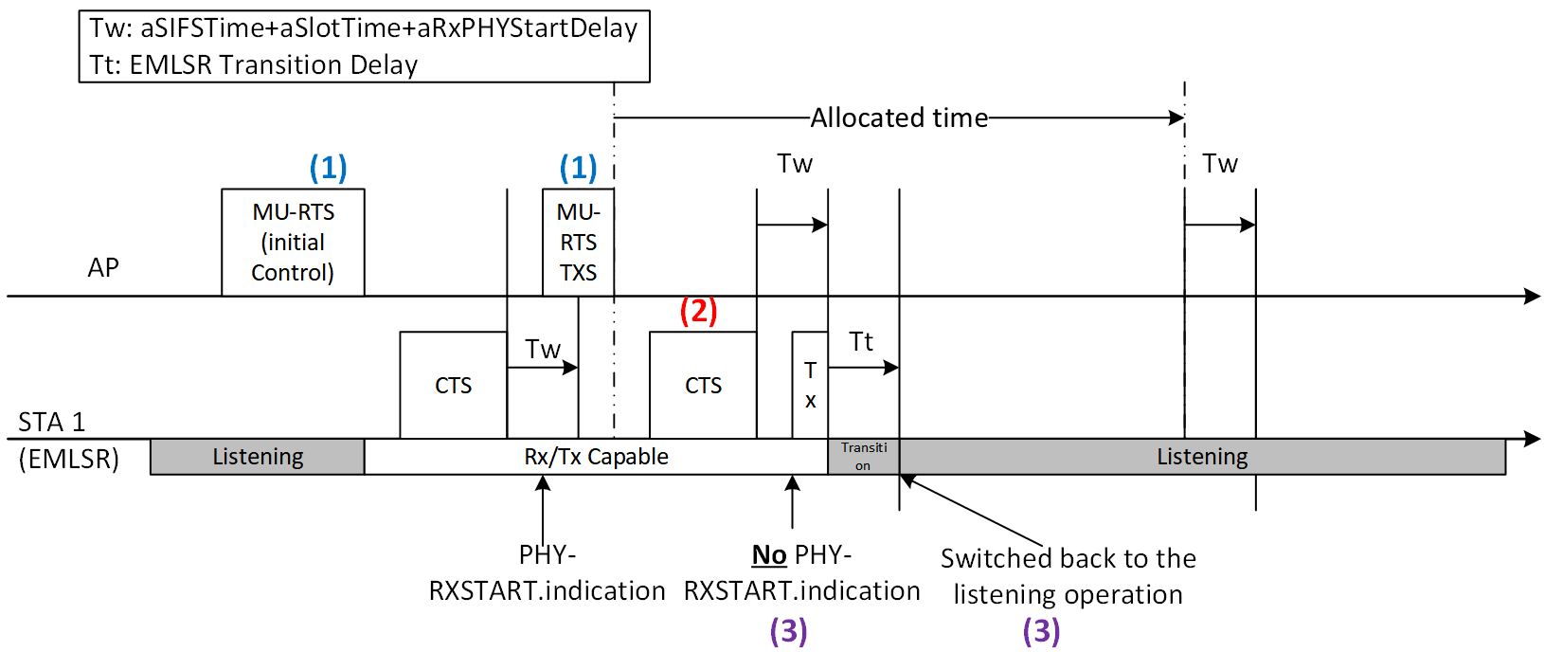

When a non-AP STA, which is operating in EMLSR operation, 1) received an initial Control frame and received an MU-RTS TXS Trigger frame from an AP, the time is allocated to the non-AP STA by the AP. 2) The non-AP STA transmits a CTS frame to the AP if it received the MU-RTS TXS Trigger frame. 3) In this case, the non-AP STA’s MAC cannot receive PHY-RXSTART.indication in the allocated time in the MU-RTS TXS Trigger frame. Therefore, the non-AP STA shall be switched back to the listening operation by the rules defined in subclause 35.3.17.

“
    - Enhanced multi-link single-radio (EMLSR) operation
(…)
e) 2)After receiving the initial Control frame of frame exchanges and transmitting an immediate response frame as a response to the initial Control frame, a non-AP STA affiliated with the non-AP MLD that was listening on the corresponding link shall be able to transmit or receive frames on the link on which the initial Control frame was received and shall not transmit or receive on the other EMLSR link(s) until the end of the frame exchanges, and subject to its spatial stream capabilities, operation mode, and the minimum MAC frame padding duration of the Padding field of the initial Control frame, the non-AP STA affiliated with the non-AP MLD shall be capable of receiving a PPDU that is sent using more than one spatial stream on the link on which the initial Control frame was received a SIFS after the end of its response frame transmission solicited by the initial Control frame. During the frame exchanges, the other AP(s) affiliated with the AP MLD shall not transmit frames to the other non-AP STA(s) affiliated with the non-AP MLD on the other EMLSR link(s).
(…)
i) 3)The non-AP MLD shall be switched back to the listening operation on the EMLSR link(s) after the EMLSR transition delay time most recently indicated by the non-AP MLD if any of the following conditions is met, and this is defined as the end of the frame exchanges:
  - 3) The MAC of the non-AP STA affiliated with the non-AP MLD that received the initial Control frame does not receive a PHY-RXSTART.indication primitive during a timeout interval of aSIFSTime + aSlotTime + aRxPHYStartDelay, where aRxPHYStartDelay is equal to 20 µs, 1) starting at the end of the PPDU transmitted by the non-AP STA affiliated with the non-AP MLD as a response to the most recently received frame from the AP affiliated with the AP MLD or starting at the end of the reception of the PPDU containing a frame for the non-AP STA from the AP affiliated with the AP MLD that does not require immediate acknowledgement.
“

However, during TXS sharing period, the EMLSR STA is supposed to trasnsmit a PPDU. According to the current spec, the EMLSR STA will be switched back to listening operation while transmitting the PPDU. We need a condition not switching into listening mode when the EMLSR STA transmits a frame during a timeout interval of aSIFSTime+aSlotTime+aRXPHYStartDelay.

Proposed Text for 11be D6.0

35.3.17 Enhanced multi-link single-radio (EMLSR) operation

(P599 L19)
i) The non-AP MLD shall be switched back to the listening operation on the EMLSR link(s) after the EMLSR transition delay time most recently indicated by the non-AP MLD if any of the following conditions is met, and this is defined as the end of the frame exchanges:
  - The MAC of the non-AP STA affiliated with the non-AP MLD that received the initial Control frame does not receive a PHY-RXSTART.indication primitive or does not transmit a PHY-TXSTART.request and receive a PHY-TXSTART.confirm during a timeout interval of aSIFSTime + aSlotTime + aRxPHYStartDelay, where aRxPHYStartDelay is equal to 20 µs, starting at the end of the PPDU transmitted by the non-AP STA affiliated with the non-AP MLD as a response to the most recently received frame from the AP affiliated with the AP MLD or starting at the end of the reception of the PPDU containing a frame for the non-AP STA from the AP affiliated with the AP MLD that does not require immediate acknowledgement.

