CR for MISC SA Comments
Date: 2024-5-12
Author(s):
Name | Affiliation | Address | Phone | email
Jay Yang | ZTE Corporation |  |  | Yang.zhijie@zte.com.cn
Yan Li | ZTE Corporation
Yun Li | ZTE Corporation

Abstract
This submission proposes resolutions for the following CIDs:

R0: initial the draft

Interpretation of a Motion to Adopt

A motion to approve this submission means that the editing instructions and any changed or added material are actioned in the TGbh D4.0 Draft. This introduction is not part of the adopted material.

Editing instructions formatted like this are intended to be copied into the TGbh D4.0 Draft. (i.e. they are instructions to the 802.11 editor on how to merge the text with the baseline documents).

TGbh Editor: Editing instructions preceded by “TGbh Editor” are instructions to the TGbh editor to modify existing material in the TGbh draft. As a result of adopting the changes, the TGbh editor will execute the instructions rather than copy them to the TGbh Draft.

CID | Name | P/L | Comment | Proposed Change | Resolution
3007 | Yang, Jay | 40/40 | the verify on Encrypted Data element is missing, please add it in. | add the Verify or decrypt on the Encrypted Data element when STA receives the second PASN frame, also when the AP receives the third PASN frame
3190 | RISON, Mark | 23/18 | "and dot11FILSActivated is true" -- why does FILS have to be activated to be able to use DID? | After the table add a "NOTE---Device ID and IRM elements are not included if dot11FILSActivated is not true because they are instead carried in the 4-way handshake."  Ditto for next subclause

CID3007

Revised--
- Add the following text as shown in the list below “Upon receiving the first PASN frame, the AP:“

NOTE --If dot11DeviceIDActivated is true, it processes the device ID in a Device ID element following the rule defined in subclause 12.2.12.1(Device ID mechanism).

— If dot11RSNAOperatingChannelValidationActivated is true and the peer STA’s RSNE indicated OCVC capability, it validates that an OCI element is present and the Channel information in the element matches current operating channel parameters (see 12.2.9). Otherwise, if there is a mismatch, processing status is set to OCI_MISMATCH.

(2)Add the following text as shown in the list below “Upon receiving the second PASN frame, the non-AP
STA:” (That’s, Insert the following text at L49,P44)

--If dot11DeviceIDActivated is true, it validates that an PASN Encrypted Data element is present, and check the decryption operation result. If the decryption operation returns failure, the non-AP STA silently discards the second PASN frame.
NOTE-- The device ID in the Device ID subelement is processed by following the rule defined in subclause 12.2.12.1(Device ID mechanism).

--If dot11IRMActivated is true, it validates that an PASN Encrypted Data element is present, and check the decryption operation result. If the decryption operation returns failure, the non-AP STA silently discards the second PASN frame.
NOTE-- The IRM in the IRM subelement is processed by following the rule defined in subclause 12.2.12.2((Identifiable random MAC address)IRM mechanism).

(3)Add the following text as shown in the list that begins: “Upon receiving the third PASN frame, the AP:
”

--If dot11DeviceIDActivated is true, it validates that an PASN Encrypted Data element is present, and check the decryption operation result. If the decryption operation returns failure, the AP silently discards the third PASN frame.
NOTE-- The device ID in the Device ID subelement is processed by following the rule defined in subclause 12.2.12.1(Device ID mechanism).

--If dot11IRMActivated is true, it validates that an PASN Encrypted Data element is present, and check the decryption operation result. If the decryption operation returns failure, the AP silently discards the third PASN frame.
NOTE-- The IRM in the IRM subelement is processed by following the rule defined in subclause 12.2.12.2((Identifiable random MAC address)IRM mechanism).

— If dot11RSNAOperatingChannelValidationActivated is true and the peer STA’s RSNE indicated OCVC capability, it validates that an OCI element is present and the Channel information in the element matches current operating channel parameters (see 12.2.9). Otherwise, if there is a mismatch, processing status is set to OCI_MISMATCH.

CID3190

Discussion:
Refer to the figure that comment on as bellow.
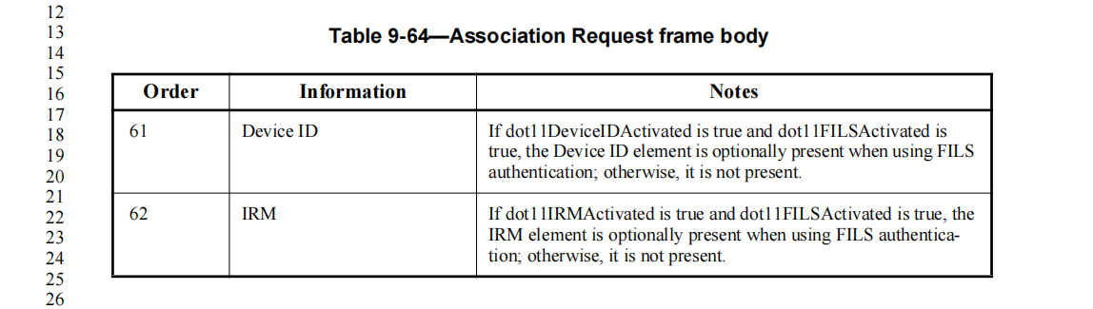

For FILS authentication, the way to exchange IRM or device ID is in the association request and association response frame. That’s, if dot11FILSActivated is not true, IRM or device ID has nothing to do in association request and association response frame. The commenter propose to add “Device ID and IRM elements are not included if dot11FILSActivated is not true”, while it’s already captured in the original text in the Notes, See “otherwise, it is not present.”

Rejected--
The proposed change is already captured by the original text in the Notes, no need further change.

