IEEE P802.11
Wireless LANs
LB286 Comment Resolution for eMLSR related CID 2056
Date: 2024-07-03
Author(s):
Name | Affiliation | Address | Phone | email
Ali Raissinia | Qualcomm Inc. |  |  | alirezar@qti.qualcomm.com
Abstract
This document provides comment resolution for CID 2056 (1 total) using P802.11bkD2.0, REVmeD5.0 and 11beD5.0 as references.

CID | Clause | Page | Comment | Proposed Change | Resolution
2056 |  | 0.00 | Add normative or informative text to support eMLSR for associated clients specifically for negotiation and measurement exchange. This could be relevant to REVmc sequence as well as NTB & TB. | As per comment | Revise  TGbk editor, add changes specified in this document  https://mentor.ieee.org/802.11/dcn/24/11-24-0966-03-00bk-lb286-comment-resolution-for-cid-56.docx

Discussion:

In prior discussions regarding MLD support the suggestions were to do the following:

- Keep negotiation frame exchange (i.e., IFTMR and IFTM) as ‘single link’transmissions as opposed to MLD transmissions.
- Keep existing TB ranging measurement exchange sequence the same as baseline even for ISTA in eMLSR mode. The reasoning is that ISTA is aware of the ranging availability window thus can make itself ready to be on-channel and not needing to have RSTA to send ICF frame(s).

The decision was for members to go check back with their implementation team to see if the above behavior would work and as such several companies reviewed their design and identified that their design requires the behavior described in 11be specification. Additionally, it was identified that negotiation management frames such as IFTMR & IFTM can also use MLD behavior.

11be specification includes the following management frames as ‘single link’ transmissions and the question is whether we should remove the IFTMR/IFTM from this list?

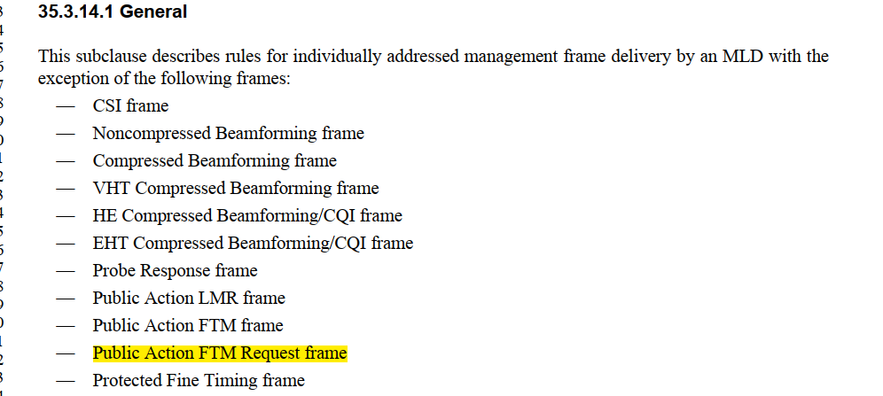

The proposal is to also add normative text where prior to any TB ranging measurement exchange the RSTA includes an ‘ICF phase’ to ensure the eMLSR ISTA is switched to the desired link before ranging measurmnet exchange can proceed. Once the ISTA is switched, the behavior is for this ISTA to be engaged in a frame exchange otherwise it would switch back to the listening operation (two/multiple 1x1 links) ‘quickly’. Therefore, right after ICF phase the ISTA must be included in the Polling, Measurement Sounding and Measurement Reporting phases. Diagrams below show two sequences.

1) both first and second instance include at least one ISTA in the eMLSR mode
2) the first instance includes at least one ISTA in eMLSR mode whereas the second instance does not include any ISTAs in eMLSR mode therefor no need to include ICF frame exchange

Note that the non-TB ranging measurement echange does not require inclusion of ICF phase since it is initiated by the ISTA.

Initial Control Frame exchange (ICF)

(first Instance)
Polling Phase

(first Instance)
Measurement Sounding Phase

(first Instance)
Measurement Reporting Phase

(first Instance)
Initial Control Frame exchange (ICF)

(Second Instance)
Polling Phase

(Second Instance)
Measurement Sounding Phase

(Second Instance)
Measurement Reporting Phase

(second Instance)
TXOP
TXOP
Availability Window

Initial Control Frame exchange (ICF)

(first Instance)
Polling Phase

(first Instance)
Measurement Sounding Phase

(first Instance)
Measurement Reporting Phase

(first Instance)
Polling Phase

(Second Instance)
Measurement Sounding Phase

(Second Instance)
Measurement Reporting Phase

(second Instance)
TXOP
TXOP
Availability Window

For the secure LTF operation the TB ranging measurement exchange needs to be performed with an eMLSR ISTA as SU operation, meaning that RSTA would need a separate sequence of ICF+TB ranging measurement exchange for each eMLSR ISTA. The main reason is that in secure LTF, the UL sounding needs to be done one at a time in which case there would be a gap in frame exchange to an eMLSR ISTA causing it to switch back to listen mode, an undersirable behavior.

Secure LTF TB ranging meaurement exchange
Initial Control Frame exchange (ICF)

One eMLSR ISTA

(first Instance)
Polling Phase

One eMLSR ISTA

(first Instance)
Measurement Sounding Phase

One eMLSR ISTA

(first Instance)
Measurement Reporting Phase

One eMLSR ISTA

(first Instance)
Initial Control Frame exchange (ICF)

One eMLSR ISTA

(Second Instance)
Polling Phase

One eMLSR ISTA

(Second Instance)
Measurement Sounding Phase

One eMLSR ISTA

(Second Instance)
Measurement Reporting Phase

One eMLSR ISTA

(second Instance)
TXOP
TXOP
Availability Window

Instruction to 11bK editor: Add the paragraphs at the end of section “11.21.6.3.1 (General)” of REVme D5.0 in P2702L51 as shown below:

NOTE- Prior to the transmission of any ranging measurement frame(s) including IFTM frame (negotiation), FTM frame (measurement) and/or FTM session termination frame sent by an AP to an associated ISTA in the EMLSR mode, the AP transmits an initial control frame exchange (see section 35.3.17 Enhanced multi-link single radio operation).

NOTE: The transmission of an initial control frame is not required for an unassociated ISTA as only the associated ISTA can negotiate to be in the EMLSR mode.

The RSTA and ISTA shall transmit all frames that are part of the ranging measurement exchange(s) on the specific link that was identified by the Link ID subfield of the Link ID Info field included in the IFTMR and IFTM negotiation frame exchange.

Instruction to 11bK editor: Add the paragraphs and figure at the end of section “11.21.6.4.3.1 (General)” of REVmeD5.0 in P272L50 as shown below:

To perform a TB ranging measurement exchange with an associated ISTA in the EMLSR mode, the RSTA shall transmit an initial control frame exchange (see section 35.3.17 Enhanced multi-link single radio operation) at the beginning of the TB ranging measurement exchange prior to the transmission of each triplet, which includes Polling, Measurement Sounding and Measurement Reporting phases; see Figure 11-xx1 (TB ranging availability window with two instances of polling/sounding/reporting triplets in separate TXOPs where only the first TXOP includes an ISTA in ELMSR mode) and Figure 11-xx2 (TB ranging availability window with two instances of polling/sounding/reporting triplets in separate TXOPs where each TXOP includes an ISTA in ELMSR mode).

Initial Control Frame exchange (ICF)

(first Instance)
Polling Phase

(first Instance)
Measurement Sounding Phase

(first Instance)
Measurement Reporting Phase

(first Instance)
Polling Phase

(Second Instance)
Measurement Sounding Phase

(Second Instance)
Measurement Reporting Phase

(second Instance)
TXOP
TXOP
Availability Window

Figure 11-xx1 TB ranging availability window with two instances of polling/sounding/reporting triplets in separate TXOPs where only the first TXOP includes an ISTA in ELMSR mode

Initial Control Frame exchange (ICF)

(first Instance)
Polling Phase

(first Instance)
Measurement Sounding Phase

(first Instance)
Measurement Reporting Phase

(first Instance)
Initial Control Frame exchange (ICF)

(Second Instance)
Polling Phase

(Second Instance)
Measurement Sounding Phase

(Second Instance)
Measurement Reporting Phase

(second Instance)
TXOP
TXOP
Availability Window

Figure 11-xx2 TB ranging availability window with two instances of polling/sounding/reporting triplets in separate TXOPs where each TXOP includes an ISTA in ELMSR mode

To perform a TB ranging measurement exchange with any combination of two or more ISTAs, where at least one ISTA is in the EMLSR mode, the AP shall transmit an initial control frame exchange (see section 35.3.17 Enhanced multi-link single radio operation) at the beginning of the TB ranging measurement exchange prior to the transmission of each triplet, and the Measurement Sounding phase shall not include more than a single TF sounding frame to avoid the ISTA(s) in the EMLSR mode switching back to the listening operation before the triplets ends.

Instruction to 11bK editor: Add the paragraphs after the second parapraph in section “11.21.6.4.5.2. (TB ranging measurement exchange with secure LTF)” of REVmeD5.0 in P2741L62 as shown below:

NOTE: In the TB ranging measurement exchange with secure LTF, the AP always transmits a single TF sounding frame per ISTA and hence if the triplet includes an associated ISTA in the EMLSR mode, it cannot include any other additional ISTAs in the same triplet.

References: P802.11bkD2.0, P802.11beD5.0 & P802.11REVmeD5.0

