“2024 June 802.11 TGbh Ad-Hoc”
RUCKUS Headquarters in Sunnyvale, California, USA
18-20 June 2024

Dear Delegates,
RUCKUS and CommScope are pleased to host the “TGbh Ad-Hoc Meeting” in Sunnyvale. The meetings will take place 18-20 June 2024 at RUCKUS’ corporate headquarters.

Meeting Location: RUCKUS Networks
St. Bernard Conference Room
350 West Java Drive
Sunnyvale, California, 94089
United States

Mixed-mode Webex Info:
Join from the meeting link:
< to be provided by IEEE >

Join by meeting number:
< to be provided by IEEE >

See 802.11 Calendar for more details.
Meeting Dates: 18-20 June 2024

Daily Start/End Time: Daily meetings will start at 9:00 am and end at 6:00 pm
Light breakfast, and a lunch will be provided

Meeting Contact: Mark Hamilton
mark.hamilton@commscope.com
+1-303-818-8472

Local Contact Logistics: Lili Occena
lili.occena@commscope.com
+1-408-470-0643

RSVP: Due June 3,2024 to allow proper preparations.
Please Email mark.hamilton@commscope.com and lili.occena@commscope.com
(Include any dietary restrictions, etc., please)

Visitor’s Badges

Visitor badges are not required.

Visas and Letters of Invitation

Please visit the following website for USA visa requirements: http://www.travel.state.gov/content/visas/en.html.

Please ensure you allow ample time to arrange your visa. Timely receipt of letter of invitation cannot be guaranteed for late requests. Each delegate is responsible for their personal travel, accommodations and business expenses.

If you need a letter of invitation to obtain a visa, please fill out the attached form and email it to lili.occena@commscope.com

Hotel Reservations, Airport, Transport and Local Information

Hotels:
Preferred hotel option – Homewood Suites by Hilton Sunnyvale-Silicon Valley The code is “RUCKUS Networks” Corporate rate.
Airport Information:
- The closest airport is San Jose International Airport (SJC)
- San Francisco International Airport (SFO) is another option, but at least a 45 minute drive away from RUCKUS so please keep that in mind.

Ground Transportation:
Taxi cabs are readily available at the San Jose International Airport. Average Lyft/Uber ride to RUCKUS is around $25.

Gratuities:
A gratuity of 18% - 20% is customary at restaurants and for taxi drivers.

Local Time:
The time in Sunnyvale is Pacific time.
Currency and Credit Cards:
The US Dollar $ is the local currency and credit cards are accepted in all major outlets.

Voltage & Plug Adapters:
Electricity in United States of America / USA is 120 Volts, alternating at 60 Hz. If you travel to the United States of America / USA with a device that does not accept 120 Volts at 60 Hertz, you will need a voltage converter.

Outlets in United States of America / USA generally accept a two pin, flat blade plug with one opening larger than the other to accommodate polarized plugs.
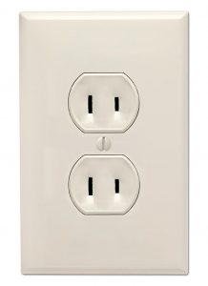OR 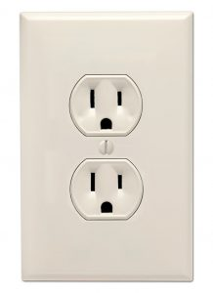
If your appliance’s plug has a different shape, you may need a plug adapter.

Parking at RUCKUS

Free parking is available in the parking lot, surrounding the building.

Closing Remarks

I look forward to seeing you in beautiful Sunnyvale.

Yours sincerely,

Mark Hamilton
Networking Standards Director, RUCKUS Networks.

