IEEE P802.11
Wireless LANs
Initial SA Ballot Issue on CID 22158
Date: 2024-05-08
Author(s):
Name | Affiliation | Address | Phone | email
Juseong Moon | KNUT |  |  | jsmoon0211@a.ut.ac.kr
Ronny Yongho Kim | KNUT |  |  | ronnykim@ut.ac.kr
Woojin Ahn | KNUT |  |  | woojin.ahn@ut.ac.kr
Gwangho Lee | KNUT |  |  | gwangho.lee@a.ut.ac.kr
Sunghyun Hwang | ETRI |  |  | shwang@etri.re.kr
Abstract
This submission explains remaining issue for CID 22158 received in initial SA ballot of 11be.

R0: Initial version.

Related Comment
CID | Commenter | Clause | P.L | Comment | Proposed Change
22158 | Yongho Kim | 35.3.17 | 566.61 | When a non-AP STA affiliated with an EMLSR non-AP MLD performs a TXS operation as defined in 35.2.1.2 and transmits a CTS response to a MU-RTS frame, since it shall switch back after the end of the frame exchanges as defined in 35.3.17 due to not receiving PHY-RXSTART.indication in shared TXOP, it can not perform TXS operation. Therefore, EMLSR non-AP STA MLD's transmission to the AP or to a peer STA is not possible. The 802.11be draft shall define an EMLMR non-AP MLD's TXS operation. | Add the following text: m) When a non-AP STA affiliated with the non-AP MLD is addressed in an MU-RTS TXS Trigger frame, the following applies: * The non-AP MLD shall be switched back to the listening operation on the EMLSR links not later than the EMLSR transition delay time most recently indicated by the non-AP MLD, as measured immediately after the end of the allocated time specified in 35.2.1.2 (Triggered TXOP sharing procedure).

Discussion

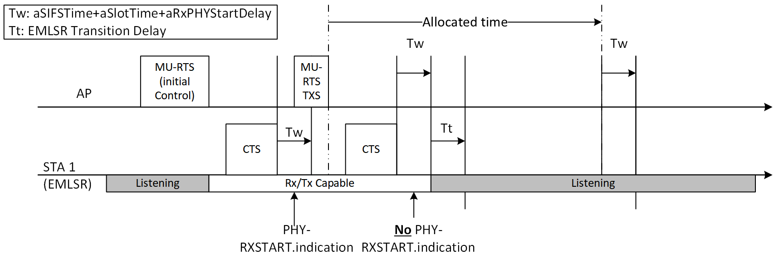
When a non-AP STA, which is operating in EMLSR operation, received an initial Control frame and received an MU-RTS TXS Trigger frame from an AP, the time is allocated to the non-AP STA by the AP. In this case, the non-AP STA’s MAC cannot receive PHY-TXSTART.indication in the allocated time in the MU-RTS TXS Trigger frame.
Therefore, the non-AP STA shall be switched back to the listening operation by the rules defined in subclause 35.3.17 (highlighted below.)

    - Enhanced multi-link single-radio (EMLSR) operation
(…)
e) After receiving the initial Control frame of frame exchanges and transmitting an immediate response frame as a response to the initial Control frame, a non-AP STA affiliated with the non-AP MLD that was listening on the corresponding link shall be able to transmit or receive frames on the link on which the initial Control frame was received and shall not transmit or receive on the other EMLSR link(s) until the end of the frame exchanges, and subject to its spatial stream capabilities, operation mode, and the minimum MAC frame padding duration of the Padding field of the initial Control frame, the non-AP STA affiliated with the non-AP MLD shall be capable of receiving a PPDU that is sent using more than one spatial stream on the link on which the initial Control frame was received a SIFS after the end of its response frame transmission solicited by the initial Control frame.
(…)
i) The non-AP MLD shall be switched back to the listening operation on the (#22375)EMLSR link(s) after the EMLSR transition delay time most recently indicated by the non-AP MLD(#22256) if any of the following conditions is met, and this is defined as the end of the frame exchanges:
  - The MAC of the non-AP STA affiliated with the non-AP MLD that received the initial Control frame does not receive a PHY-RXSTART.indication primitive during a timeout interval of aSIFSTime + aSlotTime + aRxPHYStartDelay, where aRxPHYStartDelay is equal to 20 µs, starting at the end of the PPDU transmitted by the non-AP STA affiliated with the non-AP MLD as a response to the most recently received frame from the AP affiliated with the AP MLD or starting at the end of the reception of the PPDU containing a frame for the non-AP STA from the AP affiliated with the AP MLD that does not require immediate acknowledgement.

To solve this issue, 11be should define the rules for non-AP STA which is operating EMLSR operation and is allocated time from AP with triggered TXOP sharing operation.

Proposed Text for 11be D5.1

35.3.17 Enhanced multi-link single-radio (EMLSR) operation

m) When a non-AP STA affiliated with the non-AP MLD gets the time allocation from the AP with the MU-RTS TXS Trigger frame specified in 35.2.1.2 (Triggered TXOP sharing procedure), it can be considered that the non-AP STA initiates a TXOP, and the item l) is applied to the non-AP STA. When the non-AP STA returned the time allocation or the time allocation ends, The non-AP MLD shall be switched back to the listening operation on the EMLSR links after the EMLSR transition delay time indicated by the non-AP MLD.

