IEEE P802.11
Wireless LANs
RESOLUTION OF CID 7077
Date: 2024-4-27
Author(s):
Name | Affiliation | Address | Phone | email
Mark Hamilton | Ruckus/CommScope | 350 W Java Dr  Sunnyvale, CA 94089 | 303-818-8472 | mark.hamilton2152@gmail.com
Graham SMITH | SR Technology | Sunrise, FL, USA. | 916 799 9563 | gsmith@srtrl.com
Abstract
This submission proposes resolution for CID 7077

r0 – Material taken (with thanks to Graham Smith!) from 11-24/566r4, for CID 7077, and additional changes shown with Track Changes, here.

CID | Page | Clause | Resn Status | Comment | Proposed Change | Resolution | Owning Ad-hoc
7077 | 2487.13 | 11.1.4.7 |  | Clause 6 issue - couldn’t find 6.3.128.5 | as in comment |  | MAC

2487.10
“When the STA receives one or more SSW frames with the OCB subfield equal to 1 during an A-BFT or DTI and completes SLS with the peer STA, and the address of the peer STA is an address that is newly discovered, the STA shall issue an MLME-OCB-DMGDISCOVERY.indication with the PeerInfoSet parameter including the PeerInfo vector defined in 6.3.128.5 (MLME-OCB-DMGDISCOVERY.indication) for the peer STA that transmitted the SSW frame.”

The text describes in detail the DMG-OCB-START.request, DMG-OCB-STOP.request and OCB-DMGDISCOVERY.indication where the cross reference to the original clause in 11bd is provided. Also OCB-LINKSTATUS.indication is described.

The text and Figures 11-14 and 11-15 are provided which explain the process in good detail so in this case I think we can simply use an addition to Table 6-1, but we do need to capture the details of the PeerInfo vector in the DMGDISCOVERY.indication.

RESOLUTION
Revised

Insert at end of Table 6-1

DMG operation outside the context of a BSS | DMG-OCB-START | 4 | 6.5.xx | See 11.1.4.7
 | DMG-OCB-STOP | 6
 | OCB-DMGDISCOVERY | 7 | 9.4.2.24, 9.3.4.2, 9.5.3, 9.3.4.2, 9.4.2.126, 9.4.2.265
 | OCB-LINKSTATUS | 7 | 11.27.1.1, 9.4.2.24 | See 11.27.1.1

Copy subclauses 6.3.128.2 and 6.3.128.3 from 802.11bd-2022, to a new subclause in REVme 6.5.xx, “DMG OCB operation start”.

At 2487.10 edit as follows:
“When the STA receives one or more SSW frames with the OCB subfield equal to 1 during an A-BFT or DTI and completes SLS with the peer STA, and the address of the peer STA is an address that is newly discovered, the STA shall issue an MLME-OCB-DMGDISCOVERY.indication with a “PeerInfoSet” parameter that includes a set of PeerInfo vectors defined in 6.3.128.5 (MLME-OCB-DMGDISCOVERY.indication) for the peer STA(s) that transmitted the SSW frame(s). Each PeerInfo vector consists of the parameters shown in Table 11.XX, in which the term peer STA refers to the STA that transmitted the received DMG Beacon frame, SSW frame, SSW Feedback frame, or SSW Ack frame.”

Insert new Table 11.XX
Table 11.XX—DMG Peer Info vector
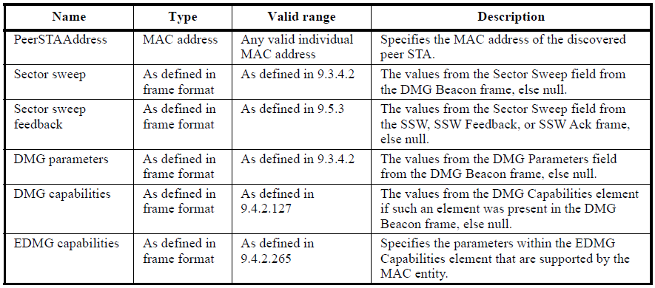
VendorSpecificInfo | A set of Vendor Specific elements | As defined in 9.4.2.25 | Zero or more elements, from the DMG Beacon frame

______________________________________________________________________________________________

