IEEE P802.11
Wireless LANs
Proposed Resolution for CID 7079 and more
Date: 2024-04-18
Author:
Name | Affiliation | Address | Phone | Email
Emily Qi | Intel Corporation | 2111 NE 25th Ave.  Hillsboro OR 97124 |  | Emily.h.qi@intel.com

This submission present proposed resolutions for 11az/11bd/11bb Roll-in related CIDs.

The proposed changes are based on REVme/D5.0.

Revision history:

R0 – initial version
R1 – added more CIDs.
R2 – incorporated the discussion on 4/17 and 4/18.

7079 | 3077.00 | 12.7.1.3 | 11az work item - 11az instructs TGme editor to replace Figure 12-29. However this figure has been modified by two CIDs. Changes need to be identified instead of replacement. | as in comment. |  | SEC

Discussion:

In the published 11az standard, it states:
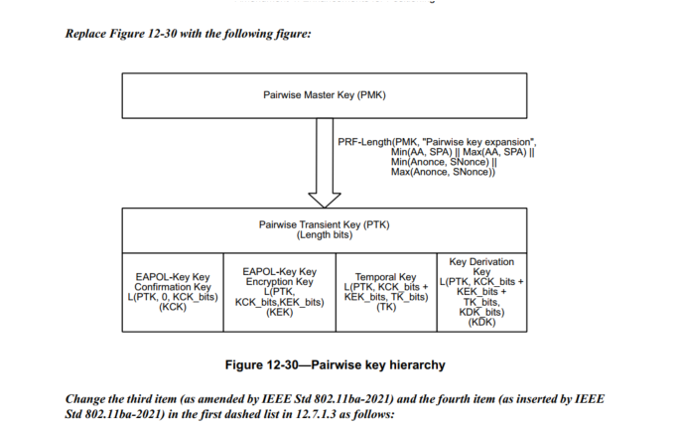

The above figure is identical with the figure in 11ba standard:
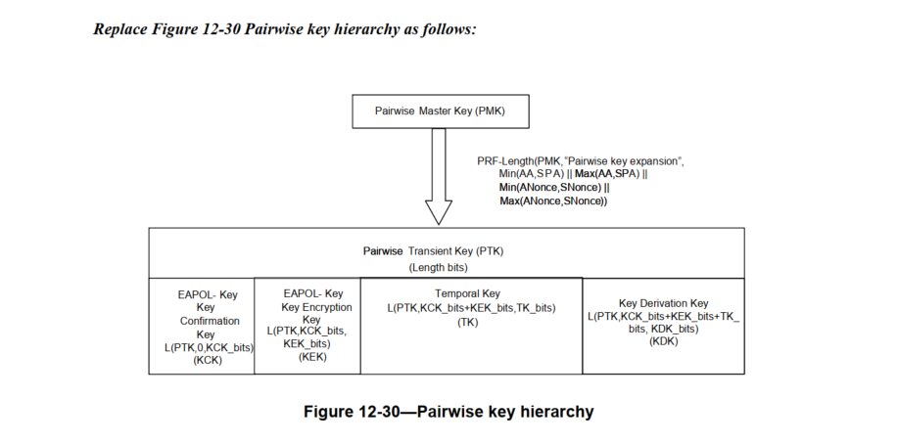
Since 11ax is based on 11ba, the editing instruction in 11az was wrong.

The more important, after 11ba roll-in, this figure has been modified by CID 3744 and CID #4057. Now, this figure in D 5.0 is shown as below:

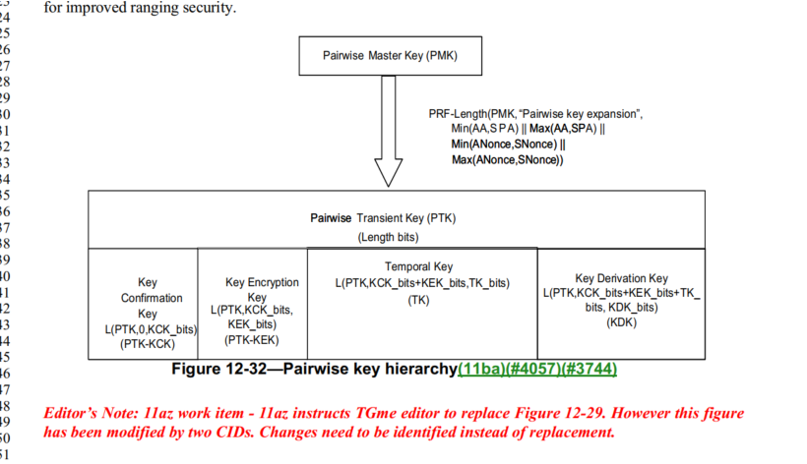

CID 3744: removed EAPOL-Key
CID 4057: Replace "(KCK)" with "(PTK-KCK)" and "(KEK)" with "(PTK-KEK)".

Therefore, TGme editor should not do any change for Figure 12-32, for 11az roll-in.

Proposed Resolutions:
Revised.
Remove the Editor Note at line 48 to 50 on page 3077.
No change to Figure 12-32 is needed.

7078 | 3068.00 | 12.6.17 | 11az work item - Changes in 12.6.19 of 11az cannot be incorporated in this section. Please review. | as in comment. |  | SEC

Discussion:
In 11az standard, 12.6.19, it states:

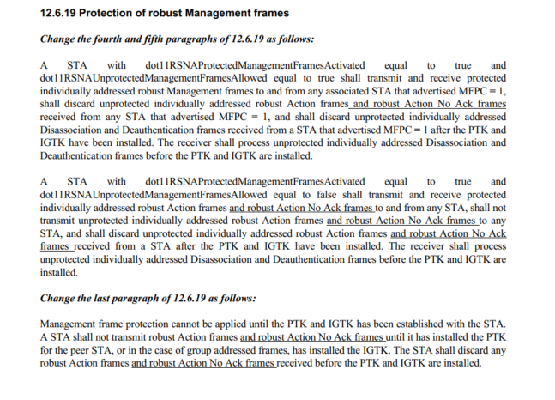
However, I couldn’t find any relevant texts in D4.0.
Subclause 12.6.17 Protection of Robust Management frames (D 4.0) has been changed due to CID 2128 (Doc 21/1128r6, Mark R’s submission).

Help is needed.
Assigned to Mark R.

Proposed Resolution:

7059 | 4953.00 | 34 | During one of the later rounds of SA Ballot, the EBCS clause was moved from a sub-clause of 11 to clause 34 in response to a comment that requested that the EBCS clause be divided between clause 11 and 10. | The commenter will provide a submission to address the comment that restores the clause 11 content and possibly moves some content to clause 10. | REVISED (GEN: 2024-03-13 03:51:34Z) The EBCS specification includes both MAC and MAC management. Move Clause 34 to a sub-clause of clause 11. | GEN

Discussion:

Motion to approve the resolution fails, see:
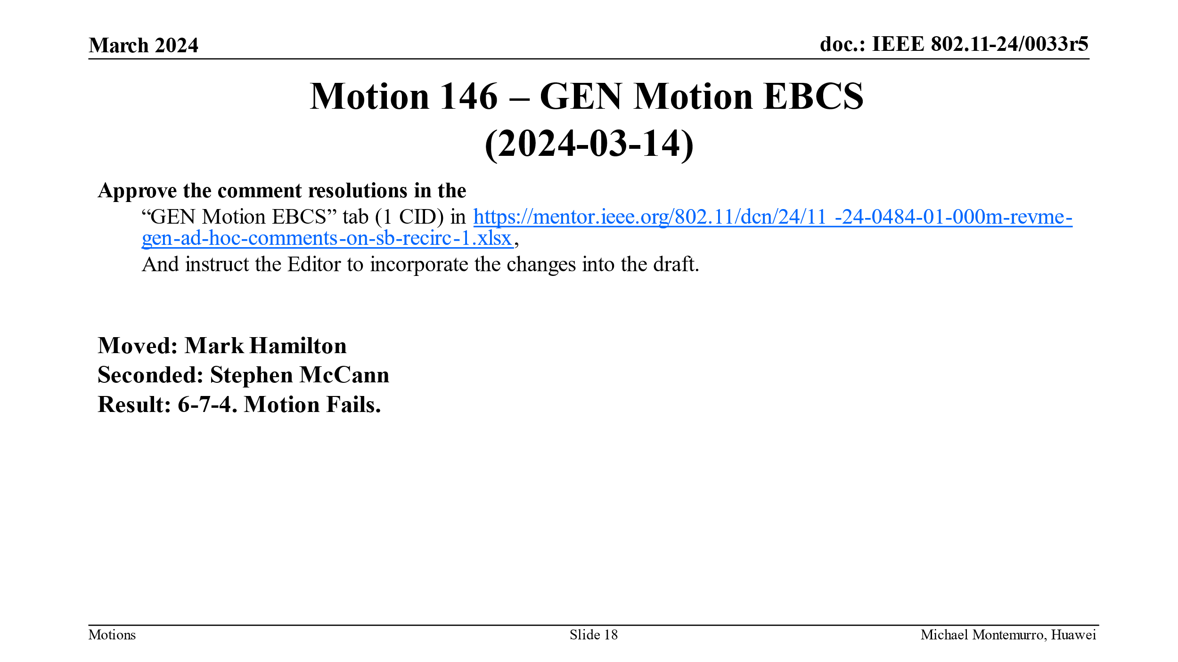

We can use the “no consensus” reject reason.

Proposed resolution:

Rejected.
The CRC reviewed the comment. The motion to approve revised changes (Move Clause 34 to a sub-clause of clause 11) failed on 3/14/2024 with the motion result of 6 Yes - 7 No - 4 abstain. The implementing revised changes does not have task group consensus.

7056 | 94 | . | The 11bc CID 5113 (Initial SA Ballot) suggests that clause 34 actually defines MAC sublayer behaviour, which it does. Therefore this clause should be moved to a sub clause of clause 10 and not stand alone. See 11-23-0486r0, "SAB Initial Ballot" tab to find CID 5113. | Move Clause 34 into Clause 10, as 10.71. |  | GEN

Discussion:

CID 7056 is like CID 7059. It proposes to move clause 34 into clause 10 (instead of clause 11).

All debating in CID 7059 can be applied to CID 7056.

Proposed resolution:
Rejected.

The CRC reviewed the comment. This comment is same as CID 7059. The motion to approve the resolution for CID 7059 (Move Clause 34 to a sub-clause of clause 11) failed on 3/14/2024 with the motion result of 6 Yes - 7 No - 4 abstain. The implementing proposed changes does not have task group consensus.

7051 | 94 | . | The title of clause 34 should state "MAC specification" to align it with the title of the previous clauses. | Change "34. Enhanced broadcast services procedures(11bc)" to "34. Enhanced broadcast services procedures MAC specification (11bc)" |  | GEN

Discussion:

Proposed change:

34. Enhanced broadcast services procedures MAC specification

I don’t think we need “procedure”, suggest the following changes:

34. Enhanced broadcast services procedures MAC specification

Proposed Resolution:

Revised.
At 4953.1, change the title of clause 34 to “Enhanced broadcast services MAC specification”.

