IEEE P802.11
Wireless LANs
Proposed Resolution for SB2 Channel Usage Related CIDs
Date: 2024-05-13
Author:
Name | Affiliation | Address | Phone | Email
Emily Qi | Intel Corporation | 2111 NE 25th Ave.  Hillsboro OR 97124 |  | Emily.h.qi@intel.com

This submission present proposed resolutions for Channel Usage Related CIDs: 7062, 7063 and 7064.

The proposed changes are based on REVme/D5.0

Revision history:

R0 – initial version
R1- updated CID 7063.
R2: incorporate the discussion from the Ad hoc.
R3: updated CID 7063

CID | Page | Clause | Comment | Proposed Change | Resolution | Owning Ad-hoc
7064 | 2784.00 | 11.21.15 | [6135]"Upon receipt of a Channel Usage element in the Probe Response or Channel Usage Response frame, the receiving STA may use the following: " The listed bullets are applied to the Channel Usage value is set to 0, 1 and 2., not applied to other values. | Changed the cited sentence to "Upon receipt of a Channel Usage element with the Channel Usage field set to 0, 1 or 2 in the Probe Response or Channel Usage Response frame, the receiving STA may use the following:" |  | MAC

Discussion:

Cited paragraph:
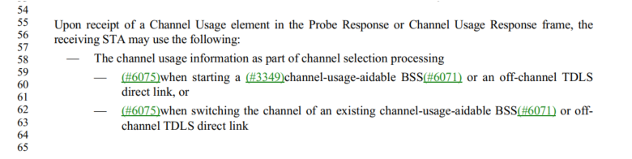
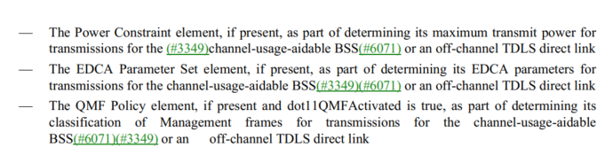
The above paragraph is for value 0, 1, and 2 only:
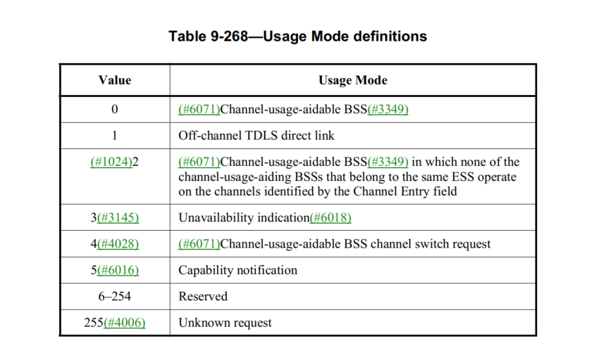Those descriptio

Proposed changes from the commenter:

Upon receipt of a Channel Usage element with the Channel Usage field set to 0, 1, or 2 (see Table 9-268) in the Probe Response or Channel Usage Response frame, the receiving STA may use the following:
- The channel usage information as part of channel selection processing
- (#6075)when starting a (#3349)channel-usage-aidable BSS(#6071) or an off-channel TDLS direct link, or
- (#6075)when switching the channel of an existing channel-usage-aidable BSS(#6071) or off-channel TDLS direct link
- The Power Constraint element, if present, as part of determining its maximum transmit power for transmissions for the (#3349)channel-usage-aidable BSS(#6071) or an off-channel TDLS direct link
- The EDCA Parameter Set element, if present, as part of determining its EDCA parameters for transmissions for the channel-usage-aidable BSS(#3349)(#6071) or an off-channel TDLS direct link
- The QMF Policy element, if present and dot11QMFActivated is true, as part of determining its classification of Management frames for transmissions for the channel-usage-aidable BSS(#6071)(#3349) or an off-channel TDLS direct link

Proposed Resolutions

Revised
Make the following changes:
Upon receipt of a Channel Usage element with the Channel Usage field set to 0, 1, or 2 (see Table 9-268) in the Probe Response or Channel Usage Response frame, the receiving STA may use the following:
- The channel usage information as part of channel selection processing
- (#6075)when starting a (#3349)channel-usage-aidable BSS(#6071) or an off-channel TDLS direct link, or
- (#6075)when switching the channel of an existing channel-usage-aidable BSS(#6071) or off-channel TDLS direct link
- The Power Constraint element, if present, as part of determining its maximum transmit power for transmissions for the (#3349)channel-usage-aidable BSS(#6071) or an off-channel TDLS direct link
- The EDCA Parameter Set element, if present, as part of determining its EDCA parameters for transmissions for the channel-usage-aidable BSS(#3349)(#6071) or an off-channel TDLS direct link
- The QMF Policy element, if present and dot11QMFActivated is true, as part of determining its classification of Management frames for transmissions for the channel-usage-aidable BSS(#6071)(#3349) or an off-channel TDLS direct link

7063 | 1168.00 | 9.4.2.84 | "The Channel Usage element defines the channel usage information for (#6071)channel-usage-aidable BSSs or an off channel TDLS direct link." is not correct. For example, the capability notification can be used for any BSS, not only for "channel-usage-aidable BSS". | delete "The Channel Usage element defines the channel usage information for (#6071)channel-usage-aidable BSSs or an off channel TDLS direct link". |  | MAC

Discussion
Cited text:

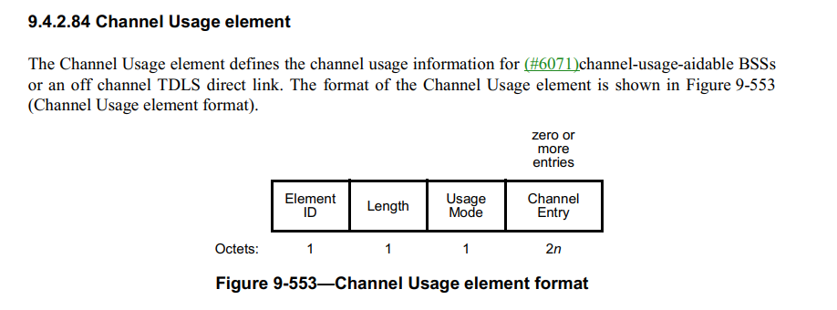
In the April ad hoc meeting, we discussed two options:

Option #1:
Change “The Channel Usage element defines the channel usage information for (#6071) channel-usage-aidable BSSs or an off channel TDLS direct link. “
To: “The Channel Usage element provides channel usage for a list of channels.”

Option #2: delete the sentence.

We had a straw poll in the Ad hoc meeting. The straw poll result was close between two options.

5/13/2024
Proposed an improved Option #1 Option #3:

Changed the cited the sentence to:
“The Channel Usage element defines channel usage information for a list of channels that is used in a BSS or an off channel TDLS direct link.”

Proposed Resolution:

Revised.
Change:
“The Channel Usage element defines the channel usage information for (#6071) channel-usage-aidable BSSs or an off channel TDLS direct link. “
To:
“The Channel Usage element defines channel usage information for a list of channels that is used in a BSS or an off channel TDLS direct link.”

7062 | 2781.00 | 11.21.15 | CID 6071 introduced the concepts of channel-usage-aidable BSS and channel-usage-aiding BSS. However, the channel usage procedure can also be used for capability notification, which can be used either in channel-usage-aidable BSS or channel-usage-aiding BSS. This paragrah is not accurage and need to be updated. | Updated this paragraph to include capability notificaiton usage. |  | MAC

Discussion:

Cited text:
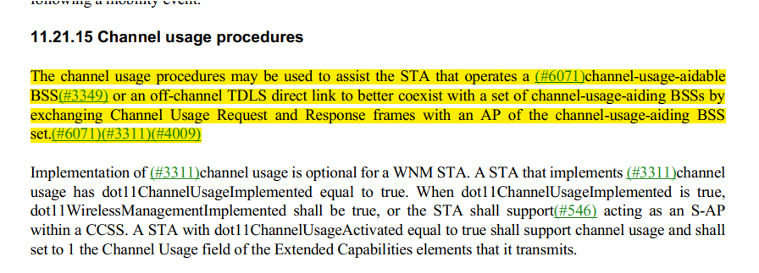

Proposed changes for CID 7062:

Change the paragraph at 2781.40 to 44 as below:

The channel usage procedures may be used:
- to assist the STA that operates a channel-usage-aidable BSS or an off-channel TDLS direct link to better coexist with a set of channel-usage-aiding BSSs by exchanging Channel Usage Request and Response frames with an AP of the channel-usage-aiding BSS set, or
- for a STA to request a channel switch by sending a Channel Usage Request frame to the AP of a channel-usage-aidable BSS, or
- for a STA to notify its associated AP of its capability by exchanging Channel Usage Request and Response frames with its associated AP.

Proposed Resolution:
Revised.
Incorporated changes under “Proposed changes for CID 7062”.

