IEEE P802.11
Wireless LANs
REVme CIDs assigned to Hamilton

Date: 2024-04-15
Author(s):
Name | Affiliation | Address | Phone | Email
Mark Hamilton | Ruckus/CommScope | 350 W Java Dr  Sunnyvale, CA, 94089 | +1 303 818 8472 | Mark.hamilton@commscope.com

Abstract
This document contains discussion and proposed resolutions for the following comments from TGme 2nd SA ballot, on IEEE P802.11-REVme/D5.0:

7188, 7105, 7106, 7108, 7113, 7114, 7107, 7115, 7103, 7116

All references are to D5.0 numbering.

Revision Notes

R0 – initial version, with proposed resolutions for CIDs 7188, 7113 (and 7202?), 7114 and 7107.
R1 –

CID 7188 (GEN):

CID | Clause | Page/Line | Comment | Proposed Change
7188 | 4.3.1 | 274.1 | Is the BSA "The area containing the members of a basic service set (BSS)." per Clause 3 or is it "the coverage area within which all the member STAs of the BSS can remain in communication" per Clause 4? The latter is typically bigger than the former, since if a STA moves a little further away it will typically still be able to be heard. | Change the Clause 3 definition to be the Clause 4 definition

Discussion:

P195.1 (clause 3.1):

Thus, a strict read of this says that the BSA is dynamically resizing, as it just (exactly) surrounds all the members of the BSS. For example, if no non-AP STA is very far from an AP (in an infrastructure BSA), then the BSA is fairly small.

In fact, an AP that has no associated non-AP STAs has an ill-defined BSA, because it is just the area that contains the AP. Is that just a few square centimeters? Or, is the BSA supposed to be the area covered by the AP’s transmissions (Beacons) – if so, to what signal level/SNR/etc?

But, in clause 4, we have (P274.1):

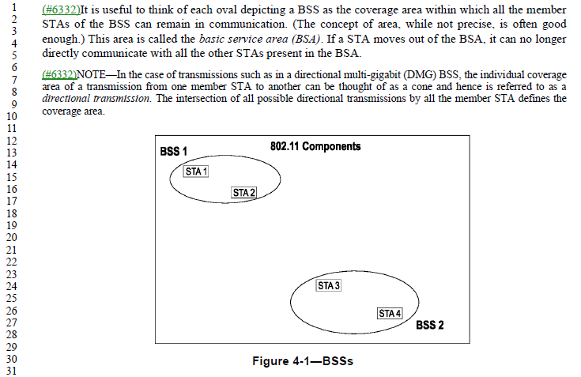

This has text saying it is “the coverage area within which all the members STAs can remain in communication.” That seems like a more useful definition, or at least closer to how we think about it.

Of course, this phrasing leaves some open questions:
- What is “the coverage area” – again, to what signal strength (or other measure) does the “coverage area” extend? And, in 4.3.6, there is a tidy statement: “For wireless PHYs, well-defined coverage areas simply do not exist.” Which points out that propagation is both dynamic and unpredictable.
- To which peer devices does a STA have to “remain in communication”? For an infrastructure BSS, that is probably each non-AP STA is in communication with the AP. But, they might not be “in communication” (within range) of each other. In an IBSS or PBSS, the STAs need only talk to the peer STAs of interest. Although, we then get into DMG clusters and PCPs…

Subclause 4.3.6 attempts to put human understandable concepts to this, in defining “area concepts” that are of interest to 802.11. That subclause is pretty clear that a strict definition will be both not accurate and not useful. The point of these terms (that use “area”) are to provide a useful human concept.

Proposed Resolution:

CID 7188: Revised.
At P195.1, change the definition of BSA to:
“The area in which the members of a basic service set (BSS) are able to communicate with each other sufficiently to provide the necessary services of the BSS, such as synchronization.

NOTE—The extent of a given BSA is unlikely to be strictly definable, nor static. See 4.3.6 for further discussion.”

CID 7113 (MAC):

CID | Clause | Page/Line | Comment | Proposed Change
7113 | 10.6.13.1 | 1971.33 | What is "OMN"? This term/acronym is not defined anywhere (and is used 6 times, including once claiming it is a type of frame). | Define OMN term/acronym in clause 3.

Discussion:

Examples of the 6 uses are:
P1971.34:
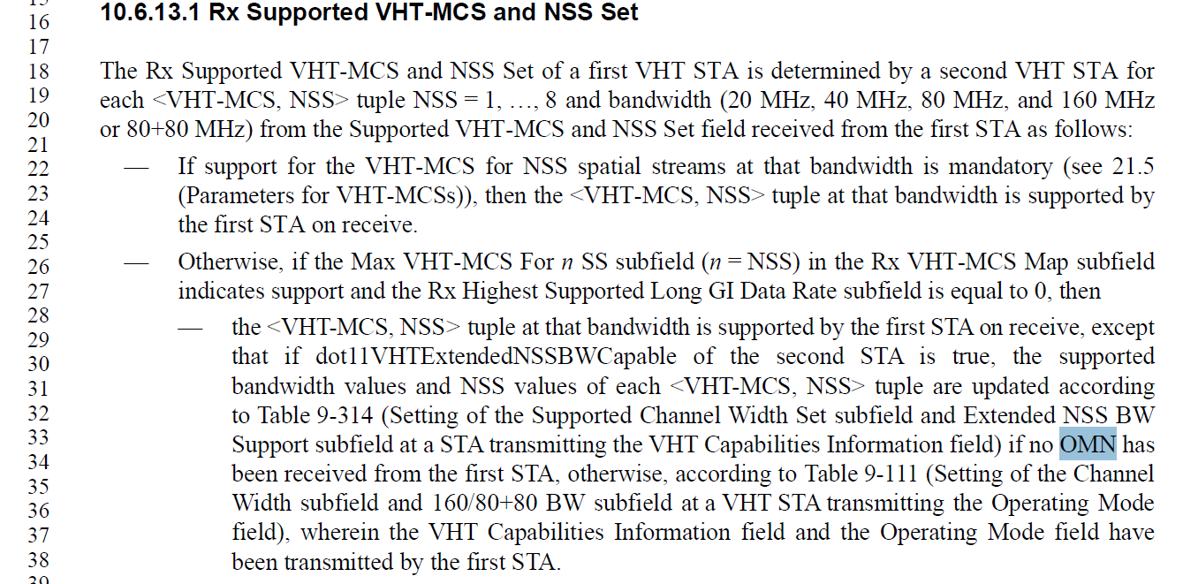
And, same thing in the next bullet, and in two bullets in TX Supported VHT-MCS and NSS Set.

P4148.44 (in 26.8.7.2 SST operation):

And P4190.3 (within the rules for Broadcast RU in HE MU PPDU):

Note that this CID overlaps with CID 7202 (which is in “Review”):
CID | Clause | Page/Line | Comment | Proposed Change
7202 | 26.15.7 | 4190.3 | "OMN frames" -- no such frames | Change to "Operating Mode Notification frames"
In this last location, the expansion of “OMN” and referencing “frames” seems appropriate.

At P4148.44, it also works to expand “OMN” to “Operating Mode Notification” as it applies to that ‘operation’.

However, at the P1971.34 location, there is no noun to go with an expanded “Operating Mode Notification” adjective. Suggest, from context, that since it talking about “no OMN has been received”, it seems to also be a reference to the frame.

Proposed Resolution (CID 7113):

At P1971.34, P1971.49, P1972.26, and P1972.43, replace “OMN” with “Operating Mode Notification frame”

At P4148.44 and P4190.3, replace “OMN” with “Operating Mode Notification”

Note to Editor: This is aligned with “Accepted” for CID 7202.

CID 7114(MAC):

CID | Clause | Page/Line | Comment | Proposed Change
7114 | 11.1.4.3.9 | 2479.51 | This isn't a sentence. Fix it to be something about the transmitting STA shall do something with the Number element. I don't know what it's supposed to say, sorry. | As in comment.

Discussion:

From 11.1.4.3.9 Contents of a probe response, on P2479.51:
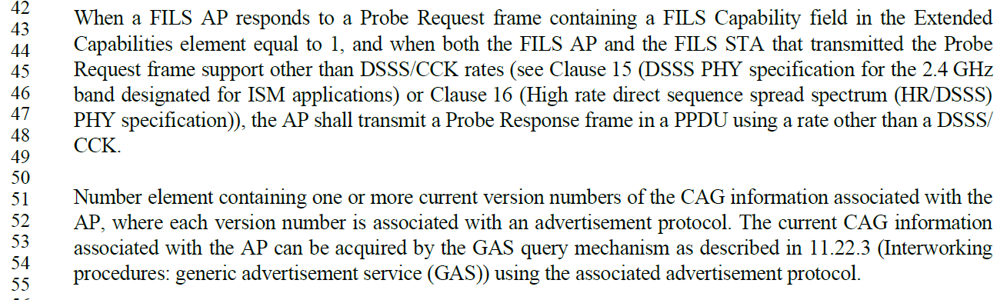

These paragraphs came from 802.11ai-2016, P102:
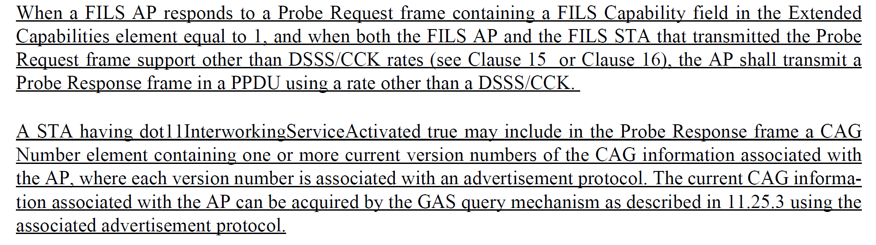

It appears that a line of text got lost, in IEEE Std 802.11-2020.

Proposed Resolution:

At P2479.51, Add to the start of this paragraph:
“A STA having dot11InternetworkingServiceActivated true may include in the Probe Response frame a CAG”

CID 7107 (SEC);

CID | Clause | Page/Line | Comment | Proposed Change
7107 | 12.7.8.2 | 3118.8 | The terms "TPK-KCK" and "TPK-TK" need to be understood in numerous places. Finding the definition (only) here is very awkward. | Add definitions for these terms in clause 3, and acronyms in 3.4.

Discussion:

The KCK (key confirmation key) concept, in general, is well defined in the definitions and acronyms.

P231.41:

P263.14:

There are KCKs for many keys, PTK, SAE, and PASN PTKSA, in addition to TPK. Each of these, is defined locally within their respective specifying subclauses. There appears no reason to make the TPK-KCK and TPK- different, by defining these terms differently and introducing more duplication in the Standard.

Proposed Resolution:

Rejected. There are KCKs for many keys, PTK, SAE, and PASN PTKSA, in addition to TPK. Each of these, is defined locally within their respective specifying subclauses. There appears no reason to make the TPK-KCK and TPK- different, by defining these terms differently and introducing more duplication in the Standard.

Not ready yet:

Purple indicates in “Discuss”

CID | Clause | Page/Line | Comment | Proposed Change
7105 | 9.3.3.5 | 738.20 | What does "ought" mean in this context? "Should"?? "Shall"?? Something non-normative?? Yes, clause 9 is generally not supposed to use normative verbs, but here the intent is now entirely unclear. | Replace "ought" with understandable phrasing. Same thing at P738.31, P741.57, P742.11, P746.48, P746.59, P752.17, P752.28, P757.16, P757.29, P760.16, and P761.11.
7106 | 9.4.2.23.3 | 1023.46 | There are "Editor's Note"s still in the draft | Clean up the "Editor's Note"s
7108 | 9.4.2.35 | 1067.64 | What exactly is the meaning of "DMG positioning". This should be a defined term or better description of when to set this bit. | Define "DMG positioning" term.
7115 | C.1 | 5252.24 | Which attributes only apply to the link with the AP? Do some atrributes only apply to the direct link then (and not the link with the AP), or even not to non-TDLS operation? This information should be in the DESCRIPTION of the affected attributes, not a hand-wave at the start of Annex C. | As in comment.
7103 | M.1 | 6103.19 | "As specified in IEEE Std 802, EPD encoding always starts with a Length/Type field…" IEEE Std 802 doesn't say that. In fact, IEEE Std 802's subclause on encoding is being re-written to clarify all the options for both EPD and LPD. This text needs to align. | (As IEEE Std 802 language stabilitzes) re-write this text to align.
7116 | R.3.2. | 6135.8 | Figure R-1 and text in R.3.2 is very confusing with respect to multiple BSSs served by "the same physical AP". This seems to be referencing an "AP device", perhaps? But the BSS(s?) in the figure are not separated, with a separate Portal for each. | As in comment.

