IEEE P802.11
Wireless LANs
Proposed Resolution for CID 7021
Date: 2024-05-14
Author(s):
Name | Affiliation | Address | Phone | email
Joseph LEVY | InterDigital Communication, Inc. | 111 W 33rd Street  New York, NY 10120 | +1.631.622.4139 | jslevy@ieee.org
Abstract
This document provides the context for the proposed resolution for CID 7021

R1: Edits to align with the comments made during the discussion in TGme 14 May 2024 AM2

CID 7021 - 4388.54
All "Tx antennas" in this paragraph should be "Tx antenna chains" | As in comment | Revised:  Replace “Tx antennas” with “transmitted space-time steams” in 5 locations in the paragraph.  Also, correct the requirement to ensure that each transmitted space-time stream is transmitted at a constant power level for each HE Ranging NDP PPDU.

4388.54:
“In each HE-LTF User Block within the HE-LTF field, the number of Tx antennas are the same as the number indicated in NUM_STS for the corresponding HE-LTF User Block and may vary from one HE-LTF User Block to another. Within the HE-STF Field, the number of Tx antennas should match the first HE-LTF User Block. In the pre-HE modulated fields, the number of Tx antennas used shall be no less than the minimum number of Tx antennas used in the HE modulated fields. The sum of the Tx power across all Tx antennas shall remain constant throughout the entire HE Ranging NDP PPDU.“

The intent of this paragraph is to ensure that each HE-LTF User Block is transmitted on a fixed set of space-time streams and that the power used to transmit it is constant on each of the space-time streams. Each space-time steam is defined by a single TX chain and a single TX antenna. Note, the single TX antenna is whatever is connected to the antenna port of the transmit chain, it could be single physical antenna or a set of physical antennas. Note for any single HE Ranging NDP the number of spatial streams is fixed (set by the HE-STF field) and the power on each spatial stream (each transmit chain) is constant for the entire NDP.

The use of the term “Tx antenna” to describe each of the spatial streams: Tx chains, and associated antennas is confusing, especially when looking at Figure 27-14 (see below). The statement that the number of Tx antennas are the same as the number of indicated in NUM_STS is also confusing as NUM_STS is the number of space-time streams.

Proposed text:
“In each HE-LTF User Block within the HE-LTF field, the number of transmitted space-time streams are indicated in NUM_STS for the corresponding HE-LTF User Block and may vary from one HE-LTF User Block to another. Within the HE-STF Field, the number of transmitted space-time streams should match the first HE-LTF User Block. In the pre-HE modulated fields, the number of transmitted space-time streams used shall be no less than the minimum number of transmitted space-time streams used in the HE modulated fields. The sum of the Tx power across all transmitted space-time streams shall remain constant throughout the entire HE Ranging NDP PPDU.“

For reference (4264.17):
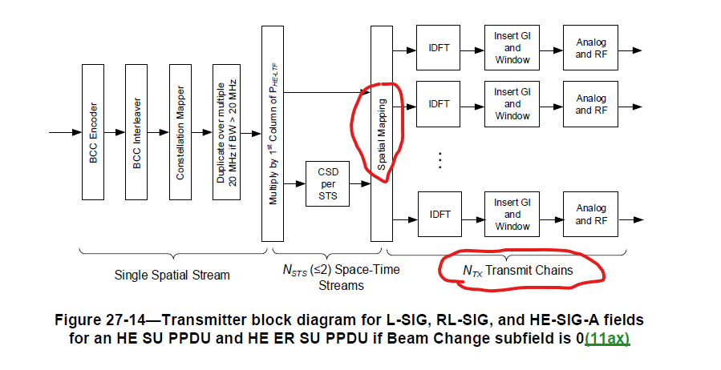

Also note the following editorial correction:
- Figure 27-50 (4387.60) the HE-LTF Field arrow has been shifted to the left, this arrow should begin at the same location as the 1st HE-LTF User Block and 1st HE-LTF Repetition Block arrows. Also, the HE-LTF Repetition Block for HE-LTF U2-A1 and HE-LTF U2-A2 is not drawn correctly as both blocks should be in a single HE-LTF Repetition Block (not two different repetition blocks), and this single repetition block is the HE-LTF User Block.
- “TX antenna” and “Tx antenna” are both present in the draft – There are 40 instances of “Tx antenna” (5 of which will be eliminated if the above change is acceptable) and 60 instances of “TX antenna”. Propose changing to TX every where.
Also note there are 1743 instances of TX, and 614 of Tx and there are 1183 instances of RX and 511 of Rx. Suggest these should all be cleaned up, but it is a big job as many of them are in figures.
References:

