IEEE P802.11
Wireless LANs
CR for CID 22344
Date: 2024-03-11
Author(s):
Name | Affiliation | Address | Phone | Email
Jinyoung Chun | LG Electronics | 19, Yangjae-daero 11gil, Seocho-gu, Seoul 137-130, Korea |  | jiny.chun@lge.com
Dongguk Lim |  |  |  | dongguk.lim@lge.com
Eunsung Park |  |  |  | esung.park@lge.com
Insik Jung |  |  |  | insik0618.jung@lge.com
Jinsoo Choi |  |  |  | js.choi@lge.com

Abstract
This submission proposes comment resolutions for CID 22344.
All the changes are based on Draft P802.11be D5.0 for SA ballot.

Revisions:
- Rev 0: Initial version of the document.

CID | Commenter | Page | Comment | Proposed Change | Resolution
22344 | Alfred Asterjadhi | 831.38 | [Xiaogang Chen] "K_r^EHT-LTF is the cardinality of the set of modulated subcarriers within for the EHT-LTF field as defined in 27.3.10 (Mathematical description of signals)." is not correct. | change to "K_r^EHT-LTF is defined in eq (36-10)" | Revised  Agree with the commenter, and more discussion is as below.  Note to Editor:  Please see the proposed text change below CID 22344 in 11-24/0434r0.
Background in Page 828~829 of 11be D5.0:
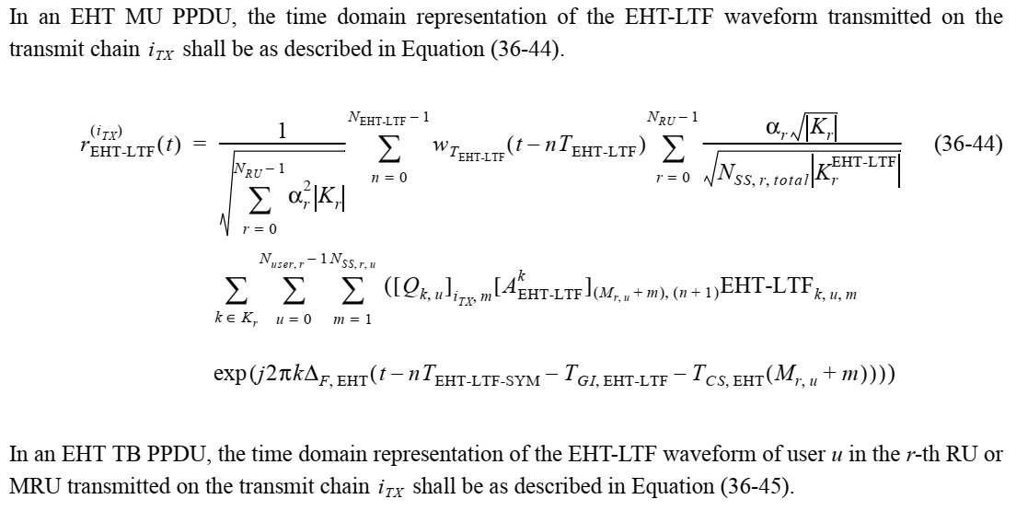
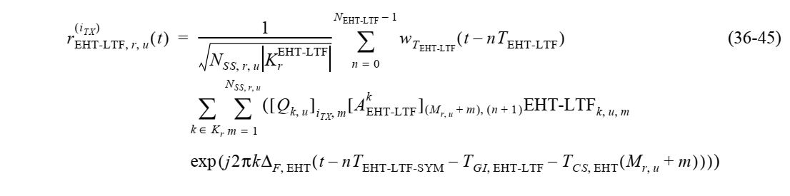
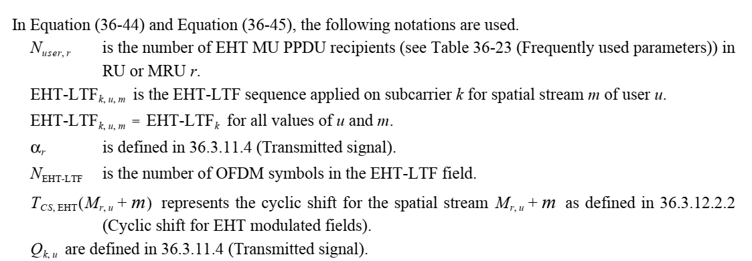
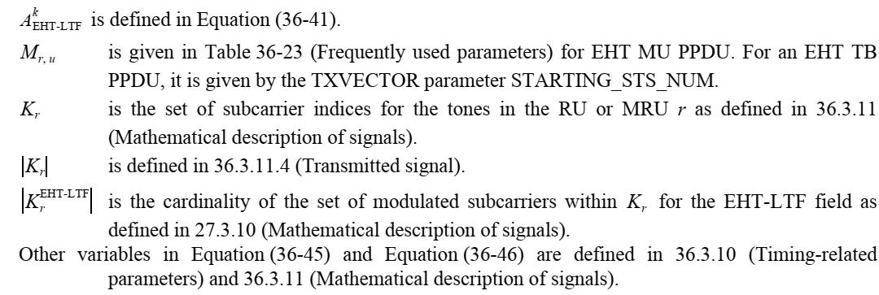

[Discussion]
$\left|K_{r}\right|$ and $\left|K_{r}^{EHT_LTF}\right|$ are defined after Equation (36-11) in Subclause 36.3.11.4 Transmitted signal. And $\left|K_{r}^{EHT_LTF}\right|$ equals to $Γ_{r}^{EHT_LTF}$. So it’s better to change $\left|K_{r}^{EHT_LTF}\right|$ to $Γ_{r}^{EHT_LTF}$. It’s the same way with HE-LTF in REVme.
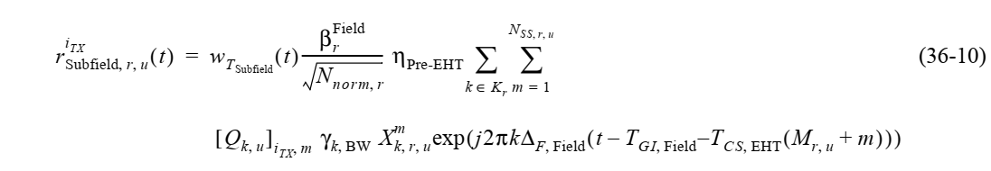
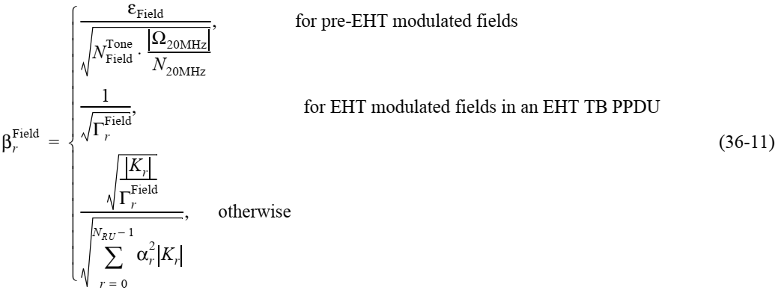
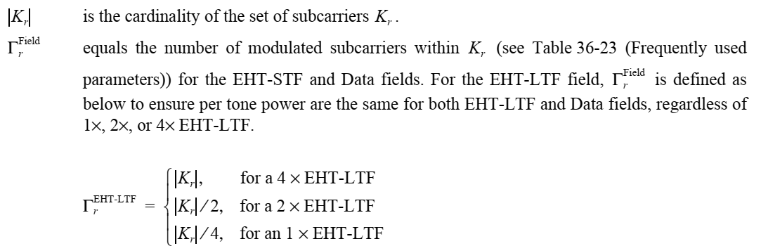

Proposed text change from P828L41 in 11be D5.0 for SA ballot.
In an EHT MU PPDU, the time domain representation of the EHT-LTF waveform transmitted on the transmit chain i_{TX} shall be as described in Equation (36-44).
rEHT-LTFiTX(t)=1r=0NRU-1αr2Krn=0NEHT-LTF-1wTEHT-LTFt-nTEHT-LTFr=0NRU-1αrKrNSS,r,totalKrEHT-LTFΓrEHT-LTF
$\sum_{k∈K_{r}}{\sum_{u=0}^{N_{user,r}-1}{\sum_{m=1}^{N_{SS,r,u}}{({\left[Q_{k,u}\right]}_{i_{TX},m}{\left[A_{\text{EHT-LTF}}^{k}\right]}_{\left(M_{r,u}+m\right),\left(n+1\right)}{\text{EHT-LTF}}_{k,u,m}}}}$ (36-44)
$\exp{(j2πk∆_{F,EHT}(t-nT_{\text{EHT-LTF-SYM}}-T_{GI,\text{EHT-LTF}}-T_{CS,EHT}(M_{r,u}+m)})))$

In an EHT TB PPDU, the time domain representation of the EHT-LTF waveform of user u in the r-th RU or MRU transmitted on the transmit chain i_{TX} shall be as described in Equation (36-45).
rEHT-LTF,r,uiTX(t)=1NSS,r,uKrEHT-LTFΓrEHT-LTFn=0NEHT-LTF-1wTEHT-LTFt-nTEHT-LTF (36-45)
$\sum_{k∈K_{r}}{\sum_{m=1}^{N_{SS,r,u}}{({\left[Q_{k,u}\right]}_{i_{TX},m}{\left[A_{\text{EHT-LTF}}^{k}\right]}_{\left(M_{r,u}+m\right),\left(n+1\right)}{\text{EHT-LTF}}_{k,u,m}}}$
$$\exp{(j2πk∆_{F,EHT}(t-nT_{\text{EHT-LTF-SYM}}-T_{GI,\text{EHT-LTF}}-T_{CS,EHT}(M_{r,u}+m)})))$$

In Equation (36-44) and Equation (36-45), the following notations are used.
$N_{user,r}$ is the number of EHT MU PPDU recipients (see Table 36-23 (Frequently used parameters)) in RU or MRU r.
${\text{EHT-LTF}}_{k,u,m}$ is the EHT-LTF sequence applied on subcarrier k for spatial stream m of user u.
${\text{EHT-LTF}}_{k,u,m}={\text{EHT-LTF}}_{k}$ is for all values of u and m.
$α_{r}$ is defined in 36.3.11.4 (Transmitted signal).
$N_{\text{EHT-LTF}}$ is the number of OFDM symbols in the EHT-LTF field.
$T_{CS,EHT}(M_{r,u}+m)$ represents the cyclic shift for the spatial stream $M_{r,u}+m$ as defined in 36.3.12.2.2 (Cyclic shift for EHT modulated fields).
$Q_{k,u}$ are defined in 36.3.11.4 (Transmitted signal).
$A_{\text{EHT-LTF}}^{k}$ is defined in Equation (36-41).
$M_{r,u}$ is given in Table 36-23 (Frequently used parameters) for EHT MU PPDU. For an EHT TB PPDU, it is given by the TXVECTOR parameter STARTING_STS_NUM.
$K_{r}$ is the set of subcarrier indices for the tones in the RU or MRU r as defined in 36.3.11 (Mathematical description of signals).
Kr
KrEHT-LTF
Kr and $Γ_{r}^{\text{EHT-LTF}}$ are defined after Equation (36-11) in 36.3.11.4 (Transmitted signal).
Other variables in Equation (36-45) and Equation (36-46) are defined in 36.3.10 (Timing-related parameters) and 36.3.11 (Mathematical description of signals).

