IEEE P802.11
Wireless LANs
LB281 resolutions on editorial comments
Date: 2024-02-29
Author(s):
Name | Affiliation | Address | Phone | email
Narengerile | Huawei | Shenzhen, China |  | narengerile@huawei.com
Rui Du
Mengshi Hu
Zhuqing Tang
Yiyan Zhang

Abstract
This document proposes the LB281 comment resolution for CIDs 4267, 4268, 4270, and 4271.

R0: initial version on Feb 29, 2024.
R1: revised version on March 10, 2024. Editorial changes applied.

4267
CID | Clause | Page | Comment | Proposed change | Proposed resolution
4267 | 9.3.1.22.14.1 | 36.43 | Receiving a Sensing Measurement Request frame does not mean a session is established and TB measurement exchanges are to be performed. Only accepting a Sensing Measurement Request frame will lead to the transmission of any subsequent Trigger frame in the TB measurement exchanges. | Suggest change 'received' to 'accepted'. | Accepted.
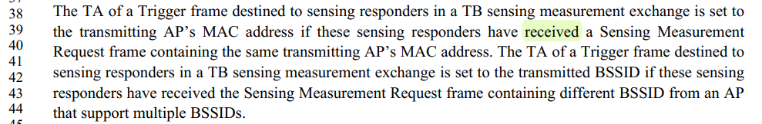

4268, 4270, 4271
CID | Clause | Page | Comment | Proposed change | Proposed resolution
4268 | 9.3.1.22.14.3 | 37.52 | The Sensing Polling Trigger frame may not be present in a TB sensing measurement exchange. Therefore, the AID/USID field cannot be identical to the same field in the Sensing Polling Trigger frame. The AID/USID12 field should be set to the AID/USID of the sensing responders that are the intended recipients of the SR2SI Sounding Trigger frame. | Please revise the sentence. | Revised.  Agree with the commenter. Please refer to the modifications with #4268 in DCN 24/0383r1: https://mentor.ieee.org/802.11/dcn/24/11-24-0383-01-00bf-lb281-resolutions-on-editorial-comments.docx
4270 | 9.3.1.22.14.5 | 39.21 | The Sensing Polling Trigger frame may not be present in a TB sensing measurement exchange. Therefore, the AID/USID field cannot be identical to the same field in the Sensing Polling Trigger frame. The AID/USID12 field should be set to the AID/USID of the sensing responders that are the intended recipients of the Sensing Reporting Trigger frame. | Please revise the sentence. | Revised.  Agree with the commenter. Please refer to the modifications with #4270 in DCN 24/0383r1: https://mentor.ieee.org/802.11/dcn/24/11-24-0383-01-00bf-lb281-resolutions-on-editorial-comments.docx
4271 | 9.3.1.22.14.6 | 40.61 | The Sensing Polling Trigger frame may not be present in a TB sensing measurement exchange. Therefore, the AID/USID field cannot be identical to the same field in the Sensing Polling Trigger frame. The AID/USID12 field should be set to the AID/USID of the sensing responders that are the intended recipients of the SR2SR Sounding Trigger frame. | Please revise the sentence. | Revised.  Agree with the commenter. Please refer to the modifications with #4271 in DCN 24/0383r1: https://mentor.ieee.org/802.11/dcn/24/11-24-0383-01-00bf-lb281-resolutions-on-editorial-comments.docx

Discussions:
The current spec refers to the AID12/USID12 field in the Sensing Polling Trigger frame to define AID12/USID12 fields in the SR2SI Sounding Trigger frame, Sensing Reporting Trigger frame and SR2SR Sounding Trigger frame, which is inaccurate because an associated STA can be assigned not to be polled in a TB sensing measurement exchange and participate directly in an SR2SI sounding phase, or an NDPA sounding/SR2SR sounding phase followed by a reporting phase. In such cases, there isn’t a field as “the corresponding subfield in the Sensing Polling Trigger frame”.
The AID12/USID12 field within each trigger frame should identify the intended recipient of this trigger frame. Therefore, to avoid confusion, the following modifications are proposed.

Modifications:
To TGbf editor: Please modify the text on P37L52 in D3.0 as follows.
The AID12/USID12 field contains the 12 least significant bits of the AID of an associated STA or the USID of an unassociated STA that is the intended recipient of the SR2SI Sounding Trigger frame.(#4268)

To TGbf editor: Please modify the text on P39L21 in D3.0 as follows.
The AID12/USID12 field contains the 12 least significant bits of the AID of an associated STA or the USID of an unassociated STA that is the intended recipient of the Sensing Reporting Trigger frame.(#4270) The UL FEC Coding Type and UL Target Receive Power fields are identical to the corresponding fields in the Basic Trigger frame; see 9.3.1.22 (Trigger frame format).

To TGbf editor: Please modify the text on P40L61 in D3.0 as follows.
The AID12/USID12 field contains the 12 least significant bits of the AID of an associated STA or the USID of an unassociated STA that is the intended recipient of the SR2SR Sounding Trigger frame.(#4271)

SP:
Do you agree to the resolution provided for CIDs 4267, 4268, 4270, and 4271 in 24/0383r1 to be included in the latest 11bf Draft?
Y/N/A

