IEEE P802.11
Wireless LANs
Comment resolutions for Reference Model (4.9.6)
Date: 2024-05-06
Author(s):
Name | Affiliation | Address | Phone | email
Sanket Kalamkar | Qualcomm Technologies Inc | 5665 Morehouse Drive, San Diego, CA 92131 |  | sankal@qti.qualcomm.com
Duncan Ho | Qualcomm Technologies Inc | 5665 Morehouse Drive, San Diego, CA 92131 | (858)829-9509 | dho@qti.qualcmom.com
Abstract
This submission proposes resolutions for following CIDs received for TGbe D5.0:

22007, 22008, 22291, 22293

22016, 22017, 22229, 22206

Revisions:
- Rev 0: Initial version of the document.
- Rev 1: Added the DCN to the document
- Rev 2: Updated text pertaining to CID 22206 based on the discussion in TGbe meeting (04/24/2024)
- Rev 3: Addressed the rest of the CIDs, i.e., 22007, 22008, 22291, and 22293

TGbe editor: The baseline for this document is 11be D5.0

Interpretation of a Motion to Adopt

A motion to approve this submission means that the editing instructions and any changed or added material are actioned in the TGbe Draft. This introduction is not part of the adopted material.

Editing instructions formatted like this are intended to be copied into the TGbe Draft (i.e., they are instructions to the 802.11 editor on how to merge the text with the baseline documents).

TGbe Editor: Editing instructions preceded by “TGbe Editor” are instructions to the TGbe editor to modify existing material in the TGbe draft. As a result of adopting the changes, the TGbe editor will execute the instructions rather than copy them to the TGbe Draft.

CID | Commenter | Clause | Pg/Ln | Comment | Proposed Change | Resolution
22016 | Mark Hamilton | 4.9.6 | 75.46 | There is only one upper MAC sublayer in an MLD. "in each upper MAC sublayer component" doesn't make sense. | Delete "in each upper MAC sublayer component". | Accepted
22017 | Mark Hamilton | 4.9.6 | 76.51 | A few incorrect "lower MAC sublayer(s)" are still in the draft. Also one snuck through as "sub-layer". | Replace "sublayers" with "entities" at P76.51. Replace "sub-layer" with "entity" at P76.52. Replace "sublayer" with "entity" at P79.28, and P82.25. In Figure 7-1, change "MLMS" to "MLME" (4x in the drawing, and 1 in the legend) and change "MLD Lower MAC Sublayer" to "MLD Lower MAC Entity" in the legend. In Figure 7-2, change "MLD lower MAC sublayer" to "MLD lower MAC entity" (2x). Replace "sublayer components" with "entities" at P75.58. | Accepted
22206 | Osama Aboulmagd | 4.9.6 | 71.27 | Communication over links using different frequency bands or channels can occur simultaneously or not depending on the capabilities of both the AP MLD and the non-AP MLD. Does the word "channels" mean within the same band. If so please explicitly mention channels in the same band | As in comment | Revised  Agree with in the commentator in principle.  Updated the text to clarify that “different channels on different frequency bands or the same frequency band.”  TGbe Editor: please implement the changes shown in this document tagged as #22206.
22229 | Stephen McCann | 4.9.6 | 72.10 | In Figure 4-30a, the AP MLD indication in the top dashed box is incorrect. The AP MLD comprises both the Upper MAC sublayer and the lower MAC sublayer. This is correctly shown in Figure 4-30c. | Move the term AP MLD from the top left hand corner of Figure 4-30a lower down, so that it indicates both the Upper MAC sublayer and the Lower MAC sublayer. A corresponding change needs to be made to the Non-AP MLD indication in the lower part of the same Figure. | Revised  Agreed with the commentator in principle. Added a one additional box encapsulating both the Upper MAC sublayer and the Lower MAC entity and moved the AP MLD indication within the newly added box. Same for the Non-AP MLD indication. The revised Visio file will be shared with the editor.
22007 | Mark Hamilton | 4.9.6 | 75.04 | If there is only one MLME (or at least only one MLME SAP) in an MLD, then is there also only one PLME/PLME-SAP? | Along with clarifying a single MLME in Figure 4-30b (as requested in another comment), there needs to be only one PLME/PLME-SAP. | Rejected.  The comment fails to identify a technical issue. In a response to the question, there are multiple PLME/PLME SAPs as shown in Figure 4-30b.
22008 | Mark Hamilton | 4.9.6 | 75.35 | The text and Figure 4-30b don't align. The text says "MLME primitives are invoked through a single MLME SAP." But, Figure 4-30b shows multiple MLME SAPs. | The commenter will bring a submission. | Revised.  Agree in principle with the comment that there is an inconsistency.  The proposed resolution is to remove “single” since it causes confusion. There is also one other instance where this inconsistency is present (see 83.13).  TGbe editor to replace “a single” with “an” in the cited text.  Also, TGbe editor to replace “a single” with “an” in (83.13).
22291 | Brian Hart | 4.9.6 | 76.15 | Very unclear how the MLD SAPs are used for groupcast. Fig 4-30a and fig 4-30b disagree with Fig 4-40c/d; and Fig 4-40c/d are unmoored from SAPs or anything definite so offer little insight. | 1. Move more detailed clause 4 work (e.g., fig 4-30c/d) to clause 5 so there is a single point of truth 1a. Having the groupcast topic split across clause 4 and 5 is unhelpful; if it was all in one place then we can avoid tripping up the reader. 2. Add normative text that AP MLD is part of the same DS (or ESS) as its affiliated APs 3. Check instances of groupcast throughout draft and check we’re using “AP MLD disseminates …” rather than anything else 4. Enhance 4-30b/c/d: 4a. Fig 4-30b: change caption to “(i.e., an AP1/2 affiliated with an AP MLD with no non-MLD STAs” [since there is only a MAC SAP for the AP MLD, not any SAPs for the affiliated APs)] 4b. Fig 4-30c “High level architecture” caption seems too strong, given that it is far from complete in terms of groupcast etc. The text calls this “high level structure” 4c. Fig 4-30c – groupcast is only shown as appearing outside the AP MLD but from elsewhere this is clearly not the case. Please apply something / anything to indicate that this is not the whole story. 4c.i. For instance, this figure strongly suggests there are two interfaces above the legacy APs – not the one MAC SAP 4c.ii. How about something at top of AP MLD (“initial groupcast processing”). Or something above affiliated AP + AP MLD boxes. Or something else again (see next) 4d. Fig 4-30c – Something more complete that e.g., (AP MLD / initial groupcast processing ? dissemination x2 ? affiliated AP x2) 5. It would be really helpful to have a figure showing the typical and important case of both two legacy APs and an MLD being present, and all the SAPs. 5a. i.e., an enhancement to the figures mentioned above | Revised.  For point #1, #2, #3: The comments ask how groupcast frames are delivered. The rules how groupcast delivery is performed are clearly stated in Subclause 35.3.15 (MLO group addressed frames).  For point #4.a: No changes required since the figure applied to both the AP MLD and non-AP MLD.  For point #4.b: Agree with the comment in that there is inconsistency in the caption of Figure 4-30c and the text. The proposed resolution is to change the word “architecture” in the caption of Figure 4-30c to “structure.”  For point #4.c: The comment is unclear in that what is means something / anything in the following part of the comment: “Please apply something / anything to indicate that this is not the whole story.”  For points #4.d, #5, and #5.a: the comments fail to identify a technical issue. The rules how groupcast delivery is performed are clearly stated in Subclause 35.3.15 (MLO group addressed frames).  TGbe editor to change the word “architecture” to “structure” in the caption of Figure 4-30c as well in (74.2).
22293 | Brian Hart | 4.9.6 | 75.16 | It seems that, now we've introduced the MLD, the MLME needs to adapt: one MLME comprising a single upper MLME at the MLD level and multiple lower MLMEs at the STA/link level. Since all MIB variables pre-11be were designed to operate at the STA level, by default they should remain there, with one instance per lower MLME; however 11be is moving some functions to the MLD level (e.g., BA), and MIB variables associated with those functions now need to be identified as singleton MLD-level MIB variables. 1) Figure 4-30b shows two MLME-SAPs, one for the left MLME and one for the right MLME, with internal interfaces to the MLD Upper MAC sublayer. This does not highlight the new architecture and a new figure is required (commenter can provide it). 2) MLME-GET/SET needs to be updated for an upper MLME and multiple lower MLMEs. 3) Since semantically some MIB variables are per STA and others are for the MLD, it needs to be documented which is which? | Do the required architectural work as in the comment, perhaps in consultation with ARCH. I recommend adding “This is an upper-MLD variable” / “This is a lower-MLME variable” to each MIB variable description. Then say something like at the start “This ASN.1 definition is for a non-MLD STA. For an MLD STA, duplicate the MIB for the upper MLME & each lower MLME, then reserve fields according to “This is a lower-MLME variable” & “This is an upper-MLD variable” respectively" (or omit them entirely) (i.e., creating a split MIB is the reader’s responsibility) | Revised.  The comment brings an interesting point from an interface perspective. However, performing all these changes does not fix any technical inconsistency since these are internal variables and need not be exposed whether they are at the MLD level or at the link level.  However, to fix inconsistency with the text and figure, we propose to remove “single” (75.35) since it causes confusion.  For (75.35), TGbe editor to replace “a single” with “an” in “MLME primitives are invoked through an MLME SAP.”  There is also one other instance where this inconsistency is present (83.13).  TGbe editor to replace “a single” with “an” in (83.13).

TGbe Editor: Change the paragraph below of this subclause as follows (#CID 22206):
4.9.6 Reference model for multi-link operation (MLO)

MLO defines a set of procedures allowing communication over one or more links between MLDs. An MLD manages such communication over one or more links. Communication over links using different channels on different frequency bands or the same frequency band (#22206) can occur simultaneously or not depending on the capabilities of both the AP MLD and the non-AP MLD (see 35.3.16.3 (Simultaneous transmit and receive (STR) operation) and 35.3.16.4 (Nonsimultaneous transmit and receive (NSTR) operation)).

TGbe Editor: Change the figure below of this subclause as follows (#CID 22229):

TGbe Editor: Change the paragraph below on page 75 of Subclause 4 as follows (#CID 22008, #CID 22293):
An MLD supports multiple MAC functions, coordinated by an SME. Each affiliated STA is enumerated with a Link ID (for example, as Link 1 and Link 2 in Figure 4-30b (Reference model for an MLD for two links)) and MLME primitives are invoked through an MLME SAP.

TGbe Editor: Change the paragraph below on page 83 of Subclause 6 as follows (#CID 22008, #CID 22293):
For MLO, the MLD SME invokes MLME SAP primitives through an MLME SAP. When a primitive is invoked for an affiliated STA, the affiliated STA can be identified by its Link ID.

TGbe Editor: Change the caption of Figure 4-30c and the following paragraph on page 74 in Subclause 4 as follows (#CID 22291):
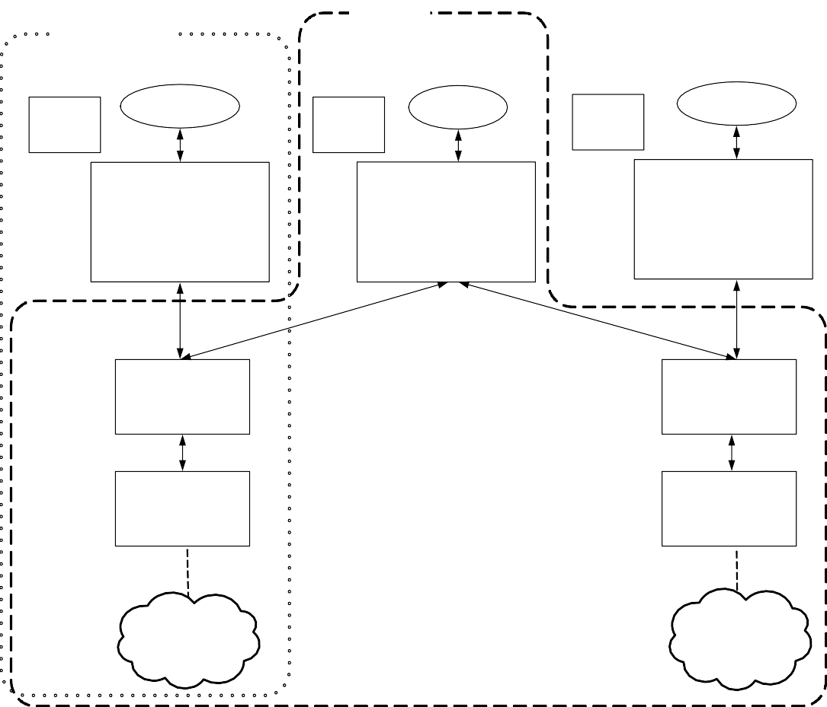
AP MLD
Affiliated AP
Affiliated AP
IEEE 802.1X
Authenticator
Non-MLD Data
frames
IEEE 802.1X
Authenticator
MLD Data
frames
IEEE 802.1X
Authenticator
Non-MLD Data
frames
Non-MLD upper MAC sublayer
(traffic to/from non-MLD peer STAs and group addressed MLD traffic)
MLD upper MAC sublayer
(individually addressed traffic to/from MLD peer STAs)
Non-MLD upper MAC sublayer
(traffic to/from non-MLD peer STAs and group addressed MLD traffic)
MLD lower MAC
entity
MLD lower MAC
entity
PHY 1
PHY n
Link 1 BSS
Mixed (MLO & non-MLO)
Link n BSS
Mixed (MLO & non-MLO)

Figure 4-30c—High level structure for AP MLD with affiliated APs

STAs. The high-level structure of an AP MLD along with its affiliated APs is shown in Figure 4-30c (High level structure for AP MLD with affiliated APs).

===============================================================================
Do you agree to the resolution provided in doc 11-24/0364r2 for the following CIDs?

22007, 22008, 22291, 22293

22016, 22017, 22206, 22229

