IEEE P802.11
Wireless LANs
CID 4047 in LB 281
Date: 2024-02-26
Author(s):
Name | Affiliation | Address | Phone | email
Xiandong Dong | Xiaomi |  |  | dongxiandong@xiaomi.com
Abstract
This submission proposes resolutions for following 1 CID received for LB281: 4047
The proposed changes are based on 802.11bf D3.0

Revisions:
- Rev 0: Initial version of the document.

CID | Commenter | Clause | Page | Comment | Proposed Change | Resolution
4047 | Chaoming Luo | 11.55.2.2 | 164.29 | The sentence "The SBP Request frame shall include a valid SBP Parameters element and a Sensing Measurement Parameters element." does not give much information, since we have detailed text saying how to set the fields. | Remove the commented sentence. | Revised  See proposed change below in <DCN11-24/0333r0>

Discussion
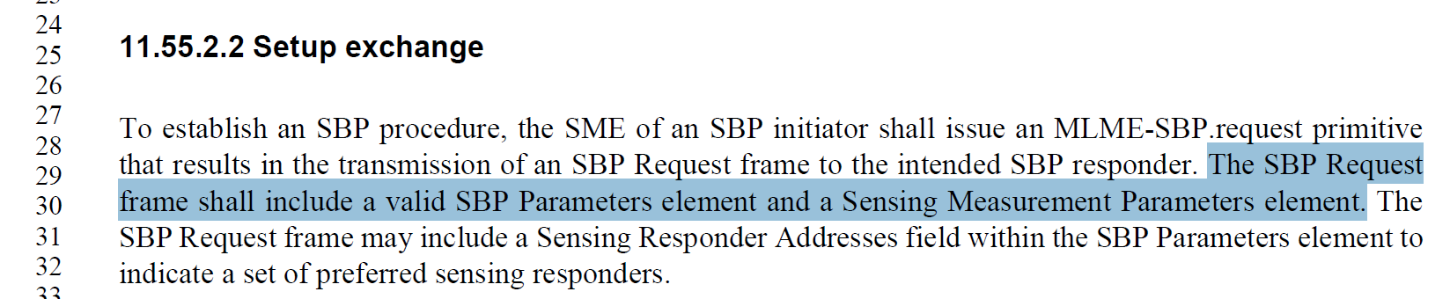

TGbf Editor: Please revise the sentence starting at P164L29 of Clause 11.55.2.2 of D3.0 as follows.

To establish an SBP procedure, the SME of an SBP initiator shall issue an MLME-SBP.request primitive that results in the transmission of an SBP Request frame to the intended SBP responder. The SBP Request frame shall include a SBP Parameters element and a Sensing Measurement Parameters element.(#4047) The SBP Request frame may include a Sensing Responder Addresses field within the SBP Parameters element to indicate a set of preferred sensing responders.

SP: Do you support the resolution to the following 1 CIDs and to incorporate the changes proposed in IEEE 802.11-24/0333r0to the latest 11bf draft for the following CIDs: 4047?

