IEEE P802.11
Wireless LANs
LB281 comment resolutions for DMG Part 2
Date: 2024.03.xx
Author(s):
Name | Company | Address | Phone | email
Rui Du | Huawei Technologies | F3, Huawei Base, Shenzhen, Guangdong, China, 518129 |  | Ray.du@huawei.com
Narengerile
Zhuqing Tang
Yiyang Zhang
Abstract
This submission contains the proposed comment resolutions for the CIDs 4195 and 4071.

R0: initial document

CID 4195

CID | Page.  Line | Clause Number | Comment | Proposed Change | Resolution
4195 | 175.43 | 11.55.3.4 DMG sensing measurement session | Will the number of beam indicies included in the TX Beam List subelement equals to the number of beam indicies included in the RX Beam List subelement? | Please clarify it and add normative text if it is needed. | Rejected.

Rejected Reason:

In P188L10, there is a paragraph describes the cases when the number of Tx beams is not equal to the number of Rx beams. For different cases, 3 different BRP PPDUs can be used.

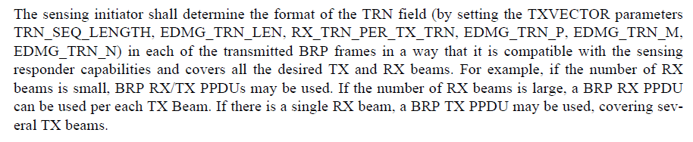

Based on what we have in 11bf D3.0, this comment is rejected.

CID 4071

CID | Page.  Line | Clause Number | Comment | Proposed Change | Resolution
4071 | 74.20 | 9.4.2.320 | The NOTE after Table 9-404u is confusing. Which of the following subelements and combinations are allowed and which not?  1. Non-TB Sensing Specific subelement  2. TB Sensing Specific sublement  3. SBP Specific sublement  4. Non-TB Sensing Specific subelement + TB Sensing Specific sublement  5. TB Sensing Specific sublement + TB Sensing Specific sublement  6. SBP Specific sublement + TB Sensing Specific sublement  7. Non-TB Sensing Specific subelement + TB Sensing Specific sublement + SBP Specific sublement  8. Non-TB Sensing Specific subelement + TB Sensing Specific sublement + SBP Specific sublement + TB Sensing Specific sublement  Possibly others?  If particular combinations are only allowed or possible, should this not be normative instead of an informative NOTE? | If it was meant that options 1, 2, and 6 are only allowed, then change the note to the following statement:  A Sensing subelements field contains one of the following subelements or sublement combination:  - Non-TB Sensing Specific subelement  - TB Sensing Specific subelement  - SBP Specific subelement and TB Sensing Specific subelement | Revised.  TGbf Editor make changes specified in 24/0308r0.  (https://mentor.ieee.org/802.11/dcn/24/11-24-0308-00-00bf-lb281-comment-resolutions-for-dmg-part-2.docx)

Instructions to the editor: please make the following changes to paragraphs from P74L20 to P74L22 in the subclause 9.4.2.320 Sensing Measurement Parameters element in D3.0 as shown below:

NOTE—A Sensing subelements field can contain either one Non-TB Sensing Specific subelement, one TB Sensing Specific subelement, or one SBP Specific subelement and one TB Sensing Specific subelement.

SP
Do you support resolutions to the following CIDs and incorporate the text changes into the latest TGbf draft: 4195 and 4071 in 11-24/0308r0?

Y/N/A

