IEEE P802.11
Wireless LANs
LB281 comment resolutions for Exchange part 2
Date: 2024.02.xx
Author(s):
Name | Company | Address | Phone | email
Rui Du | Huawei Technologies | F3, Huawei Base, Shenzhen, Guangdong, China, 518129 |  | Ray.du@huawei.com
Narengerile
Zhuqing Tang
Yiyan Zhang
Abstract
This submission contains the proposed comment resolutions for the CIDs 4079, 4081 and 4204.

R0: initial document
R1: editorial modifications for CID 4081 based on the discussions.

CID 4079

CID | Page.  Line | Clause Number | Comment | Proposed Change | Resolution
4079 | 146.24 | 11.55.1.5.2.1 | The fourth bullet looks wrong because, without "alone", it can be interpreted as "A TB sensing measurement exchange shall not consist of a polling phase and a reporting phase". It should be "- only a polling phase and a reporting phase." | In the fourth bullet, add "only" before "a polling phase". | Accepted.

Instructions to the editor: please make the following changes to paragraphs from P146L17 to P146L24 in the subclause 11.55.1.5.2.1 General in D3.0 as shown below:

A TB sensing measurement exchange shall not consist of
— a reporting phase alone,
— an NDPA sounding phase alone,
— a TF sounding phase of the SR2SR variant alone in which the sensing responder is a sensing
receiver, or
— only a polling phase and a reporting phase.

CID 4081

CID | Page.  Line | Clause Number | Comment | Proposed Change | Resolution
4081 | 32.45 | 9.3.1.19.5 | The RA field is set to the address of that AP, not that STA, please modify it. | as in comment | Revised.  TGbf Editor make changes specified in 24/0307r1.  (https://mentor.ieee.org/802.11/dcn/24/11-24-0307-01-00bf-lb281-comment-resolutions-for-exchange-part-2.docx)

Instructions to the editor: please make the following changes to the paragraph from P32L43 to P32L46 in the subclause 9.3.1.19.5 Sensing NDP Announcement frame format in D3.0 as shown below:

In a non-TB sensing measurement exchange (see 11.55.1.5.3 (Non-TB sensing measurement exchange)), there is only one intended recipient STA, which is an AP, and the RA field is set to the address of that AP.

CID 4204

CID | Page.  Line | Clause Number | Comment | Proposed Change | Resolution
4204 | 33.40 | 9.3.1.19.5 Sensing NDP Announcement frame format | Do we need to separate Figure 9-75o into 2 subcases (one for TB and one for non-TB) ? Just like Figure 9-75l and Figure 9-75m. | Add new figure if it is needed. | Rejected.

Rejected Reason

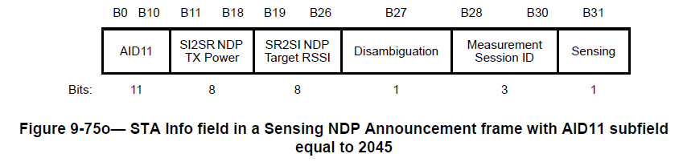

In non-TB sensing measurement exchange, both SI2SR NDP TX Power and SR2SI NDP Target RSSI fields will be used.
In TB sensing measurement exchange, SI2SR NDP TX Power field will be used and SR2SI NDP Target RSSI field is reserved.
The only difference is the usage of SR2SI NDP Target RSSI field, and there is no need to separate Figure 9-75o into two figures.
Based on the discussion above on, this CID is rejected.

SP
Do you support resolutions to the following CIDs and incorporate the text changes into the latest TGbf draft: 4079, 4081 and 4204 in 11-24/0307r1?

Y/N/A

