IEEE P802.11
Wireless LANs
LB281 comment resolutions for OST CIDs Part 1
Date: 2024.02.28
Author(s):
Name | Company | Address | Phone | email
Zhuqing Tang | Huawei Technologies | Huawei Base, Shenzhen, Guangdong, China |  | tangzhuqing@huawei.com
Rui Du
Narengerile
Yiyan Zhang
Abstract
This submission contains the proposed comment resolutions for the CIDs: 4005, 4026, 4027, 4028, 4029, 4070.

R0: initial document
R1: add some screenshots from 11bf Draft 3.0, for reference

CID 4005
,
CID | Commenter | Page.  Line | Clause Number | Comment | Proposed Change | Resolution
4005 | Chaoming Luo | 71.36 | 9.4.2.299 | The name of the element is misleading without clarifying that an "ISTA Availability Window element" actually contains multiple 10TUs slots (i.e., multiple availability windows), e.g., Availability Bitmap 10000100001000010100 represents 5 slots in a 200TUs Beacon Interval . | Change to "If used in a sensing procedure, a value of 1 in an Availability Bit indicates transmitting STA's availability at t (start, k) time for a duration of 10 TUs, which is a sensing availability window, " | Revised  TGbf Editor make changes specified in 24/0301r1.  (https://mentor.ieee.org/802.11/dcn/24/11-24-0301-01-00bf-lb281-comment-resolutions-for-ost-cids-part-1.docx)

Discussion

For reference:
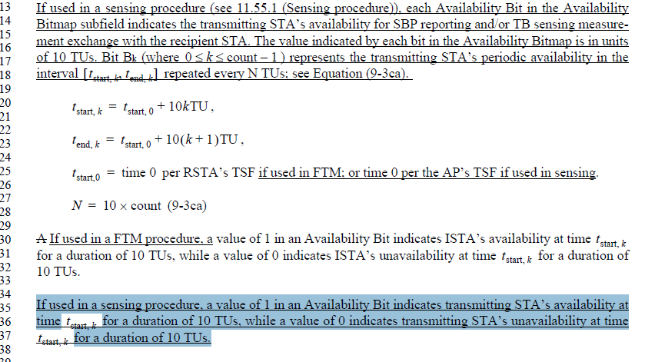

Instructions to the editor: please make the following changes to the paragraph of P71L36 in the subclause 9.4.2.299 ISTA Availability Window element: as shown below:

If used in a sensing procedure, a value of 1 in an Availability Bit indicates transmitting STA’s availability at
time $t_{start,k}$ for a duration of 10 TUs, which is a sensing availability window, while a value of 0 indicates transmitting STA’s unavailability at time for a duration of 10 TUs.

CID 4070

CID | Commenter | Page.  Line | Clause Number | Comment | Proposed Change | Resolution
4070 | Stephan Sand | 71.04 | 9.4.2.299 | The editorial instruction states "Change the last three paragraphs of 9.4.2.299 (ISTA Availability Window element) as follows:", but the last paragraph of the base line is missing in 11bf D3.0. So does it stay unchanged or is it removed? | Change the editorial instruction as follows:  Change the two paragraphs before the last one of 9.4.2.299 (ISTA Availability Window element) as follows: | Accepted

Discussion:
For reference, the text that the commenter indicated is highlighted as follows:
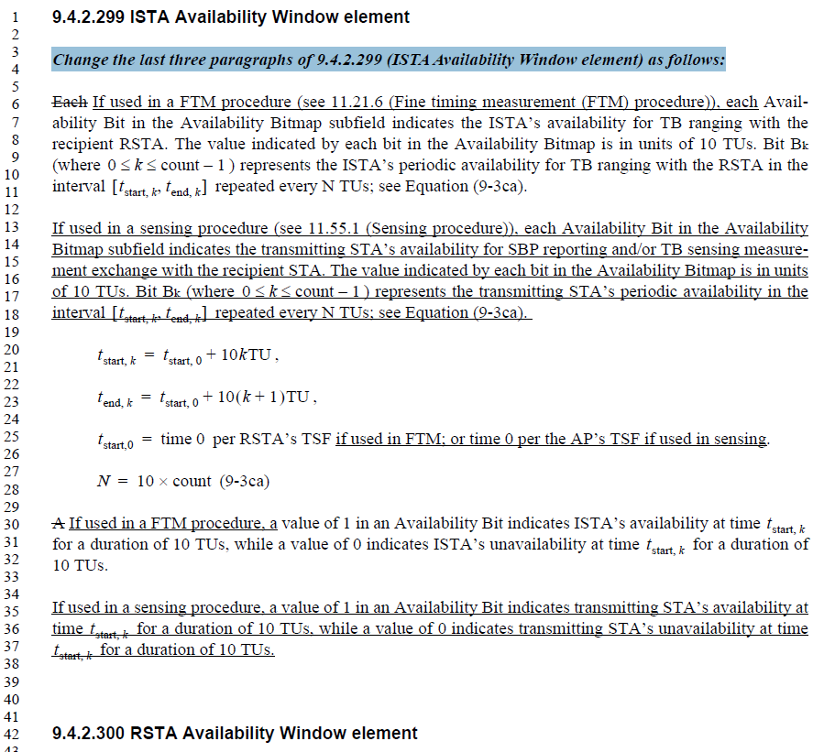

In the REVme D5.0, the last three paragraphs of 9.4.2.299 (ISTA Availability Window element) is shown as follows:

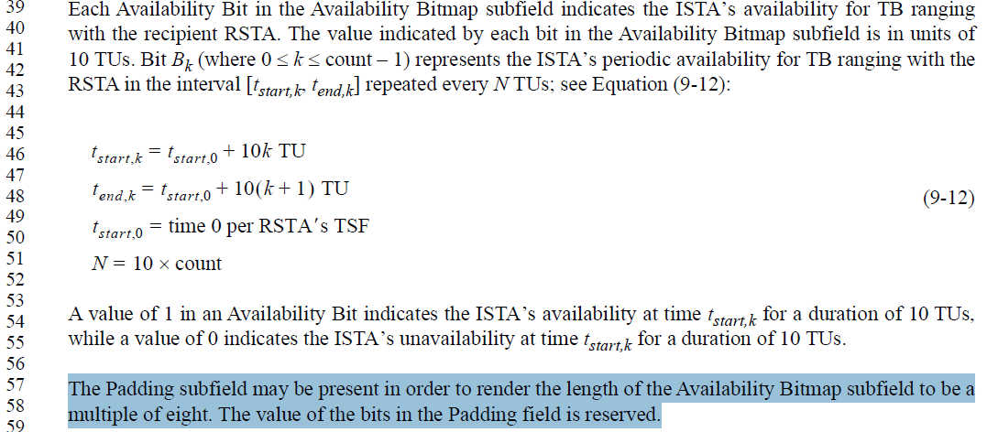
Comparing the above screenshots, the corresponding text in 11bf is changed based on the last two paragraphs before the last paragraph in the REVme D5.0. Therefore, the last paragraph should remain unchanged.

CIDs 4026, 4027, 4029
,
CID | Commenter | Page.  Line | Clause Number | Comment | Proposed Change | Resolution
4026 | Chaoming Luo | 142.39 | 11.55.1.4.1 | if the Beacon Interval is 200TUs, "exactly one Availability Window Information field" may be not sufficient, since the SBP inititiator may request 10TUs/20TUs (i.e., 10TUs available, 10TUs not available, repeat, so the Availability Bitmap is 10101010101010101010), if the SBP responder assigns the requested ones, the Availability Window Information field has to contain 5 Availability Window Information fields, each assigns one 10TU slot per 100TUs (see the Periodicity subfield in the Availability Window Information subfield). P168L13 has the same issue. | Change to "The RSTA Availability Information field in the RSTA Availability Window element containing  at least one Availability Window Information field." | Rejected  Please refer to <DCN0210r2> for the rejected reason which is also copied as follows:  “Discussion: The scenario mentioned in the example is not achievable for TB sensing measurement exchange. That is, we cannot do sensing measurement every 20 TUs within a 200-TU BI. This is because due to current definition and design, we can only do 1 slot (10 TUs) per BI, not 10 slots as indicated in the example. Otherwise, we will be overusing the channel with sensing.”
4027 | Chaoming Luo | 142.43 | 11.55.1.4.1 | "The assigned availability window" should be "Each  assigned sensing availability window", since one RSTA Availability Window element may assign multiple 10TUs slots, i.e. multiple sensing availability windows. | Change to "Each assigned sensing availability window" | Rejected  Please refer to <DCN0210r2> for the rejected reason.
4029 | Chaoming Luo | 142.59 | 11.55.1.4.1 | Better wording is needed, since one RSTA Availability Window element may assign multiple 10TUs slots, i.e. multiple sensing availability windows. | Change to "how an AP (sensing initiator) assigns sensing availability window(s) from the received ISTA Availability Window element of a non-AP STA (sensing responder)." | Rejected  Please refer to <DCN0210r2> for the rejected reason.

CIDs 4028

CID | Commenter | Page.  Line | Clause Number | Comment | Proposed Change | Resolution
4028 | Chaoming Luo | 142.50 | 11.55.1.4.1 | Upper case should be used when refering to a name, "TB sensing specific subelement" should be "TB Sensing Specific subelement". Similar issue in P142L52, "TB sensing specific subelement" should be "TB Sensing Specific subelement", and "ISTA availability window element" should be "ISTA Availability Window element". | As in comment. | Accepted

Discussion

For reference:

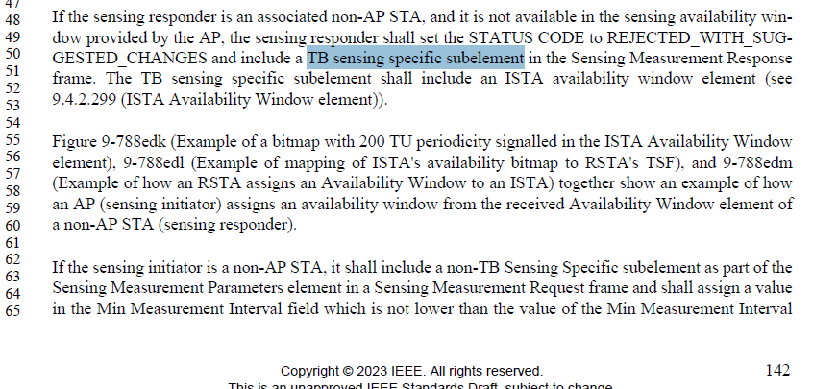

SP
Do you support resolutions to the following CIDs and incorporate the text changes into the latest TGbf draft: 4005, 4026, 4027, 4028, 4029, 4070 in 11-24/0301r1?

Y/N/A

