IEEE P802.11
Wireless LANs
Resolution to CID 22097 (Power management terminology)
Date: 2024-02-16
Author(s):
Name | Affiliation | Address | Phone | email
Michael Montemurro | Huawei |  |  | montemurro.michael@gmail.com
Background
This contribution addresses CID 22097 to align the P802.11be draft power management terminology changes in REVme D5.0

Discussion:
In clause 11.2.1, Power Management modes and states are described. However, the text describing requirements related to the use of these modes uses terminology like “wake up”, “sleep”. This document suggests changes to text in the standard to align with mode and state definitions for power management.

Here is the text in the standard:
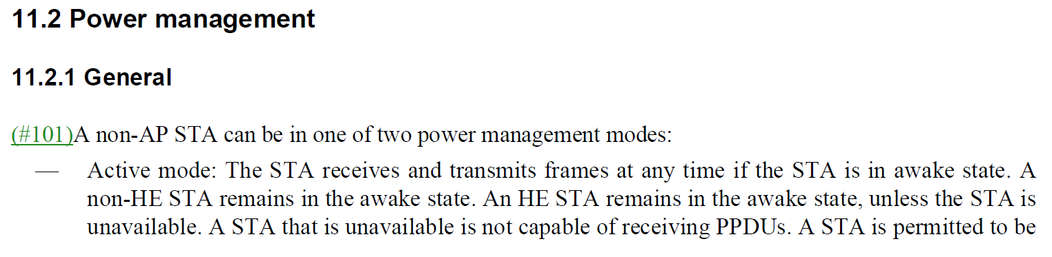
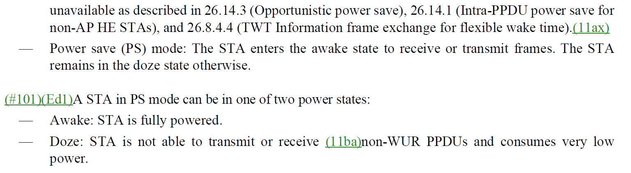

Use of “wake up”
Based on the context in the draft, the term “wake up” seems to be used to refer to a transition between doze and awake states in PS mode.

The following text proposes changes to the usage of “wake up” when it refers to a transition from doze state to awake state.

NOTE: No changes were made to WUR terminology, which uses “wake-up” in various operational descriptions. Also no changes were made to baseline text that was not added by TGbe.

Proposed changes for “wake up” usage (as mark up):

553.26: "If all non-AP STAs affiliated with the non-AP MLD and operating on enabled links are in power save mode, at least one of these non-AP STAs shall transition to awake stateto receive at least one Beacon frame scheduled for transmission …"

1003.50: "by not having to transition to awake stateto listen to beacons other than the DTIM beacons…"

1025.33: "…that is monitoring only another link and is in the doze state and scheduled to transition to awake state to receive the DTIM beacon on that link…"

1025.43: "…without having to transition to awake state to receive additional beacons thus conserving power…”

1027.65: "…the non-AP MLD is required to transition to awake state to receive at least one Beacon frame…”

1028.58: "…non-AP STA 3 is required to transition to awake state to receive at least one Beacon frame

1036.27:” TWT agreements to be setup on three links, and they have different TWT parameters, such as target wake time”

1042.34: "...both STA2 and STA3 transition to awake state to receive the Beacon frames on Link 2 and Link 3, respectively ..."

Use of “sleep”
Based on the context in the draft, the term “sleep” seems to be used to refer to a transition between awake and doze states in PS mode.

The following text for replacing the use of sleep when it refers to a transition between doze state and awake state in PS mode.

Proposed changes for “sleep” usage (as mark up):

66.22: "..that all the non-AP STAs affiliated with the non-AP MLD might transition to doze state for a specified length of time.."

Use of “awaken”

The use of awaken is yet another term that really means transition to awake state.

NOTE: the scope of these changes are only in text that was added by TGbe. The baseline text will be updated in REVme.

Proposed changes for “awaken” usage (as mark up):

91.22, 96.61, 99.40: “…often at least one STA affiliated with the MLD transitions to the awake state to receive the next Beacon frame…”

