IEEE P802.11
Wireless LANs
LB279 Comment Resolution for CID 1363, 1029, 1391, 1169
Date: 2024-01-12
Author(s):
Name | Affiliation | Address | Phone | email
Shuling Julia Feng | Mediatek Inc | 2840 Junction Ave, San Jose, CA, USA |  | Julia.feng@mediatek.com
Abstract
This submission proposes resolutions to the following comments submitted in LB279 on 11bk D1.0.

CIDs: 1363, 1029, 1391, 1169

Revision history:
R0: Original version
R1: Reassign CID 1124 to Christian Berger since it overlaps with CID 1163. Propose option 1 and option 2 to resolve CID 1169 based on group feedbacks on revision R0.
R2: Group decides on Option 2.

CID | Clause | Page | Comment | Proposed change | Proposed resolution
1363 | 11.21.6.3.4 | 29.02 | Title change (and clause 9 changes) imply there should be more text changes in 11.21.6.3.4. This new title (which no longer includes "HE-" doesn't match the first line of text, for example, which introduces "a securte HE-LTF measurement exchange". Deeper in the text, there are now sentences like (REVme D4.1) P2654.36: "When an RSTA has assigned a secure HT-LTF measurement exchange mode, by including a Secure HE-LTF sublement ... and setting its Secure HE-LTF Required field to 1, ... the RSTA shall also include a Secure LTF Parameters element" Also note that P55.12 of the TGbk draft changes "secure HE-LTF measurement exchange" in this location, but that phrase is not changed in other locations. Is this inconsistency really desired? | Clarify, explicitly, how the text in this subclause is modified, and where the "HE-" is removed (and where it is not, if anywhere). | REVISED  Discussion:  Following 11bk general editorial instruction, all occurrence of text “secure HE-LTF” shall be replaced with “secure LTF”, all occurrence of text “Secure HE-LTF” shall be replace with “Secure LTF”. These texts occur one or multiple times in Tables list, Figures list, Clause 3.2, Clause 8.3.5.18, Clause 9.3.1, Clause 9.4.2, Clause 9.6.7, Clause 11.21.6, Clause 12, Clause 27, Annex B, Annex C, Annex J, and Annex AE in REVme_D4.2.  To TGbk editor: Please change all occurrence of “secure HE-LTF” and “Secure HE-LTF” in 11bk D1.0 and baseline standards clauses 8, 9, 11, 12, and Annex J to “secure LTF” and “Secure LTF” respectively. Please also instruct REVme editor to make the same changes in REVme4.2.
1029 | 11.21.6.4.3 | 0.00 | Update the figure numbers to allign with those in 802.11-REVme/D4.1. Or just show the parts that need changes from the baseline. | As in comment. | REVISED  Discussion:  All figure numbers in 11bk D1.0 (Figure 9-xxx, Figure 11-xxx, Figure 36-xxx) need to be aligned with those in preceding publications of 11bkD2.0. Propose to have a unified resolution to align them all in 11bkD2.0.  To TGbk editor: Please change all figure numbers of 11bk D1.0 to reflect baseline numbering in  IEEE Std 802.11-REVme/D4.2, and  IEEE Std 802.11be/D5.0.
1391 | 11.21.6.4.3.1 | 31.23 | The case for EHT TB PPDUs is missing. | Add "or EHT TB PPDUs" after "HE TB PPDUs" | REVISED  The commented text is on P31L24.  To TGbk editor: Please change the text on P31L24 as follows.  when transmitting any HE TB PPDUs or EHT TB PPDUs for TB ranging
1169 | 11.21.6.4.3.1 | 40.04 | The sentence "If there is only one R2I LMR it may be carried instead in an HE SU PPDU" seems contradicts with the added setences since the added sentence requires that the one R2I LMR of 320MHz ranging needs to be carried in EHT PPDU. | As in comment | REVISED  Please see discussions and proposed resolutions in https://mentor.ieee.org/802.11/dcn/24/11-24-0232-01-00bk-lb279-comment-resolution-for-cid-1363-1029-1124-1391-1169.docx.  TGbk editor: make changes identified below in 11-24/232r2.  https://mentor.ieee.org/802.11/dcn/24/11-24-0232-02-00bk-lb279-comment-resolution-for-cid-1363-1029-1124-1391-1169.docx.

CID 1169

Discussions:

The paragraph commented is written as follows in 11bk D1.0,

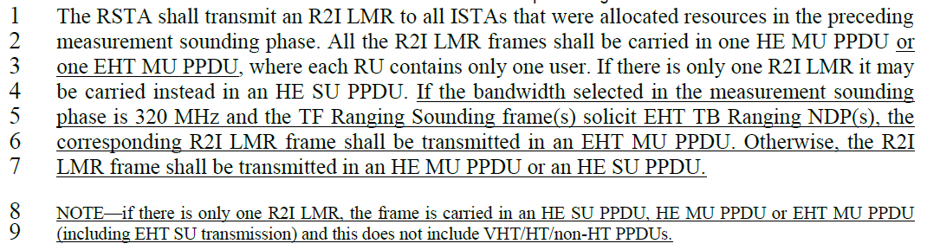

In the 3rd sentence of this paragraph, “may” is used to indicate the only one R2I LMR may be carried in an HE SU PPDU in addition to the two options (one HE MU PPDU or one EHT MU PPDU) mentioned in the preceding sentence. Agree with the commentor this indication seems subtle and can be confusing to some readers. Propose Option 1 for this reason.

Furthermore, it’s obvious that if there is only one R2I LMR, it’s carried in one PPDU. If we have clarified on PPDU types and stated multiple R2I LMR frames must be carried in one PPDU, we can remove the commented sentence in this paragraph to avoid confusion. Propose Option 2 for this reason.

esolution:

To TGbk editor: Please change the text from P40L1 to P40L7 as follows.

The RSTA shall transmit an R2I LMR to all ISTAs that were allocated resources in the preceding measurement sounding phase. If the bandwidth selected in the measurement sounding phase is 320 MHz and the TF Ranging Sounding frame(s) solicit EHT TB Ranging NDP(s), the corresponding R2I LMR frame(s) shall be transmitted in an EHT MU PPDU. Otherwise, the R2I LMR frame(s) shall be transmitted in an HE MU PPDU or an HE SU PPDU. If there is more than one R2I LMR, all the R2I LMR frames shall be carried in one HE MU PPDU or one EHT MU PPDU, where each RU contains a single user.

