IEEE P802.11
Wireless LANs
LB279 Comment Resolution for CID 1363, 1029, 1124, 1391, 1169
Date: 2024-01-12
Author(s):
Name | Affiliation | Address | Phone | email
Shuling Julia Feng | Mediatek Inc | 2840 Junction Ave, San Jose, CA, USA |  | Julia.feng@mediatek.com
Abstract
This submission proposes resolutions to the following comments submitted in LB279 on 11bk D1.0.

CIDs: 1363, 1029, 1124, 1391, 1169

Revision history:
R0: Original version

CID | Clause | Page | Comment | Proposed change | Proposed resolution
1363 | 11.21.6.3.4 | 29.02 | Title change (and clause 9 changes) imply there should be more text changes in 11.21.6.3.4. This new title (which no longer includes "HE-" doesn't match the first line of text, for example, which introduces "a securte HE-LTF measurement exchange". Deeper in the text, there are now sentences like (REVme D4.1) P2654.36: "When an RSTA has assigned a secure HT-LTF measurement exchange mode, by including a Secure HE-LTF sublement ... and setting its Secure HE-LTF Required field to 1, ... the RSTA shall also include a Secure LTF Parameters element" Also note that P55.12 of the TGbk draft changes "secure HE-LTF measurement exchange" in this location, but that phrase is not changed in other locations. Is this inconsistency really desired? | Clarify, explicitly, how the text in this subclause is modified, and where the "HE-" is removed (and where it is not, if anywhere). | REVISED  Discussion:  Following 11bk general editorial instruction, all occurrence of text “secure HE-LTF” shall be replaced with “secure LTF”, all occurrence of text “Secure HE-LTF” shall be replace with “Secure LTF”. These texts occur one or multiple times in Tables list, Figures list, Clause 3.2, Clause 8.3.5.18, Clause 9.3.1, Clause 9.4.2, Clause 9.6.7, Clause 11.21.6, Clause 12, Clause 27, Annex B, Annex C, Annex J, and Annex AE in REVme_D4.2.  To TGbk editor: Please change all occurrence of “secure HE-LTF” and “Secure HE-LTF” in 11bk D1.0 to “secure LTF” and “Secure LTF” respectively. Please also instruct REVme editor to change all occurrence of “secure HE-LTF” and “Secure HE-LTF” in REVme4.2 to “secure LTF” and “Secure LTF” respectively.
1029 | 11.21.6.4.3 | 0.00 | Update the figure numbers to allign with those in 802.11-REVme/D4.1. Or just show the parts that need changes from the baseline. | As in comment. | REVISED  Discussion:  All figure numbers in 11bk D1.0 (Figure 9-xxx, Figure 11-xxx, Figure 36-xxx) need to be aligned with those in preceding publications of 11bkD2.0. Propose to have a unified resolution to align them all in 11bkD2.0.  To TGbk editor: Please align all figure numbers in 11bk D2.0 with those in preceding publications, namely  IEEE Std 802.11-REVme/D4.2, and  IEEE Std 802.11be/D5.0).
1124 | 11.21.6.4.3 | 34.11 | From the context, it looks like the requirement is on the ISTA to take an action based on receiptof the TF Ranging Sounding frame, not the frame itself. | Change  "If the TF Ranging Sounding frame is transmitted in a 320 MHz PPDU, the I2R NDP shall be an 11 EHT TB Ranging NDP. If the TF Ranging Sounding frame is transmitted in a PPDU of 160 MHz 12 or less, the I2R NDP shall be an HE TB Ranging NDP."  to  "If the TF Ranging Sounding frame is transmitted by the ISTA in a 320 MHz PPDU, the I2R NDP shall be transmitted as an 11 EHT TB Ranging NDP. If the TF Ranging Sounding frame transmitted by the ISTA in a PPDU of 160 MHz 12 or less, the I2R NDP shall be an HE TB Ranging NDP. | REVISED  This paragraph and preceding ones describe how TF Ranging Sounding frame solicits HE TB Ranging NDP and EHT TB Ranging NDP.  To TGbk editor: Please modify the text from P34L11 to P66L13 as follows.  If the TF Ranging Sounding frame is transmitted in a 320 MHz PPDU, the I2R NDP solicited shall be an EHT TB Ranging NDP. If the TF Ranging Sounding frame is transmitted in a PPDU of 160 MHz or less, the I2R NDP solicited shall be an HE TB Ranging NDP.
1391 | 11.21.6.4.3.1 | 31.23 | The case for EHT TB PPDUs is missing. | Add "or EHT TB PPDUs" after "HE TB PPDUs" | REVISED  The commented text is on P31L24.  To TGbf editor: Please modify the text on P31L24 as follows.  when transmitting any HE TB PPDUs or EHT TB PPDUs for TB ranging
1169 | 11.21.6.4.3.1 | 40.04 | The sentence "If there is only one R2I LMR it may be carried instead in an HE SU PPDU" seems contradicts with the added setences since the added sentence requires that the one R2I LMR of 320MHz ranging needs to be carried in EHT PPDU. | As in comment | REVISED  Please see proposed resolution below this table.

CID 1169
Discussions:

The paragraph commented is written as follows in 11az D7.0,

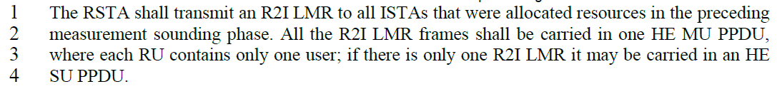

The paragraph commented is written as follows in 11bk D1.0,

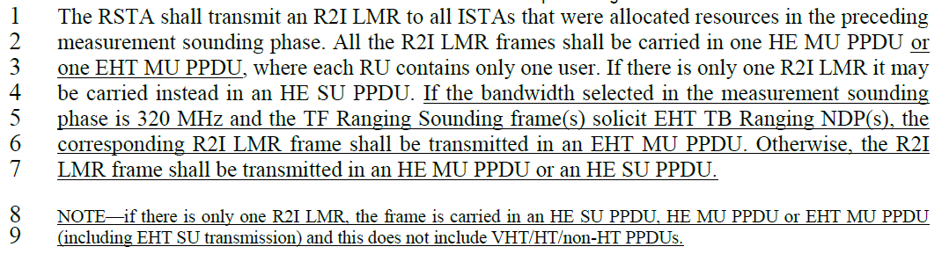

Proposed resolution:

To TGbf editor: Please modify the text from P40L1 to P40L7 as follows.

The RSTA shall transmit an R2I LMR to all ISTAs that were allocated resources in the preceding measurement sounding phase. All the R2I LMR frames shall be carried in one HE MU PPDU or one EHT MU PPDU, where each RU contains only one user. If there is only one R2I LMR it may be carried instead in an HE SU PPDU or an EHT MU PPDU including EHT SU transmission. If the bandwidth selected in the measurement sounding phase is 320 MHz and the TF Ranging Sounding frame(s) solicit EHT TB Ranging NDP(s), the corresponding R2I LMR frame shall be transmitted in an EHT MU PPDU. Otherwise, the R2I LMR frame shall be transmitted in an HE MU PPDU or an HE SU PPDU.

SP:

Do you agree to the resolutions provided for the following CIDs in 802.11-24/0232r0 to be included in 11bk Draft 2.0?

CIDs: 1363, 1029, 1124, 1391, 1169

Y/N/A

