IEEE P802.11
Wireless LANs
Comment resolution for OST comments part 2
Date: 2024-01-22
Author(s):
Name | Affiliation | Address | Phone | email
Chaoming Luo | OPPO |  |  | luochaoming@oppo.com
Abstract
This submission resolves miscellaneous comments under ‘OST’ topic. The following CIDs are resolved: 4175, 4176, 4184.

Revisions:

- Rev 0: Initial version of the document.

4175
CID | Commenter | Page | Comment | Proposed Change | Resolution
4175 | Manish Kumar | 141.07 | It is not clear when the aSensingFrameExchangeExpiry timeout perios starts. | Add the normative text about the period | Revised  Agree in principle. Although it is obvious when the timer starts, it is reader friendly to add text to clarify it.  TGbf editor to make the changes shown in Https://mentor.ieee.org/802.11/dcn/24/11-24-0196-00-00bf-lb281-ost-part-2.docx under all headings that include CID 4175.

Discussion
In 11me D4.2 we have timer related text as follows:

10.4 MSDU, (11ax)A-MSDU, and MMPDU fragmentation
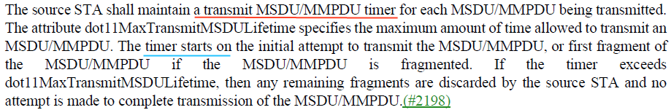

10.5 MSDU, (11ax)A-MSDU, and MMPDU defragmentation
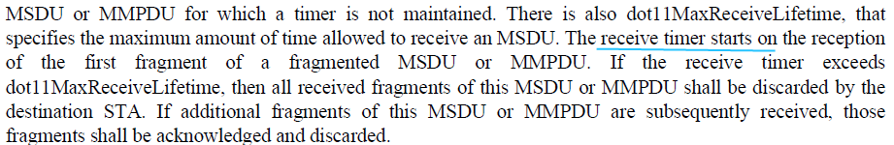

11be D5.0
35.3.13 MLD individually addressed data delivery without block ack negotiation
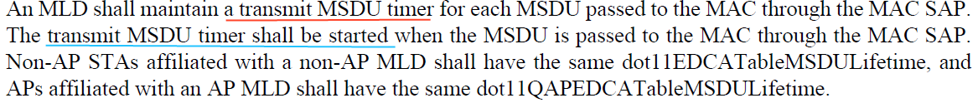

35.3.16.8 Medium access recovery procedure
35.3.16.8.1 General
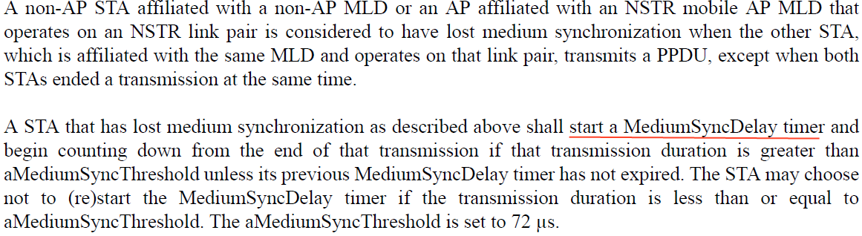

Resolution
11.55.1.3 Sensing capabilities exchange
TGbf editor to change the first row in Table 11-32a—Sensing procedure timing-related parameters at P139L5 of draft D3.0 as follows:
Table 11-32a—Sensing procedure timing-related parameters
Parameter | Value | Description
aSensingFrameExchangeExpiry | 20 ms | The maximum time interval between the reception of a Sensing Measurement Request frame and the transmission of the corresponding Sensing Measurement Response frame, between the reception of a Sensing Measurement Query frame and the transmission of the corresponding Sensing Measurement Request frame, or between the reception of a Sensing Measurement Query frame  and the transmission of the corresponding Sensing Measurement Termination frame.  The transmitter of the Sensing Measurement Request frame or Sensing Measurement Query frame starts the corresponding timer when the frame is transmitted. The receiver of the Sensing Measurement Request frame or Sensing Measurement Query frame starts the corresponding timer when the frame is received. (#4175)

4176
CID | Commenter | Page | Comment | Proposed Change | Resolution
4176 | Manish Kumar | 141.33 | The tuple can't be used by the initiator to identify the measurement session | fix the bug | Rejected.  For a sensing initiator, it can differentiate measurement sessions initiated by itself via the Measurement Session IDs in multiple tuples.  For a sensing responder, it can differentiate measurement sessions initiated by different sensing initiators via the sensing initiator’s MAC addresses in multiple tuples. Futher, for a sensing responder, if there are multiple measurement sessions established with a same sensing initiator, the sensing responder can differentiate measurement sessions initiated by that sensing initiators via the Measurement Session IDs in multiple tuples which have the same sensing initiator’s MAC address.

4184
CID | Commenter | Page | Comment | Proposed Change | Resolution
4184 | Manish Kumar | 0.00 | Clarify whether link2 of a MLD needs to support sensing if link1 supports sensing. | I assume the answer is no. If this understanding is right, the MLD part needs to be updated accordingly. Otherwise add the nomative text. | Revised.  Agree in principle with the commenter.  TGbf editor to make the changes shown in Https://mentor.ieee.org/802.11/dcn/24/11-24-0196-00-00bf-lb281-ost-part-2.docx under all headings that include CID 4184.

Discussion
Sensing is a per-link functionality, so the current text does need refinement to reveal it.
In clause 11, suggest to change “EHT STA” to “non-MLD non-AP EHT STA or non-AP STA affiliated with a non-AP MLD or AP affiliated with an AP MLD” . Note that according to 11be D5.0 clause 4.3.16a Extremely high throughput (EHT) STA “In an EHT AP, mandatory support for MLO”, so, there is no “non-MLD EHT AP”.
And suggest to add a sentence to say sensing is a per-link functionality. Note that the term “per-link” has already been used in 11be, e.g., “35.3.3.3 Advertisement of complete or partial per-link information”, “there are no independent block ack agreements for each TID on a per-link basis”.

Resolution

11.55.1.2 Dependencies and timing-related parameters
A STA that is an HE or EHT STA HE STA or non-MLD non-AP EHT STA or non-AP STA affiliated with a non-AP MLD or AP affiliated with an AP MLD may support the sensing procedure. The support of sensing procedure is a per-link functionality (#4184). A STA that supports the sensing procedure is referred to as a sensing STA. A sensing STA has dot11SensingImplemented equal to true and shall set the Sensing field in the Extended Capabilities element to 1. A sensing STA shall support the sensing procedure as both a sensing initiator and a sensing responder.

SP
Do you support resolutions to the following CIDs and incorporate the text changes into the latest TGbf draft: 4175, 4176, 4184, in 11-24/0196r0.

Y/N/A

