IEEE P802.11
Wireless LANs
CR for SBP part in LB 281
Date: 2024-01-22
Author(s):
Name | Affiliation | Address | Phone | email
Xiandong Dong | Xiaomi |  |  | dongxiandong@xiaomi.com
Abstract
This submission proposes resolutions for following 7 CIDs received for WG LB281:4006 4052 4054
The proposed changes are based on 802.11bf D3.0

Revisions:
- Rev 0: Initial version of the document.

CID | Commenter | Clause | Page | Comment | Proposed Change | Resolution
4006 | Chaoming Luo | 9.4.2.322 | 79.54 | It should be the expiry value described by the formula of the exponent. | Change to "The SBP procedure expiry value is equal to ..." | Accept

Discussion
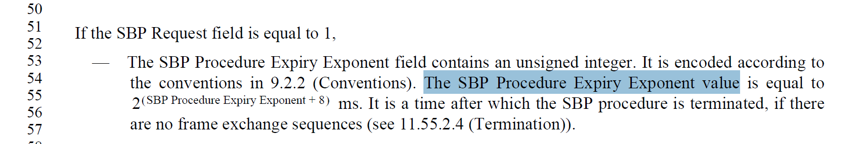

CID | Commenter | Clause | Page | Comment | Proposed Change | Resolution
 | Chaoming Luo | 9.4.2.322 | 81.14 | Format issue, the words "Role Bitmap field)." should be put before the figure. | As in comment | revised

Discussion

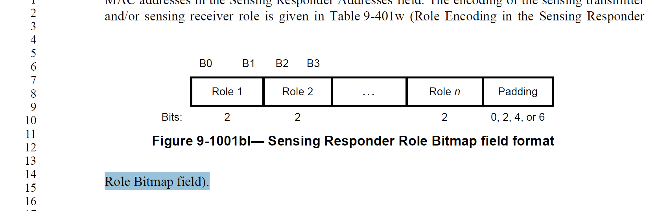

CID | Commenter | Clause | Page | Comment | Proposed Change | Resolution
 | Chaoming Luo | 9.4.2.322 | 81.61 | A better wording is needed.  The sentence's intention is to say the value of one field is the same with another field, but the text does not clearly reveal it. | Change to "The value of AID/USID field corresponding to the SBP initiator in the Sensing  Responder IDs field is the same as the AID/USID field within the SBP Response frame."  And it may be even better to change the "AID/USID" field in the SBP Response frame to "SBP Initiator AID/USID" field. | Revised

Discussion
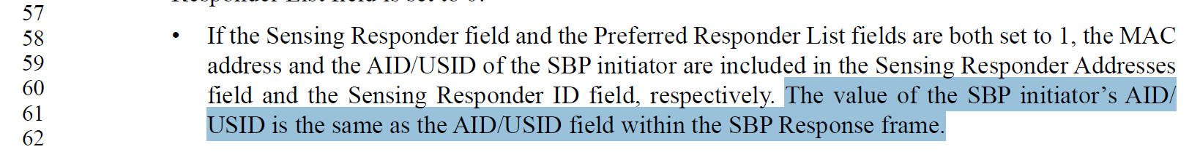

CID | Commenter | Clause | Page | Comment | Proposed Change | Resolution
4052 | Chaoming Luo | 11.55.2.3 | 169.35 | P169L35 to P169L48 should be moved to clause 11.55.2.2 Setup exchange, since they are talking about setup procedure. And they should be put together with the note in P165L63. | As in comment | Accept

Discussion
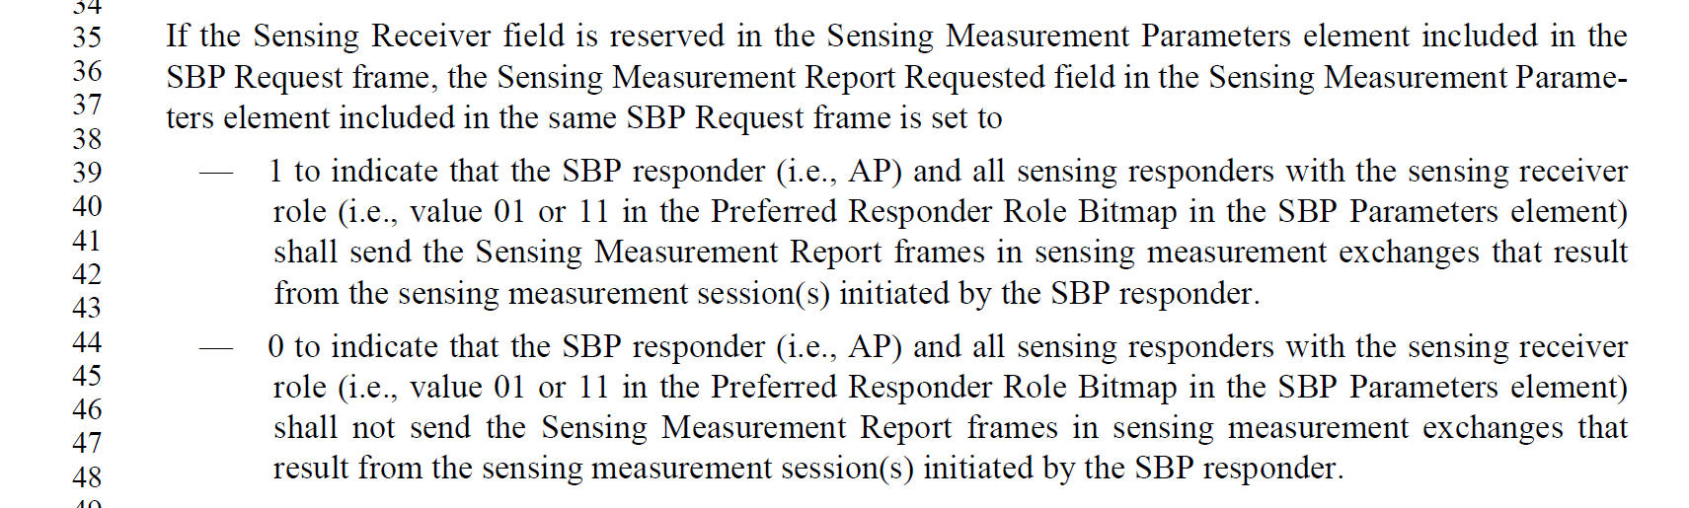

CID | Commenter | Clause | Page | Comment | Proposed Change | Resolution
 | Chaoming Luo | 11.55.2.4 | 169.52 | A better wording is needed to make it easier to read. | Change the two paragraphs to:  An SBP procedure may be terminated by the  SBP initiator by transmitting an SBP Termination frame at any time.  An SBP procedure may be terminated by the  SBP Responder by transmitting an SBP Termination frame at any time, if the SBP initiator is associated with the SBP responder. If the SBP responder intends to terminate an SBP procedure with an SBP initiator that is not associated with, the SBP responder should transmit an SBP Termination frame during the sensing availability window in which the SBP initiator is present. | Accept

Discussion
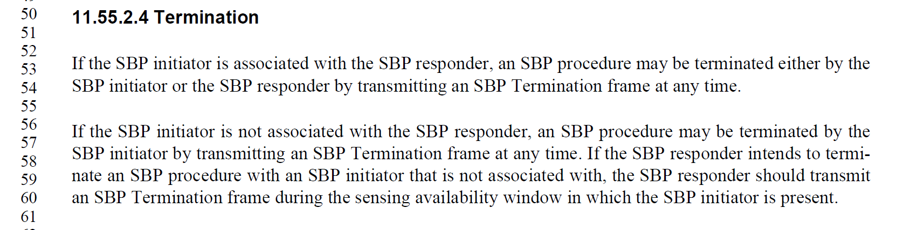

CID | Commenter | Clause | Page | Comment | Proposed Change | Resolution
4054 | Chaoming Luo | 11.55.2.4 | 170.22 | Remove "(see 11.55.2.4 (Termination))" since the commented paragraph itself is in clause 11.55.2.4 | As in comment. | Accept

Discussion
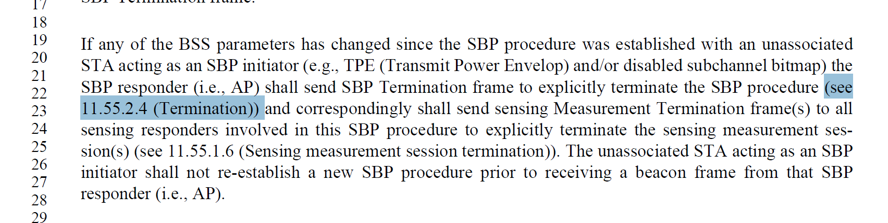

SP: Do you support the resolution to the following 7 CIDs and to incorporate the changes proposed in IEEE 802.11-24/0192r1 to the latest 11bf draft for the following CIDs: 4006 4052 4054 ?

