IEEE P802.11
Wireless LANs
LB279 Comment Resolution EHT MAC/PHY Part 3
Date: 2024-01-08
Author(s):
Name | Affiliation | Address | Phone | email
Christian Berger | NXP | 350 Holger Way, San Jose, CA |  | christian.berger@nxp.com

Abstract
This submission proposes to address the following CIDs 1345, 1350, 1351, 1354, and 1355 changes are relative to Draft P802.11be_D4.0, Draft P802.11REVme_D4.2, and Draft P802.11bk D1.0.

Revisions:
- Include link in resolution box and incorporate discussion input

Interpretation of a Motion to Adopt

A motion to approve this submission means that the editing instructions and any changed or added material are actioned in the TGax Draft. This introduction is not part of the adopted material.

Editing instructions formatted like this are intended to be copied into the TGbk Draft (i.e. they are instructions to the 802.11 editor on how to merge the text with the baseline documents).

TGbk Editor: Editing instructions preceded by “TGbk Editor” are instructions to the TGbk editor to modify existing material in the TGaz draft. As a result of adopting the changes, the TGbk editor will execute the instructions rather than copy them to the TGbk Draft.

The text preceded by “Discussion” is not part of the adopted changes.

CID | P.L | Clause | Comment | Proposed Change | Resolution
1345 | 92.19 | 36.3.12.10a.2 | What is meant by "First" 80 MHz subblock? Lowest frequency? | Clarify | Reject  As described earlier in the text “The subblocks are enumerated first to last starting at the lowest frequencies to the highest.” – see also Figure-36-28a for more illustration of the naming convention.
1350 |  | 36.3.20.5 | It is not clear when this ToD test is applied. When is this test performed, what are the grading criteria, and what is the penalty for a poor score? | Clarify | Reject  See Annex P, this has been around since 11mc and is also present in HT/VHT/HE PHYs
1351 | 94.23 | 36.3.20.5 | This looks dimensionally wrong: dividing a value in Hz by a value in MHz | Either divide by 320 000 000 Hz or say the units of fH and fHL are MHz | Reject  See Annex P, this has been around since 11mc and is also present in HT/VHT/HE PHYs  Dividing a variable given in Hz by a value given in MHz seems straight forward.
1354 | 95.20 | 36.3.22 | " forwarding the TIME_OF_DEPARTURE corresponding to the time when the first frame energy is sent by the transmitting port and TIME_OF_DEPARTURE_ClockRate parameter within the TXSTATUS vector" is incomprehensible | Change to " setting the TIME_OF_DEPARTURE in the TXSTATUS vector to the time when the first frame energy was sent by the transmitting port" | Revise  TGbk editor, make the changes identified in document  https://mentor.ieee.org/802.11/dcn/24/11-24-0183-01-00bk-lb279-comment-resolution-eht-mac-phy-part-3.docx
1355 | 95.22 | 36.3.22 | "If dot11TimingMsmtActivated is true, then the PHY shall forward the value of TX_START_OF_FRAME_OFFSET in TXSTATUS vector. " is incomprehensible. What does it mean to forward? How does a parameter get forwarded? | As it says in the comment | Revise  TGbk editor, make the changes identified in document  https://mentor.ieee.org/802.11/dcn/24/11-24-0183-01-00bk-lb279-comment-resolution-eht-mac-phy-part-3.docx

- CID (1354/1355) Discussion:
- 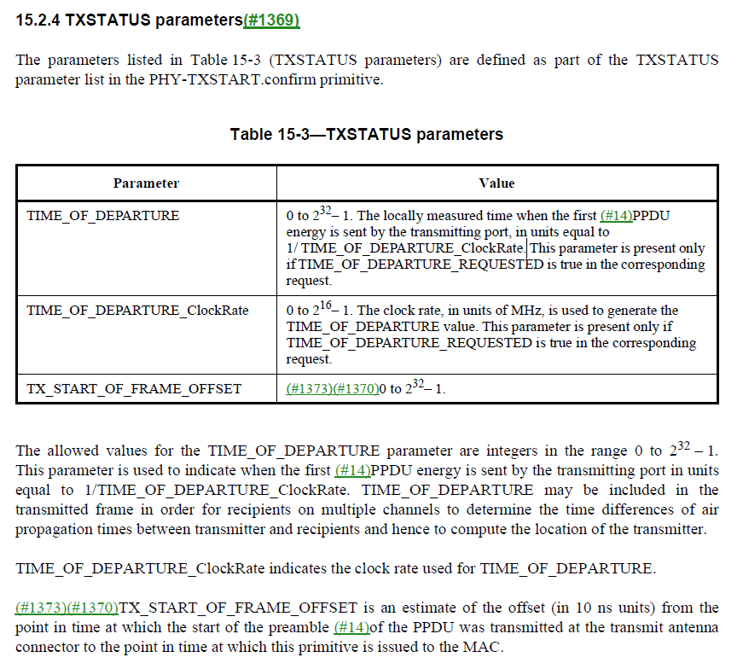

- CID (1354/1355) TGbk Editor: Change Clause 36.3.22 (p.95 in 11bk) as follows:
- Change clause 36.3.22 as follows. [202309-03]
          - 36.3.22 EHT transmit procedure
The PHY indicates the state of the primary channel and other channels (if any) via the PHY-CCA.indication primitive (see 36.3.21.6 (CCA sensitivity) and 8.3.5.12 (PHY-CCA.indication)). Transmission of the PPDU shall be initiated by the PHY after receiving the PHY-TXSTART.request(TXVECTOR) primitive. The TXVECTOR elements for the PHY-TXSTART.request primitive are specified in Table 36-1 (TXVECTOR and RXVECTOR parameters).
Transmission of the PHY preamble may start if TIME_OF_DEPARTURE_REQUESTED is false and shall start immediately if TIME_OF_DEPARTURE_REQUESTED is true, based on the parameters passed in the PHY-TXSTART.request primitive.
If all of the following conditions are met:
- if dot11TODImplemented and dot11TODActivated are true or if dot11TimingMsmtActivated is true,
- the TXVECTOR parameter TIME_OF_DEPARTURE_REQUESTED is true,
then the PHY shall issue a PHY-TXSTART.confirm(TXSTATUS) primitive to the MAC, setting the TIME_OF_DEPARTURE parameter to the value of the time when the first frame energy is sent by the transmitting port and providing the corresponding clock rate in the TIME_OF_DEPARTURE_ClockRate parameter within the TXSTATUS vector. If dot11TimingMsmtActivated is true, then the PHY shall also set the value of TX_START_OF_FRAME_OFFSET parameter in the TXSTATUS vector as described in clause 15.2.4 (TXSTATUS parameters).

