IEEE P802.11
Wireless LANs
LB281 Reporting CID Resolutions
Date: 2024-02-26
Author(s):
Name | Affiliation | Address | Phone | email
Chris Beg | Cognitive Systems | 560 Westmount Road North  Waterloo Ontario, Canada |  | chris.beg@cognitivesystems.com
Abstract
This submission addresses the following 8 LB281 CIDs: 4040 4041 4042 4043 4044 4142 4143 4279.

Revision history:
R0 – initial version

CID | Clause | Page | Comment | Proposed Change | Resolution
4040 | 11.55.1.5.3.4 | 160.47 | Better wording is needed. | Change to "Each report segment of a measured CSI" | Revised  Incorporate changes specified in 24/0149r0 (https://mentor.ieee.org/802.11/dcn/24/11-24-0149-00-00bf-LB281_reporting_cid_resolution.docx).
4041 | 11.55.1.5.3.4 | 160.57 | Better wording is needed. | Change to "Each report segment of a measured CSI" | Revised  Incorporate changes specified in 24/0149r0 (https://mentor.ieee.org/802.11/dcn/24/11-24-0149-00-00bf-LB281_reporting_cid_resolution.docx).
4042 | 11.55.1.5.3.4 | 160.60 | Better wording is needed. | Change to "Each report segment of a measured CSI" | Revised  Incorporate changes specified in 24/0149r0 (https://mentor.ieee.org/802.11/dcn/24/11-24-0149-00-00bf-LB281_reporting_cid_resolution.docx).
4043 | 11.55.1.5.3.4 | 160.62 | Better wording is needed. | Change to "shall be the same for all report segments of a measured CSI" | Revised  Incorporate changes specified in 24/0149r0 (https://mentor.ieee.org/802.11/dcn/24/11-24-0149-00-00bf-LB281_reporting_cid_resolution.docx).
4044 | 11.55.1.5.3.4 | 160.63 | Better wording is needed. | Change to "All report segments of a measured CSI" | Revised  Incorporate changes specified in 24/0149r0 (https://mentor.ieee.org/802.11/dcn/24/11-24-0149-00-00bf-LB281_reporting_cid_resolution.docx).

Notes:
- Outside the scope of these comments, P160.61-62 references the Remaining Report Segments field and First Report Segment field as belonging to the Sensing Measurement Report Control field. This is incorrect, as the referenced fields are part of the Segmentation Control field.

TGbf Editor: Modify P160.40-65 in D3.0 as follows:

If the size of the measured CSI (see 9.4.1.73.4 (Sensing Measurement Report field)) exceeds aSensingReportSegmentSize, then the measured CSI shall be divided into a maximum of 32 successive segments.

aSensingReportSegmentSize shall be 3 750 octets.

Each measured CSI segment shall be included in a separate Sensing Measurement Report Container field. The Sensing Measurement Report Control field shall be included in the Sensing Measurement Report Container field that carries the first measured CSI segment (e.g., the Sensing Measurement Report Container in which the First Report Segment field in the Segmentation Control field is equal to 1 and the Invalid Indication field in the Segmentation Control field is equal to 0). The Sensing Measurement Report Control field shall not be included in a Sensing Measurement Report Container that does not carry the first measured CSI segment (e.g., all Sensing Measurement Report Containers in which the First Report Segment field in the Segmentation Control is equal to 0 or the Invalid Indication field in the Segmentation Control field is equal to 1). Each measured CSI segment shall be of length equal to aSensingReportSegmentSize, except for the last segment which may be smaller.

Each measured CSI segment is identified by the value of the Remaining Report Segments field and the First Report Segment field in the Segmentation Control field. The other non-reserved fields of the Segmentation Control field shall be the same for all measured CSI segments. All measured CSI segments shall be sent in a single A-MPDU contained in a PPDU and shall be included in the A-MPDU in the descending order of the values of the Remaining Report Segments field.

CID | Clause | Page | Comment | Proposed Change | Resolution
4142 | 9.4.1.73.1 | 51.08 | Add a word like "typically" or "normally" before the word "contains" in the sentence so that it would read like "The Sensing Measurement Report Container field contains 'typically' a single sensing measurement report or a sensing measurement report segment." since the frame can also have no 'Sensing Measurement Report Control' nor 'Sensing Measurement Report' fields. | As per comment | Revised  Incorporate changes specified in 24/0149r0 (https://mentor.ieee.org/802.11/dcn/24/11-24-0149-00-00bf-LB281_reporting_cid_resolution.docx).

Discussion:
Since there are 2 optional fields within the Sensing Measurement Report Container field. As indicated by the comment, this field may be used differently for multiple scenarios (also including the delivery of CSI Variation Feedback which contains a Measurement Report Control field but no Measurement Report field).

In 802.11REVme D4.2, many similar sub-sections under section 9.4.1 seem to begin with what frame the field is used in, and what information it carries. For example:

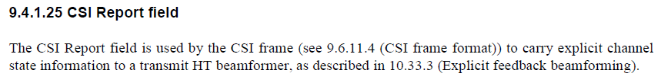
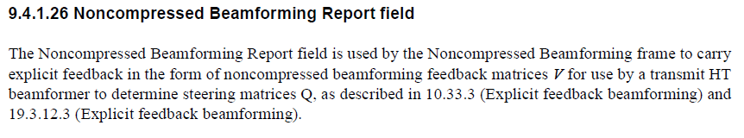
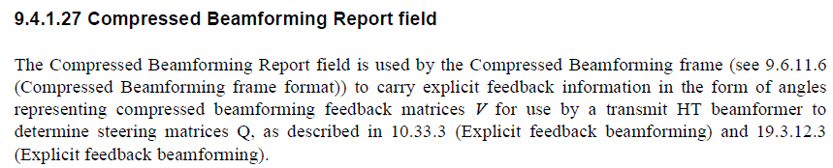
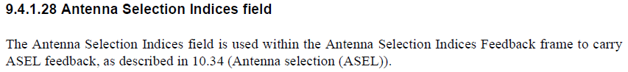
Given the above examples, a slightly different structure to describe the usage is recommended. Rather than containing a single sensing measurement report [segment], a more generic description of what the field carries may be: sensing measurement results obtained from a single sensing measurement exchange.

TGbf Editor: Modify P51.08-11 in D3.0 as follows:

The Sensing Measurement Report Container field is used in a Sensing Measurement Report frame (see 9.6.7.55 (Sensing Measurement Report frame format)) to carry sensing measurement results obtained from a single sensing measurement exchange (see 11.55.1.5 (Sensing measurement exchange)).. The format of the Sensing Measurement Report Container field is defined in Figure 9-189g (Sensing Measurement Report Container field format).
CID | Clause | Page | Comment | Proposed Change | Resolution
4143 | 9.4.1.73.1 | 52.39 | change the word "processes" to "process"? | As per comment | Accept

Discussion:
For reference, by accepting the comment, the following modification will be made.

The Sensing Measurement Report Control field is defined in 9.4.1.73.3 (Sensing Measurement Report Control field) and the Sensing Measurement Report field is defined in 9.4.1.73.4 (Sensing Measurement Report field). The process of encoding and decoding the CSI sent within a Sensing Measurement Report field is described in 9.4.1.73.2 (CSI encoding and decoding).

CID | Clause | Page | Comment | Proposed Change | Resolution
4279 | 11.55.1.5.2.5 | 155.64 | This NOTE seems to be too self-evident to have. Any reason to have such a NOTE? | Suggest remove the NOTE. | Accept

Discussion:

The NOTE identified in the comment is as follows:

In 802.11bf D3.0 (section 11.55.1.5.2.5), the text on P155.43-47 states there shall not be any UL resources assigned in a Sensing Reporting Trigger frame if the Sensing Measurement Report Requested field was set to 0.

In 802.11REVme D4.2, the following baseline text (section 9.3.1.22.1) is available to define how the RA address field is set:
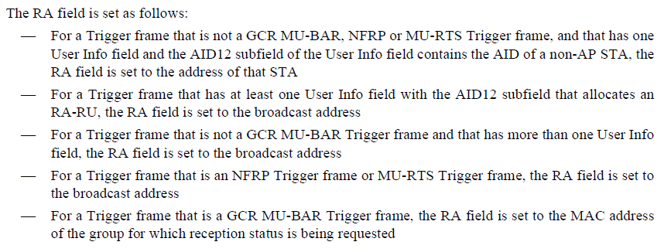

In 802.11bf D3.0, text in section 9.1.22.14.1 further clearifies the RA may be unicast or broadcast.
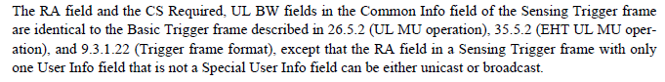

Even though the RA of a trigger frame may be set to the unicast STA address, such a condition where the Sensing Reporting Trigger frame contains a single User Info field with the AID12/USID12 set to a sensing responder NOT assigned to deliver a report is already specified not to occur, because the presence of such a User Info field is intened to provides the UL resource assignment (RU Allocation field).

It appears that the identified NOTE is not necessary because there is already sufficient behaviour defined which would prevent the case covered from occurring.
SP:
Do you support the resolution to CIDs 4040 4041 4042 4043 4044 4142 4143 4279 from 11-24/0149r0 and to incorporate the changes into the latest TGbf draft?

