IEEE P802.11
Wireless LANs
802.11 TGbh
LB282 General Arch and Misc CID resolutions
Date: 2024-01-14
Author(s):
Name | Affiliation | Address | Phone | email
Mark Hamilton | Ruckus/CommScope | 350 W Java Dr, Sunnyvale, CA 94089 | 303-818-8472 | mark.hamilton2152@gmail.com
Abstract
This submission proposes resolutions to the following comments received from the initial working group ballot (LB282): 64, 83, 86, 88, 89, 93, 1, 111, 116, 224, 223, 43, 241, 131, 230, 171, 284, 2, 3, 133, 117, 135.

Revision History

R0 – Iinitial version
R1 – Added several more proposed resolutions. Still 3 CIDs yet to be done.

Draft version

Changes are relative to TGbh D2.0.

Ready for Discussion

CID | Commenter | Clause Number | Page/  Line | Comment | Proposed Change
64 | Liuming Lu | Abstract | 3.1 | The description is confusing:1) IEEE Std 802.11 is missing, 2) the maintainance of the exising services is needed.3) the user privacy needs to be clarified. | Suggest to change "This amendment specifies modifications to the medium access control layer (MAC) mechanisms to preserve the existing services that might otherwise be restricted in environments where STAs in an Extended Service Set (ESS) use randomized or changing MAC addresses, without affecting user privacy." to "This amendment specifies modifications to the IEEE Std 802.11 medium access control layer (MAC) that enable the maintainance and preservation of the existing services that might otherwise be restricted in environments where STAs in an Extended Service Set (ESS) use randomized or changing MAC addresses, without affecting the privacy of the users corresponding to the STAs."

Discussion:

Current text:
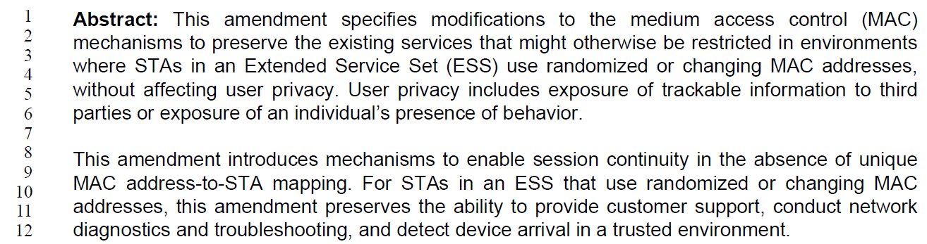

Suggested new text (changes shown):
This amendment specifies modifications to the IEEE Std 802.11 medium access control layer (MAC) mechanisms that enable the maintainance and preservation of to preserve the existing services that might otherwise be restricted in environments where STAs in an Extended Service Set (ESS) use randomized or changing MAC addresses, without affecting user the privacy of the users corresponding to the STAs

To addres the points raised in the comment:
- IEEE Std 802.11 is missing: While it could be argued that this should be clear because this is an amendment to 802.11, it seems reasonable to be clear and add this. However, the specific new text proposed also adds “layer” to “MAC”, which is technically incorrect as the MAC is a sublayer.
- the maintainance of the exising services is needed: The proposed new text says “that enable the maintenance … of the existing services. This amendment does not “enable maintenance”. It’s not clear what point the commenter is trying to make – perhaps that the amendment is doing maintenance on the existing services? But, the amendment is really adding two new features, to be used along with the existing services. No reference to “maintenance” of the existing services seems appropriate. In addition, the proposed new text also adds explicit mention that the existing services are preserved. This has been a long-standing tradition of IEEE Std 802.11 that amendments do not break existing services/implementations, and it does not seem to be stated in other amendments’s Abstract.
- the user privacy needs to be clarified: From the proposed new text, it seems the confusion is what “user” is intended by “without affecting user privacy”, and this could be clarified to be explicit that the intent is to not affect the privacy of the users of the interacting STAs. This change seems acceptable.

Proposed Resolution:

Revised
Replace the cited text with:
This amendment specifies modifications to the IEEE Std 802.11 medium access control (MAC) sublayer mechansisms to preserve the existing services that might otherwise be restricted in environments where STAs in an extended service set (ESS) use randomized or changing MAC addresses, without affecting the privacy of the users corresponding to the STAs.

CID | Commenter | Clause Number | Page/  Line | Comment | Proposed Change
83 | Mark RISON | 1.3 | 16.9 | What is "private device identification"? | Delete "private device"

Current text:
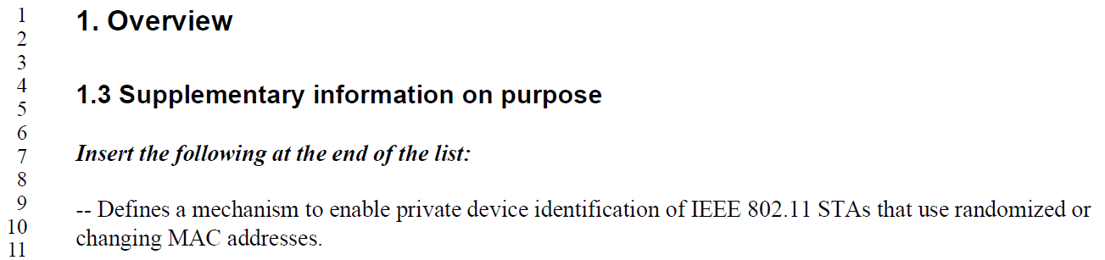

Discussion:

The text meant to be parsed as “the private identification of a device” (not mentioning a “private device”). It could be clarified. However, deleting the text is not the best solution, because we lose the concept of the identification being private.

Proposed Resolution:

Revised
Replace “private device identification” with “the private (from third-parties) identification of a device”

CID | Commenter | Clause Number | Page/  Line | Comment | Proposed Change
86 | Mark RISON | 4.5.4.10 | 18.15 | What is "a network"? BSS? ESS? Something else? | Use a more precise term

Current text:
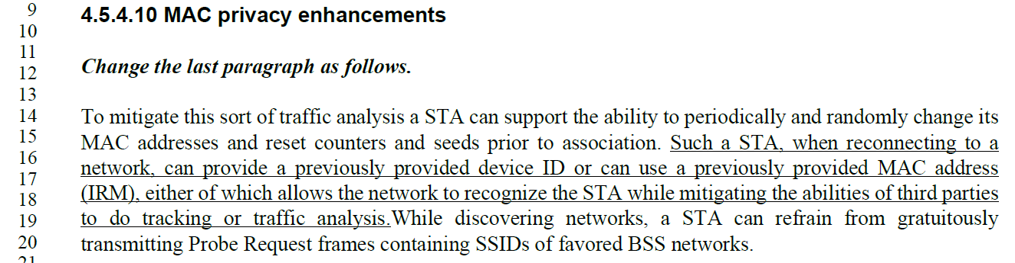

Discussion:

Proposed Resolution:

Rejected
The meaning of “network” in the new text is the same as the meaning in the baseline, in the following sentence. Further, we note that clause 4 is meant to be descriptive and not strict in precision to allow interoperability. What is meant by the term is clarified in the normative text in other clauses.

CID | Commenter | Clause Number | Page/  Line | Comment | Proposed Change
88 | Mark RISON | 6.5.7.2.2 | 19.53 | "dot11FILSActivated is true and " -- why does FILS have to be activated to be able to use DID? | Delete this cited text; also at line 59 and next page lines 26 and 32 and next page lines 5 and 10 and 42 and 47
89 | Mark RISON | 9.3.3.9 | 23.62 | No dot11FILSActivated here? | As it says in the comment

Current text for CID 88:
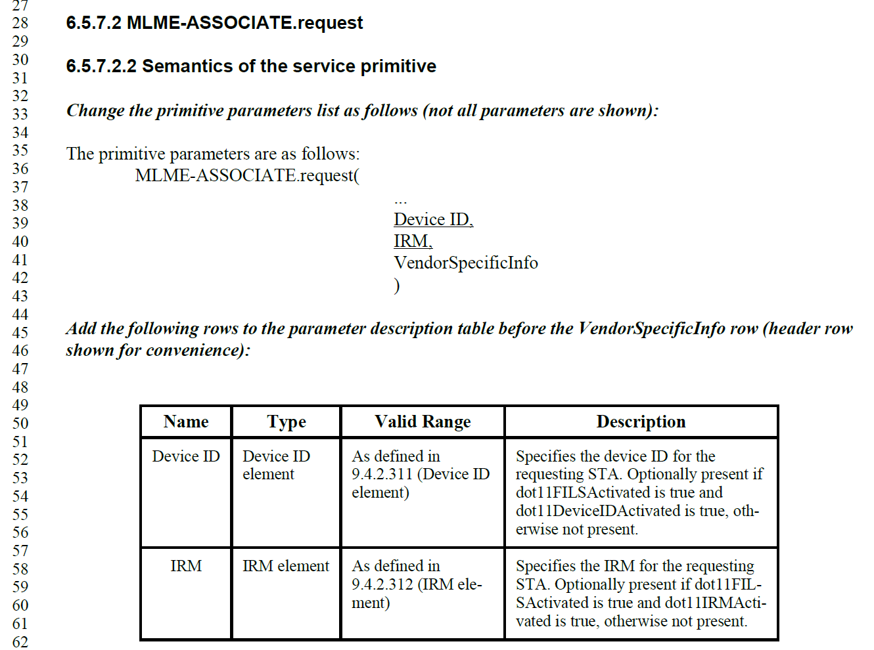

Current text for CID 89:
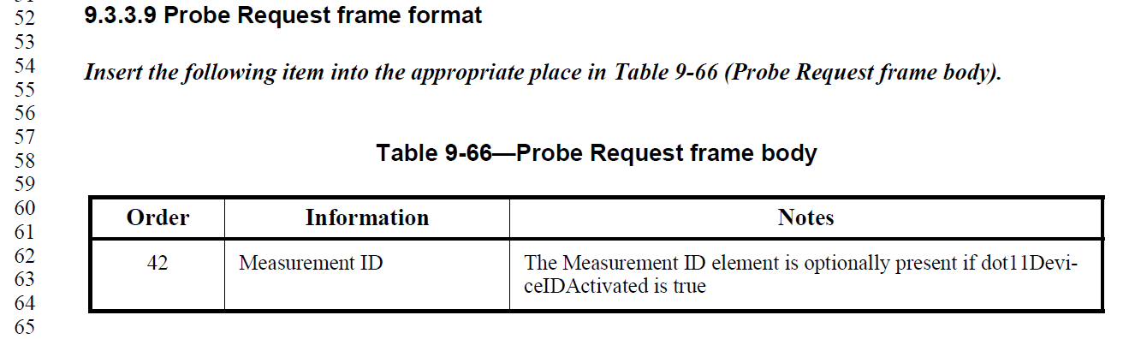

Discussion:

CID 88 Depends on direction on Association-time DID (CIDs 243 and 239).

But, either way on that, the Probe Request Notes cited in CID 89 are correct, the identification of a device that is performing Probe Request is used for probing in reaction to a Beacon measurement request, and is independent of whether the STA uses FILS or not during association.

Proposed Resolutions:

CID 88: Pending

CID 89:
Rejected.
The identification of a device that is performing Probe Request is used for optionally identifying a non-AP STA that is probing in reaction to a Beacon measurement request, and is independent of whether the STA uses FILS or not during association.

CID | Commenter | Clause Number | Page/  Line | Comment | Proposed Change
93 | Mark RISON | 9.4.2.1 | 24.45 | The IRM element looks eminently extensible to me | Change "No" in the penultimate column to "Yes"

Discussion:

Current text:

The cited location, which does say the IRM element is not extensible:
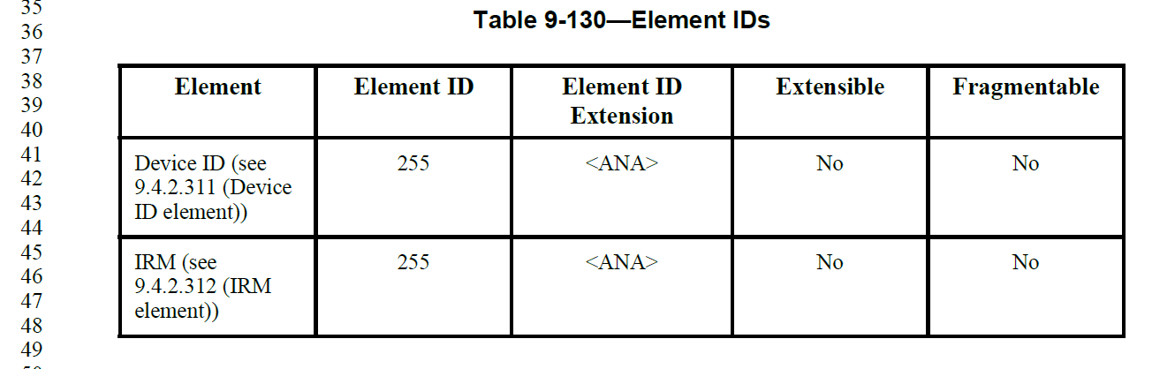

And, the contents of the IRM element do appear to be well formed to allow extending (and parsing, based on the Length field):
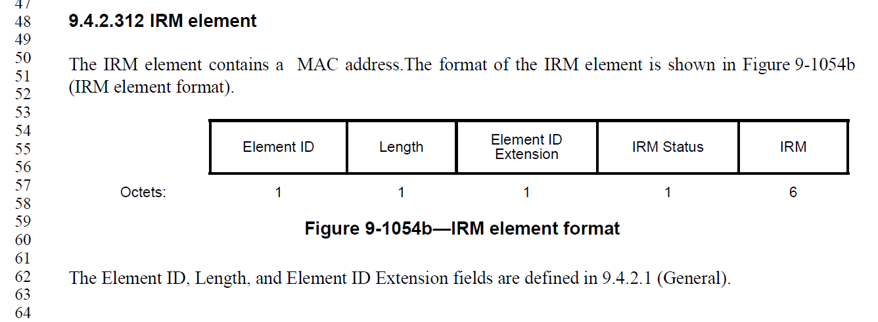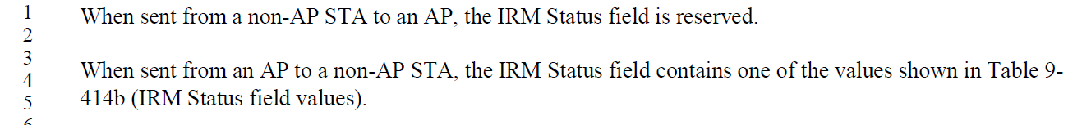

Proposed Resolution:

Accepted

CID | Commenter | Clause Number | Page/  Line | Comment | Proposed Change
1 | Rojan Chitrakar | 9.4.2.311 | 26.44 | "Optionally the device ID may be constructed as an opaque  identifier (see Annex AD)." | Why only mention the optional method? Anyway, how the device ID is constructed should not be in clause 9.

Current text:
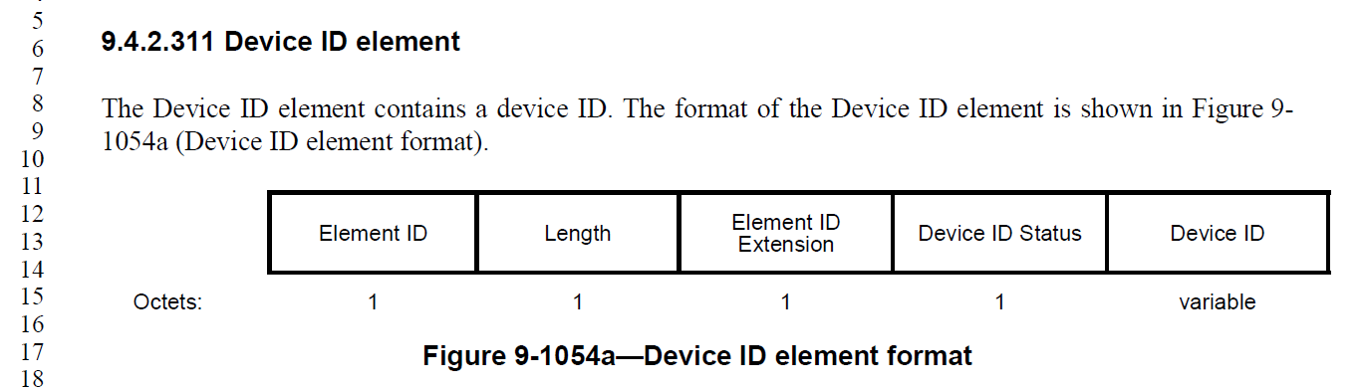

Discussion:
Agree with the commenter that this text is not necessary here, as it is mentioned in clause 12, and is (currently) an optional behavior of implementation, anyway. However, it seems useful to note here that the Device ID field may not contain literally the STA identification as might be expected by an implementer. Suggest changing this to a NOTE.

Proposed Resolution:

Revised

[ This CID may be affected by the resolution to CID 242. Resolce that comment first, and modify this resolution if/as appropriate.]

Change the cited sentence to a “NOTE--”, and change “may” to “might”. Also, add an explicit reference to 12.2.12.1, “… as described in 12.2.12.1”.

CID | Commenter | Clause Number | Page/  Line | Comment | Proposed Change
111 | Mark RISON | 9.6.35.1 | 27.54 | "These frames are identified by the single octet IRM Action field, which follows immediately after the Category field." duplicates the figure and should be "An IRM Action field, in the field immediately after the Category field, differentiates the formats." | As it says in the comment

Current text:
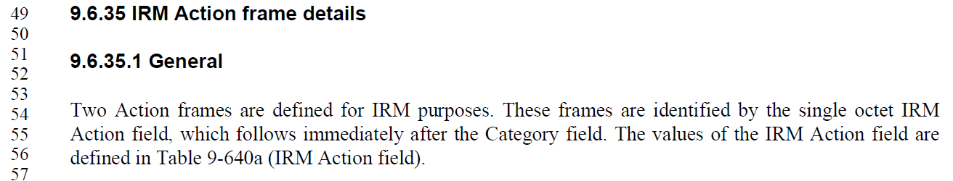

Discussion:

The general definition for Action frames is in 9.4.1.11, which specifies the Action Details field, which contains this Action field:
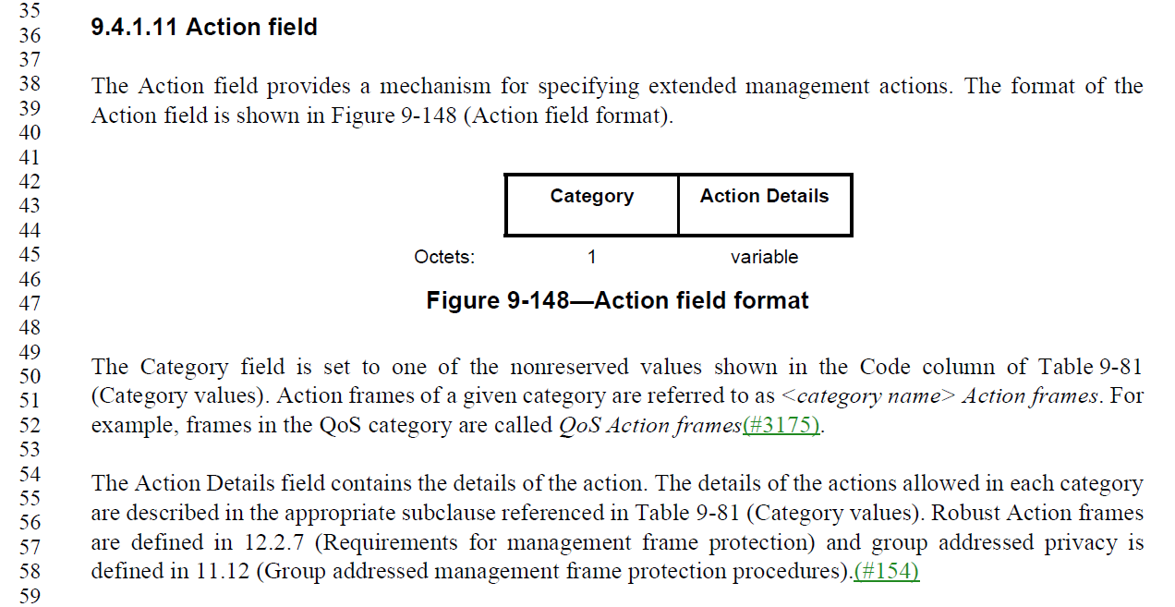

There is a lack of consistency in how the Action field (within the Action Details field) is described. However, a couple examples of different styles are:
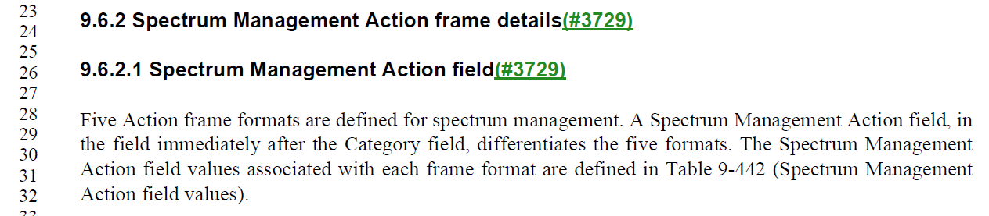

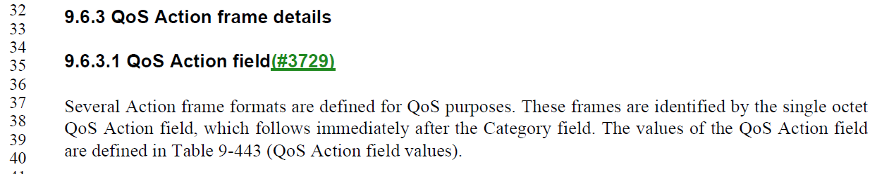

Note that the QoS Action frame uses wording very similar to the cited text. It is noted that nowhere in 9.4.1.11 does it specify that the <frame specific> Action field is 1 octet, and the first octet of the Action Details. Thus, it seems that this specification is necessary in each of the <frame specific> Action frame details subclauses. (There is no requirement that all types of Action frames agree that the <frame specific> Action field must be 1 octet, so each frame type should so specify.)

Thus, it seems that the error is in the baseline, in clauses similar to 9.6.2, which fail to specify the size of the <frame specific> Action field.

Proposed Resolution:

Rejected.
The information about the size and location of the IRM Action field does not appear in any Figure that can be found.

Note to the commenter, as 9.4.1.11 does not specify how the Action Details field is formatted, including how the <frame specific> Action field is carried, this information is needed in the 9.6.x subclauses. It is noted that this information is not always present in the baseline in these subclauses, and that may be an appropriate comment/discussion for REVm.

CID | Commenter | Clause Number | Page/  Line | Comment | Proposed Change
116 | Mark RISON | 11.10.9.1.1 | 29.25 | I have a nasty feeling Management frames don't have an RA field | Change "RA field" to "Address 1 field"; also at 25.24. At 31.48 change "TA field" to "Address 2 field"

Current text:
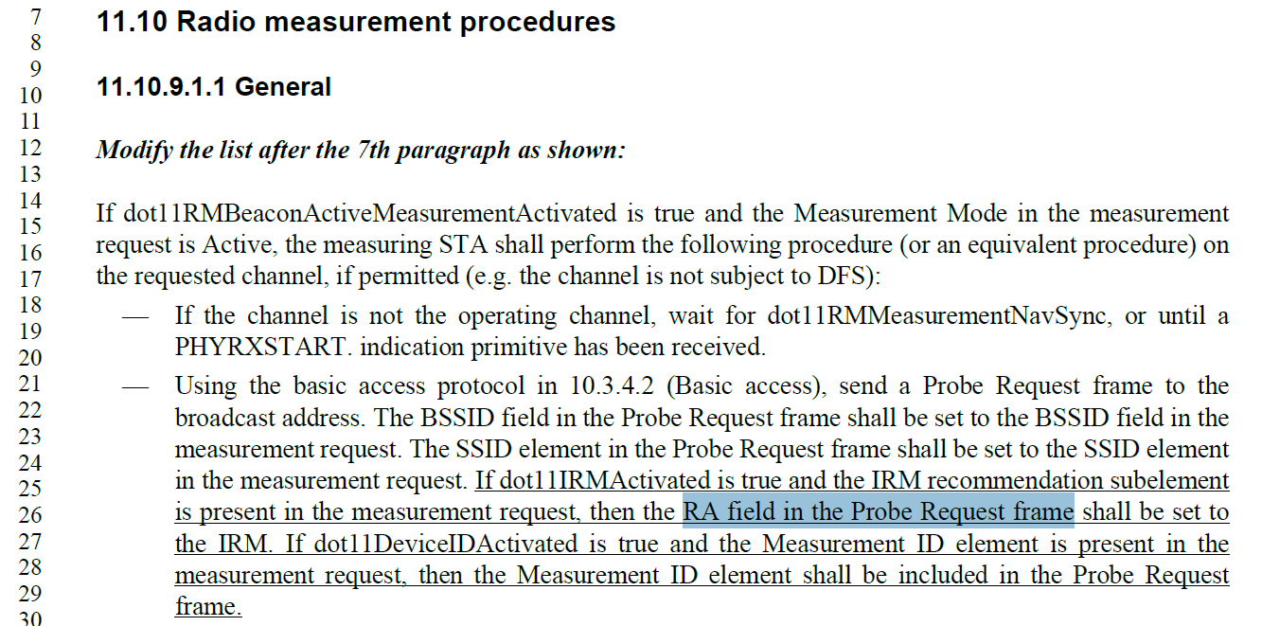

Discussion:
The frame body of a Probe Request frame is described in 9.3.3.9 in the REVme baseline. There is no discussion of the frame header in that subclause. Thus, we look to the general format for (PV0) Management frames, in 9.3.3.1. Indeed, that subclause does not specify RA (nor TA) fields in the frame header, but rather Address 1, Address 2 and Addres 3 fields.

Proposed Resolution:

Accepted

CID | Commenter | Clause Number | Page/  Line | Comment | Proposed Change
224 | Liwen Chu | 12.2.12 | 30.6 | It is not clear how to harmonize 11be with 11bh. | add the solution to the draft

Discussion:

Due to the current admenement ordering agreement, 11bh baseline is only REVme, and does not include 11be. Thus, no discussion of, or reference to, 11be features is appropriate in 11bh. Rather, 11be now includes 11bh in its baseline, and the relationship between the two needs to be discussed (if/as needed) in 11be.

Proposed Resolution:

Rejected
Due to the current admenement ordering agreement, 11bh baseline is only REVme, and does not include 11be. Thus, no discussion of, or reference to, 11be features is appropriate in 11bh. Rather, 11be now includes 11bh in its baseline, and the relationship between the two needs to be discussed (if/as needed) in 11be.

The commenter is invited to propose text in TGbe to relate the two amendments. It is noted that TGbh is currently having a discussion about the best way to gather a group of 11bh SMEs to help contribute such text to 11be. The commenter is invited to join that process, informally.

CID | Commenter | Clause Number | Page/  Line | Comment | Proposed Change
223 | Liwen Chu | 12.2.12 | 31.29 | Chcnage the description "from a non-AP STA withdot11DeviceIDActivated equal to true" by using a capability seting. The AP can't detect non-AP STA's capability directly. | As in comment

Discussion:
This CID is covered by the resolution to CIDs 40 and 128, in 11-24/0049.

Proposed Resolution:

<Copy the resolution to CIDs 40 and 128 from 11-24/0049, assuming that resolution is still appropriate after discussion and agreement.>

CID | Commenter | Clause Number | Page/  Line | Comment | Proposed Change
43 | Graham Smith | 12.2.12.1 | 31.45 | "When a non-AP STA receives a frame that contains a Device ID Status field in the Device ID KDE or Device ID element equal to 0 it may proceed with the assumption that the shared identity state with the AP or ESS (as per the concepts of 12.2.10) is now bound to the TA field in the Association Request frame most recently transmitted by the non-AP STA." I don't really know what this means. I thought the idea of device ID was to seperate the MAC address from the identity, i.e, nothing to do with the TA. Unless someone can explain the usefulness of this sentence, I would delete it. | Delete cited sentence
241 | Daniel Harkins | 12.2.12.1 | 31.46 | what is the non-AP STA supposed to do with this binding? | Either explain what the non-AP STA does with this binding or remove this paragraph.

Current text:
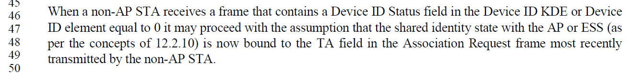

Discussion:
The concept is that with the successful negotiation of a Device ID, the AP/ESS (the “network”) now has an identification for the non-AP STA that is using the MAC address that is currently in use by that non-AP STA. So, future frames from that non-AP STA can be identified based on the TA in those frames, and then linked to that STA’s known identification within the AP/ESS/network, while still remaining anonymous to third parties.

The purpose and use of the identification of the non-AP STA is beyond the scope of 80.11bh. The assumption is that the non-AP STA and the AP/ESS/network are participating in use of this feature, because they both desire to have some state information which persists longer than the association and/or which has further semantics to the non-AP device and the network, beyond (above) 802.11. This concept is introduced in 12.2.12:
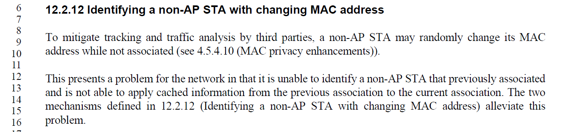
However, this could be clarified that the non-AP STA, by participating in the feature, is assumed to also have a reason (beyond the scope of 802.11) for wanting this mapping (“binding”) to connect the non-AP STA to this cached information.

Proposed Resolution:

CID 43:
Rejected.
The concept is that with the successful negotiation of a Device ID, the AP/ESS (the “network”) now has an identification for the non-AP STA that is using the MAC address that is currently in use by that non-AP STA. So, future frames from that non-AP STA can be identified based on the TA in those frames, and then linked to that STA’s known identification within the AP/ESS/network, while still remaining anonymous to third parties.

CID 241:
Revised.
At 30.13, insert a sentence, “Similarly, this presents a problem for the non-AP STA in that it cannot assume the network can recognize the STA as correlated to any cached information from previous association(s).” In the next sentence, change “this problem” to “these problems”.

CID | Commenter | Clause Number | Page/  Line | Comment | Proposed Change
131 | Mark RISON | 12.2.12.1 | 31.? | There are 4x references to "shared identity state" but this state is not defined | As it says in the comment
133 | Mark RISON | 12.2.12.1 | ?.46 | "may proceed with the assumption that the shared identity state with the AP or ESS (as per the concepts of 12.2.10) is now bound to the TA field in the Association Request frame" -- it is not clear what the implications/consequences of this assumption are | As it says in the comment

Current text:
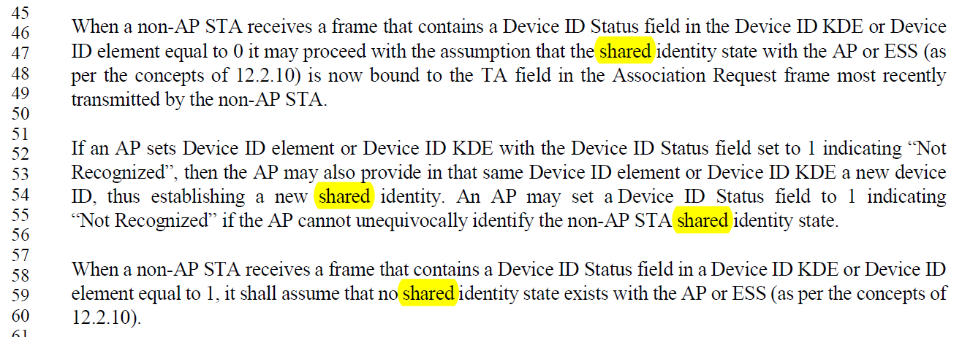

Discussion:
There are two potential issues underlying this coment.
- This text, referencing a “shared identity state” is meant to be referring to the same concept as described in the introductory text, in 12.2.12:
However, in 12.2.12 this information is described as “cached information”, rather than as “shared identity state”. These terms should be aligned or a cross-reference made explicit and clear.
- This state is ultimately intended to refer to the “state” discussed in 12.2.10 (Support of MAC privacy enhancements), where the limits of mapping a randomized or changing non-AP STA’s MAC address to such state stored on the AP (or ESS/network) is discussed. 802.11bh is intended to extend the ability to recognize such mapping of a non-AP STA to such state, while relaxing these limits.

Use of consistent wording would help, as would an explicit reference to 12.2.10.

Proposed Resolution (for both CIDs):

Revised
Modify the text in the second paragraph of 12.2.12, as shown:
This presents a problem for the network in that it is unable to identify a non-AP STA that previously associated and is not able to apply cached information (“shared identity state”) from the previous association to the current association (see 12.2.10). The two mechanisms defined in 12.2.12 (Identifying a non-AP STA with changing MAC address) alleviate this problem.

CID | Commenter | Clause Number | Page/  Line | Comment | Proposed Change
230 | Okan Mutgan | 12.2.12.2 | 33.30 | This paragraph says "indicates support" in the following sentences:  "A non-AP STA indicates support for the IRM mechanism.."  and  "If a non-AP STA indicates support for the IRM mechanism ... and the AP indicates support for the IRM mechanism ..."  The intention here should be the "indicates activation" | Change "indicates support" to "indicates activation"

Current text:
(Note, this is the first two sentence of the paragraph at P33.50):
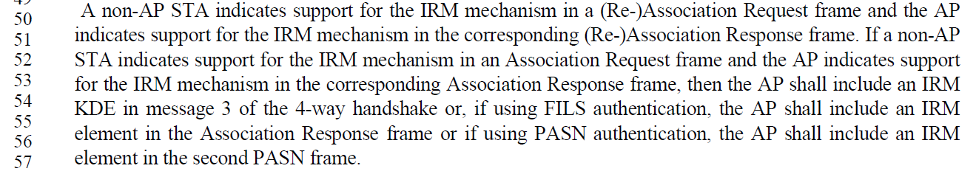

Discussion:
While not specific, nor consisten in the baseline wording, the verb “activation” seems consistent with the intent for a dot11…Activated MIB attribute, per 11-15/355r13.

There are multiple places in the current draft that mention “support” for this concept, and it should be modified to be consistent across the draft.

Proposed Resolution:

Revised
At P30.33 (the NOTE in 12.2.12), change “If an AP and a non-AP STA both support both IRM and device ID,” to “If an AP and a non-AP STA both have both IRM and device ID activated,”

At P30.38, change “An AP that has dot11DeviceIDActivated equal to true advertises support of the device ID mechanism” to “An AP that has dot11DeviceIDActivated equal to true advertises activation of the device ID mechanism”

At P30.61, change “Support of the device ID mechanism” to “Activation of the device ID mechanism”

At P33.12, change “Support of the IRM mechanism” to “Activation of the IRM mechanism”

At P33.30, change “When associating to an AP that advertises support for IRM” to “When associating to an AP that advertises activation of IRM”

At P33.50, modify the text as shown:
A non-AP STA indicates support for activation of the IRM mechanism in a (Re-)Association Request frame and the AP indicates support for activation of the IRM mechanism in the corresponding (Re-)Association Response frame. If a non-AP STA indicates support for activation of the IRM mechanism in an Association Request frame and the AP indicates support for activation of the IRM mechanism in the corresponding Association Response frame,

At P41.54, change “when true at an AP indicates that the AP supports IRM.” to “when true at an AP indicates that the AP supports has IRM activated.”

CID | Commenter | Clause Number | Page/  Line | Comment | Proposed Change
171 | Mark RISON | 12.7.3 | 35.47 | Which NOTE? | Clarify
284 | James Yee | 12.7.3 | 35.47 | Which NOTE does "SEE NOTE" refer to? | Please clarify

Current text:
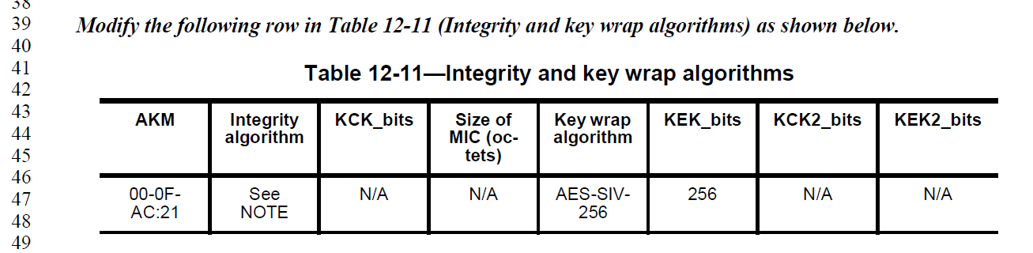

Discussion:
The 802.11bh amendment is attempting to modify an existing row of Table 12-11, as shown above, and below.

The intent, from 11-23/1725r5:
Add the following rows in Table 12-11—Integrity and key wrap algorithms in 12.7.3 EAPOL-Key PDU construction and processing as follows:

Table 12-11—Integrity and key wrap algorithms

AKM | Integrity  algorithm | KCK_bits | Size of  MIC  (octets) | Key wrap  algorithm | KEK_bits | KCK2_bits | KEK2_bits
00-0F-AC:21 |  |  |  | AES-SIV-256 | 256

The highlighted text above should have actually been “to the existing rows” (Add the following to the existing rows in Table 12-11…)

The exiting row came from 11az, as (per table 12-11 in REVme D4.1):

And, we note that the “See NOTE” is already present in the baseline (as is the NOTE itself at the bottom of Table 11-12).

Proposed Resolution:

Revised. Make the changes shown in 11-24/0044r8, for CID 211

CID | Commenter | Clause Number | Page/  Line | Comment | Proposed Change
2 | Rojan Chitrakar | B | 40.1 | IRM Action frame should be added in B.4.4.2 MAC frames | Add IRM Action frames in B.4.4.2 MAC frames

Discussion:
There does not seem to be a general convention to list Action frames in B.4.4.2, other than some S1G frames which are explicitly optional, or dependent on support of optional facilities within S1G, such as FT47.*. However, requirements to support other action frames’ do seem to be generally listed on the same row as the (optional) facility that uses them, for example CFMBO, PC34.1.10, PC35.5, etc.

However, the question is whether the use of Duplicate IRM and New IRM frames is optional, or mandatory, if IRM is activated. The text for both of these frames uses only “may” language, so we assume it is intended to be an optional extension of the IRM mechanism. In that case, it makes sense to list these frames in B.4.4.2, with the optionality make clear.

Proposed Resolution:

Revised
Add two rows to the table in B.4.4.2 (“MAC frames”), as shown:
Item | MAC frame | References | Status | Support
FT<ana> | IRM Action | 9.6.35 | CFIRM:O | Yes □ No □
FR<ana> | IRM Action | 9.6.35 | CFIRM:O | Yes □ No □

CID | Commenter | Clause Number | Page/  Line | Comment | Proposed Change

Discussion:

Current text:

Proposed Resolution:

Revised
Text here

Not ready yet

CID | Commenter | Clause Number |  | Page/  Line |  | Comment | Proposed Change
3 | Rojan Chitrakar | B.4 | 40.12 |  | Both of the listed IUT configurations seem more like features rather than IUT configurations. |  | Add the two mechanisms as a feature subclause instead of IUT configurations.
117 | Mark RISON |  |  |  | There are many instances of "association". Shouldn't many/most/all of these be "(re)association"? |  | As it says in the comment | Rejected. It is intentional that the capabilities for the features is shared in both Association and Reassociation frames (for consistency of the RSNE). But, the identification can only change, and therefore needs only to be exchanged, in Association frames.
135 | Mark RISON | 12 |  |  | "equal to 0" is not immediately obvious |  | Change to "indicating Recognized". Also set to 1 indicating "Not Recognized" -> set to indicate Not Recognized | Revised. Change to “equal to 0, indicating Recognized”. Change “set to 1” to “set to 1, indicating Not Recognized”

An aside – perhaps these changes would be useful clarification/correction of our terminology/upper/lower-case spelling:

Starting at P30.18 (third paragraph of 12.2.12, modify the text as shown:

The first mechanism, referred to as the device ID mechanism, has the AP provide an identifier to the non-AP STA during association or PASN authentication that the non-AP STA can them report back to the AP during a future association or PASN authentication. The second mechanism, referred to as the IRM mechanism, has the non-AP STA provide a random MAC address (different from the address it is using) to the AP during association or PASN authentication and then use that MAC address for the next association or PASN authentication.

The two mechanisms, device ID mechanism and IRM mechanism, both allow the network to recognize the STA while mitigating the abilities of third parties to do traffic analysis and tracking of the non-AP STA.

The two mechanisms, device ID and IRM mechanism, may be used concurrently.

NOTE—The Device ID and IRM mechanisms are independent schemes that allow an AP to recognize a non-AP STA prior to association and identify it during association respectively. A device ID is allocated by an AP, and an IRM is selected by a non-AP STA. If an AP and a non-AP STA both support both the IRM mechanism and the device ID mechanism, the non-AP STA might provide both an IRM and a device ID.

At 31.1, change “device ID element” to “Device ID element’.

Completed

References:

https://mentor.ieee.org/802.11/dcn/23/11-23-1152-24-00bh-ieee-802-11bh-lb274-comments.xlsx

https://mentor.ieee.org/802.11/dcn/23/11-23-1245-24-00bh-cid-resolutions-irm-1.docx

