IEEE P802.11
Wireless LANs
802.11 TGbh
LB282 General Arch and Misc CID resolutions
Date: 2024-01-14
Author(s):
Name | Affiliation | Address | Phone | email
Mark Hamilton | Ruckus/CommScope | 350 W Java Dr, Sunnyvale, CA 94089 | 303-818-8472 | mark.hamilton2152@gmail.com
Abstract
This submission proposes resolutions to the following comments received from the initial working group ballot (LB282): 64, 83, 86, 88, 89, 93, 1, 111, 116, 224, 223, 43, 241, 131, 230, 171, 284, 2, 3, 133, 117, 135.

Revision History

R0 – Iinitial version
R1 –

Draft version

Changes are relative to TGbh D2.0.

Ready for Discussion

CID | Commenter | Clause Number | Page/  Line | Comment | Proposed Change
64 | Liuming Lu | Abstract | 3.1 | The description is confusing:1) IEEE Std 802.11 is missing, 2) the maintainance of the exising services is needed.3) the user privacy needs to be clarified. | Suggest to change "This amendment specifies modifications to the medium access control layer (MAC) mechanisms to preserve the existing services that might otherwise be restricted in environments where STAs in an Extended Service Set (ESS) use randomized or changing MAC addresses, without affecting user privacy." to "This amendment specifies modifications to the IEEE Std 802.11 medium access control layer (MAC) that enable the maintainance and preservation of the existing services that might otherwise be restricted in environments where STAs in an Extended Service Set (ESS) use randomized or changing MAC addresses, without affecting the privacy of the users corresponding to the STAs."

Discussion:

Current text:
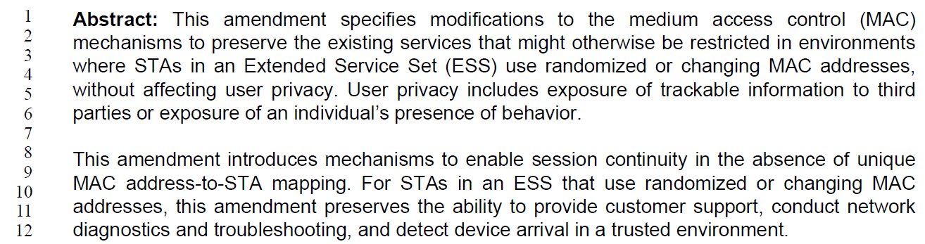

Suggested new text (changes shown):
This amendment specifies modifications to the IEEE Std 802.11 medium access control layer (MAC) mechanisms that enable the maintainance and preservation of to preserve the existing services that might otherwise be restricted in environments where STAs in an Extended Service Set (ESS) use randomized or changing MAC addresses, without affecting user the privacy of the users corresponding to the STAs

To addres the points raised in the comment:
- IEEE Std 802.11 is missing: While it could be argued that this should be clear because this is an amendment to 802.11, it seems reasonable to be clear and add this. However, the specific new text proposed also adds “layer” to “MAC”, which is technically incorrect as the MAC is a sublayer.
- the maintainance of the exising services is needed: The proposed new text says “that enable the maintenance … of the existing services. This amendment does not “enable maintenance”. It’s not clear what point the commenter is trying to make – perhaps that the amendment is doing maintenance on the existing services? But, the amendment is really adding two new features, to be used along with the existing services. No reference to “maintenance” of the existing services seems appropriate. In addition, the proposed new text also adds explicit mention that the existing services are preserved. This has been a long-standing tradition of IEEE Std 802.11 that amendments do not break existing services/implementations, and it does not seem to be stated in other amendments’s Abstract.
- the user privacy needs to be clarified: From the proposed new text, it seems the confusion is what “user” is intended by “without affecting user privacy”, and this could be clarified to be explicit that the intent is to not affect the privacy of the users of the interacting STAs. This change seems acceptable.

Proposed Resolution:

Revised
Replace the cited text with:
This amendment specifies modifications to the IEEE Std 802.11 medium access control (MAC) sublayer mechansisms to preserve the existing services that might otherwise be restricted in environments where STAs in an Extended Service Set (ESS) use randomized or changing MAC addresses, without affecting the privacy of the users corresponding to the STAs.

CID | Commenter | Clause Number | Page/  Line | Comment | Proposed Change
83 | Mark RISON | 1.3 | 16.9 | What is "private device identification"? | Delete "private device"

Current text:
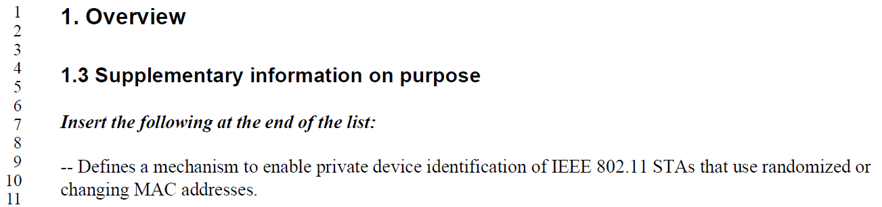

Discussion:

The text meant to be parsed as “the private identification of a device” (not mentioning a “private device”). It could be clarified. However, deleting the text is not the best solution, because we lose the concept of the identification being private.

Proposed Resolution:

Revised
Replace “private device identification” with “the private (from thid-parties) identification”

CID | Commenter | Clause Number | Page/  Line | Comment | Proposed Change
86 | Mark RISON | 4.5.4.10 | 18.15 | What is "a network"? BSS? ESS? Something else? | Use a more precise term

Current text:
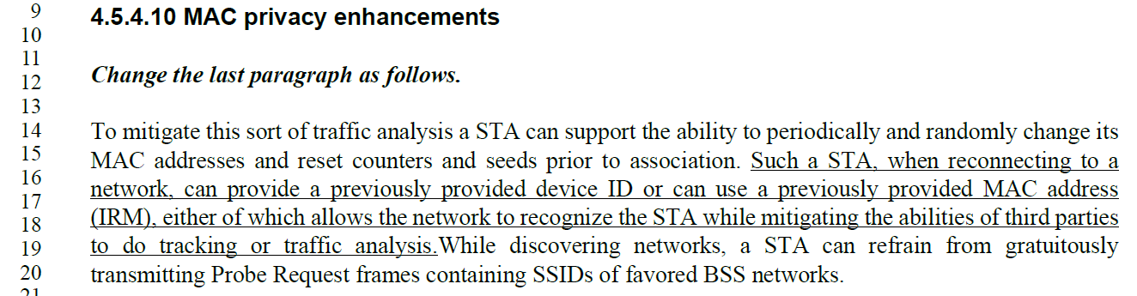

Discussion:

Proposed Resolution:

Rejected
The meaning of “network” in the new text is the same as the meaning in the baseline, in the following sentence. Further, we note that clause 4 is meant to be descriptive and not strict in precision to allow interoperability. What is meant by the term is clarified in the normative text in other clauses.

CID | Commenter | Clause Number | Page/  Line | Comment | Proposed Change
88 | Mark RISON | 6.5.7.2.2 | 19.53 | "dot11FILSActivated is true and " -- why does FILS have to be activated to be able to use DID? | Delete this cited text; also at line 59 and next page lines 26 and 32 and next page lines 5 and 10 and 42 and 47
89 | Mark RISON | 9.3.3.9 | 23.62 | No dot11FILSActivated here? | As it says in the comment

Current text for CID 88:
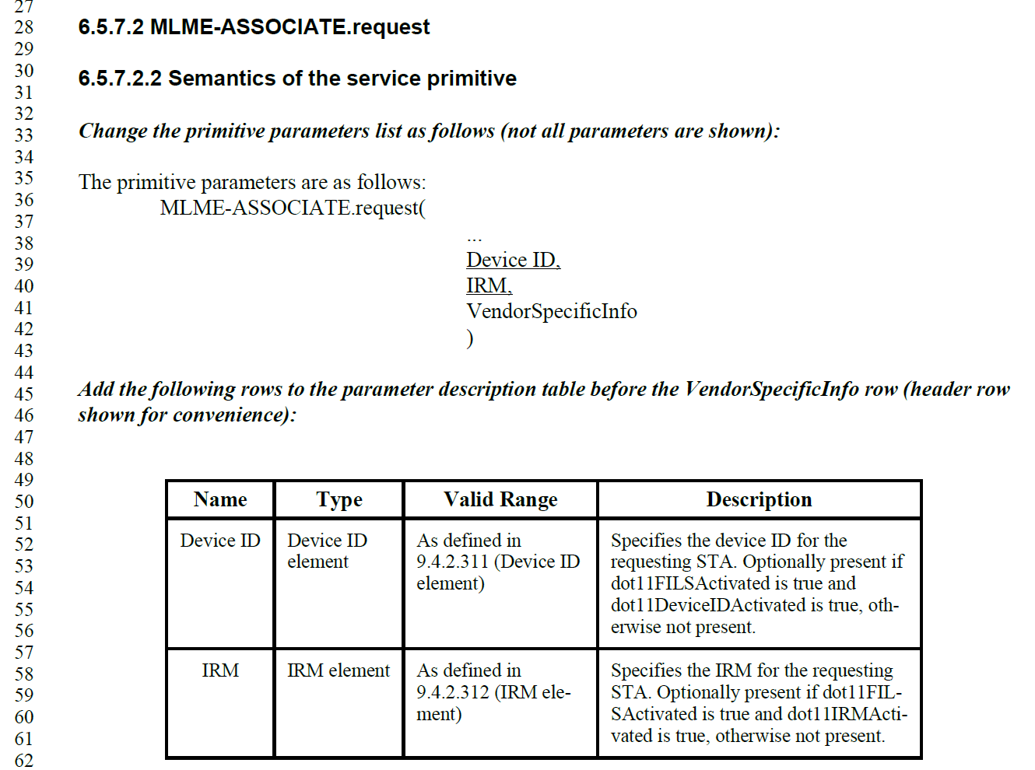

Current text for CID 89:
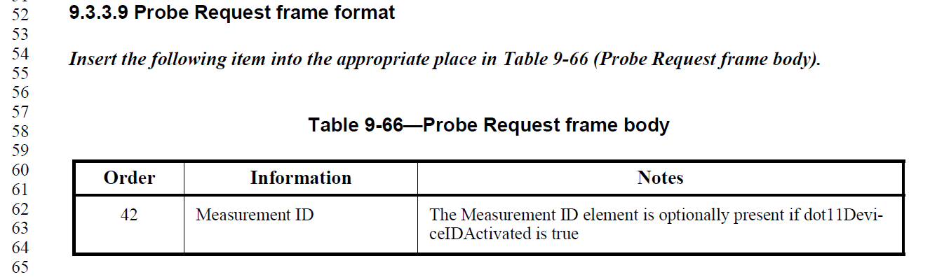

Discussion:

CID 88 Depends on direction on Association-time DID (CIDs 243 and 239).

But, either way on that, the Probe Request Notes cited in CID 89 are correct, the identification of a device that is performing Probe Request is used for probing in reaction to a Beacon measurement request, and is independent of whether the STA uses FILS or not during association.

Proposed Resolutions:

CID 88: Pending

CID 89:
Rejected.
The identification of a device that is performing Probe Request is used for optionally identifying a non-AP STA that is probing in reaction to a Beacon measurement request, and is independent of whether the STA uses FILS or not during association.

CID | Commenter | Clause Number | Page/  Line | Comment | Proposed Change
93 | Mark RISON | 9.4.2.1 | 24.45 | The IRM element looks eminently extensible to me | Change "No" in the penultimate column to "Yes"

Discussion:

Current text:

The cited location, which does say the IRM element is not extensible:
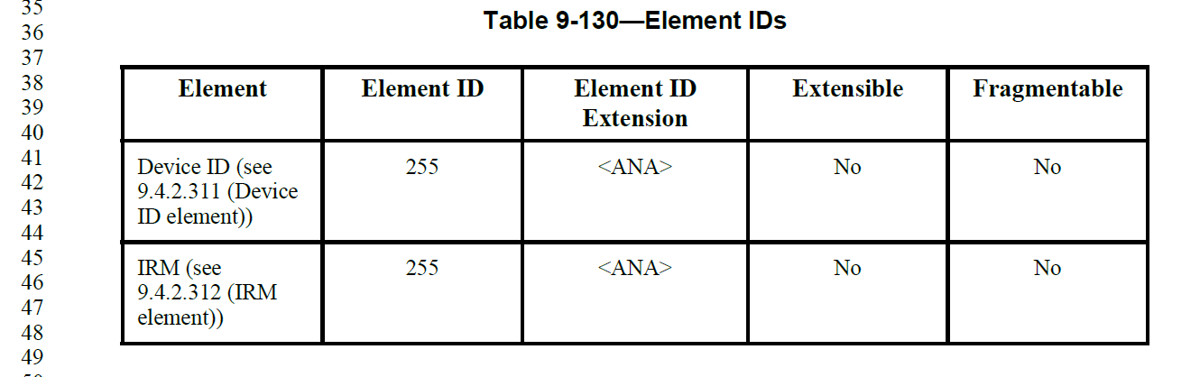

And, the contents of the IRM element do appear to be well formed to allow extending (and parsing, based on the Length field):
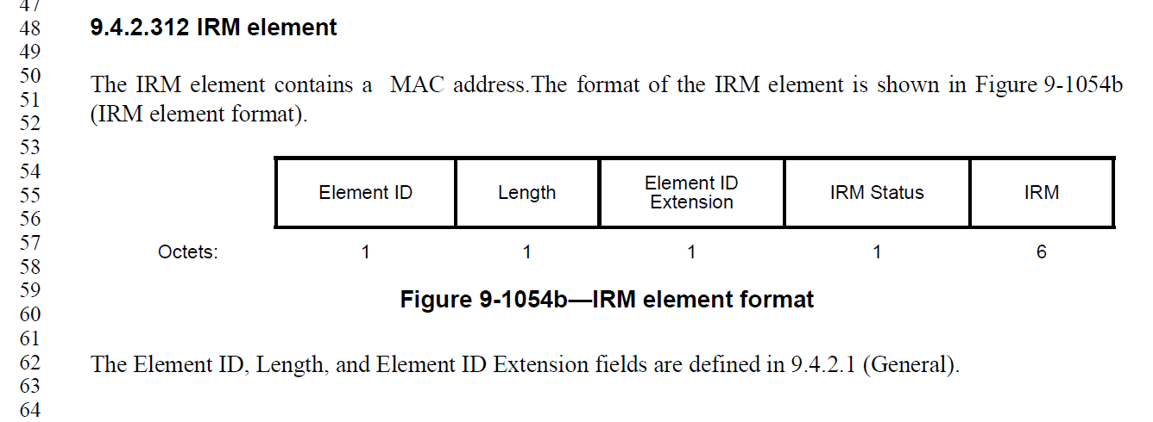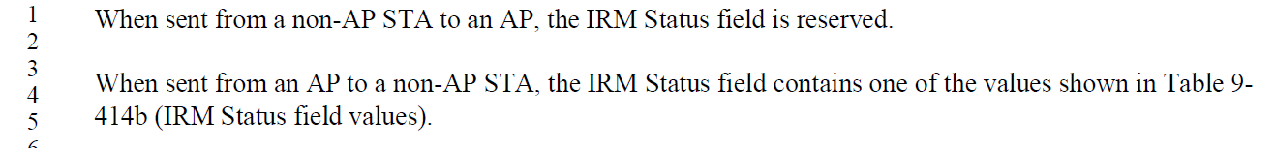

Proposed Resolution:

Accepted

CID | Commenter | Clause Number | Page/  Line | Comment | Proposed Change

Discussion:

Current text:

Proposed Resolution:

Revised
Text here

Not ready yet

CID | Commenter | Clause Number |  | Page/  Line |  | Comment | Proposed Change
1 | Rojan Chitrakar | 9.4.2.311 | 26.44 |  | "Optionally the device ID may be constructed as an opaque  identifier (see Annex AD)." |  | Why only mention the optional method? Anyway, how the device ID is constructed should not be in clause 9.
111 | Mark RISON | 9.6.35.1 | 27.54 |  | "These frames are identified by the single octet IRM Action field, which follows immediately after the Category field." duplicates the figure and should be "An IRM Action field, in the field immediately after the Category field, differentiates the formats." |  | As it says in the comment
116 | Mark RISON | 11.10.9.1.1 | 29.25 |  | I have a nasty feeling Management frames don't have an RA field |  | Change "RA field" to "Address 1 field"; also at 25.24. At 31.48 change "TA field" to "Address 2 field"
224 | Liwen Chu | 12.2.12 | 30.6 |  | It is not clear how to harmonize 11be with 11bh. |  | add the solution to the draft
223 | Liwen Chu | 12.2.12 | 31.29 |  | Chcnage the description "from a non-AP STA withdot11DeviceIDActivated equal to true" by using a capability seting. The AP can't detect non-AP STA's capability directly. |  | As in comment
43 | Graham Smith | 12.2.12.1 | 31.45 |  | "When a non-AP STA receives a frame that contains a Device ID Status field in the Device ID KDE or Device ID element equal to 0 it may proceed with the assumption that the shared identity state with the AP or ESS (as per the concepts of 12.2.10) is now bound to the TA field in the Association Request frame most recently transmitted by the non-AP STA." I don't really know what this means. I thought the idea of device ID was to seperate the MAC address from the identity, i.e, nothing to do with the TA. Unless someone can explain the usefulness of this sentence, I would delete it. |  | Delete cited sentence
241 | Daniel Harkins | 12.2.12.1 | 31.46 |  | what is the non-AP STA supposed to do with this binding? |  | Either explain what the non-AP STA does with this binding or remove this paragraph.
131 | Mark RISON | 12.2.12.1 | 31 |  | There are 4x references to "shared identity state" but this state is not defined |  | As it says in the comment
230 | Okan Mutgan | 12.2.12.2 | 33.30 |  | This paragraph says "indicates support" in the following sentences:  "A non-AP STA indicates support for the IRM mechanism.."  and  "If a non-AP STA indicates support for the IRM mechanism ... and the AP indicates support for the IRM mechanism ..."  The intention here should be the "indicates activation" |  | Change "indicates support" to "indicates activation"
171 | Mark RISON | 12.7.3 | 35.47 |  | Which NOTE? |  | Clarify
284 | James Yee | 12.7.3 | 35.47 |  | Which NOTE does "SEE NOTE" refer to? |  | Please clarify
2 | Rojan Chitrakar | B | 40.1 |  | IRM Action frame should be added in B.4.4.2 MAC frames |  | Add IRM Action frames in B.4.4.2 MAC frames
3 | Rojan Chitrakar | B.4 | 40.12 |  | Both of the listed IUT configurations seem more like features rather than IUT configurations. |  | Add the two mechanisms as a feature subclause instead of IUT configurations.
133 | Mark RISON | 12.2.12.1 | ?.46 |  | "may proceed with the assumption that the shared identity state with the AP or ESS (as per the concepts of 12.2.10) is now bound to the TA field in the Association Request frame" -- it is not clear what the implications/consequences of this assumption are |  | As it says in the comment
117 | Mark RISON |  |  |  | There are many instances of "association". Shouldn't many/most/all of these be "(re)association"? |  | As it says in the comment
135 | Mark RISON | 12 |  |  | "equal to 0" is not immediately obvious |  | Change to "indicating Recognized". Also set to 1 indicating "Not Recognized" -> set to indicate Not Recognized

Starting at P30.18 (third paragraph of 12.2.12, modify the text as shown:

The first mechanism, referred to as the device ID mechanism, has the AP provide an identifier to the non-AP STA during association or PASN authentication that the non-AP STA can them report back to the AP during a future association or PASN authentication. The second mechanism, referred to as the IRM mechanism, has the non-AP STA provide a random MAC address (different from the address it is using) to the AP during association or PASN authentication and then use that MAC address for the next association or PASN authentication.

The two mechanisms, device ID mechanism and IRM mechanism, both allow the network to recognize the STA while mitigating the abilities of third parties to do traffic analysis and tracking of the non-AP STA.

The two mechanisms, device ID and IRM mechanism, may be used concurrently.

NOTE—The Device ID and IRM mechanisms are independent schemes that allow an AP to recognize a non-AP STA prior to association and identify it during association respectively. A device ID is allocated by an AP, and an IRM is selected by a non-AP STA. If an AP and a non-AP STA both support both the IRM mechanism and the device ID mechanism, the non-AP STA might provide both an IRM and a device ID.

At 31.1, change “device ID element” to “Device ID element’.

Completed

References:

https://mentor.ieee.org/802.11/dcn/23/11-23-1152-24-00bh-ieee-802-11bh-lb274-comments.xlsx

https://mentor.ieee.org/802.11/dcn/23/11-23-1245-24-00bh-cid-resolutions-irm-1.docx

